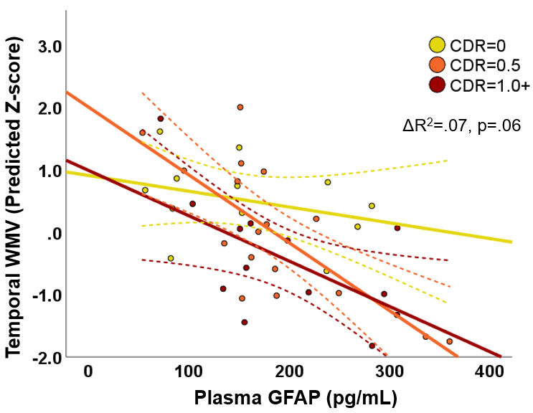
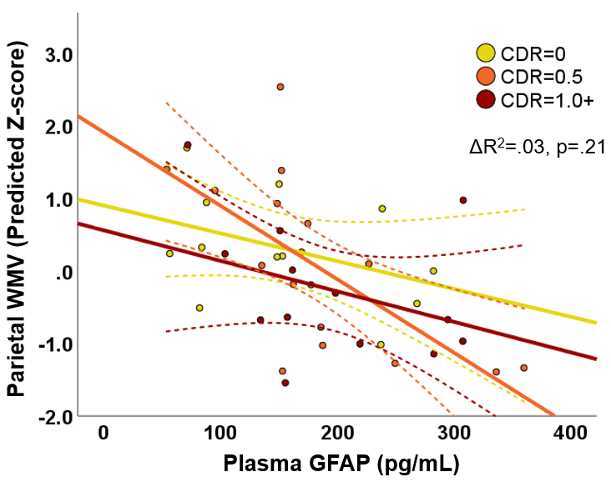
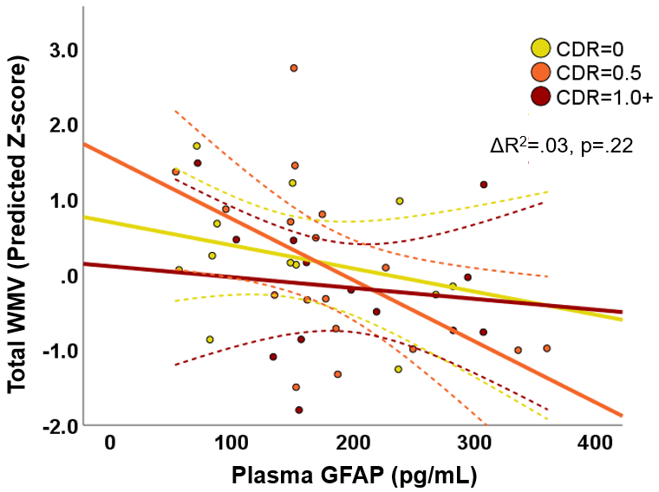
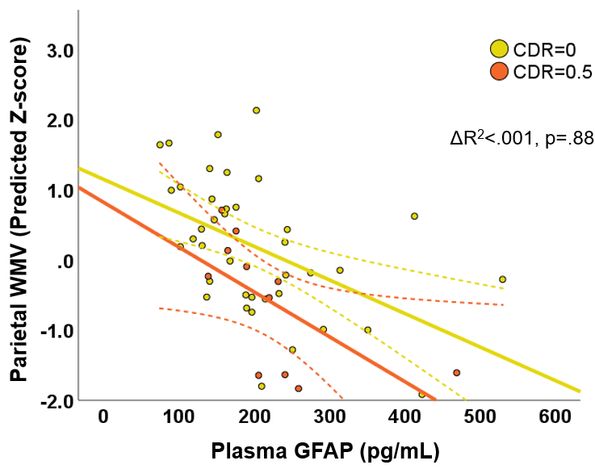
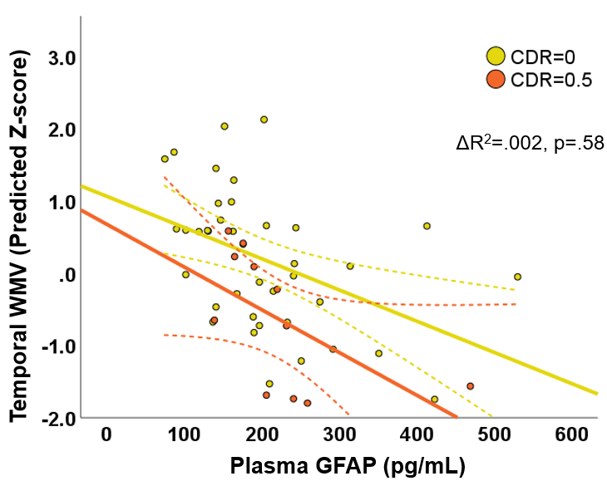
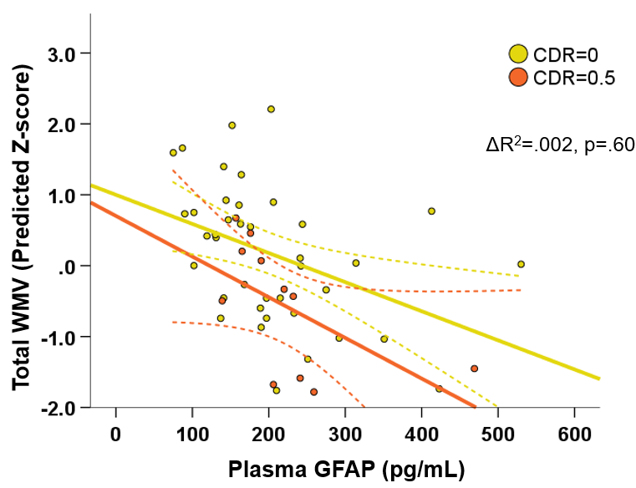
Cohort 1
Cohort 2
Supplemental Figure 1: Scatterplots depicting non-statistically significant plasma GFAP x functional status interactions with white matter volumes (restricted to ROIs depicted in Figure 1 showing relevant independent associations of plasma GFAP). Y-axes represent model-predicted standardized (z-score) volumes based on age, sex, total intracranial volume, scanner, CDR Sum of Boxes, plasma GFAP, plasma NfL, and plasma GFAP x CDR Sum of Boxes. Groups are stratified in scatterplots based on CDR Global Score for ease of visualization (“Clinically Normal,” CDR=0; “MCI,” CDR=0.5; “Dementia,” CDR=1.0+). Dashed lines show 95% confidence interval around the linear fit line for each subgroup. ΔR² values represent the change in overall model fit associated with addition of the GFAP x CDR Sum of Boxes interaction term.

Cohort 1
Cohort 2

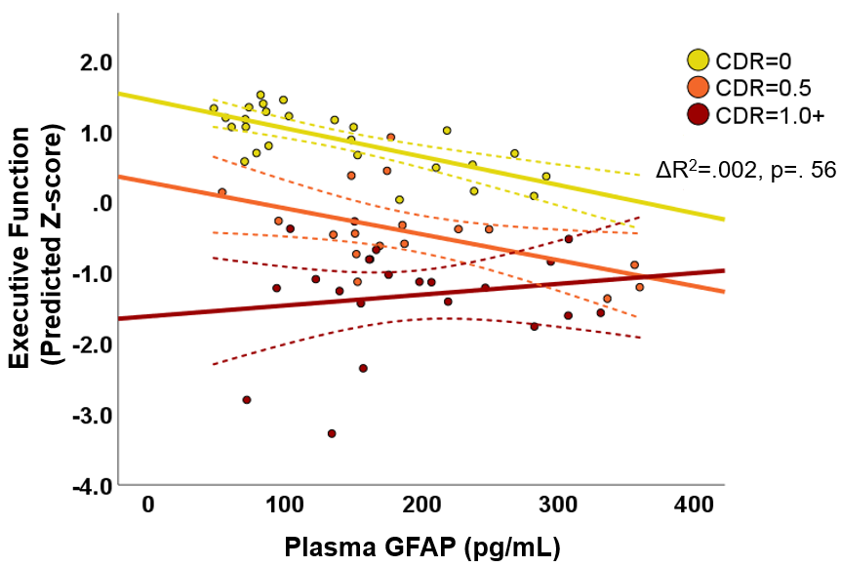
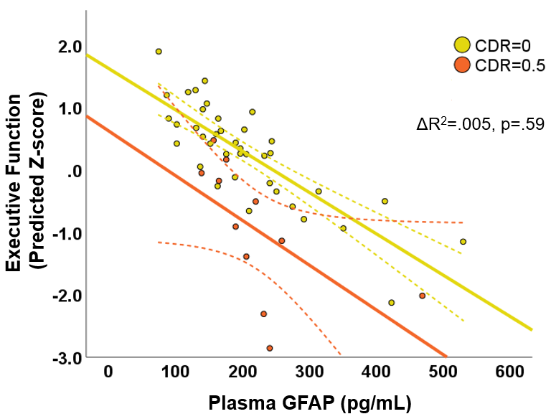

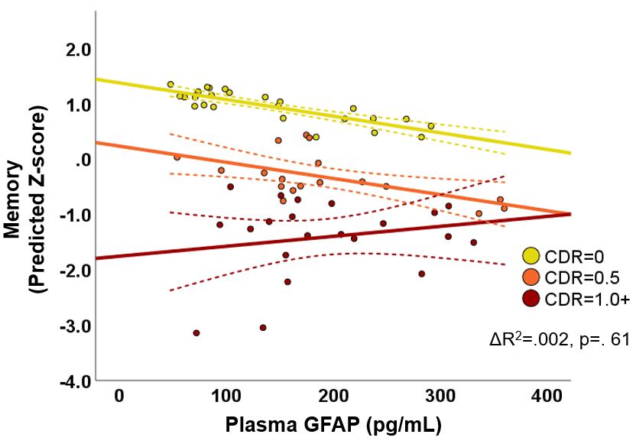
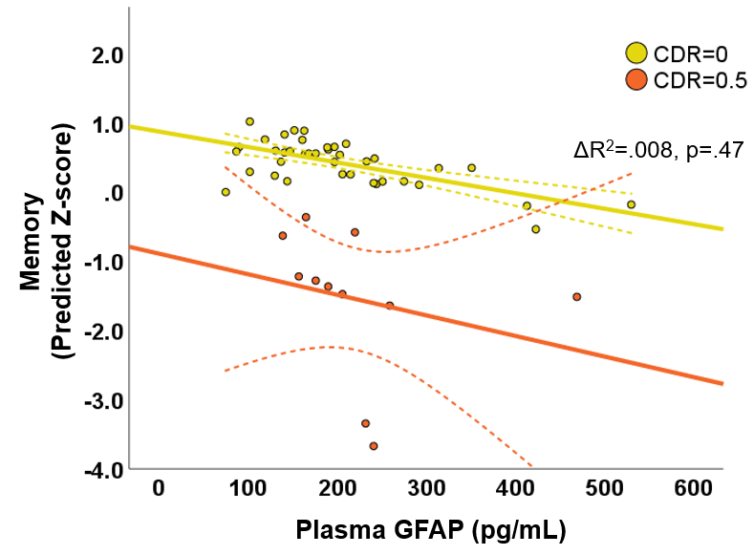

Supplemental Figure 2: Scatterplots depicting non-statistically significant plasma GFAP x functional status interactions with cognitive outcomes (restricted to domains depicted in Figure 2 showing relevant independent associations of plasma GFAP). Y-axes represent model-predicted standardized (z-score) volumes based on age, sex, years of education, CDR Sum of Boxes, plasma GFAP, plasma NfL, and plasma GFAP x CDR Sum of Boxes. Groups are stratified in scatterplots based on CDR Global Score for ease of visualization (“Clinically Normal,” CDR=0; “MCI,” CDR=0.5; “Dementia,” CDR=1.0+). Dashed lines show 95% confidence interval around the linear fit line for each subgroup. ΔR² values represent the change in overall model fit associated with addition of the GFAP x CDR Sum of Boxes interaction term.

