Supplemental Methods
Experimental and Behavioral Task Design
The experimental design was a two-by-five mixed factorial. The between-subjects factor was population (2 levels). The within-subjects factor was WM load (5 levels). To manipulate load, participants were administered the N-back task while undergoing fMRI. The N-back task is a forced-choice measure of WM that requires examinees to monitor a continuous stream of stimuli and respond each time an item is repeated from N before. This task was chosen because it is commonly used to study brain and cognitive functioning in SZs (Glahn et al. 2005). Stimuli were high frequency pseudowords. Items were created by first generating all consonant-vowel-consonant combinations of letters in the English alphabet (e.g., “COW” and “BAP”). MCWord (Medler and Binder 2005) was used to identify word frequency and orthographic neighborhood statistics. We eliminated all words with a non-zero frequency, and then selected words in the top 20% of the orthographic neighborhood statistic. We then created 15 pseudoword lists that would allow us to administer 1- through 5-back conditions up to three times without repeating items. Lists consisted of 20 pseudowords with 4 targets (items repeated from N back; 20%), 4 lures (items repeated, but not from N back; 20%), and 12 foils (non-repeated items; 60%). Item order and placement within the lists was pseudo-randomized using a script written in R.
Stimulus presentation followed a block design. Specifically, we created three N-back runs, each consisting of 5 blocks of trials (i.e., 1- through 5-back load conditions). One run was administered outside of the scanner and the remaining two were administered within the scanner. Blocks were counterbalanced over runs. The task was administered using PsychoPy (Peirce et al. 2019). Pseudowords were presented in white font on a black background for 2500ms with a 500ms inter-item-interval. The timing was constrained so that each block would last exactly 60s. Blocks were separated by 20s intervals (with a fixation cross) including before the first block and after the last.
Image Preprocessing
We used local scripts as well as software from Analysis of Functional NeuroImages (AFNI; Ver. 18.1.14) (Cox 1996) and FMRIB Software Library (FSL; Ver. 5.0.10) (Jenkinson et al. 2012) to process the structural and functional images. We first used AFNI’s segmentation tool (3dSkullStrip) to remove non-brain tissue from structural images. Adjustments were performed manually as needed. Registration of the anatomical images consisted of using AFNI’s Talairach tool (auto_tlrc) to automatically warp the images into Talairach space (Talairach and Tournoux 1988) using the ICBM-452 brain template (Rex, Ma, and Toga 2003). Multiband functional images were reconstructed using local scripts. Distortions due to inhomogeneities in the B₀ magnetic field were corrected using FSL’s TOPUP tool. After correction, all images were visually inspected to ensure that B₀ distortions—especially in the orbitofrontal cortex and the lateral temporal lobe—were reduced. Scanner artifacts (spikes) were removed using AFNI’s 3dDespike tool. Next, AFNI’s alignment tool (align_epi_anat) was used to co-register functional images (3dvolreg) within the time-series and then align them to the (unregistered) structural images (3dAllineate). In all cases, the time-series was visually inspected to identify an optimal base image. We began with a local Pearson correlation cost function (Saad et al. 2009) and a 12 parameter affine transformation, visually inspected the alignment, and then, if the alignment was not satisfactory, re-aligned using other cost functions until achieving satisfactory results. Given the block design, the data were not time shifted (Poldrack, Mumford, and Nichols 2011). Using AFNI’s 3dTqual tool, the Spearmen correlation of each volume with the median volume was used to identify outliers and to create a censor file for the time-series. The cutoff for censoring time points for each subject was based on the larger value of 0.02 (absolute cutoff) or 3.5 times the median absolute deviation (relative cutoff). The co-registered functional images were then blurred to an effective full width at half maximum of 6 mm smoothness using AFNI’s 3dBlurToFWHM tool.
To account for physiological motion, respiration and cardiac activity were acquired in parallel with the functional images and converted to sines and cosines of the first and second phase cycles modeling the physiological activity (Glover, Li, and Ress 2000). Using AFNI’s 3dDeconvolve tool, a general linear model (GLM) was then applied to each participant’s co-registered functional images and movement time-series data (ignoring censored values). The GLM analysis incorporated covariates accounting for linear, quadratic, cubic, and quartic drift, six motion parameters, eight physiological noise regressors, and the reference functions. The GLM was performed on a slice-by-slice basis with slices re-assembled into a 3D map. The physiological regressors had a differential correction depending on slice to account for the differential effects of physiological motion depending on brain location. The reference functions were vectors representing the behavioral paradigm convolved with a model of the hemodynamic response using a gamma function.
To prepare for group analyses, individual statistical maps reflecting parameter estimates for each simple contrast (1-, 2-, 3-, 4-, and 5-back vs. low-level fixation baseline) were rescaled to reflect percent signal change. We then removed non-brain tissue from the functional maps using AFNI’s 3dresample tool with masks based on the structural images. AFNI’s adwarp tool was then used to warp the masked individual statistical maps into Talairach space. Regions of interest (ROIs) were based on results from a quantitative meta-analysis on the N-back task using the activation likelihood estimates (Owen et al. 2005). Specifically, using the meta-analysis coordinates, we selected ROIs in regions traditionally considered to be part of the DLPFC, ventrolateral PFC (VLPFC), parietal association cortex (PAC), and anterior midcingulate cortex (dMCC). The first two ROIs were in the DLPFC. The first was centered near the anterior portion of the left middle frontal gyrus (aMFG) primarily near Brodmann area 10 (RAI x = 38, y = -44, z = 20; radius = 6mm) and the second was centered near the posterior portion of the left middle frontal gyrus (pMFG) primarily near Brodmann area 46 (RAI x = 44, y = -18, z = 22; radius = 14.2mm). The third ROI, a marker of the VLPFC, was located near the opercular part of the inferior frontal gyrus (IFG) primarily near Brodmann area 44 (RAI x = 50, y = -12, z = 5; radius = 11.3mm). The fourth ROI was centered near the dMCC primarily near Brodmann area 32 (RAI x = 2, y = -12, z = 42; radius = 9mm). The fifth ROI, a marker of the PAC, was centered near the left inferior parietal lobule (IPL)—mostly the supramarginal gyrus—primarily near Brodmann area 40 (RAI x = 34, y = 48, z = 38; radius = 10.7mm). To create an ROI mask, we used AFNI’s 3dUndump tool with the ICBM-452 brain template as the master which determined the geometry of the output. To remove non-gray matter from the ROIs, we created a gray matter mask of the ICBM-452 brain template using FMRIB's Automated Segmentation Tool (FAST). We transformed the partial value map to a discrete image by assigning the value of 1 to any ROI greater than .5, and otherwise 0. BOLD parameter estimates for the simple contrasts over voxels within each ROI were averaged to create the neuronal activity data.

Supplemental References
Cox, R. W. 1996. “AFNI: Software for Analysis and Visualization of Functional Magnetic Resonance Neuroimages.” Computers and Biomedical Research 29(3):162–73. doi: DOI 10.1006/cbmr.1996.0014.
Glahn, David C., J. Daniel Ragland, Adir Abramoff, Jennifer Barrett, Angela R. Laird, Carrie E. Bearden, and Dawn I. Velligan. 2005. “Beyond Hypofrontality: A Quantitative Meta-Analysis of Functional Neuroimaging Studies of Working Memory in Schizophrenia.” Human Brain Mapping 25(1):60–69. doi: 10.1002/hbm.20138.
Glover, G. H., T. Q. Li, and D. Ress. 2000. “Image-Based Method for Retrospective Correction of Physiological Motion Effects in FMRI: RETROICOR.” Magnetic Resonance in Medicine 44(1):162–67. doi: 10.1002/1522-2594(200007)44:1<162::aid-mrm23>3.0.co;2-e.
Jenkinson, M., C. F. Beckmann, T. E. Behrens, M. W. Woolrich, and S. M. Smith. 2012. “FSL.” Neuroimage 62(2):782–90. doi: 10.1016/j.neuroimage.2011.09.015.
Medler, D. A., and J. R. Binder. 2005. “MCWord: An on-Line Orthographic Database of the English Language.”
Owen, Adrian M., Kathryn M. McMillan, Angela R. Laird, and Ed Bullmore. 2005. “N-Back Working Memory Paradigm: A Meta-Analysis of Normative Functional Neuroimaging Studies.” Human Brain Mapping 25(1):46–59. doi: 10.1002/hbm.20131.
Peirce, Jonathan, Jeremy R. Gray, Sol Simpson, Michael MacAskill, Richard Höchenberger, Hiroyuki Sogo, Erik Kastman, and Jonas Kristoffer Lindeløv. 2019. “PsychoPy2: Experiments in Behavior Made Easy.” Behavior Research Methods 51(1):195–203. doi: 10.3758/s13428-018-01193-y.
Poldrack, Russell A., Jeanette A. Mumford, and Thomas E. Nichols. 2011. Handbook of Functional MRI Data Analysis. 1 edition. Cambridge New York Melbourne Madrid: Cambridge University Press.
Rex, D. E., J. Q. Ma, and A. W. Toga. 2003. “The LONI Pipeline Processing Environment.” Neuroimage 19(3):1033–48. doi: 10.1016/S1053-8119(03)00185-X.
Saad, Ziad S., Daniel R. Glen, Gang Chen, Michael S. Beauchamp, Rutvik Desai, and Robert W. Cox. 2009. “A New Method for Improving Functional-to-Structural MRI Alignment Using Local Pearson Correlation.” NeuroImage 44(3):839–48. doi: 10.1016/j.neuroimage.2008.09.037.
Talairach, J., and Pierre Tournoux. 1988. Co-Planar Stereotaxic Atlas of the Human Brain : 3-Dimensional Proportional System : An Approach to Cerebral Imaging. Stuttgart ; New York: Georg Thieme.

Supplemental Table 1. Parameter Estimates and Effect Sizes for Best Fitting Models Regressing Neuronal Activity in Brain Regions of Interest onto N-Back, Marginal Performance, and Conditional Performance

Predictor | ROI | Effect | b | SE |  | d_{5%} | d | d_{95%}
N-Back | Left aMFG | Group | 0.013 | 0.037 | [ | -0.44 | 0.10 | 0.64 | ]
N-Back | Left aMFG | Linear | -0.035 | 0.031 | [ | -0.86 | -0.31 | 0.23 | ]
N-Back | Left aMFG | Group-By-Linear | -0.059 | 0.031 | [ | -1.08 | -0.53 | 0.03 | ]
Marginal Performance | Left aMFG | Group | 0.004 | 0.041 | [ | -0.52 | 0.03 | 0.57 | ]
Marginal Performance | Left aMFG | Linear | -0.037 | 0.093 | [ | -0.66 | -0.11 | 0.43 | ]
Marginal Performance | Left aMFG | Group-By-Linear | 0.199 | 0.093 | [ | 0.04 | 0.59 | 1.15 | ]
Conditional Performance | Left aMFG | Group | 0.016 | 0.037 | [ | -0.42 | 0.12 | 0.67 | ]
Conditional Performance | Left aMFG | Linear | 0.024 | 0.018 | [ | -0.19 | 0.36 | 0.91 | ]
Conditional Performance | Left aMFG | Quadratic | -0.024 | 0.009 | [ | -1.29 | -0.73 | -0.17 | ]
Conditional Performance | Left aMFG | Group-By-Linear | 0.034 | 0.018 | [ | -0.04 | 0.52 | 1.07 | ]
Conditional Performance | Left aMFG | Group-By-Quadratic | -0.020 | 0.009 | [ | -1.15 | -0.59 | -0.04 | ]
N-Back | Left pMFG | Group | -0.026 | 0.027 | [ | -0.81 | -0.27 | 0.28 | ]
N-Back | Left pMFG | Linear | -0.031 | 0.023 | [ | -0.92 | -0.37 | 0.17 | ]
N-Back | Left pMFG | Quadratic | -0.041 | 0.023 | [ | -1.05 | -0.49 | 0.06 | ]
N-Back | Left pMFG | Group-By-Linear | -0.023 | 0.023 | [ | -0.82 | -0.27 | 0.27 | ]
N-Back | Left pMFG | Group-By-Quadratic | 0.046 | 0.023 | [ | 0.01 | 0.56 | 1.12 | ]
Marginal Performance | Left pMFG | Group | 0.002 | 0.027 | [ | -0.52 | 0.03 | 0.57 | ]
Marginal Performance | Left pMFG | Linear | 0.159 | 0.062 | [ | 0.15 | 0.71 | 1.27 | ]
Marginal Performance | Left pMFG | Group-By-Linear | 0.070 | 0.062 | [ | -0.24 | 0.31 | 0.86 | ]
Conditional Performance | Left pMFG | Group | -0.021 | 0.026 | [ | -0.77 | -0.22 | 0.33 | ]
Conditional Performance | Left pMFG | Linear | 0.031 | 0.014 | [ | 0.08 | 0.63 | 1.19 | ]
Conditional Performance | Left pMFG | Quadratic | -0.022 | 0.007 | [ | -1.46 | -0.89 | -0.32 | ]
Conditional Performance | Left pMFG | Group-By-Linear | 0.010 | 0.014 | [ | -0.35 | 0.19 | 0.74 | ]
Conditional Performance | Left pMFG | Group-By-Quadratic | -0.001 | 0.007 | [ | -0.60 | -0.05 | 0.49 | ]
N-Back | Left IFG | Group | 0.026 | 0.032 | [ | -0.32 | 0.22 | 0.77 | ]
N-Back | Left IFG | Linear | -0.036 | 0.031 | [ | -0.87 | -0.32 | 0.23 | ]
N-Back | Left IFG | Group-By-Linear | 0.003 | 0.031 | [ | -0.52 | 0.02 | 0.57 | ]
Marginal Performance | Left IFG | Group | 0.035 | 0.036 | [ | -0.27 | 0.27 | 0.82 | ]
Marginal Performance | Left IFG | Linear | 0.109 | 0.113 | [ | -0.28 | 0.27 | 0.82 | ]
Marginal Performance | Left IFG | Quadratic | 0.240 | 0.174 | [ | -0.17 | 0.38 | 0.93 | ]
Marginal Performance | Left IFG | Group-By-Linear | 0.207 | 0.113 | [ | -0.04 | 0.51 | 1.06 | ]
Marginal Performance | Left IFG | Group-By-Quadratic | -0.026 | 0.174 | [ | -0.59 | -0.04 | 0.50 | ]
Conditional Performance | Left IFG | Group | 0.031 | 0.032 | [ | -0.27 | 0.27 | 0.82 | ]
Conditional Performance | Left IFG | Linear | 0.020 | 0.013 | [ | -0.13 | 0.42 | 0.97 | ]
Conditional Performance | Left IFG | Group-By-Linear | 0.004 | 0.013 | [ | -0.46 | 0.08 | 0.63 | ]
N-Back | dMCC | Group | 0.035 | 0.026 | [ | -0.17 | 0.38 | 0.92 | ]
N-Back | dMCC | Linear | -0.009 | 0.029 | [ | -0.63 | -0.08 | 0.46 | ]
N-Back | dMCC | Group-By-Linear | 0.017 | 0.029 | [ | -0.39 | 0.16 | 0.70 | ]
Marginal Performance | dMCC | Group | 0.056 | 0.027 | [ | 0.01 | 0.57 | 1.12 | ]
Marginal Performance | dMCC | Linear | 0.108 | 0.062 | [ | -0.07 | 0.48 | 1.03 | ]
Marginal Performance | dMCC | Group-By-Linear | 0.084 | 0.062 | [ | -0.17 | 0.38 | 0.92 | ]
Conditional Performance | dMCC | Group | 0.041 | 0.026 | [ | -0.11 | 0.44 | 0.99 | ]
Conditional Performance | dMCC | Linear | 0.035 | 0.017 | [ | 0.01 | 0.56 | 1.12 | ]
Conditional Performance | dMCC | Quadratic | -0.024 | 0.009 | [ | -1.34 | -0.77 | -0.21 | ]
Conditional Performance | dMCC | Group-By-Linear | -0.001 | 0.017 | [ | -0.57 | -0.02 | 0.52 | ]
Conditional Performance | dMCC | Group-By-Quadratic | -0.007 | 0.009 | [ | -0.78 | -0.23 | 0.31 | ]
N-Back | Left IPL | Group | -0.031 | 0.024 | [ | -0.90 | -0.35 | 0.19 | ]
N-Back | Left IPL | Linear | -0.022 | 0.023 | [ | -0.82 | -0.27 | 0.28 | ]
N-Back | Left IPL | Quadratic | -0.047 | 0.023 | [ | -1.11 | -0.56 | 0.00 | ]
N-Back | Left IPL | Group-By-Linear | -0.031 | 0.023 | [ | -0.92 | -0.37 | 0.18 | ]
N-Back | Left IPL | Group-By-Quadratic | 0.088 | 0.023 | [ | 0.48 | 1.06 | 1.64 | ]
Marginal Performance | Left IPL | Group | -0.008 | 0.025 | [ | -0.63 | -0.09 | 0.46 | ]
Marginal Performance | Left IPL | Linear | 0.130 | 0.056 | [ | 0.09 | 0.65 | 1.21 | ]
Marginal Performance | Left IPL | Group-By-Linear | 0.069 | 0.056 | [ | -0.21 | 0.34 | 0.89 | ]
Conditional Performance | Left IPL | Group | -0.026 | 0.023 | [ | -0.86 | -0.31 | 0.24
Conditional Performance | Left IPL | Linear | 0.041 | 0.014 | [ | 0.27 | 0.84 | 1.4
Conditional Performance | Left IPL | Quadratic | -0.027 | 0.007 | [ | -1.68 | -1.10 | -0.51
Conditional Performance | Left IPL | Group-By-Linear | 0.014 | 0.014 | [ | -0.27 | 0.28 | 0.83
Conditional Performance | Left IPL | Group-By-Quadratic | 0.010 | 0.007 | [ | -0.14 | 0.41 | 0.95

Note: Percentage Change in Blood-Oxygenation-Level Dependent (BOLD) Response as a Function of N-Back Load, Marginal Performance, and Conditional Performance. Models included either linear or linear and quadratic terms based on the results of model fit comparisons. Patients diagnosed with schizophrenia and plotted in red and healthy comparison subjects are plotted in blue. ROI = region of interest; aMFG = anterior middle frontal gyrus; pMFG = posterior middle frontal gyrus; IFG = inferior frontal gyrus; dMCC = dorsal mid cingulate cortex; IPL = inferior parietal lobule. Statistically significant effects are highlighted in bold font.

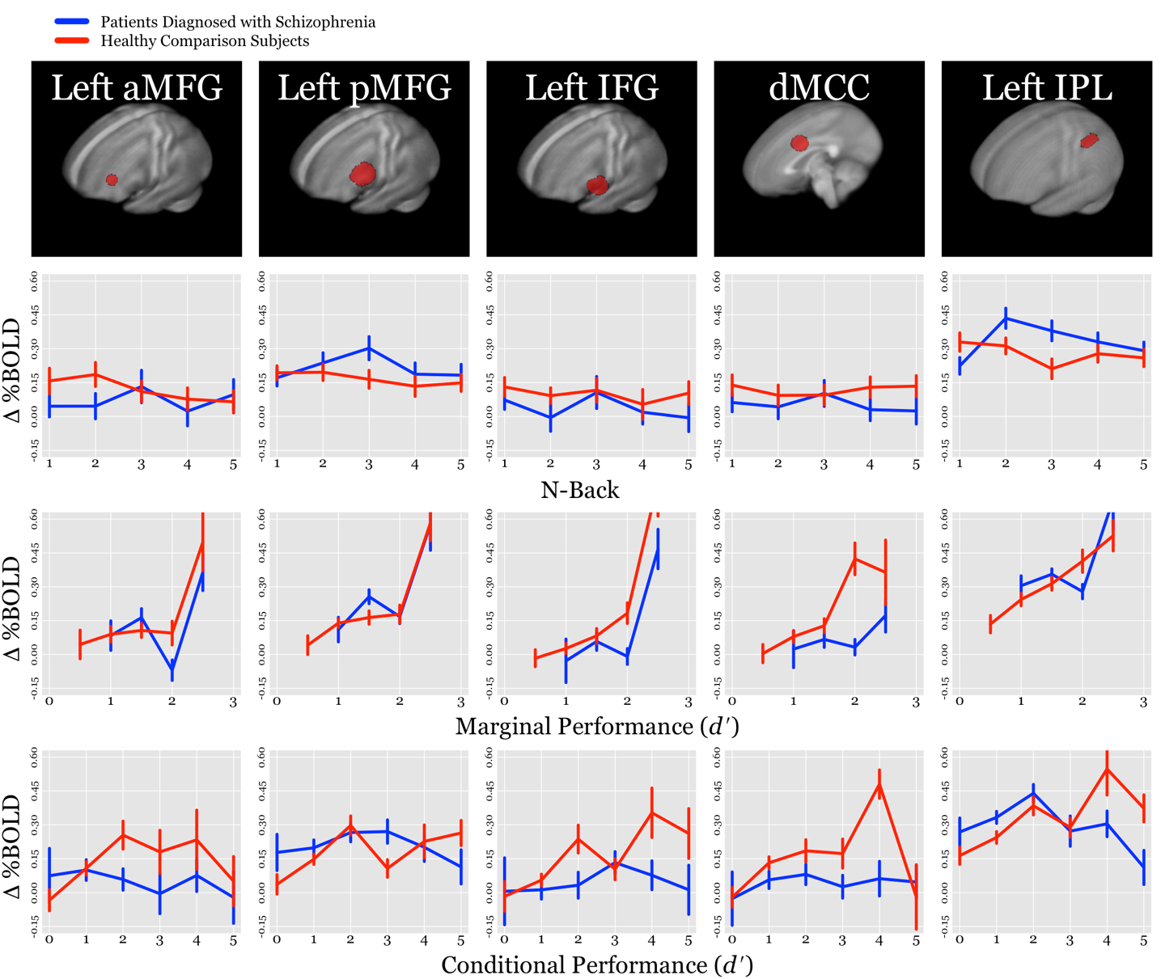
Supplemental Figure 1. Means and standard errors for percentage Change in Blood-Oxygenation-Level Dependent (BOLD) Response as a Function of N-Back Load, Marginal Performance, and Conditional Performance. Patients diagnosed with schizophrenia and plotted in red and healthy comparison subjects are plotted in blue. ROI = region of interest; aMFG = anterior middle frontal gyrus; pMFG = posterior middle frontal gyrus; IFG = inferior frontal gyrus; dMCC = dorsal mid cingulate cortex; IPL = inferior parietal lobule. Statistically significant effects are highlighted in bold font.

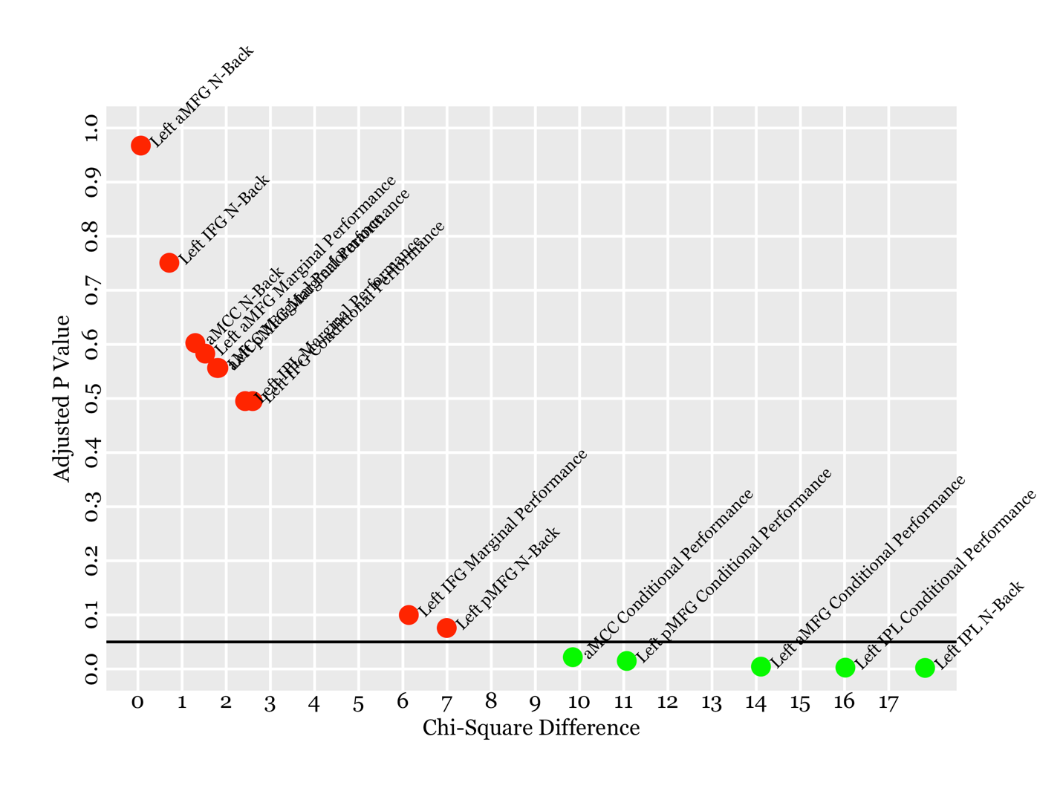
Supplemental Figure 2. Post hoc analyses of power. Results of chi-square differences tests by adjusted significance values from Table 2 of the main text.

