The relationship between negative symptoms and cognitive function in schizophrenia
Caitlin O. B. Yolland*, Sean P. Carruthers, Wei Lin Toh, Erica Neill, Philip J Sumner, Elizabeth H. Thomas, Eric Tan, Caroline Gurvich Andrea Phillipou, Tamsyn E. Van Rheenen, and Susan L. Rossell
Supplementary Material

*Corresponding author:
C Yolland, Centre for Mental Health, Swinburne University, PO Box 218, Hawthorn, VIC 3122, Australia. Email: cyolland@swin.edu.au

Supplementary Table 1. Comparison of SANS/SAPS scores across emergent cluster subgroups

 | Cluster 1 | Cluster 2 | Cluster 3 | Cluster 4
 | High Hallucinations | Low Affective/Alogia High Everything | High Negative Symptoms | Asymptomatic |  | 1 vs. 2 |  | 1 vs. 3 |  | 1 vs. 4 |  | 2 vs. 3 |  | 2 vs. 4 |  | 3 vs. 4
 | (n=34) | (n=27) | (n=26) | (n=43) | Test Statistic | d | p | d | p | d | p | d | p | d | p | d | p
DEL | 2.2 (1.4) | 3.7 (0.9) | 2.0 (1.5) | 1.1 (1.6) | F_{3,110.8} = 20.7,  p < 0.001ª | 1.3 | <0.01 | 0.1 | 0.96 | 0.7 | 0.01 | 1.4 | <0.01 | 2.0 | <0.01 | 0.6 | 0.13
HAL | 3.8 (0.8) | 3.6 (1.0) | 0.7 (1.1) | 0.2 (0.6) | F_{3,84.9} = 144.3,  p < 0.001ª | 0.2 | 0.89 | 3.2 | <0.01 | 5.1 | <0.01 | 2.8 | <0.01 | 4.1 | <0.01 | 0.6 | 0.22
AF | 1.4 (1.5) | 1.2 (1.5) | 2.6 (1.3) | 1.0 (1.1) | F_{3,107.8} = 7.7,  p < 0.001ª | 0.1 | 0.99 | 0.9 | 0.01 | 0.3 | 0.71 | 1.0 | 0.01 | 0.2 | 0.91 | 1.3 | <0.01
AL | 0.6 (0.9) | 1.0 (1.1) | 2.1 (1.4) | 0.6 (1.0) | F_{3,126} = 13.3,  p < 0.001 | 0.4 | 0.48 | 1.3 | <0.01 | 0.0 | 1.00 | 0.9 | 0.01 | 0.4 | 0.45 | 1.2 | <0.01
An-As | 0.4 (0.8) | 3.1 (0.9) | 3.0 (1.0) | 0.3 (0.6) | F_{3,91.9} = 108.2,  p < 0.001ª | 3.2 | <0.01 | 2.9 | <0.01 | 0.1 | 0.98 | 0.1 | 0.99 | 3.7 | <0.01 | 3.3 | <0.01
Av-Ap | 0.5 (0.9) | 1.4 (1.2) | 1.8 (1.5) | 0.3 (0.7) | F_{3,80.3} = 13.4,  p < 0.001ª | 0.9 | 0.01 | 1.1 | <0.01 | 0.3 | 0.75 | 0.3 | 0.58 | 1.1 | <0.01 | 1.3 | <0.01
Data were reported as mean (SD) unless otherwise stated. ªBrown-Forsythe F-ratio reported. DEL: SAPS Delusions; SAPS HAL: Hallucinations; FA: SANS Affective Flattening; AL: SANS Alogia; An-As: SANS Anhedonia-Asociality; Av-Ap: SANS Avolition-Apathy
Figure S1. Agglomeration schedule

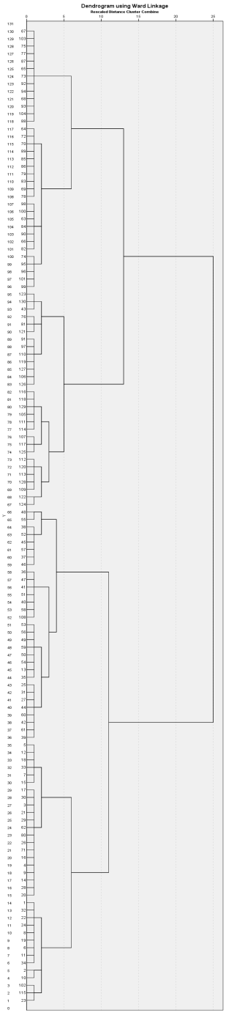

Figure S2. Dendrogram of cluster solution.

Figure S3. Canonical discriminant functions plot.
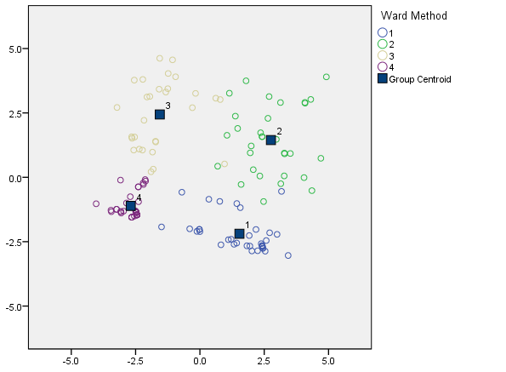

Figure S4. Means plot of subgroup SAPS Global rating of hallucinations
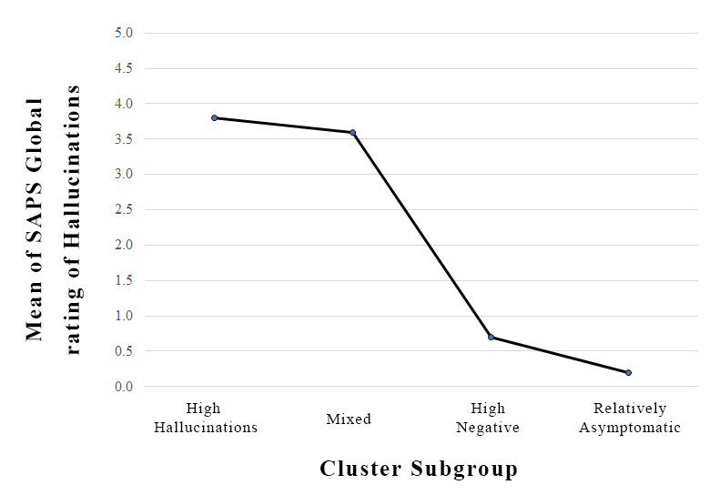

Figure S5. Means plot of subgroup SAPS Global rating of delusions
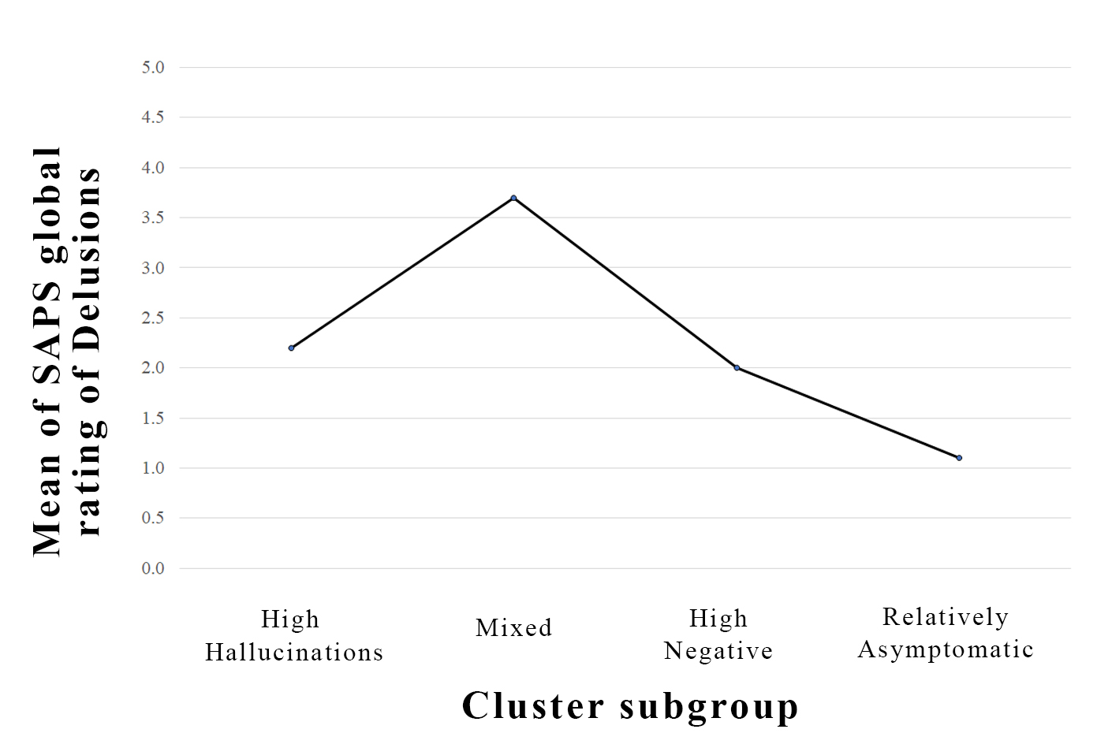
Figure S6. Means plot of subgroup SANS Global rating of affective flattening
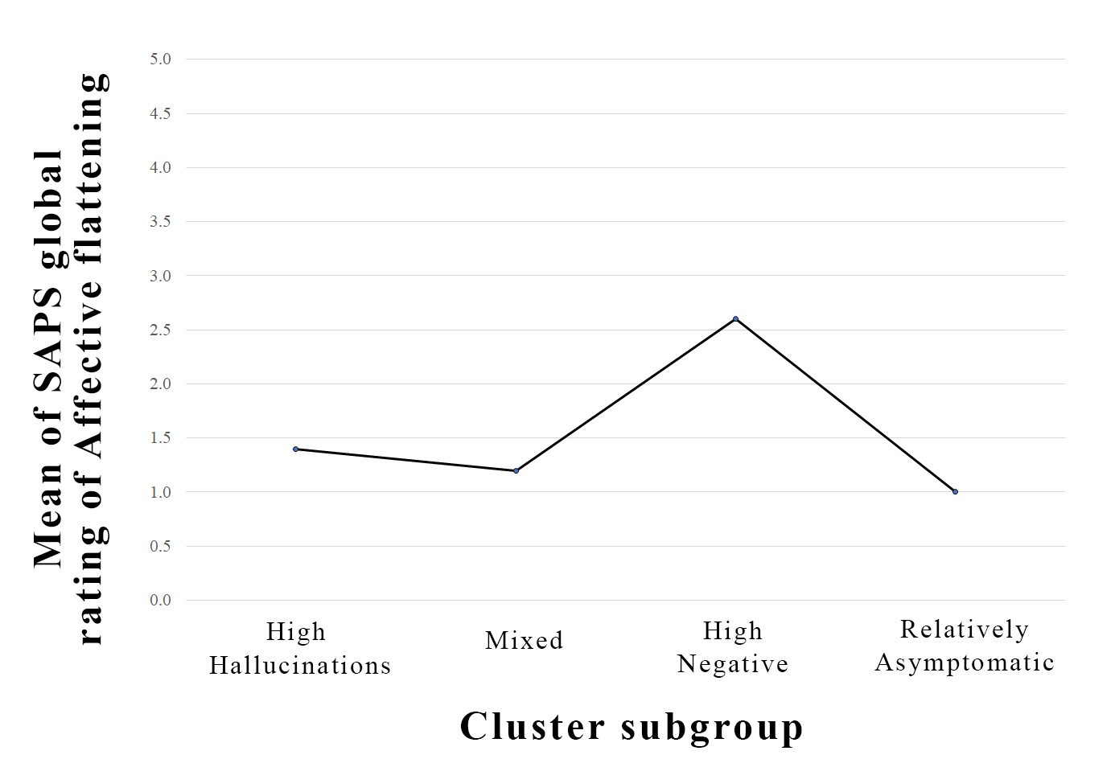

Figure S7. Means plot of subgroup SANS Global rating of alogia
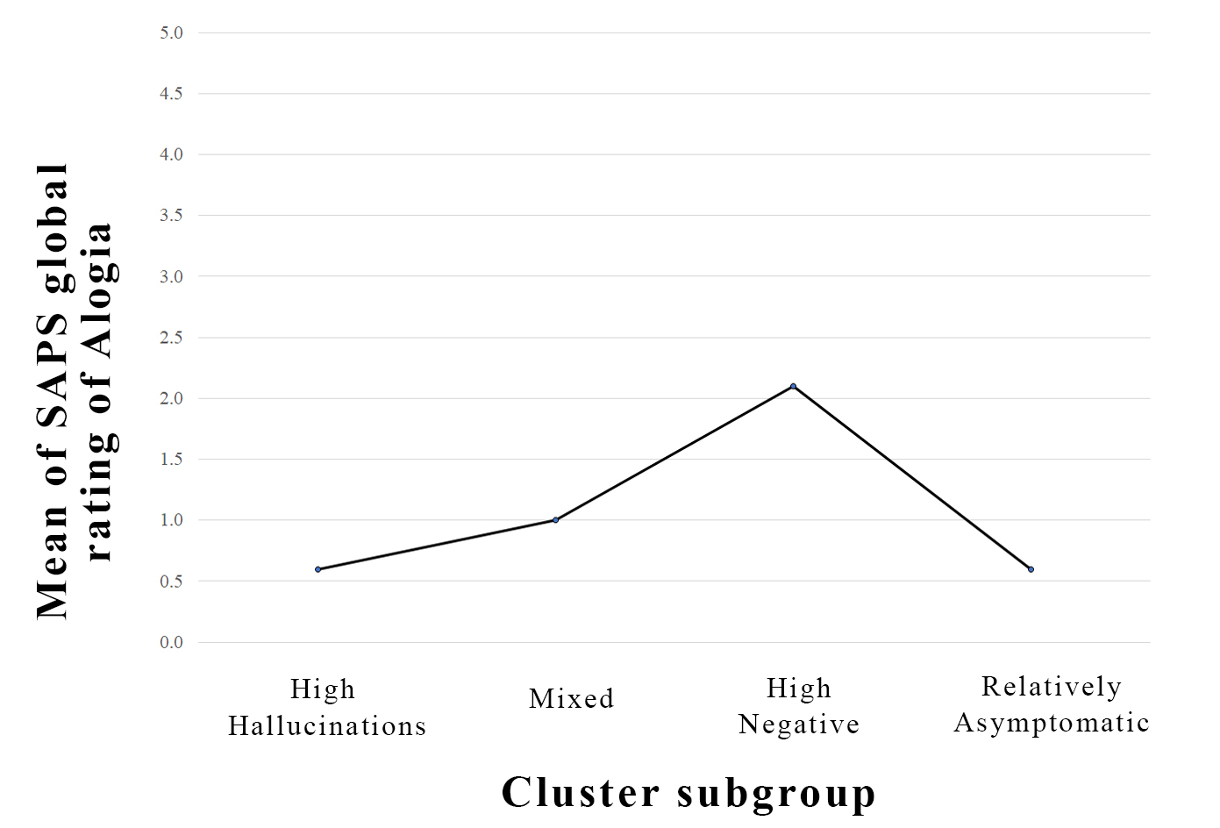

Figure S8. Means plot of subgroup SANS Global rating of avolition-apathy
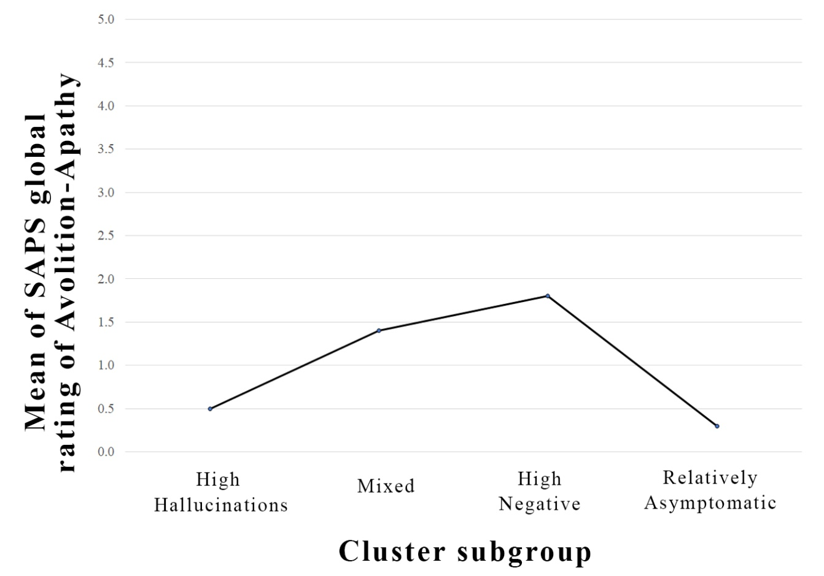

Figure S9. Means plot of subgroup SANS Global rating of anhedonia-asociality
