Supplementary Table 1.
Demographic and clinical characteristics in participants used in the NART validation analyses.

 | Participants with schizophrenia  n = 102 | Participants with bipolar I disorder  n = 101 | Healthy control participants  n = 613 | Statistic
Age | 29.3 (9.6) | 31.3 (12.2) | 32.4 (8.8) | F = 5.02, p = 0.007  SZ < HC
Gender (m/f) | 64/38 | 49/52 | 331/282 | x² = 4.3, p = 0.016
WASI IQ | 100.5 (15.2) | 107.2 (13.5) | 113.5 (9.9) | F = 66.8, p < 0.001  SZ < BD < HC
NART IQ | 108.2 (7.3) | 110.9 (7.0) | 113.6 (5.3) | F = 43.3, p < 0.001  SZ < BD < HC
IQ decline | 7.7 (11.9) | 3.7 (10.6) | 0.1 (8.3) | F = 33.7, p < 0.001  SZ > BD > HC
Education (years) | 12.6 (2.6) | 13.0 (2.3) | 14.4 (2.2) | F = 38.3, p < 0.001  SZ, BD < HC
PANSS positive | 16.7 (5.0)¹ | 10.2 (3.8) | - | t = 10.5, p < 0.001
PANSS negative | 17.6 (5.9)² | 10.3 (3.6) | - | t = 10.7, p < 0.001
IDS-C | 18.0 (10.4)³ | 16.3 (11.1)⁴ | - | t = 1.1, p = 0.291
YMRS | 5.5 (5.2)⁵ | 3.4 (5.4) | - | t = 2.8, p = 0.005
¹ n = 100 due to missing data; ² n = 101 due to missing data; ³ n = 80 due to missing data; ⁴ n = 98 due to missing data; ⁵ n = 92 due to missing data

Supplementary Table 2.
Variance Ratio Criterions (VRC) for increasing number of clusters by sample

Number of clusters | Participants with schizophrenia  n = 223 | Participants with bipolar I disorder  n = 175 | Participants with schizophrenia or bipolar I disorder  n = 398
2 | 298.96 | 199.13 | 495.09
3 | 295.44 | 206.59 | 522.54
4 | 255.94 | 198.60 | 467.36
5 | 252.90 | 200.81 | 435.45

Supplementary Figure 1.
Scree plot based on agglomeration coefficients from hierarchical cluster analysis of premorbid (NART) and current (WASI) IQ in participants with schizophrenia (n = 223).

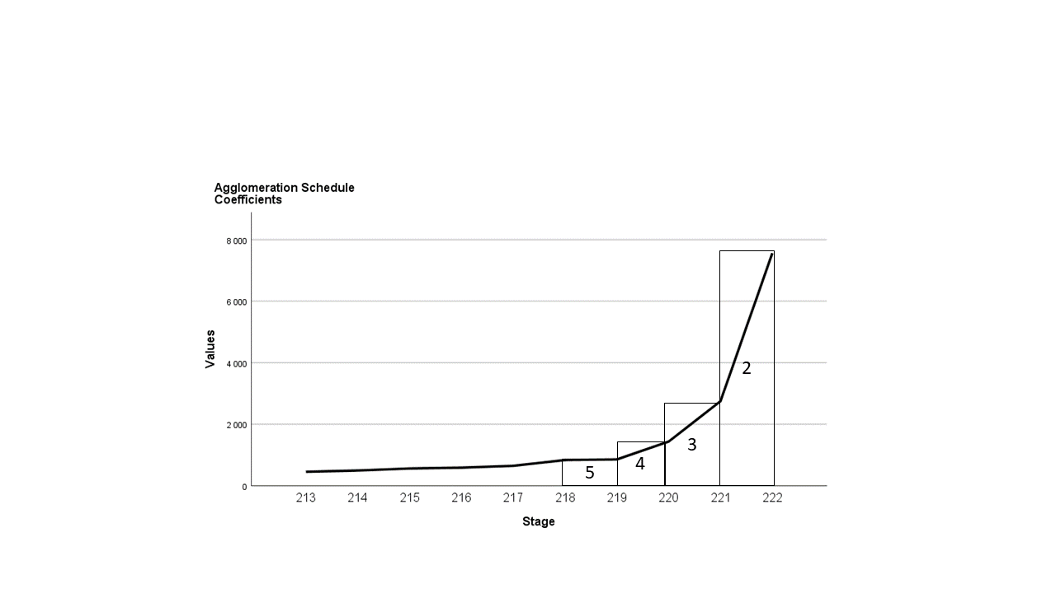

Supplementary Figure 2.
Scree plot based on agglomeration coefficients from hierarchical cluster analysis of premorbid (NART) and current (WASI) IQ in participants with bipolar disorder (n = 175).

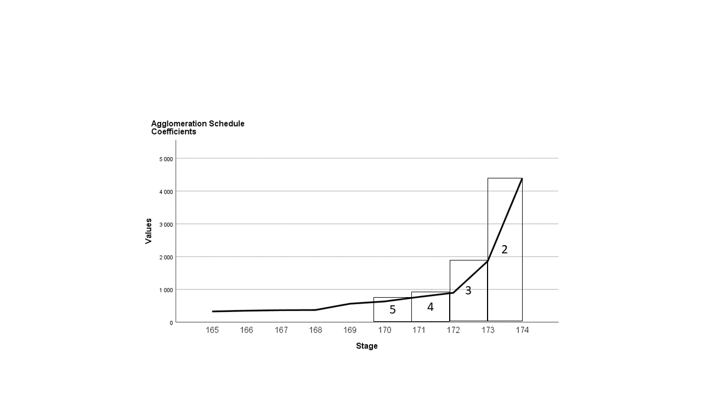
Supplementary Figure 3.
Scree plot based on agglomeration coefficients from hierarchical cluster analysis of premorbid (NART) and current (WASI) IQ in participants with schizophrenia or bipolar disorder (n = 398).

