Non-spatial impairments affect false positive neglect diagnosis based on cancellation tasks
Hanne Huygelier ª, Margaret Jane Moore ^{b} , Nele Demeyere ^{b}, & Céline R. Gillebert ^{a, b *}
ª Department of Brain and Cognition, KU Leuven, Leuven, Belgium
^{b} Department of Experimental Psychology, University of Oxford, Oxford, United Kingdom

Supplementary Materials 1 – Adjusted cut-offs

Introduction
Here we provide a ready-to-use set of adjusted cut-offs for the OCS cancellation task. We generated cut-offs for a cancellation task with 50 uniformly distributed targets, of which 20 targets are located on the left side, 10 in the center and 20 on the right side of the page. Cut-offs were generated for each number of total cancelled targets ranging from 0 to 50 (Table S1). The cut-offs corresponding to 0, 1, 2, 48, 49 and 50 cancelled targets show that spatial neglect cannot be diagnosed in case of these total cancelled targets, because the cut-offs cannot be exceeded (Table S1). For all other levels of total cancelled targets, neglect diagnosis is possible. For instance, for a total cancelled targets ranging from 3 to 6 and from 44 to 47, cut-offs equal -3 and 3 (Table S1). For instance, if a patients cancels a total of 6 targets, with 5 targets on the right side and 1 target on the left side, the R-L score would equal 4 which exceeds the threshold of 3.
An equivalent procedure is also available to test whether patient’s R-L scores differed from zero in our online application (http://www.psytests.be/stats/cancellation_task). This application allows clinicians to use adjusted R-L cut-offs for cancellation tasks with different numbers of targets and also provides interval estimates.

Guidelines for users
- Administer a version of the Oxford Cognitive Screen hearts cancellation task.
- Count the total number of targets that the patient cancelled across the entire cancellation array. This value will be referred to as “Total Correct”.
- Count the number of targets that the patient cancelled on the left side of the page. This value will be referred to as “Left correct”.
- Count the number of targets that the patient cancelled on the right side of the page. This value will be referred to as “Right correct”.
- Calculate the R-L score by subtracting the Left correct score from the Right correct score.
- Now, find the row in Table S1 of which the Total Score matches your patient’s Total Correct. Use the cut-off values on that row.
- If your patient’s R-L score < cut-off for right-sided neglect, the result indicates right-sided neglect. If your patient’s R-L score > cut-off for left-sided neglect, the result indicates left-sided neglect.
Table S1. Adjusted cut-offs for the OCS cancellation task.
Total Score | Cut-off for right-sided neglect | Cut-off for left-sided neglect
0 | 0 | 0
1 | -1 | 1
2 | -2 | 2
3 – 6 | -3 | 3
7 – 12 | -4 | 4
13 – 37 | -5 | 5
38 – 43 | -4 | 4
44 – 47 | -3 | 3
48 | -2 | 2
49 | -1 | 1
50 | 0 | 0

Example of use
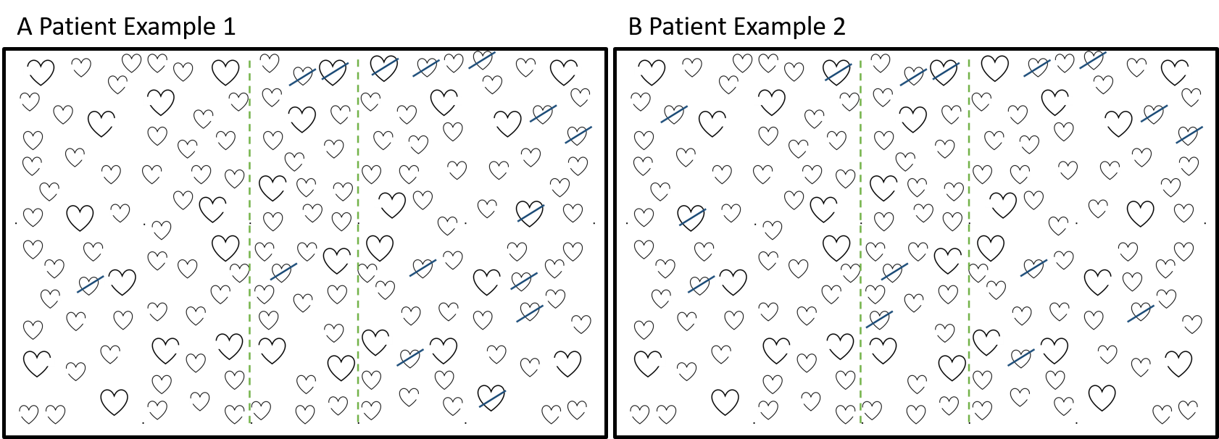
Figure S1. Two examples of responses on the OCS cancellation task. The green dashed lines are added for illustration purposes but are not present when administering the task. 20 targets are located on the left of the first green line, and 20 targets on the right of the second green line. The blue slanted lines represent the cancellation marks made by the patients.
The cancellation task of a patient that made the cancellation responses illustrated in Figure S1 would be scored as reported in Table S2.
Table S2. Examples of using adjusted-cut-offs.
Patient Example 1 |  |  | Patient Example 2
Total Correct: | 15 |  | Total Correct: | 15
Left correct: | 1 |  | Left correct: | 4
Right correct: | 11 |  | Right correct: | 7
R-L score: | 10 |  | R-L score: | 3
Cut-offs to use: | +/- 5 |  | Cut-offs to use: | +/- 5
Conclusion: | 10 > 5; left-sided neglect |  | Conclusion: | 3 < 5 and 3 > -5; no neglect

