Supplemental Table: P-values from nested regression models evaluating covariates and model fit for associations between cognitive test scores and MRI findings from Cerebrovascular Disease and its Consequences in American Indian study (2010-2013)
 |  | 3MSE | CVLT LF | WAIS-IV Coding | COWA
 |  | P-value | P-value | P-value | P-value
Any infarct | Model 0 | <0.001 | 0.047 | <0.001 | 0.001
 | Model 1 | 0.037 | 0.390 | <0.001 | 0.163
 | Model 2 | 0.051 | 0.447 | <0.001 | 0.280
Lacunar infarct | Model 0 | 0.001 | 0.179 | <0.001 | 0.025
 | Model 1 | 0.086 | 0.589 | 0.016 | 0.652
 | Model 2 | 0.097 | 0.671 | 0.028 | 0.838
Cortical infarct | Model 0 | 0.023 | 0.024 | <0.001 | 0.004
 | Model 1 | 0.361 | 0.200 | <0.001 | 0.172
 | Model 2 | 0.470 | 0.233 | <0.001 | 0.259
Hemorrhage | Model 0 | 0.141 | 0.015 | 0.267 | 0.613
 | Model 1 | 0.277 | 0.038 | 0.998 | 0.766
 | Model 2 | 0.327 | 0.039 | 0.849 | 0.924
WMH Grade | Model 0 | <0.001 | 0.008 | <0.001 | <0.001
 | Model 1 | 0.032 | 0.334 | 0.003 | 0.152
 | Model 2 | 0.061 | 0.361 | 0.006 | 0.290
Sulcal Grade | Model 0 | <0.001 | 0.026 | <0.001 | <0.001
 | Model 1 | 0.058 | 0.362 | 0.008 | 0.009
 | Model 2 | 0.116 | 0.276 | 0.027 | 0.044
Ventricle Grade | Model 0 | <0.001 | 0.216 | <0.001 | <0.001
 | Model 1 | 0.255 | 0.648 | 0.003 | 0.017
 | Model 2 | 0.324 | 0.753 | 0.018 | 0.096
(log) WMH Volume (mL) | Model 0 | <0.001 | 0.273 | <0.001 | <0.001
 | Model 1 | 0.010 | 0.959 | 0.011 | 0.044
 | Model 2 | 0.019 | 0.961 | 0.014 | 0.067
HC Volume (mL) | Model 0 | <0.001 | <0.001 | <0.001 | <0.001
 | Model 1 | 0.001 | 0.014 | <0.001 | 0.161
 | Model 2 | <0.001 | 0.012 | <0.001 | 0.161
Brain Volume (L) | Model 0 | <0.001 | <0.001 | <0.001 | <0.001
 | Model 1 | 0.032 | 0.098 | 0.004 | 0.005
 | Model 2 | 0.017 | 0.035 | 0.005 | 0.019
Model 0 unadjusted; Model 1 adjusted for age, sex, site, marital status, income, education, Native language speaking ability (bilingual status); Model 2 adjusted for Model 1 and additionally for obesity, diabetes, hypertension, hypercholesterolemia; 3MSE: Modified Mini Mental State Examination; CVLT LF: California Verbal Learning Test 2nd Edition Short Form long delay free recall; WAIS-IV: Weschler Adult Intelligence Scale – 4th Edition (Coding sub-test); COWA: Controlled Oral Word Association test (F, A, S words); WMH = white matter hyperintensities; HC = hippocampus; Brain (grey & white matter), WMH, and HC volumes modeled as raw volumetric estimates, but adjusted in all 3 models for intracranial volume

Supplemental Figures (Legend): Scatterplots and unadjusted model fit (linear and loess) of cognitive scores with volumetric and graded MRI findings in elderly American Indians from the Cerebrovascular Disease and its Consequences in American Indian study (2010-2013). Figure (A) Mini Mental State Examination (3MSE); Figure (B) California Verbal Learning Test (CVLT) 2nd edition short form long delay free recall; Figure (C) Weschler Adult Intelligence Scale (WAIS) IV digit coding subtest; Figure (D) Controlled Oral Word Association f,a,s test. Scatter plots model cognitive tests on Y-axis, by MRI findings on X-axis, including brain volume as % intracranial (IC) volume (upper left), hippocampus (HC) volume as % IC volume (upper center), white matter hyperintensities (WMH) volume as % IC volume (upper right), ventricle enlargement grade (lower left), sulcal widening grade (lower center), and white matter hyperintensities grade (lower right). Plots also include linear fit line (red) and loess fit with 95% confidence interval (orange line and grey shaded area). Scatter points colored according to Cook’s distance, a measure of outlier influence on linear model, with lighter colors conferring higher degree of influence. Axes include notation marks indicating distribution density of X- and Y-variables.

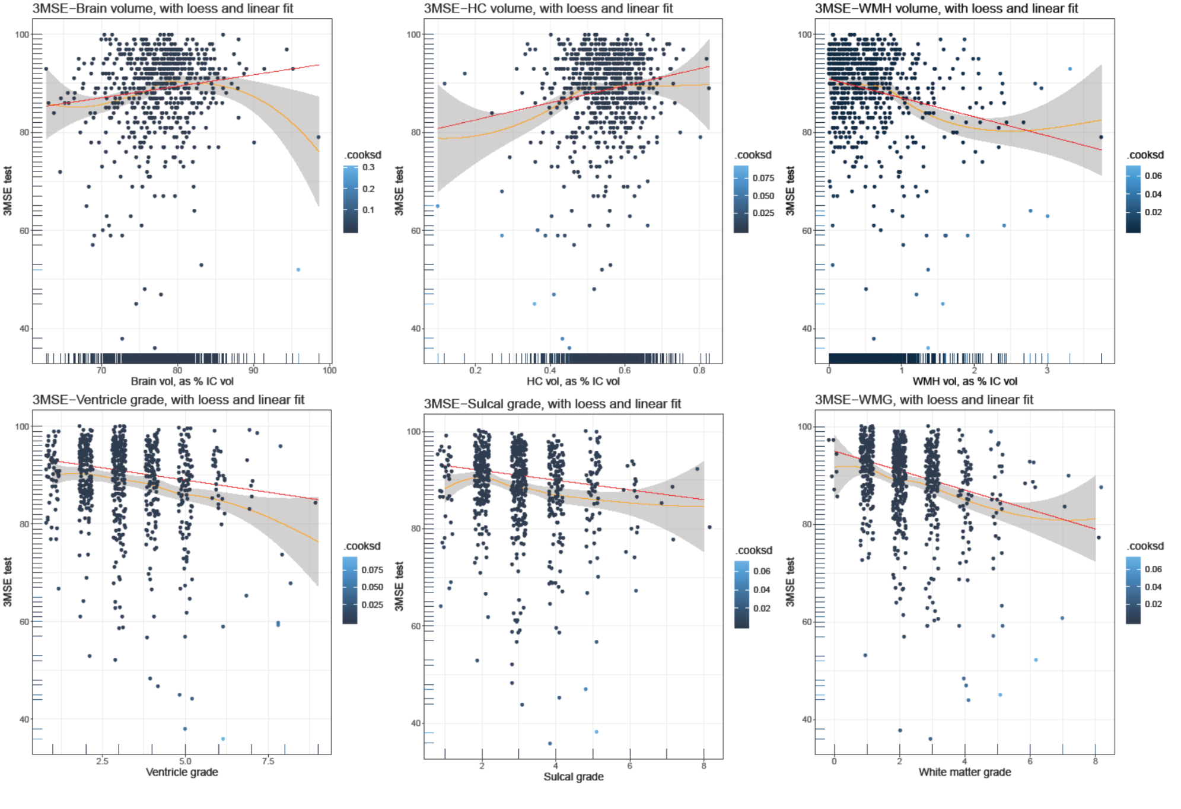
Supplemental Figure (A): Scatterplots and model fit (linear and loess) of 3MSE scores with volumetric and graded MRI findings
Supplemental Figure (B): Scatterplots and model fit (linear and loess) of CVLT-LF scores with volumetric and graded MRI findings
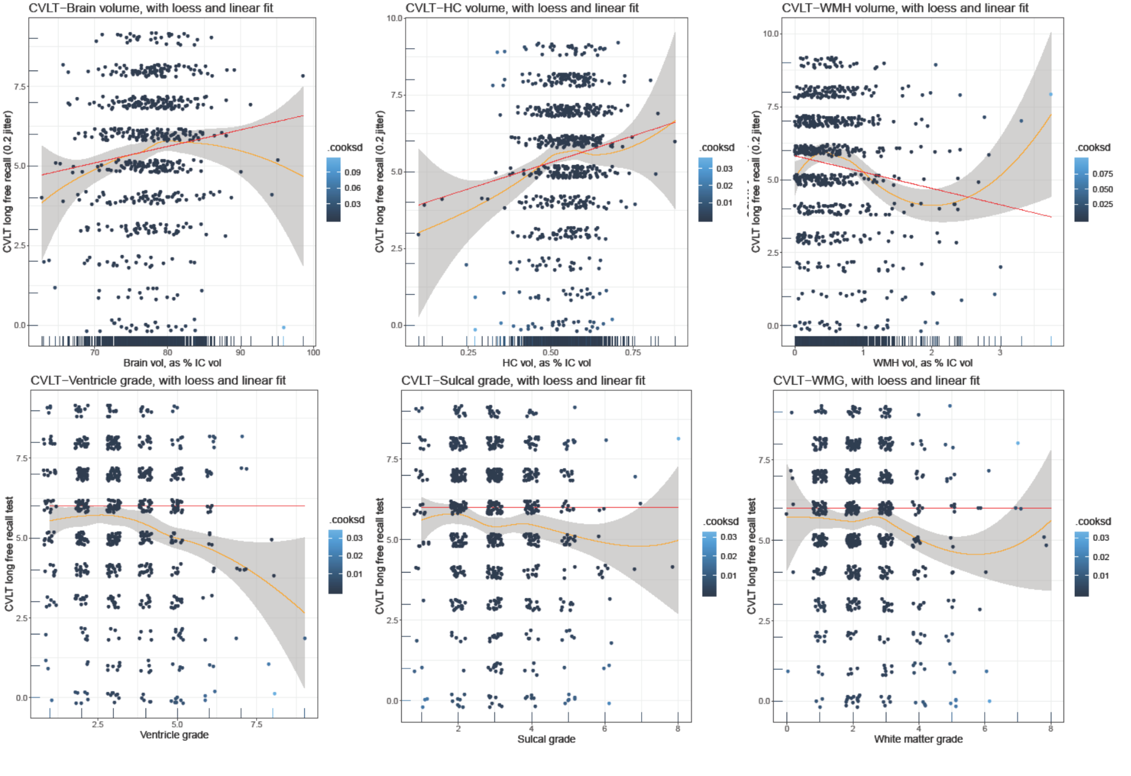
Supplemental Figure (C): Scatterplots and model fit (linear and loess) of WAIS scores with volumetric and graded MRI findings
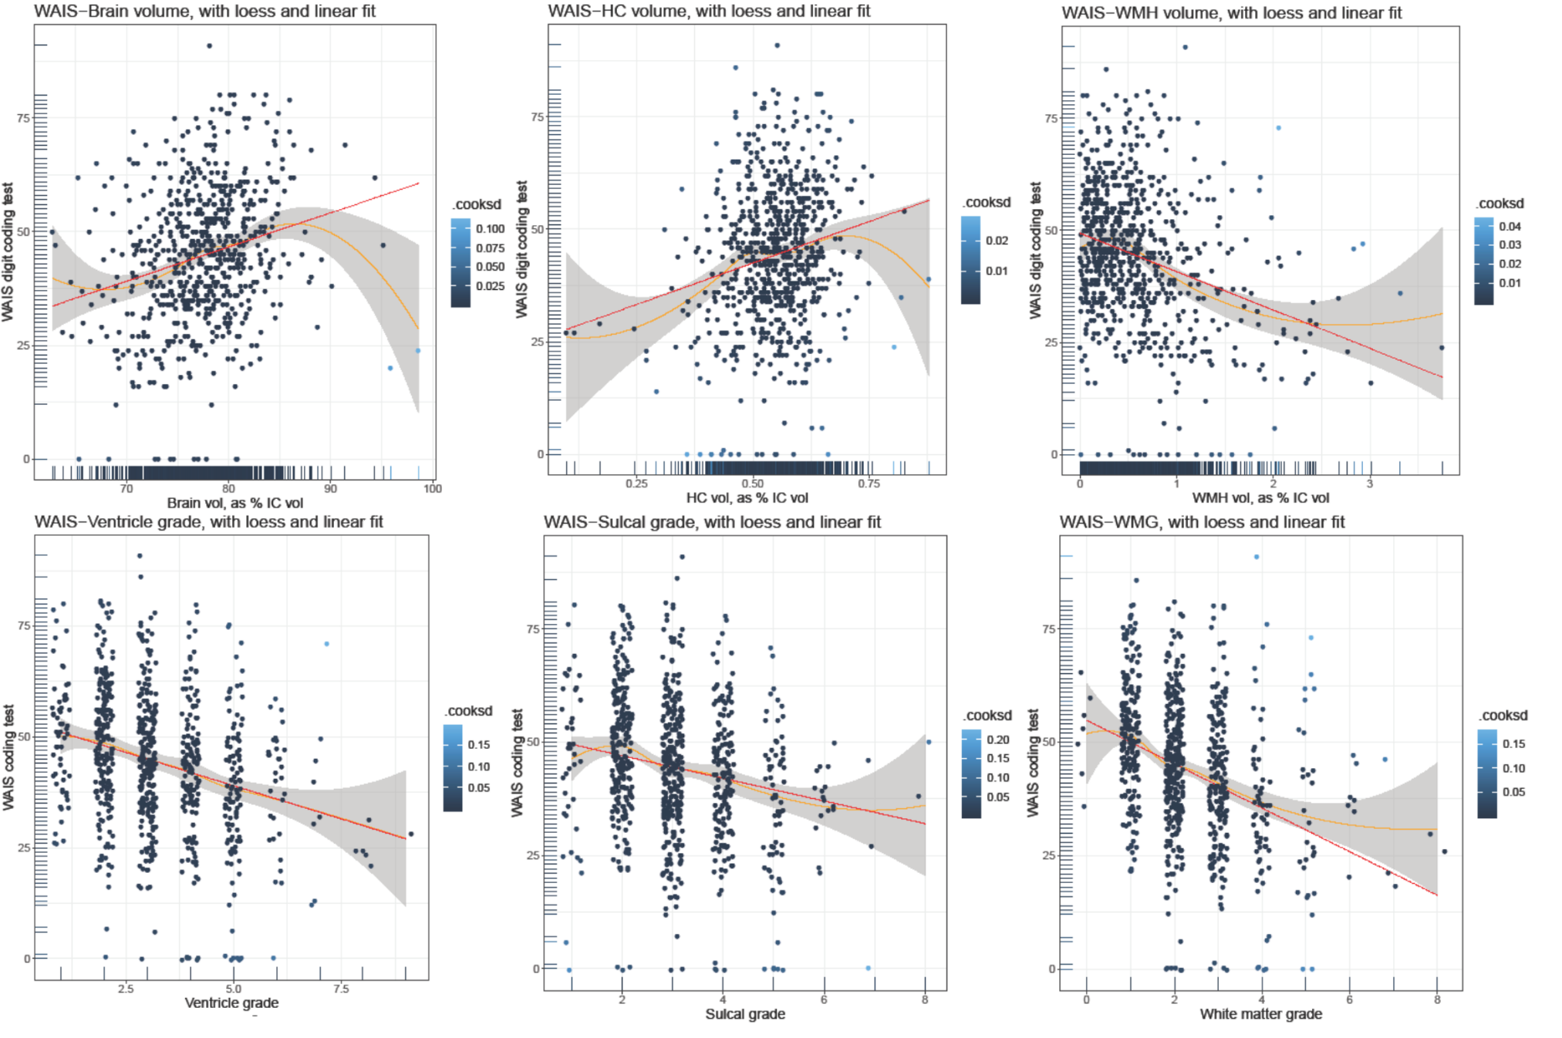
Supplemental Figure (D): Scatterplots and model fit (linear and loess) of COWA scores with volumetric and graded MRI findings
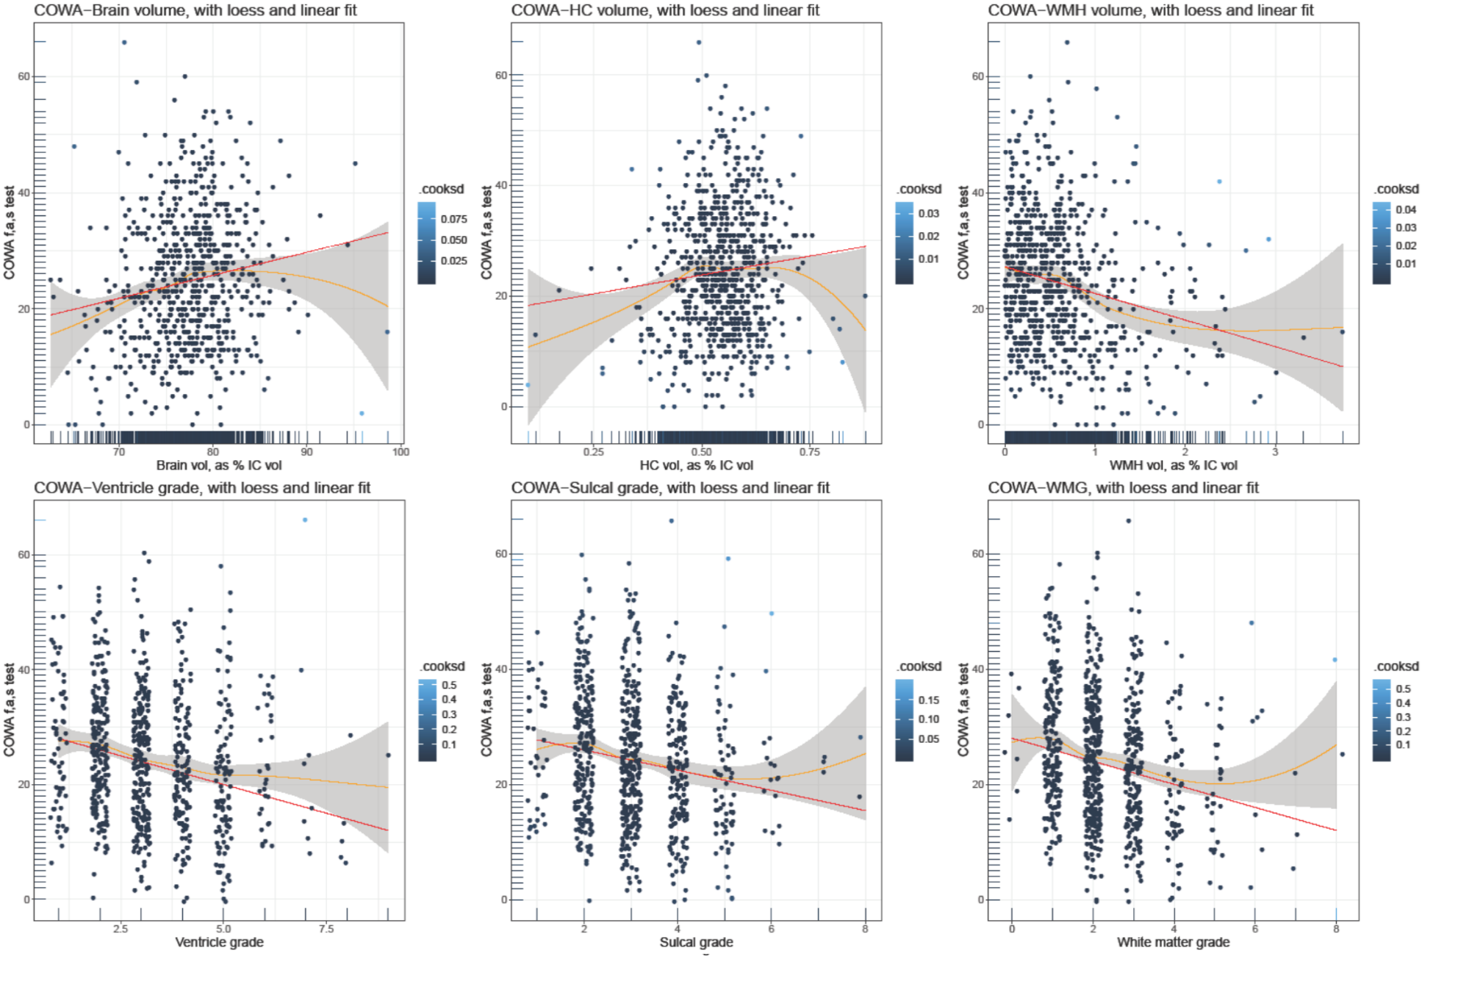
Supplemental Table: Non-standardized beta coefficients with 95% confidence intervals (95% CI) from linear regressions of cognitive test scores with MRI findings from elderly American Indians from the Cerebrovascular Disease and its Consequences in American Indian study (2010-2013)
 | 3MSE | CVLT LF | WAIS-IV Coding | COWA
 | β (95%CI)  P-value  FDR (Q-value) | β (95%CI)  P-value  FDR (Q-value) | β (95%CI)  P-value  FDR (Q-value) | β (95%CI)  P-value  FDR (Q-value)
Any Infarct | -1.3 (-2.7, 0.0) | -0.1 (-0.5, 0.2) | -3.7 (-5.7, -1.8) | -0.9 (-2.5, 0.7)
Lacunar infarct | -1.3 (-2.9, 0.2) | -0.1 (-0.5, 0.3) | -2.6 (-4.9, -0.3) | 0.2, (-2.0, 1.6)
Cortical Infarct | -0.6 (-2.4, 1.1) | 0.3 (-0.7, 0.2) | -5.0 (-7.3, -2.8) | 1.1 (-2.9, 0.8)
Hemorrhage | -1.3 (-4.0, 0.3) | -0.7 (-1.4, 0.0) | -0.4 (-4.1, 3.4) | 0.2 (-3.0, 3.3)
WMH Grade | -1.2 (-2.5, 0.1) | -0.2 (-0.5, 0.2) | -3.0 (-5.1, -0.9) | -0.8 (-2.4, 0.7)
Sulcal Grade | -0.9 (-2.1, 0.2) | -0.2 (-0.6, 0.2) | -2.5 (-4.6, -0.3) | -1.7 (-3.4, 0.0)
Ventricle Grade | -0.6 (-1.7, 0.6) | 0.1 (-0.3, 0.4) | -2.5 (-4.6, -0.4) | -1.4 (-3.0, 0.2)
log WMH Volume (mL) * | -0.7 (-0.1, -1.3) | -0.004 (-0.159, 0.151) | -1.2 (-0.2, -2.2) | -0.7 (-1.5, 0.1)
HC Volume (mL) * | 0.001 (0.001, 0.002) | 0 (0, 0) | 0.002 (0.001, 0.003) | 0.001 (0, 0.001)
Brain Volume (L) * | 16.2 (2.9, 29.4) | 3.3 (0.2, 6.4) | 28.7 (8.9, 48.5) | 20.0 (3.3, 36.7)
Comparison units for MRI findings (independent variable) include infarct, lacune, and hemorrhage present vs absent; WMH grade, sulcal grade, and ventricle grade per 1 point higher grade, range 0-9; log WMH volume, HC volume per 1 mL increase in volume; brain volume per 1 L increase in volume. Model adjusted for age, sex, site, marital status, income, education, Native language speaking ability (bilingual), obesity, diabetes, hypertension, hypercholesterolemia; 3MSE: Modified Mini Mental State Examination; CVLT LF: California Verbal Learning Test 2nd Edition Short Form long delay free recall; WAIS-IV: Weschler Adult Intelligence Scale 4th Edition (Coding sub-test); COWA: Controlled Oral Word Association test (F, A, S words)
*Volumetric models adjusted for model 2, as well as for intracranial volume; volumetric beta coefficient & 95% CI estimates that are listed as 0 were calculated to 3 decimal places as <0.0001

