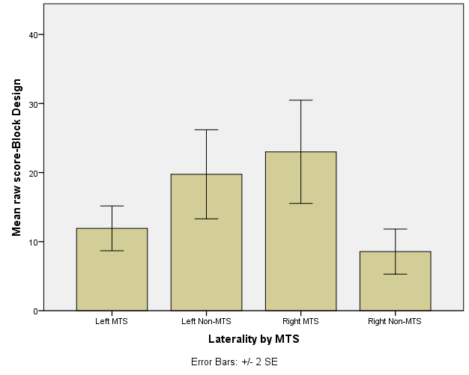

Figure 2. Block Design performance for four TLE groups. Error bars represent standard errors.

a. b.

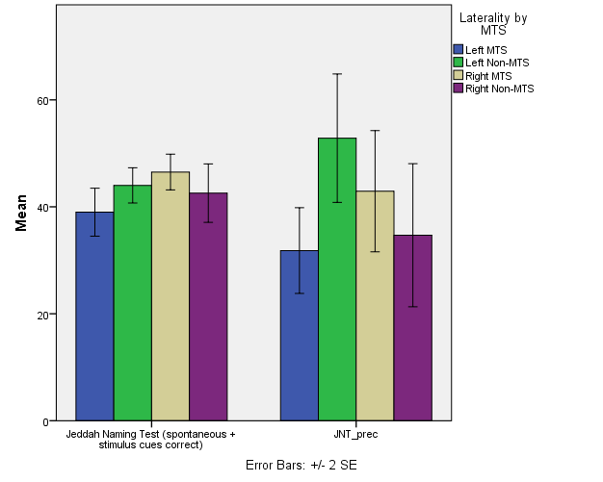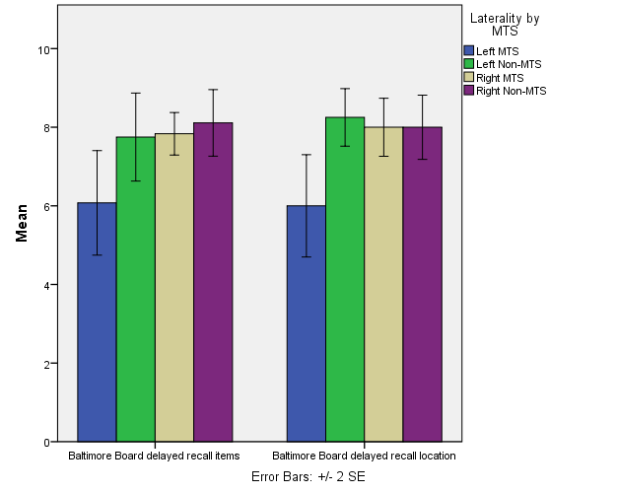
c. d.

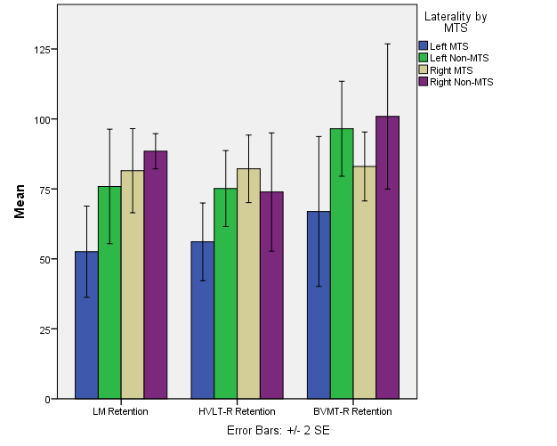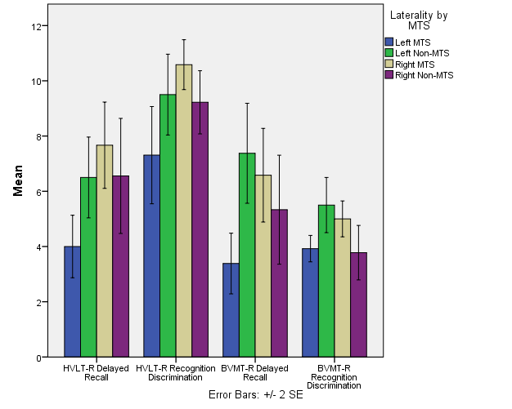
Figure 3. (a) Jeddah Naming Test total correct and percent retention for four TLE groups. (b) Baltimore Board Test item recall and delayed recall for four TLE groups. (c) Percent retained after a delay on Logical Memory (LM), Hopkins Verbal Learning Test-Revised (HVLT-R), and Brief Visuospatial Memory Test- Revised (BVMT-R) for four TLE groups. (d)
Delayed Recall and Recognition Discrimination for HVLT-R and BVMT-R for four TLE groups. Error bars represent standard errors.

