Supplemental materials.
Supplement 1:
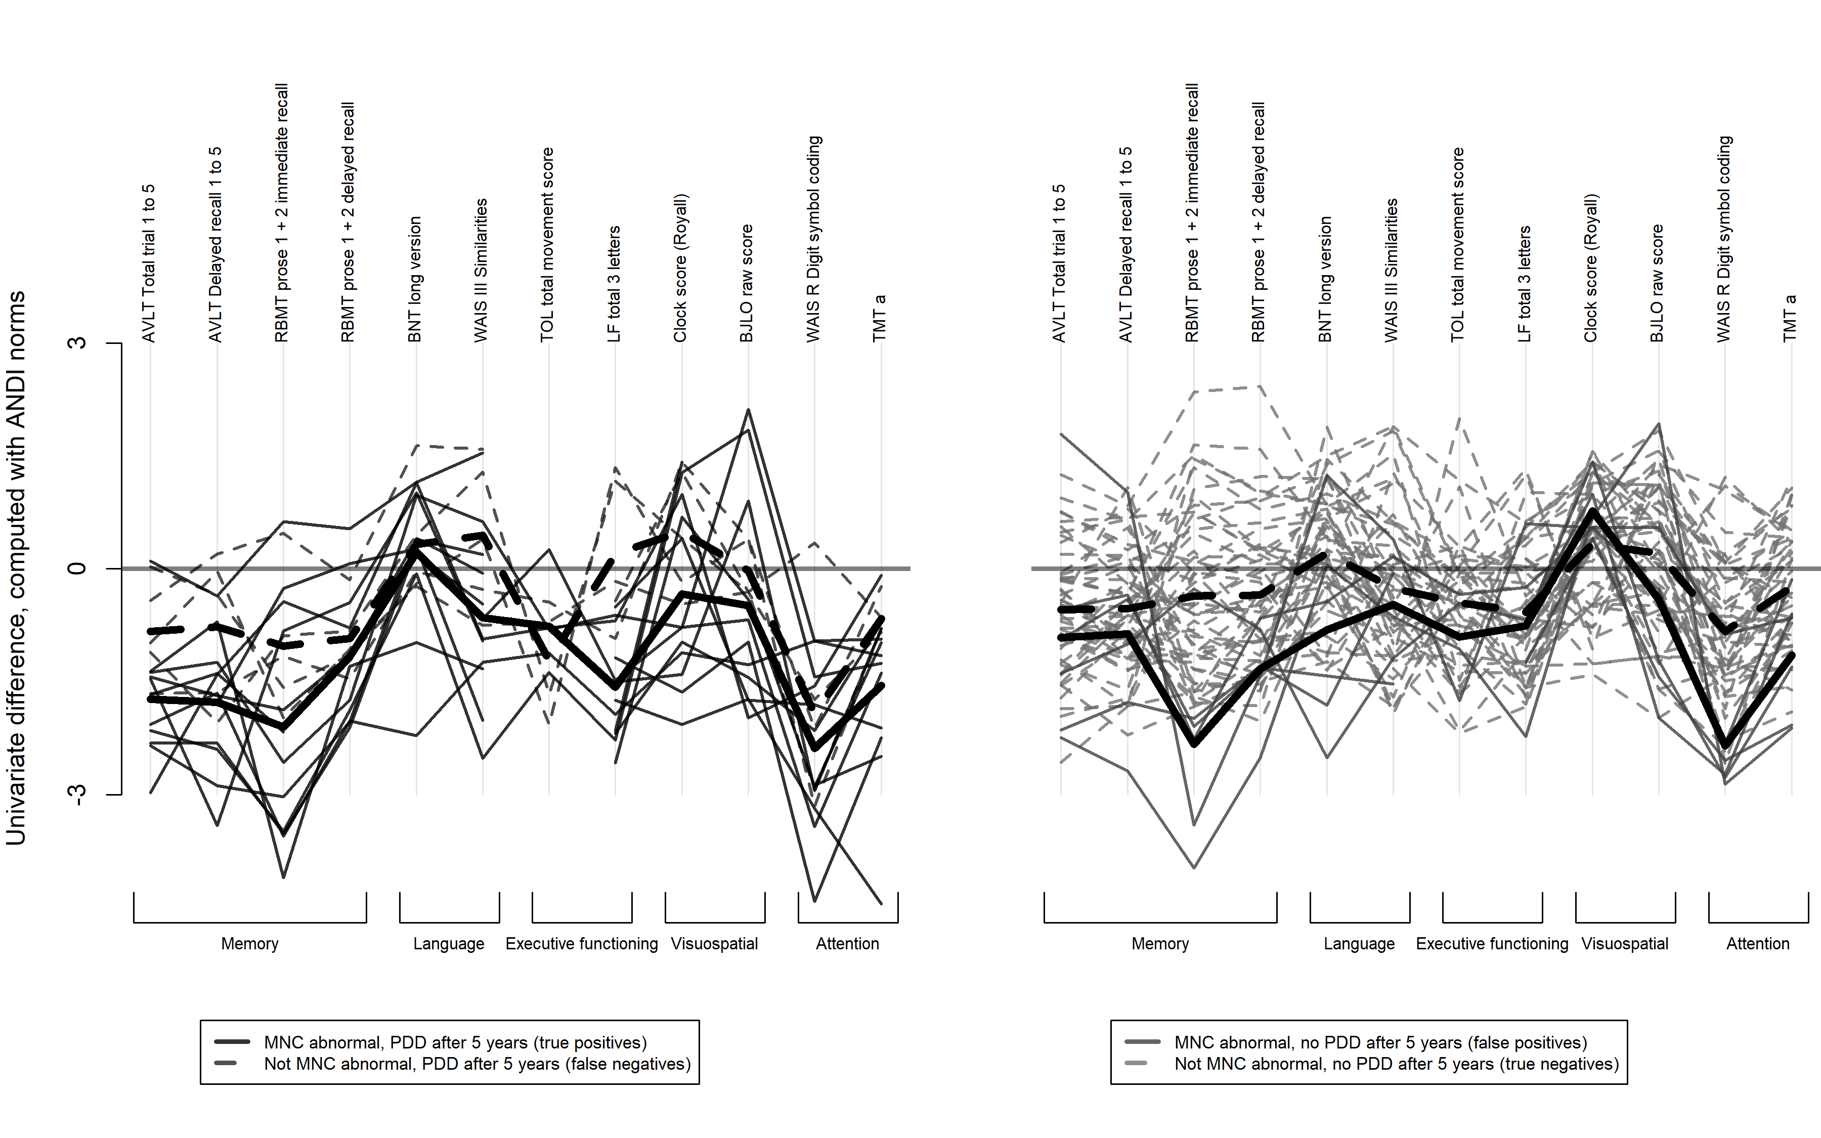

Figure 3. Score profiles of individual patients, in terms of differences between expected scores according to the norm and observed scores. The left panel shows the patients who progressed to PDD after five years. The right panel shows those that did not progress to PDD after five years. Solid lines: patients who are MNC abnormal at baseline, dashed lines: patients who are not MNC abnormal at baseline. The thick black lines denote the matching mean scores. Note that not all patients completed all tests. Therefore, some lines are interrupted.

Supplement 2: Overlap in diagnosis between methods.
We investigated whether the patients who were diagnosed as impaired were the same across methods, or whether there were differences. If there were differences, we examined whether the differences between methods in who was diagnosed as impaired, can explain the differences in the performance of the methods in terms of prediction of progression PDD after three and five years.
As can be seen in Table 5, there were 19 PD patients who were unimpaired according to the MNC method applied with ANDI, whereas they were impaired according to the original PD-MCI method. One of these patients progressed to PDD after three years, and two progressed to PDD after five years. Although the number of patients impaired according to the PD-MCI method (N=43) was higher than the number impaired according to the MNC method (N=32), there were still patients who were only diagnosed as impaired by the MNC method. Of the eight patients who were impaired according to the MNC method while they were not impaired according to the traditional PD-MCI criteria, two progressed to PDD after three years, and four progressed to PDD after five years. Therefore, these eight patients seem to be an important subgroup that was missed with the traditional method. Overall, there was a moderate degree of agreement between methods (78%, κ = 0.49).

Table 5
A comparison of the classifications between the traditional PD-MCI criteria and the MNC method applied with ANDI. Note that the number of PDD cases and missing cases are cumulative.
 | ANDI MNC abnormal |  |  | ANDI MNC normal
 |  | 3 years | 5 years |  | 3 years | 5 years
PD-MCI | 24 | 6 PDD | 8 PDD | 19 | 1 PDD | 2 PDD
 |  | 12 no PDD | 4 no PDD |  | 16 no PDD | 10 no PDD
 |  | 6 missing | 12 missing |  | 2 missing | 7 missing
no PD-MCI | 8 | 2 PDD | 4 PDD | 72 | 0 PDD | 3 PDD
 |  | 4 no PDD | 2 no PDD |  | 56 no PDD | 40 no PDD
 |  | 2 missing | 2 missing |  | 16 missing | 29 missing

We made a similar comparison of the two methods that make use of the ANDI database. The PD-MCI criteria applied with ANDI and the MNC methods applied with ANDI yielded different results, although there was a good degree of agreement between methods (86%, κ = 0.63). Nine patients had PD-MCI according to the criteria applied with ANDI but are normal according to the MNC method. None of these patients progressed to dementia after three or five years. Eight patients were MNC abnormal but did not have PD-MCI according to the criteria. Of these eight, two progressed to PDD after three years, and two more patients (four in total) had progressed to dementia after five years. Again, the MNC method identified some patients who would progress to PDD but who were not detected by the PD-MCI method.
Table 6
Cross-classification table of the two methods applied with ANDI

 | ANDI MNC abnormal |  |  | ANDI MNC normal
 |  | 3 years | 5 years |  | 3 years | 5 years
ANDI PD-MCI | 24 | 6 PDD | 8 PDD | 9 | 0 PDD | 0 PDD
 |  | 12 no PDD | 4 no PDD |  | 8 no PDD | 4 no PDD
 |  | 6 missing | 12 missing |  | 1 missing | 5 missing
ANDI no PD-MCI | 8 | 2 PDD | 4 PDD | 82 | 1 PDD | 5 PDD
 |  | 4 no PDD | 2 no PDD |  | 64 no PDD | 45 no PDD
 |  | 2 missing | 2 missing |  | 17 missing | 31 missing

Last, we compared the two applications of the PD-MCI criteria. More patients were diagnosed with the traditional PD-MCI criteria than with the ANDI-MCI-criteria. There was a good degree of agreement between methods (85%, κ = 0.68). This could suggest that the ANDI PD-MCI criteria method diagnosed the same patients as the original PD-MCI criteria, but fewer. The results in Table 7 indicate that this indeed was the case to some extent. There were 13 PD patients who were unimpaired according to the PD-MCI criteria applied with ANDI, but were impaired according to the PD-MCI criteria as applied by Broeders et al. (2013). Three of these patients progressed to PDD after 5 years. The fact that the PD-MCI method with ANDI diagnosed fewer patients implies that future PDD patients were missed at baseline. However, there were also three patients who were diagnosed as PD-MCI by the PD-MCI criteria applied with ANDI who were normal when using the PD-MCI criteria as applied by Broeders et al. (2013). Of these three, one became demented after three years. Thus, using ANDI with the PD-MCI criteria also identified one patient who progressed to PDD who was missed by the traditional method.

Table 7
Cross-classification table of the two methods using the PD-MCI criteria.
 | ANDI PD-MCI |  |  | ANDI no PD-MCI
 |  | 3 years | 5 years |  | 3 years | 5 years
PD-MCI | 30 | 5 PDD | 7 PDD | 13 | 2 PDD | 3 PDD
 |  | 20 no PDD | 8 no PDD |  | 8 no PDD | 6 no PDD
 |  | 5 missing | 15 missing |  | 3 missing | 4 missing
no PD-MCI | 3 | 1 PDD | 1 PDD | 77 | 1 PDD | 6 PDD
 |  | 0 no PDD | 0 no PDD |  | 60 no PDD | 42 no PDD
 |  | 2 missing | 2 missing |  | 16 missing | 29 missing

Supplement 3: Post hoc analysis without 4 deviations criterion
In the main analysis, we allowed patients who had no subjective complaints to meet PD-MCI criteria if they had at least four deviations on neuropsychological tests. We supposed that caregivers would not have missed such broad impairments. Had we interviewed them, they most likely would have reported cognitive decline. To investigate the effect of this choice, we performed a post hoc analysis, without this added criterion. As can be seen in Table 4, in terms of predicting PDD after 3 years, we found that sensitivity decreased, while specificity increased. In terms of predicting PDD after 5 years, sensitivity decreased, while specificity improved slightly. Figure 4 gives an overview of progression to PDD for this analysis. We conclude from this analysis that our choice to add this four deviations criterion was justified. It prevented missing PD-MCI cases (false negatives), while few cases were erroneously diagnosed as PD-MCI (false positives), especially at 5 years follow-up.

Table 8
Sensitivity and specificity for progression to PDD of the PD-MCI criteria applied with ANDI, specified for three- and five-year follow-up. In parentheses: 90% confidence interval (Agresti, & Coull; 1998).

 | three-year follow-up |  | five-year follow-up
 | sensitivity | specificity | sensitivity | specificity
PD-MCI criteria ANDI  without 4 deviations criterion | 0.56 (0.30-0.78) | 0.88 (0.80-0.92) | 0.29 (0.15-0.50) | 0.91 (0.83-0.96)

Figure 4. Progression of PD patients (n = 123) to PDD after 3 (n = 97) and 5 years (n = 73) for the PD-MCI criteria applied with ANDI, without the four deviations criterion.

