Supplementary materials

Assumptions

Normality
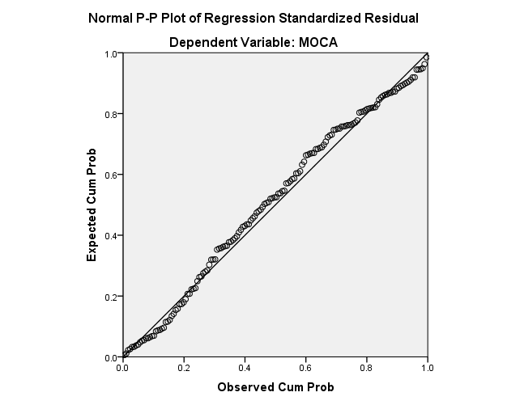

Constant Variance
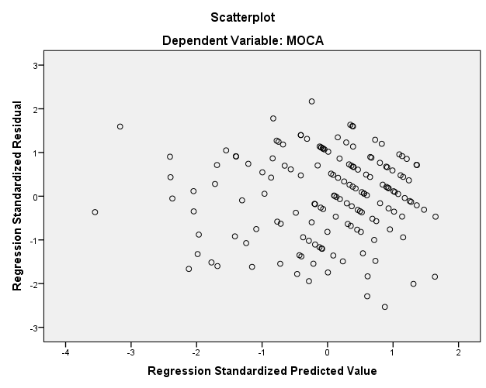

Multicolinearity in regression

Coefficientsª
Model |  | Unstandardized Coefficients |  | Standardized Coefficients | t | Sig. | Collinearity Statistics
 |  | B | Std. Error | Beta |  |  | Tolerance | VIF
1 | (Constant) | 13.381 | 1.142 |  | 11.715 | .000
 | prev_stroke | -.122 | .423 | -.018 | -.287 | .774 | .953 | 1.050
 | Rockwood | -.053 | .019 | -.207 | -2.841 | .005 | .697 | 1.434
 | Stoke_Type | .408 | .388 | .066 | 1.051 | .295 | .923 | 1.083
 | prestroke_cog | -2.281 | .652 | -.221 | -3.499 | .001 | .929 | 1.076
 | Delirium | -2.810 | .664 | -.272 | -4.230 | .000 | .895 | 1.118
 | Age | -.052 | .016 | -.242 | -3.191 | .002 | .641 | 1.561
 | Sex | -.223 | .388 | -.038 | -.574 | .567 | .842 | 1.188
 | NIHSS | -.200 | .055 | -.233 | -3.628 | .000 | .892 | 1.121
a. Dependent Variable: MOCA

Linearity
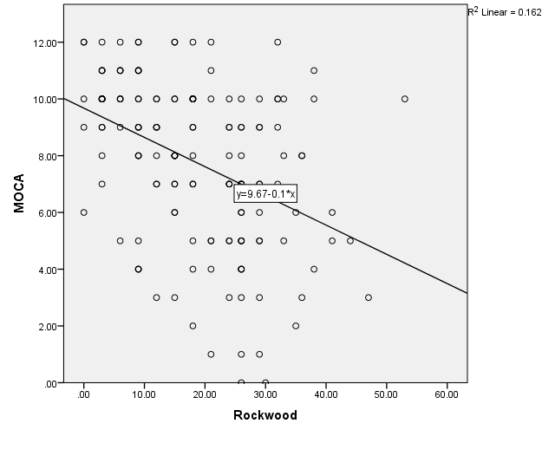

Supplementary material Figure 1: Frailty measure

Rockwood Frailty Index

Depression  Anxiety  Polypharmacy  Hypertension  Atrial Fibrilation  Prev cerebrovascualar disease  Diabetes  Vascular disease  Hyperlipidaemia  Heart failure  Previous Myocardial infarction | Haemoglobin (low)  Care-home resident  Carers  Hearing aid  Sensory impairment (e.g. blind/deaf)  Continence bladder  Continence bowel  Falls  Fracture  Chronic-Obstructive-Pulmonary-Disease  Cancer | Liver disease  Peptic ulcer  Arthritis  Impaired external ADL  Impaired ADL  Mobility aid  Assistance walking  Calcium  Albumin (low)  High glucose  Renal failure

