Appendix Figure 1. Sample flow diagram of BLS participants from birth to 26 years of age
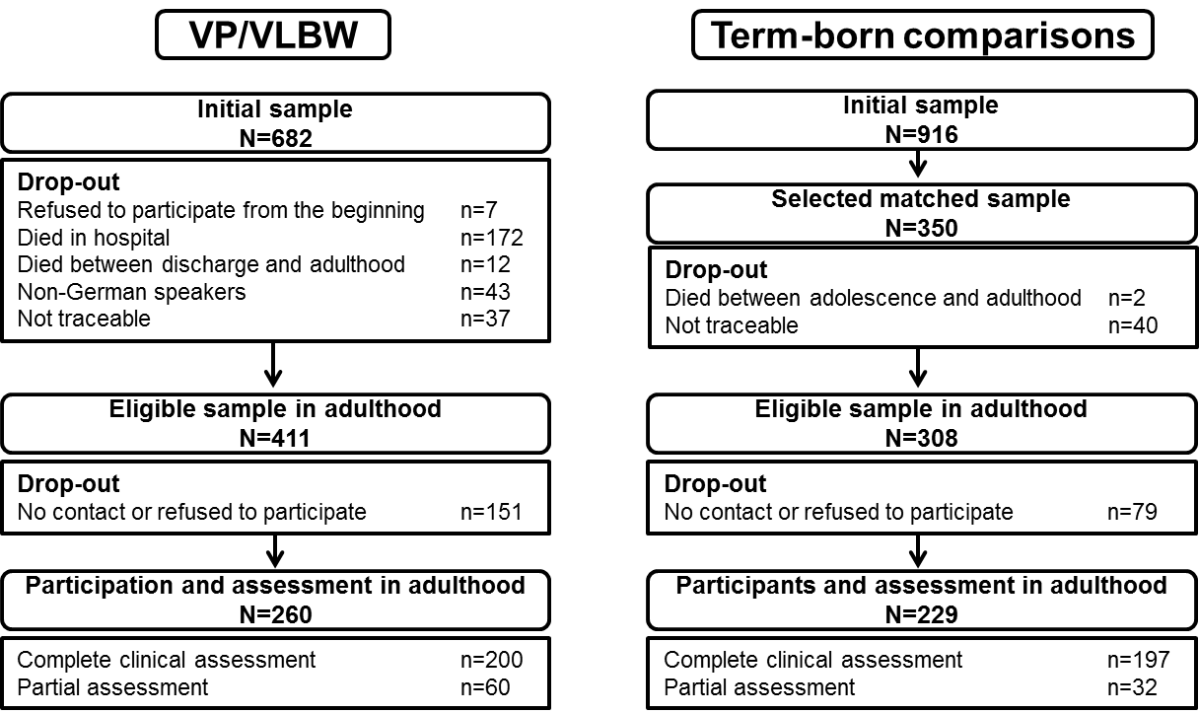
Appendix Figure 2. Initial full Model 1.
