Supplemental Online Materials

Table S1. Fit statistics for the tests of measurement invariance
Model (type of invariance) | Log-likelihood | p | $$χ^{2}$$ | df | RMSEA | CFI | TLI
Weak invariance  (same factor loadings) | -94001.443 | 47 | 548.43 | 72 | 0.040 | 0.967 | 0.959
Strong invariance  (same factor loadings and intercepts) | -94464.348 | 40 | 1313.04 | 79 | 0.061 | 0.916 | 0.903
Strict invariance  (same factor loadings, intercepts, and residual variances) | -94766.527 | 33 | 1301.10 | 86 | 0.058 | 0.917 | 0.912

Table S2. Doubly multivariate repeated measures analysis and follow-up pairwise comparisons.
 | Main Effects and Interactions |  |  |  |  | Within-Age Group Effect of Time
 | Time | Age X Time | Subtest/  Factor X Time | Subtest/  Factor X Age | Subtest/  Factor X Age X Time | 30s - 40s | 40s - 50s | 50s - 60s | 60s - 70s | 70+ - 80+
 | Wilks' Λ | Wilks' Λ | Wilks' Λ | Wilks' Λ | Wilks' Λ | F | F | F | F | F
Subtests | .83*** | .94*** | .87*** | .92*** | .98***
Immediate Recall |  |  |  |  |  | 0.53 | 4.24* | 10.20*** | 13.00*** | 35.71***
Delayed Recall |  |  |  |  |  | 3.71 | 0.16 | 5.70* | 18.48*** | 40.45***
Number Series |  |  |  |  |  | 0.69 | 0.77 | 14.59*** | 56.00*** | 29.87***
Category Fluency |  |  |  |  |  | 0.02 | 1.69 | 13.87*** | 27.74*** | 41.61***
Backward Digit Span |  |  |  |  |  | 1.18 | 2.92 | 0.03 | 8.87*** | 20.19***
30-SACT |  |  |  |  |  | 11.22*** | 23.04*** | 100.82*** | 118.37*** | 47.84***
SGST |  |  |  |  |  | 37.22*** | 119.15*** | 235.30*** | 240.09*** | 87.48***
Factor Scores | .86*** | .95*** | .96*** | .98*** | 1.00 | 14.97*** | 15.38*** | 132.38*** | 194.48*** | 217.49***
Episodic Memory |  |  |  |  |  | 1.02 | 1.01 | 11.19*** | 24.22*** | 66.99***
Executive Functioning |  |  |  |  |  | 30.51*** | 68.87*** | 256.48*** | 333.54*** | 236.14***
Note: * indicates significant difference at p <.05, ** indicates significant difference at p < .01, *** indicates significant difference
at p < .001.Supplemental Figure Caption

Figure S1a to i. Loess functions for differences scores (MIDUS 3-MIDUS 2) of the seven subtests and the two factors scores as a function of age at MIDUS 2. EM is episodic memory; EF is executive functioning

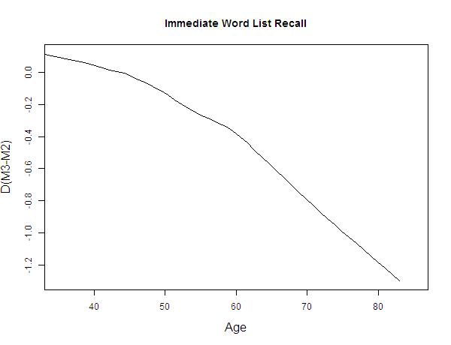

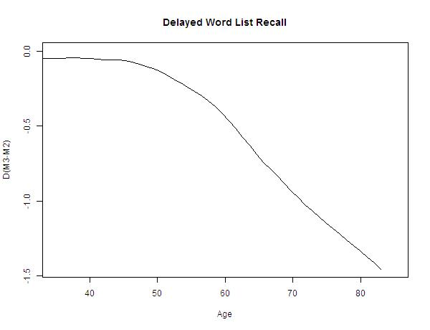

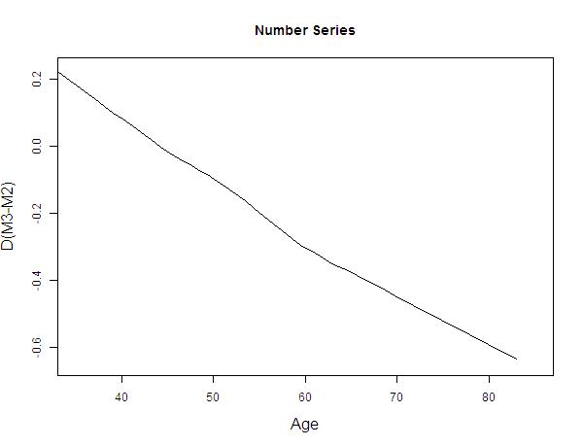
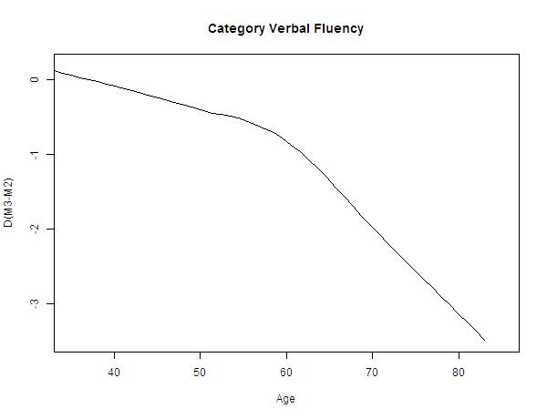
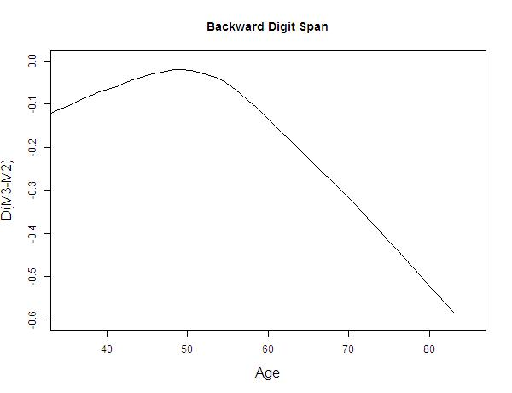
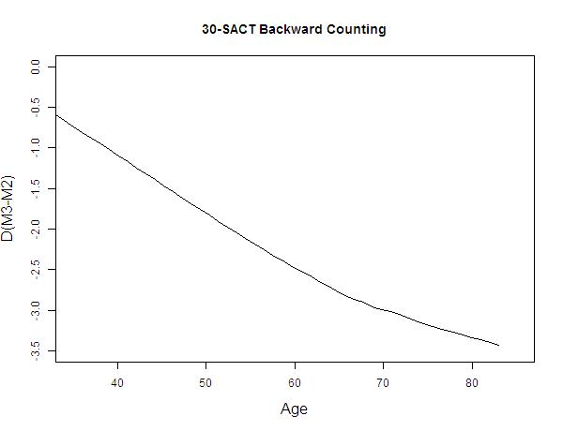
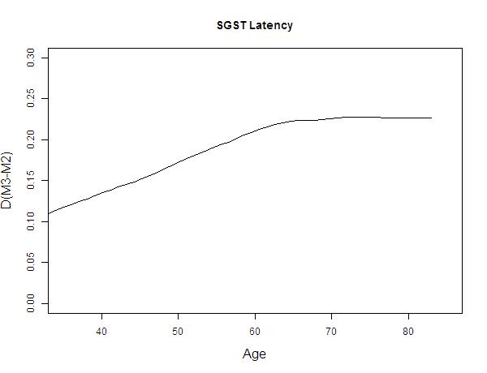
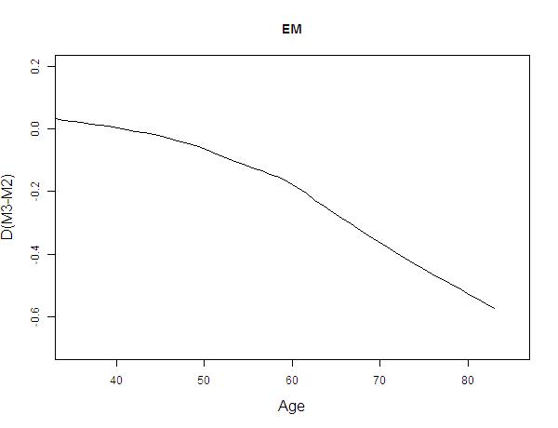
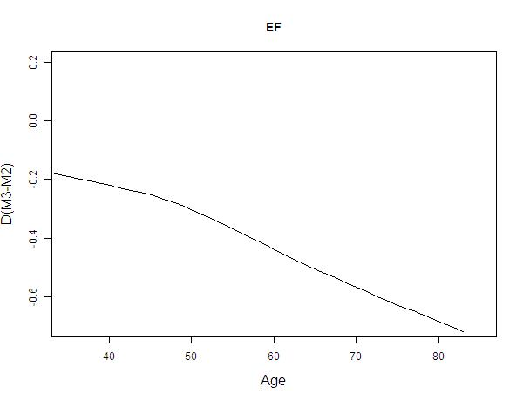

Figure S2. Comparison of Refresher (MR) and MIDUS 3 (M3) Samples for all Subtests
