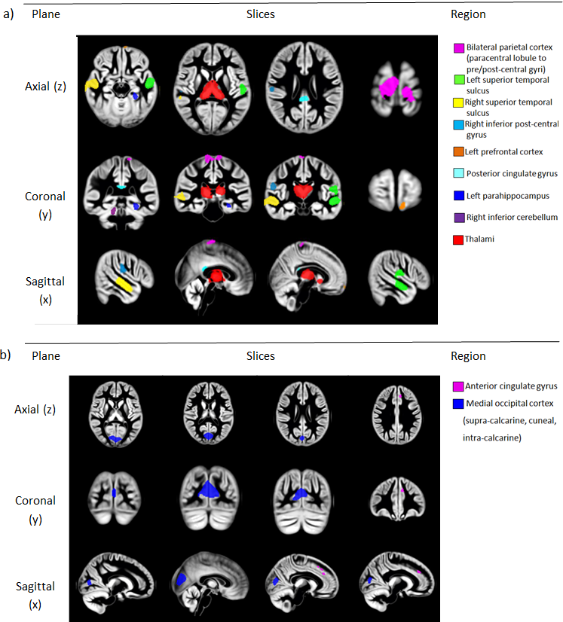

**Figure 2.** Additional slices from VBM statistical parametric maps showing regional grey matter volume differences for a) Contrast: 1 VPT < FT, and 2) Contrast 2: VPT > FT, FWE-corrected *p*<.05. The colorbar index shows the corresponding region of interest for each panel.