**Supplementary Material**

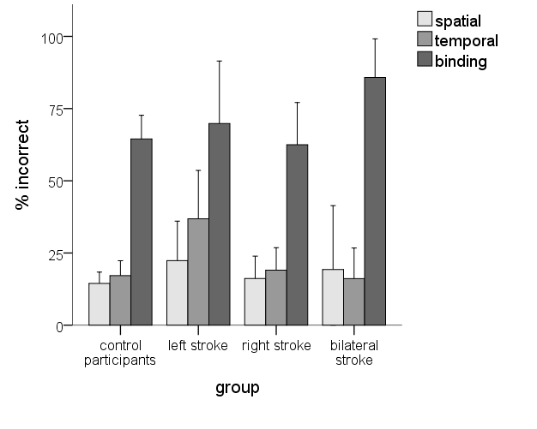

**Figure A.** Performance on spatial and temporal order memory and binding, across groups that differ by lateralization of brain damage after stroke. Error bars display the 95% confidence interval.

|  |  |  |  |  |  |  |  |  |  |  |  |  |
| --- | --- | --- | --- | --- | --- | --- | --- | --- | --- | --- | --- | --- |
| Table A | | | | | | | | | | | | |
| *Case statistics for the seven individual patients who showed abnormal scores against the normative sample of control participants* | | | | | | | | | | | | |
|  | **object relocation performance** | | | | | | | | | | | |
|  | **spatial** | | | | **temporal** | | | | **binding** | | | |
| patient | error % | z-score | *p* | z-ccc | error % | z-score | *p* | z-ccc | error % | z-score | *p* | z-ccc |
| MS | **46\*** | 2.454 | .003 | 3.407 | 29 | 0.696 | .128 | 1.645 | 75 | 0.390 | .161 | 1.512 |
| DG | **42\*** | 2.117 | .023 | 2.424 | 8 | -0.519 | .682 | -0.422 | **0\*** | -2.391 | .016 | -2.583 |
| LS | **80\*\*** | 5.061 | .001 | 5.364 | 29 | 0.696 | .536 | 0.639 | 56 | -0.314 | .610 | -0.526 |
| PM | 17 | 0.197 | .981 | -0.025 | **67\*** | 2.902 | .006 | 2.944 | 92 | 1.020 | .415 | 0.846 |
| PS | 30 | 1.170 | .457 | 0.780 | **63\*** | 2.666 | .026 | 2.395 | 75 | 0.835 | .787 | 0.282 |
| HB | **67\*\*** | 4.088 | .001 | 4.137 | **71\*** | 3.166 | .004 | 3.180 | 92 | 1.020 | .455 | 0.776 |
| JB | **63\*** | 3.738 | .002 | 3.486 | **63\*** | 2.666 | .033 | 2.309 | 100 | 1.317 | .485 | 0.736 |
| control  m *(sd)* | 15 *(13)* |  |  |  | 17 *(17)* |  |  |  | 65 *(27)* |  |  |  |
| Note. Abnormality of scores expressed in z-values and (two-tailed) probability that the case’s score is an observation from the control population, with effect sizes (z-ccc). Higher scores indicate worse performance (% incorrectly replaced objects). * *p* < .05, ** *p* < .001, uncorrected | | | | | | | | | | | | |