Supplemental Figure 1
Funnel plot showing publication bias for objective neuropsychological measures of vigilance.

Supplemental Figure 2
Funnel plot showing publication bias for objective neuropsychological measures of inhibition.

Supplemental Figure 3
Funnel plot showing publication bias for objective neuropsychological measures of working memory.

Supplemental Figure 4
Funnel plot showing publication bias for objective neuropsychological measures of shifting.

Supplemental Figure 5
Funnel plot showing publication bias for objective neuropsychological measures of generativity.

Supplemental Figure 1

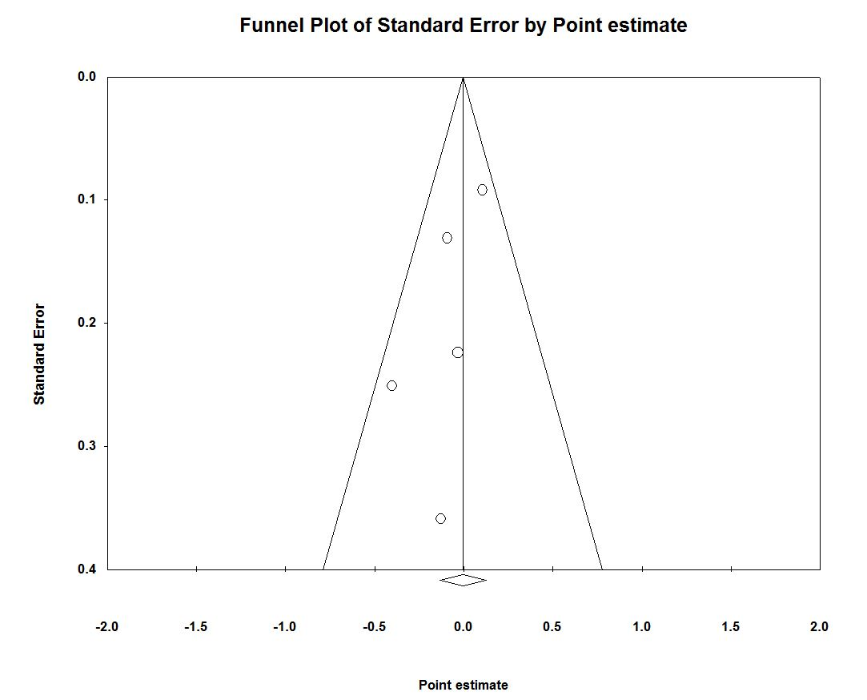

Supplemental Figure 2

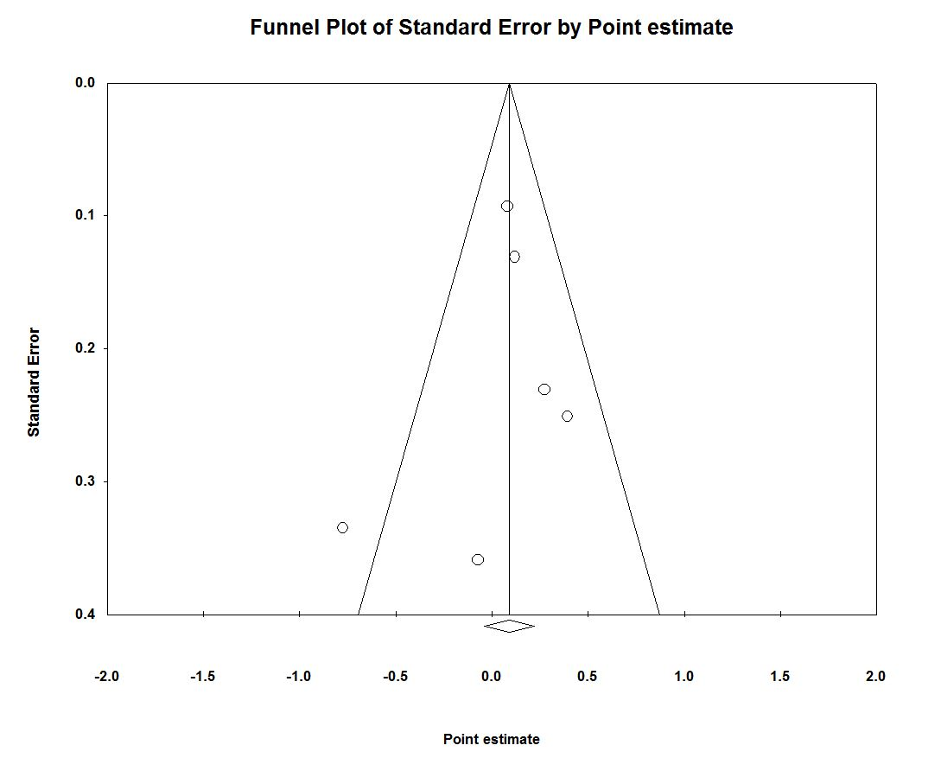

Supplemental Figure 3

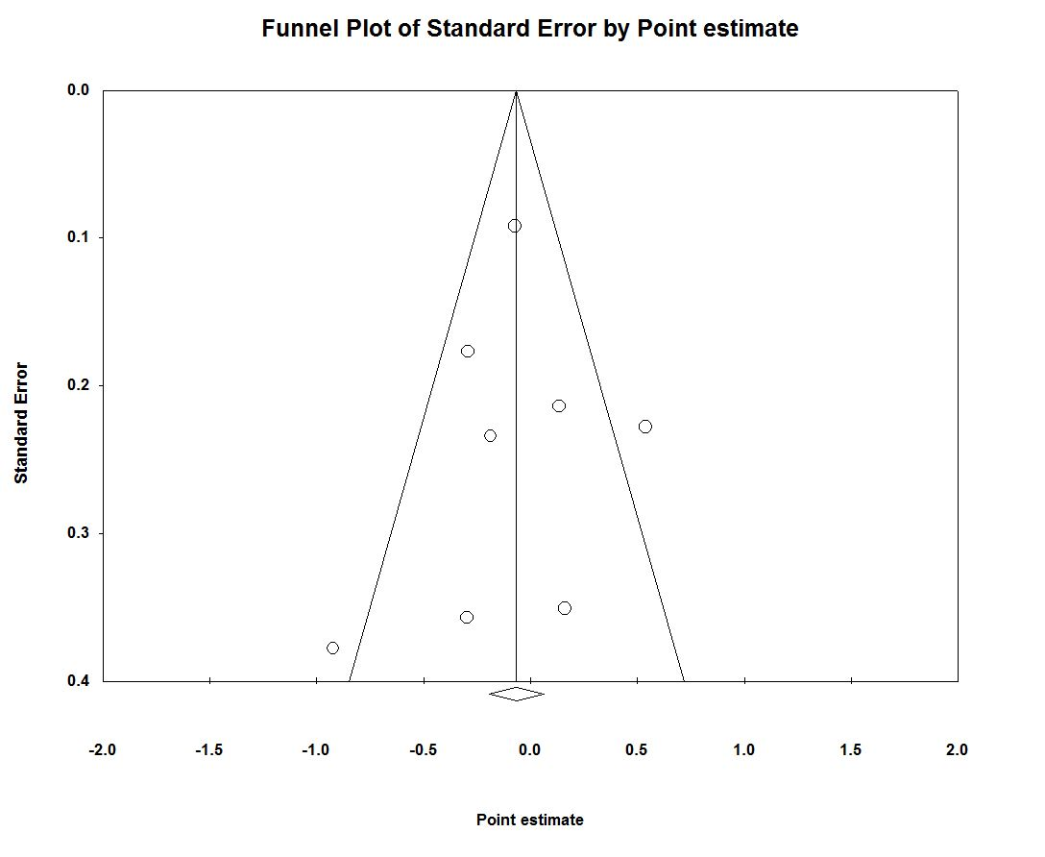

Supplemental Figure 4

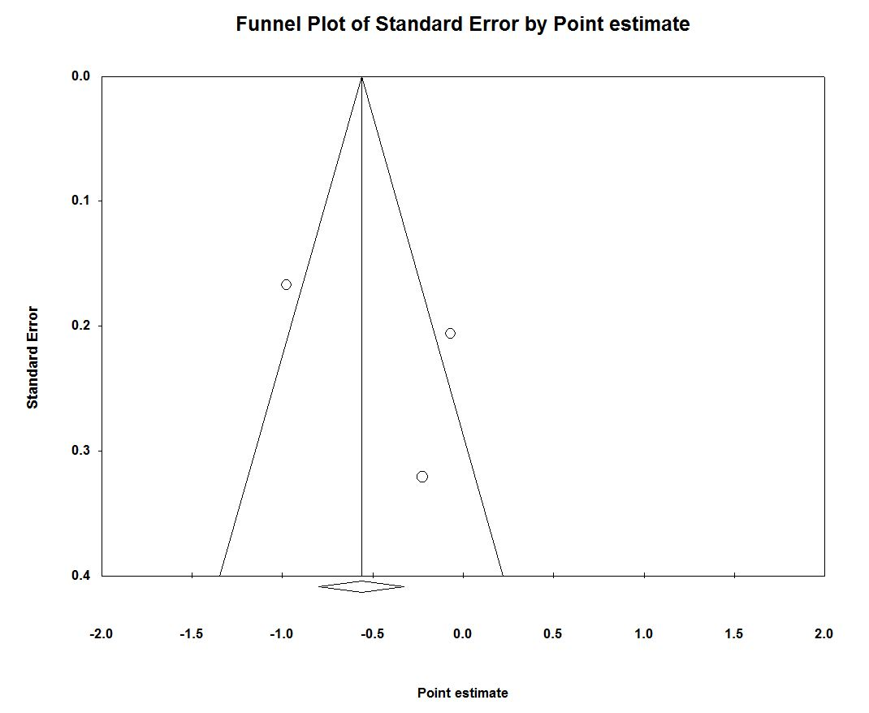

Supplemental Figure 5

