Changes in Neuroticism and Conscientiousness scores with age.
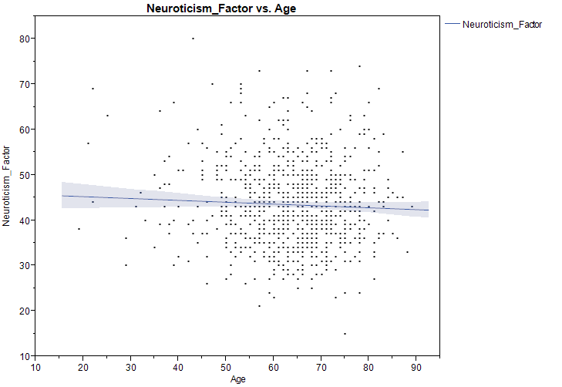
Linear regression with 95% confidence intervals of Neuroticism Factor T scores with age in our cohort showing very subtle decline with increasing age.
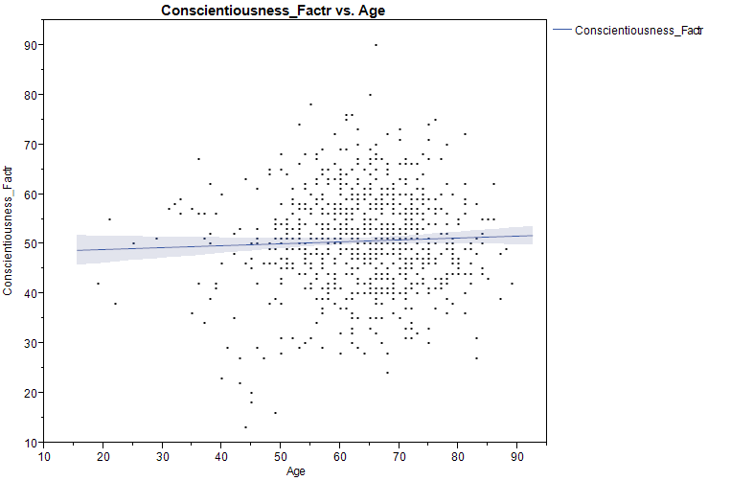
Linear regression with 95% confidence intervals of Conscientiousness Factor T scores with age in our cohort showing very subtle increase with increasing age.

