First order configural face processing task

A Scrambled Faces Task was used to assess first-order configural face processing. This task was designed to disrupt first-order information, while maintaining featural and second-order configural information. Twelve different gray-scaled emotionally neutral faces (six males, six females) from the Pictures of Facial Affect series (Ekman & Friesen, 1976) were used. Each face was presented as either normal, that is, with no alteration or disruption (‘face’ condition), or scrambled (‘scrambled-face’ condition). Scrambled faces involved a disruption of the first-order relations. Images were edited such that the normal first-order configuration of the eyes above the nose above the mouth was changed. This method was adapted from previous research on this type of face processing (1994). Photo editing software was used to capture the eyes region or the combined nose and mouth region of the face. The locations of the two regions were then switched to preserve the featural information and the specific second-order configural information, i.e. the features remained the same shape and distance apart, however, were reordered in terms of location. The blurring tool was used to maintain continuity of skin shade. New ‘scrambled-faces’ showed the nose above the mouth above the eyes. Images were 290 x 390 pixels in size. Supplementary Figure 1 presents an example of the task stimuli.
Participants were presented with a randomised sequence of normal or scrambled faces. Each face was presented in the centre of the screen for 2000ms seconds followed by a fixation cross (+) for 1500ms. Participants were told they were going to see a picture on the screen and they were to decide if the picture was a real face or not. Via a two-button press participants were instructed to respond as quickly and accurately as possible to indicate whether the picture was either a ‘face’ or a ‘non-face’. After reading the instructions, participants completed five practice trials followed by 72 randomised experimental trials in total. Each face and associated scrambled face was presented three times (36 ‘faces’ and 36 ‘non-faces’). The task took approximately four and a half minutes to complete.

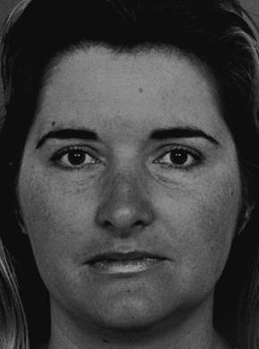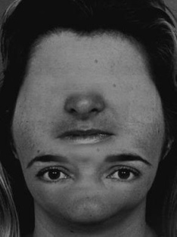
Figure 1. Face (left) and Scrambled Face (right)

Statistical analysis
A two (condition; face, scrambled face) * three (group; controls, BD, SZ) repeated measures ANOVA with post-hoc LSD tests was conducted to investigate performance on the Scrambled Faces Task across groups.

Results

Supplementary Table 1 presents the accuracy and response time scores on the Scrambled Faces Task per group.

Table 2. Accuracy and response time performance on the Scrambled Faces Task per group

 |  | Controls |  | BD |  | SZ
 |  | M | SD | M | SD | M | SD
Accuracy (%) | Overall | 98.76 | 1.33 | 98.41 | 2.24 | 94.39 | 10.09
 | Face | 99.11 | 1.52 | 97.94 | 2.73 | 93.85 | 13.64
 | Scrambled face | 98.41 | 2.06 | 98.87 | 2.21 | 94.94 | 8.35
Response time (ms) | Overall | 684.89 | 112.57 | 715.16 | 123.09 | 792.08 | 208.67
 | Face | 690.71 | 120.92 | 730.34 | 136.92 | 793.36 | 229.42
 | Scrambled face | 679.08 | 115.85 | 699.97 | 119.48 | 790.80 | 197.97
BD= bipolar disorder; SZ=schizophrenia

Accuracy. There was no significant main effect of condition (F(1,80)=.42, p=.52) and no condition by group interaction (F(2,80) = .70, p=.50) but there was a group effect (F(2,80)=4.48, p=.01), with SZ patients performing less accurately than controls (p=.03) and BD patients (p=.05) overall.
Response time. There was no main effect of condition (F(1,80)=2.70, p=.10) and no condition by group interaction (F(2,80) = 8.1, p=.45) but there was a group effect (F(2,80)=3.57, p=.03), with SZ patients performing slower than controls overall (p=.04).
Correlations. Only one noteworthy association was found in regards to the correlations between symptom scales and performance; the negative symptom score of the PANSS correlated negatively with accuracy in the face condition of the Scrambled Faces Task in SZ patients (r=-.49, p=.01), such that performance was worse in those with greater negative symptomatology.

