Table S1. Treatment modules that comprise CBT for Chronic Loneliness in Young People

Module | Description
- Assessment | The aim of this module is to complete a structured CBT assessment of the participants loneliness. The CBT assessment will cover each of the modules within Käll et al., (2020) formulation. The assessment will also include questions regarding the participants development/early experiences, current living situation, education, physical health, lifestyle (diet, sleep, exercise, hobbies/interests, social media use) and a risk assessment, before identifying three goals for treatment.
- Formulation and psychoeducation | The aim of this module is to collaboratively complete a modular formulation of the factors maintaining the participants chronic loneliness (Käll et al., 2020). The participant will also be given psychoeducation on loneliness, the intervention process and will collaboratively develop a treatment plan based on their formulation and goal-based outcomes.
3. Challenging negative interpersonal appraisals and counterproductive behaviours | The aim of the module is to change the negative thought patterns and counter-productive behaviours which are maintaining chronic loneliness (Käll et al., 2020). Participants will be given psychoeducation on the CBT model and the relationship between thoughts, behaviours, physical feelings, and emotions. Participants will be supported to identify the negative interpersonal appraisals and counterproductive behaviours which are maintaining their loneliness. The participant will then be supported to develop within-session behavioural experiments to challenge the counterproductive processes that are maintaining their loneliness, which will then be reinforced through agreed homework tasks.
4. Challenging negative thoughts and cognitive biases | The aim of the module is to challenge the negative cognitions and cognitive biases that are maintaining chronic loneliness. Participants will be given psychoeducation on automatic thought processes, negative thinking traps and their role in chronic loneliness. The participant will be supported to develop strategies to challenge thinking errors. The module is based upon the Cognitive Coping modules of MATCH-ADTC (Chorpita & Weisz, 2009).
5. Challenging self-focussed attention, hypervigilance and camouflaging | The aim of the module is to challenge self-focussed attention, hypervigilance and/or camouflaging when they are maintaining chronic loneliness. The module is comprised of three submodules: 5A, Reducing Self-Focussed Attention, 5B Reducing Hypervigilance and 5C Reducing Camouflaging Behaviours. Each submodule provides psychoeducation on the role of that difficulty in maintaining chronic loneliness. The participant will then be supported to develop within-session behavioural experiments to challenge the counterproductive processes, which will then be reinforced through agreed homework tasks. Module 5A is based upon CBT for Social Anxiety in Adolescence (Leigh & Clark, 2018), with module 5B being a hypervigilance-focussed adaptation of this. Module 5C is a novel module informed by the literature regarding the role of camouflaging in mental health difficulties in those on the autism spectrum (Cook et al., 2021).
6. Values-based social skills training | The aim of this module is to identify the participants social communication strengths and areas for development. The participant will then be supported to develop their social skills in line with their values and treatment goals aiming to reduce their loneliness. The module is informed by the UCLA PEERS program (Laugeson et al., 2012) and the social skills module of the internet-based CBT for loneliness in adults (Käll et al., 2021). The module is comprised of four submodules: 6A Conversation skills, 6B Managing Teasing and Bullying, 6C Managing disagreements and 6D Dating and Flirting. An emphasis on remote communication is embedded across all submodules.
7. Problems solving | The aim of the module is to teach formal problem-solving to overcome practical barriers to reducing loneliness. The module is based upon the Problem-Solving module within MATCH-ADTC (Chorpita & Weisz, 2009). Participants will be provided with psychoeducation on the problem-solving STEPS before having the opportunity to practice the skills within the session. The participant will then be supported to use the problem-solving skills to overcome the practical barriers that are maintaining their loneliness.
8. Finding Friends | The aim of the module is to map the young person’s current social world and identify opportunities for the development of positive social relationships. Participants will be supported to map their current relationships and rate them in terms of positivity, similarity, support and time spent together. Participants will then link their current social groups based on compatibility. Participants will then be supported to identify strategies to improve their connection with current groups, as well as develop connections with new social groups. The module is informed by the Groups4Health intervention (Haslam et al., 2016).
9. Managing Emotions | The aim of the module is to develop strategies to manage emotional responses where they are maintaining chronic loneliness. The module is comprised of two submodules; 9A: Activity selection (for low mood) and 9B Learning to relax (for anxiety management). Both submodules are based on MATCH-ADTC (Chorpita & Weisz, 2009).
10. Relapse Prevention | The aim of the module is to develop a relapse prevention plan with the young person and their parent/carer. This will focus on what the family has learnt during the sessions, strategies to maintain their progress and overcome future difficulties and the difference between a lapse and relapse. Participants will be supported to complete a written plan in addition to a relapse prevention video.

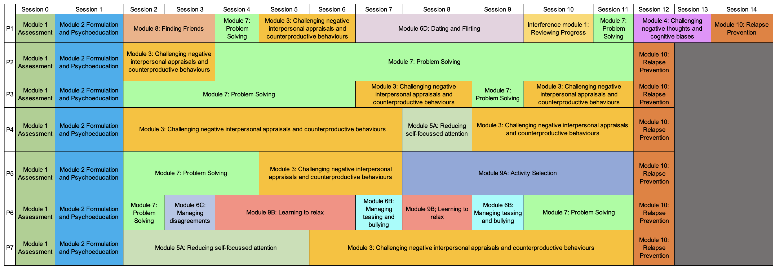

Figure S1. Participants individualised treatment modules

Table S2. Baseline scores of the SCED participants on the UCLA-LS-3, RCADS and SDQ | UCLA-LS-3 | Revised Child Anxiety and Depression Scale (RCADS) T-score |  |  |  |  |  |  |  | Strengths and Difficulties Questionnaire (SDQ)
 |  | Separation Anxiety | Generalised Anxiety | Panic | Social Phobia | Obsessions/ Compulsions | Depression | Total Anxiety | Total Anxiety & Depression | Total Difficulties | Emotional problems | Conduct problems | Hyperactivity | Peer problems | Prosocial | Impact
 | Self-report
P1 | 55 | 78.10 | 65.53 | 62.01 | 51.46 | 64.59 | 72.19 | 66.44 | 69.82 | 22 (Very High) | 6 (High) | 4 (Slightly Raised) | 5 (Close to average) | 7 (Very High) | 6 (Close to average) | 3 (Very High)
P2 | 61 | 77.14 | 52.69 | 63.37 | 52.07 | 48.87 | 55.76 | 61.07 | 60.52 | 23 (Very High) | 6 (High) | 4 (Slightly Raised) | 6 (Slightly Raised) | 7 (Very High) | 6 (Slightly lowered) | 3 (Very High)
P3 | 65 | 65.37 | 45.98 | 65.75 | 62.35 | 40.89 | 60.43 | 58.08 | 59.16 | 18 (High) | 8 (Very High) | 2 (Close to average) | 3 (Close to average) | 5 (Very High) | 8 (Close to average) | 5 (Very High)
P4 | 57 | 75.38 | 52.09 | 78.73 | 67.46 | 53.15 | 59.10 | 69.58 | 68.93 | 24 (Very High) | 6 (High) | 6 (Very High) | 8 (Very High) | 4 (High) | 6 (Slightly lowered) | 0 (Close to average)
P5 | 66 | 75.38 | 69.53 | >80 | 67.46 | 63.91 | 72.69 | 77.42 | 78.94 | 21 (Very High) | 7 (Very High) | 3 (High) | 6 (Slightly raised) | 5 (Very High) | 5 (Close to average) | 5 (Very High)
P6 | 45 | 56.10 | 53.17 | 56.98 | 50.68 | 58.13 | 63.56 | 55.64 | 58.32 | 24 (Very High) | 4 (Slightly Raised) | 6 (Very High) | 7 (High) | 7 (Very High) | 10 (Close to average) | 3 (Very High)
P7 | 63 | >80 | 60.81 | >80 | 79.46 | >80 | >80 | >80 | >80 | 21 (Very High) | 9 (Very High) | 3 (Close to average) | 5 (Close to average) | 4 (High) | 7 (Close to average) | 2 (High)
 | Parent-report
P1 | - | 78.10 | 65.53 | 62.01 | 51.46 | 64.59 | 72.19 | 66.44 | 69.82 | 20 (Very High) | 7 (Very High) | 2 (Close to average) | 4 (Close to average) | 7 (Very High) | 7 (Slightly Lowered) | 5 (Very High)
P2 | - | 62 | 71.45 | 77 | 67.56 | 53.66 | 75.48 | 70.63 | 72.66 | 17 (High) | 8 (Very High) | 3 (Slightly Raised) | 1 (Close to average) | 5 (Very High) | 6 (Low) | 6 (Very High)
P3 | - | 75.66 | 59.82 | 63.04 | 60.62 | 42.31 | 75.52 | 64.45 | 66.43 | 16 (High) | 6 (Very High) | 1 (Close to average) | 3 (Close to average) | 6 (Very High) | 7 (Slightly Lowered) | 3 (Very High)
P4 | - | 70.44 | 55.10 | >80 | 71.50 | 50.43 | 68.55 | 69.84 | 70.92 | 21 (Very High) | 7 (Very High) | 3 (Slightly Raised) | 4 (Close to average) | 7 (Very High) | 10 (Close to average) | 5 (Very High)
P5 | - | 70.44 | 61.72 | >80 | 58.82 | 73.77 | >80 | 71.48 | 76.48 | 27 (Very High) | 8 (Very High) | 3 (Close to average) | 9 (Slightly Raised) | 7 (Very High) | 10 (Close to average) | 3 (Very High)
P6 | - | 56.93 | 58.25 | 49.19 | 68.16 | 51.39 | 72.19 | 60.78 | 65.11 | 21 (Very High) | 3 (Close to average) | 6 (Very High) | 6 (Slightly Raised) | 6 (Very High) | 4 ( Very Low) | 5 (Very High)
P7 | - | 62.41 | 55.10 | 64.88 | 71.50 | 50.43 | >80 | 64.89 | 70.23 | 15 (Slightly Raised) | 5 (High) | 5 (High) | 3 (Close to average) | 2 (Close to average) | 4 Very Low) | 4 (Very High)

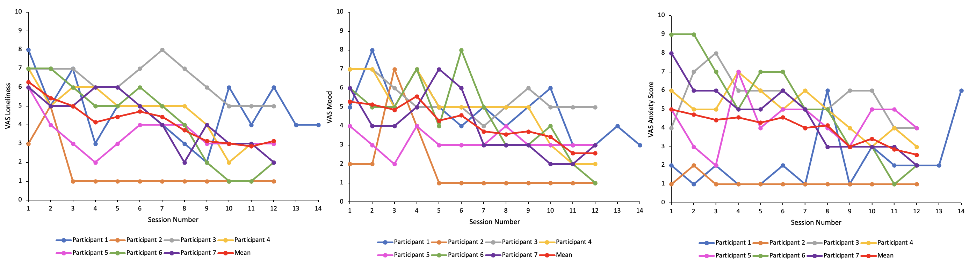
Figure S2. The VAS ratings for loneliness, anxiety and mood scores

Figure S3. The GBO ratings across the intervention phase.

