Beyond Exposure Therapy: Formulation Based Therapy Treating a Fear of
Urinary Incontinence – A Case Study

Torstein Stapley
Centre for Anxiety Disorders and Trauma, South London and Maudsley NHS Foundation Trust, UK

Tracey Taylor and Victoria Bream
Centre for Anxiety Disorders and Trauma, South London and Maudsley NHS Foundation Trust, UK

Background: The current literature on the specific phobia of urinary incontinence is limited, with no specific empirically established model or treatment protocol. Aims: This article consists of a case study of formulation driven Cognitive Behaviour Therapy (CBT) for phobia of urinary incontinence. Method: Martin attended a total of 12 treatment sessions. The treatment included the development of an idiosyncratic formulation, and the use of well-established cognitive and behavioural treatment strategies from other anxiety disorders. Results: Both outcome measures and Martin’s subjective report indicate that the treatment was effective. Conclusion: This case study contributes to the current limited literature on this phobia, and emphasises the importance of formulation driven CBT to map for idiosyncratic features and target cognitive and behavioural factors.

Keywords: urinary incontinence, CBT, behavioural experiments, empirically grounded interventions

Ethical Statement: The authors have abided by the Ethical Principles of Psychologists and Code of Conduct as set out by the BABCP and BPS.
This research received no specific grant from any funding agency, commercial or not-for-profit sectors.
Conflicts of Interest: None
Acknowledgements: to “Martin” for his courage and determination to overcome his difficulties and to our colleagues at the Centre for Anxiety Disorders and Trauma and the PG Diploma in Cognitive Therapy at IOPPN, King’s College London.

Introduction

A specific phobia of urinary incontinence refers to a marked fear and anxiety of urinary incontinence in public settings that is out of proportion to the actual likelihood of its occurrence, and results in significant distress and impairment, usually leading to avoidance or the use of safety seeking-behaviours. Earlier published cases have described fear of urinary incontinence as variants of agoraphobia, panic disorder, OCD or specific phobia, resulting in variety of suggested treatment approaches including bladder training, relaxation, exposure and response prevention (Kamboj et al., 2015; Pajak & Kamboj, 2014; Tan & Lim, 2015). Kamboj et al. (2015), in a survey of non-treatment seekers have explored the symptomatology and cognitive phenomenology of this disorder, identifying the role of mental imagery. Pajak & Kamboj (2014) have asserted that rescripting intrusive images can result in a reduction of fear associated with bladder sensations. Tan & Lim (2015) have suggested that CBT grounded in exposure work may offer an effective treatment approach. Whilst it has been identified that both cognitive and behavioural factors may play a role when treating this phobia, there is no established treatment model. Salkovskis (2002) argues that CBT progresses through a multi-dimensional approach, where empirically grounded clinical interventions from other disorders may be used in the absence of adequate data for a new presentation. The case study aims to demonstrate the utility of this approach in treating this debilitating phobia, and to add to the current limited literature on this specific phobia.

Method

“Martin”, (a pseudonym) presented with a phobia of urinary incontinence. Cognitive, physical, emotional and behavioural factors that played a part in the development and maintenance of the phobia were identified. Martin described a clear catastrophic misinterpretation of physical sensations, thus when collaboratively developing an idiosyncratic formulation, it was informed by Clark’s (1986) established cognitive behavioural model of Panic Disorder, in the absence of an existing model of phobia of urinary incontinence. Clark (1986) established that the catastrophic misinterpretation of physical sensations can result in the experience of severe anxiety, further causing the individual to change their behaviour to reduce or avoid the anxiety, reinforcing the catastrophic interpretation. Therapeutic interventions were driven by the collaborative formulation.

Measures
Martin completed validated self-report outcome measures on a weekly basis including functional impairment (WSAS; Mundt, Marks, Shear, & Griest, 2002), specific anxiety based cognitions (Fear Questionnaire; Marks & Mathews, 1979) and Agoraphobic Cognitions Questionnaire; Chambless et al., 1984). At his first appointment Martin indicated substantial Specific Phobia symptomatology on the Fear Questionnaire (FQ).
Patient profile
Martin was a man in his early 30’s who self-referred for treatment to his local Improving Access to Psychological Therapies (IAPT) Service. Assessment indicated that Martin met the DSM-5 (American Psychiatric Association, 2013) diagnostic criteria for Specific Phobia. His fear of urinary incontinence began 9 months previous, after he suddenly experienced a burning sensation in his urethra whilst travelling on public transport. The fear of public incontinence provoked severe anxiety, and he exited the public transport to use a nearby bathroom. However the sensation persisted and he stopped to use bathrooms four more times over the next fifteen minutes. Following this event Martin experienced a marked perceived risk of urinary incontinence in public that resulted in severe anxiety when he believed he did not have immediate and easy access to a toilet. His fear and level of avoidance was persistent and had lasted more than 6 months. His anxiety caused significant distress and impairment, reduced his quality of life, and made it hard for him to focus on work related tasks, or engage in his relationship. He did not meet criteria for any other disorder.
We formulated a specific event when Martin attended a meeting at work and noticed that his bladder felt full. His interpretation of this physical sensation was ‘I’m going to wet myself’, which triggered anxiety. Martin’s increased anxiety caused him to notice physical sensations, including pressure on his bladder, tense muscles, increased heart rate, agitation, and a sense that his trousers felt tighter. These physical sensations activated further catastrophic misinterpretations: ‘I will lose control of my bladder and wet myself’, ‘It will be everywhere and form a big puddle’; ‘It will be everywhere, and everyone will notice’ and ‘It will stink, and others will be angry, disgusted and offended by me’. In an effort to prevent this happening, Martin would engage in thought suppression, distraction and reassurance seeking, and pre-plan excuses and exit routes. He would actively avoid social situations, travel on public transport, or any other situations where he might not be able to take himself away from others and have immediate access to a bathroom. When leaving his home, he would meticulously plan his journey, bring changes of clothes, wear dark clothing, and use male sanitary pads.

Procedures and intervention
Martin attended an initial two-hour assessment and a total of twelve one-hour sessions of CBT. In between each session, Martin would complete the homework tasks, listen to his recording of the previous session and create a brief summary of key points from the session. The first two sessions focused on collaboratively developing a shared maintenance formulation and identifying treatment goals. Session three offered psychoeducation on the role of attention and bladder capacity and average urine output per hour. Subsequent sessions focused on behavioural experiments testing the impact of avoidance and the use of safety seeking behaviours in maintaining his beliefs about his incontinence, which required spontaneity and inventiveness by both client and therapist, use of survey data, and cognitive restructuring. To reduce self-focused attention, attention training was introduced towards the end of treatment, followed by a detailed therapy blueprint and relapse prevention plan. Table 1 below outlines examples of behavioural experiments conducted.
Table 1 about here

Results
Martin’s scores on all outcome measures significantly reduced, indicating a significant reduction in distressing symptomatology and phobia cognitions. His WASA indicated subclinical functional impairment, whilst the Phobia Scales and the anxiety specific measures (FQ, ACQ) no longer indicated the presence of a phobia. He no longer met DSM-5 diagnostic criteria for a specific phobia at discharge. Subjectively, Martin reported significant progress and said therapy had allowed him to regain his old life. Martin identified the use of behavioural experiments and a survey to test his beliefs as particularly useful therapy interventions. Two particular behavioural experiments resulted in a significant change in Martin’s scores: (1) therapist modelling to pretend to lose continence in public, and (2) Martin engaging in physical exercise for 20 minutes after drinking a sizeable quantity of water. His belief ratings rapidly shifted from 100% to 0% in these BEs; in the event of a lesser shift, the therapist and Martin would have planned and executed further behavioural experiments as in-session and self-directed tasks until he had achieved a 0% belief in these threat appraisals. At the end of therapy Martin was regularly attending meetings, and was travelling on public transport daily without preplanning his trips or engaging in safety seeking behaviour. He had booked a long-haul flight, and reported no anxiety about the upcoming journey.

Discussion
Established cognitive models of anxiety disorders e.g. panic (Clark, 1986), social anxiety (Clark & Wells, 1995) are based on clear formulations that focus therapeutic interventions on key cognitions. This case study helps to address the ‘gap in literature’ for specific phobia of urinary incontinence by illustrating how, in the absence of an empirically supported treatment protocol, an idiosyncratic formulation grounded in empirically supported and well-established models of therapy, can help guide treatment, determine treatment interventions and impact on the effectiveness of therapy. It shows how a multitude of cognitive strategies rather than exposure alone can help reduce anxiety in ‘viscerally-centred’ phobias by challenging the catastrophic misinterpretation of physical sensations.
To establish an empirically valid model for this phobia that accurately outlines maintaining factors across individuals, further research is required using a larger population. This will give clients with this debilitating phobia confidence early on in therapy that treatment will be effective.

References
American Psychiatric Association. (2013). Diagnostic and statistical manual of mental disorders (5th ed.). Arlington, VA: Author.

Chambless, D. L., Caputo, G. C., Bright, P., & Gallagher, R. (1984). Assessment of fear of fear in agoraphobics: The Body Sensations Questionnaire and the Agoraphobic Cognitions Questionnaire. Journal of Consulting and Clinical Psychology, 52, 1090 - 1097.

Clark, D.M. (1986). A cognitive approach to panic. Behaviour research and therapy, 24(4), 461-470.

Clark, D. M., & Wells, A. (1995). A cognitive model of social phobia. In R. G. Heimberg, M. R. Liebowitz, D. A. Hope, & F. R. Schneier (Eds.), Social phobia: Diagnosis, assessment, and treatment (p. 69–93). The Guilford Press.

Kamboj, S.K., Langhoff, C., Pajak, R., Zhu, A., Chevalier, A., Watson, S. (2015). Bowel and bladder-control anxiety: a preliminary description of a viscerally-centred phobic syndrome. Behavavioural Cognitive Psychotherapy, 43, 142-157

Marks, I.M., and Mathews, A. M. (1979). Brief standard self-rating for phobic patients. Behavior Research and Therapy, 17, 263-267.
Mundt, J. C., Marks, I. M., Shear, K. M., & Griest, J. M. (2002). The Work and Social Adjustment Scale: a simple measure of impairment in functioning. The British Journal of Psychiatry, 180, 461-464.

Pajak, R. and Kamboj, S.K. (2014). Experimental single-session imagery rescripting of distressing memories in bowel/bladder-control anxiety: a case series. Frontiers in Psychiatry, 5, 182.

Pajak, R., Langhoff, C., Watson, S., Kamboj, S.K. (2013). Phenomenology and thematic content of intrusive imagery in bowel and bladder obsession. Journal of Obsessive-Compulsive and Related Disorders, 2, 233-240.

Salkovskis, P. M. (2002). Empirically grounded clinical interventions: Cognitive-behavioural therapy progresses through a multi-dimensional approach to clinical science. Behavioural and Cognitive Psychotherapy, 30, 3-9.

Tan, T. and Lim, L. (2015) Cognitive Behavior Therapy of Urinary Incontinence Phobia: A Case Report. Open Journal of Psychiatry, 5, 60-65.

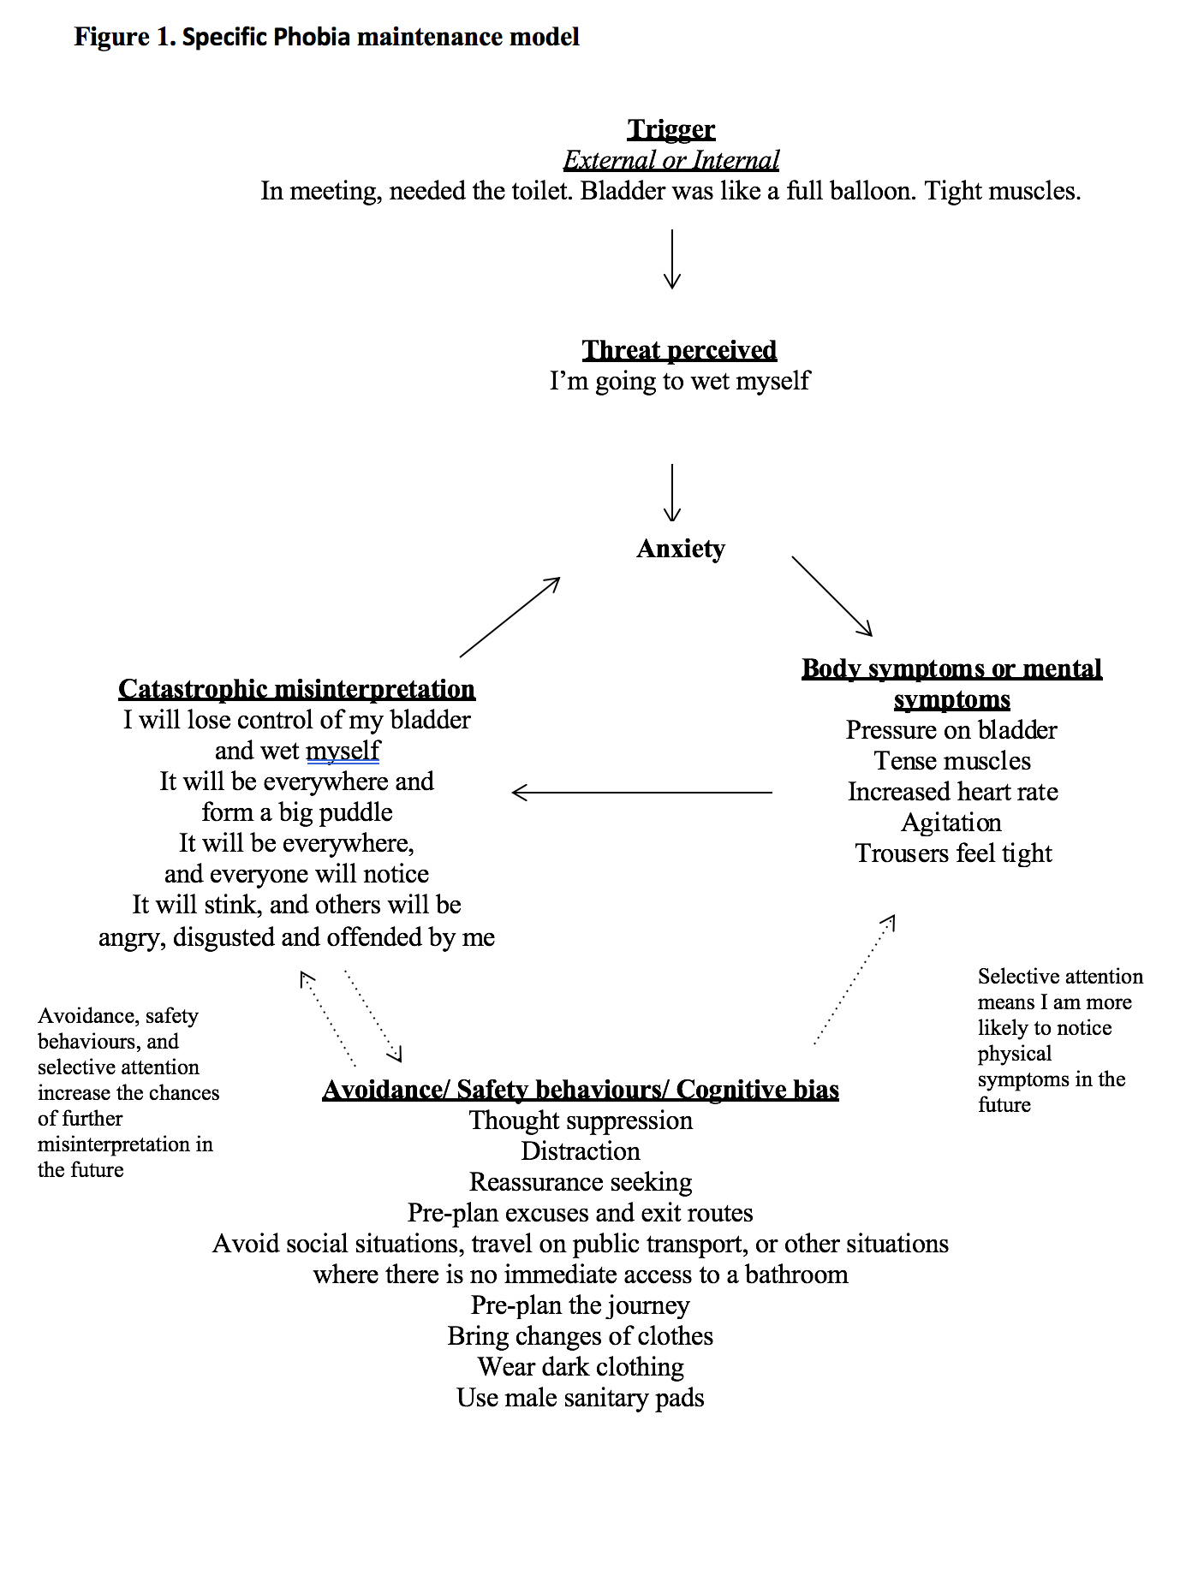

Table 1. Overview of behavioural experiments and predictions tested
Prediction to be tested and belief rating | Experiment | Outcome / Learning
I will lose control of my bladder and wet myself (100%) | Martin drank a large amount of water before and during the session and then did jumping jacks in a crowded place to test his beliefs. | Despite feeling like I was going to wet myself I did not. I can cope better than I think.  Re-rating of original belief:  0%
It will be everywhere and form a big puddle (100%) | Martin dressed in light coloured trousers and purposefully wet himself in his shower at home when he was alone. | It is a lot harder than expected to wet myself when wearing trousers, and no puddle formed when I did wet myself.  Re-rating of original belief:  0%
It will be everywhere, and everyone will notice / It will stink, and others will be angry, disgusted and offended by me (100%) | Therapist modelling - The therapist walked around in public, stood by a crowded bus stop and entered a busy café with a visible wet patch on his trousers. | Becoming incontinent in public is not as awful as predicted – Most people don’t notice and those who do don’t seem to care.  Re-rating of original belief:  0%

Table 2. Outcome measures over the course of therapy

Session number | PHQ-9 | GAD-7 | WSAS | Phobia Scales | FQ | ACQ
Assessment | 12 | 12 | 23 | 11 | 62 | 34/410
1 | 10 | 10 | 17 | 6 | 51 | 27/270
2 | 10 | 10 | 10 | 5 | 50 | 24/240
3 | 7 | 6 | 12 | 9 | 27 | 23/220
4 | 10 | 12 | 18 | 11 | 19 | 23/210
5 | 3 | 3 | 12 | 7 | 12 | 20/190
6 | 7 | 7 | 10 | 6 | 6 | 21/180
7 | 4 | 5 | 18 | 4 | 6 | 20/130
8 | 3 | 4 | 9 | 4 | 10 | 24/130
9 | 5 | 4 | 10 | 4 | 7 | 23/20
10 | 3 | 2 | 3 | 3 | 4 | 23/20
11 | 4 | 3 | 2 | 2 | 2 | 19/10
12 | 3 | 2 | 5 | 0 | 0 | 23/10

