Targeting Intrusive Imagery Using a Competing Task Technique: A Case Study

Lalitha Iyadurai

Department of Psychiatry, University of Oxford, Oxford, UK

Susie A. Hales

Oxford Institute of Clinical Psychology Training, University of Oxford, Oxford, UK

Simon E. Blackwell
Mental Health Research and Treatment Center, Ruhr-Universität Bochum, Bochum, Germany

Kerry Young

Woodfield Trauma Service, Central and North West London NHS Foundation Trust, London, UK

Emily A. Holmes
Department of Psychology, Uppsala University, Uppsala, Sweden and Department of Clinical Neuroscience, Karolinska Institutet, Stockholm, Sweden

* Corresponding author: Lalitha Iyadurai, Department of Psychiatry, University of Oxford, Warneford Hospital, Oxford OX 3 7JX. Email: lalitha.iyadurai@psych.ox.ac.uk

Abstract
Background: Even in cases with complexity, simple techniques can be useful to target a specific symptom. Intrusive mental images are highly disruptive, drive emotion, and contribute to maintaining psychopathology. Cognitive science suggests we might target intrusive images using competing tasks.
Aims: We describe an imagery-targeting competing task technique within a cognitive behavioural therapy (CBT) framework with a patient with bipolar disorder and post-traumatic stress disorder (PTSD) symptoms. The intervention technique – including Tetris computer game-play – was used 1) to target a specific image within one therapy session, and 2) to manage multiple images in daily life.
Method: A single case (AB) design was used. 1) To target a specific image, the patient brought the image to mind and then, after mental rotation instructions and gameplay practice, played Tetris for 10 minutes. Outcomes, pre- and post-technique, were: vividness/distress ratings when the image was brought to mind; and reported intrusion frequency over a week. 2) To manage multiple images, the patient played Tetris when used the intervention after an intrusive image occurred. Outcomes were weekly measures of: a) imagery characteristics; and b) symptoms of PTSD, anxiety, depression and mania.
Results: 1) For the target image, there were reductions in vividness (80% to 40%), distress (70% to 0%), and intrusion frequency (daily to twice/week). 2) For multiple images, there were reductions from baseline to follow-up in a) imagery vividness (38%), realness (66%) and compellingness (23%), and b) symptoms of PTSD symptoms (IES-R score 26.33 to 4.83).
Conclusion: This low-intensity intervention procedure aiming to directly target intrusive mental imagery may offer an additional, complementary tool in CBT.
Keywords: mental imagery, intrusions, bipolar disorder, PTSD, cognitive science, imagery-focused cognitive therapy, single case experimental design.
Introduction
Vivid, emotional, recurrent, intrusive mental images feature in a wide range of psychological disorders (Hackmann, Bennett-Levy, & Holmes, 2011). These images can be highly distressing and disrupt patients’ daily lives, presenting a treatment target in their own right (Iyadurai et al., 2019). Further, intrusive images may be a central driving symptom in the maintenance of some disorders, such as bipolar disorder (Holmes et al., 2011) and post-traumatic stress disorder (Ehlers & Clark, 2000). Techniques to target intrusive images offer potential to alleviate distress, improve functioning and may have downstream benefits for treating psychological disorders.
Established techniques to target intrusive imagery in cognitive behavioural therapy (CBT), such as imaginal reliving and imagery rescripting, involve detailed discussion of imagery content and meaning (Hackmann et al., 2011). This prospect can feel frightening for some patients (Krakow & Zadra, 2006). Further, these techniques address single images, and may not be optimal when patients experience multiple intrusive images or images with frequently changing content. Metacognitive techniques can help patients disengage from images, but can be challenging to use when images are very powerful or compelling. In these circumstances, simple, low-intensity techniques to disrupt intrusive images would offer a useful additional tool in CBT.
A potential novel approach developed from basic cognitive science research involves the use of cognitive tasks that tax visuospatial working memory to directly target imagery characteristics rather than content or meaning. Intrusive imagery in psychological disorders tends to be predominantly visual e.g. 80% of intrusive memories in PTSD (Hackmann, Ehlers, Speckens & Clark, 2004). Cognitive science research in working memory and mental imagery suggests that visuospatial cognitive tasks compete with visual images for cognitive resources (Andrade, Kavanagh, & Baddeley, 1997; Engelhard, van den Hout, Janssen, & van der Beek, 2010; Kavanagh, Freese, Andrade, & May, 2001; van den Hout, Muris, Salemink, & Kindt, 2001). Performing visuospatial tasks, such as spatial pattern tapping and bilateral eye movements, during recall of a distressing image, has been shown to reduce both its vividness and emotionality (Engelhard et al., 2010; Kavanagh et al., 2001; Van den Hout & Engelhard, 2012). This finding has been extended to traumatic images in patients with PTSD (Lilley, Andrade, Turpin, Sabin-Farrell, & Holmes, 2009). Further, performing such visuospatial tasks during or soon after watching an experimental trauma film (a film with traumatic content), compared to no task or a verbal task, has been found to reduce the frequency with which images of the film intrude in daily life over the following week (Holmes & Bourne, 2008; James et al., 2016). Such tasks are thought to compete for cognitive resources with visual aspects of the memory whilst those memories are labile, i.e. during a time window of memory consolidation (McGaugh, 2000).
A procedure with greater potential ecological validity – a brief behavioural intervention including playing the popular visuospatial computer game “Tetris” – has also been shown to reduce the frequency of intrusive images over the first week following a trauma film, relative to a control procedure or no task, in a series of laboratory studies (e.g. Holmes, James, Coode-Bate, & Deeprose, 2009; Holmes, James, Kilford, & Deeprose, 2010). This simple behavioural intervention has now been tested in two proof-of-concept trials after real-life trauma, and found to reduce intrusive memories in the first week after the trauma (Horsch et al., 2017; Iyadurai et al., 2018). Further, this intervention has now been used to disrupt established trauma memories (i.e. those that have already consolidated) by targeting memory reconsolidation, both in the laboratory (James et al., 2015; Kessler et al., 2020) and in patients with chronic PTSD (Kessler et al., 2018). Based on this experimental and proof-of-concept clinical research, this approach could offer a simple, low-intensity and non-threatening technique that could be easily delivered in CBT to directly target the vividness, emotionality and frequency of intrusive images, irrespective of image content.
Here we describe the use of this novel technique in CBT – a simple visuospatial task intervention procedure including playing the visuospatial computer game Tetris - to target intrusive imagery as part of a formulation-driven imagery-focused treatment for mood instability (Hales et al., 2018; Holmes et al., 2016; Holmes, Hales, Young, & Di Simplicio, 2019) with a patient with bipolar disorder and co-morbid PTSD symptoms. We describe how the technique was used with two different applications: 1) to target the vividness, distress and frequency of a specific problematic image within a single therapy session and 2) to disrupt various problematic images as an adaptive strategy in day-to-day life over the treatment period.

Case presentation
Ruth (pseudonym) was referred for outpatient psychological treatment by her psychiatrist, following a diagnosis of bipolar II disorder. At assessment, using the Structured Clinical Interview for DSM-IV-TR (First, Spitzer, Gibbon, & Williams, 2002), she was currently euthymic but reported ongoing fluctuations in mood and energy levels, which affected her ability to work and engage in daily routines consistently. She additionally had PTSD symptoms and generalised anxiety disorder. She was currently taking three types of medication for mood management.
Ruth reported that her main problem was recurrent intrusive images with varying content, including “flashback” images of traumatic events in her childhood, “flashforward” images of anxiety-provoking social situations and “obsessive” images related to security at home. She experienced the images as highly vivid and detailed, leading them to feel very real and compelling. Consequently, she felt distressed, anxious and often guilty, and found the images affected her sleep, concentration and work. She avoided certain social situations and often spent hours checking her home. Following an imagery micro-formulation that linked these factors, we agreed to target her recurrent images in treatment, with the aim of reducing anxiety and stabilising mood. A visuospatial task intervention was selected as one suitable treatment technique, 1) to specifically target image vividness/realness, which was hypothesized to drive the impact on anxiety and mood, and 2) as it could be used to target multiple images with different content.

Measures

1) Targeting a specific image within session (pre- and post-technique outcomes)
Vividness and distress ratings of the image when brought to mind (0-100%); reported intrusion frequency of the selected image over the last week (number of days on which the image intruded).

2) Managing multiple images in daily life (weekly measures)

a) Imagery characteristics during the past week
Visual Analogue Scale (VAS) ratings of realness, vividness, and compellingness of imagery, (0=not at all to 10=extremely); subjective distress of intrusions assessed using the Impact of Events Scale-Revised intrusion subscale score (see below).

b) Symptoms of PTSD, anxiety, depression and mania during the past week
Impact of Events Scale-Revised (IES-R; Weiss & Marmar, 1997): a widely-used 22-item self-report measure assessing post-traumatic distress (score range 0-88), with subscales for intrusion, avoidance and hyperarousal symptoms; Beck Anxiety Inventory (BAI; Beck, Brown, Epstein, & Steer, 1988): a well-established 21-item self-report measure of anxiety symptoms; Quick Inventory of Depression Symptoms (QIDS; Rush et al., 2003): a widely-used 9-item self-report measure of depression symptoms; Altman Self-Rating Mania Scale (ASRM; Altman, Hedeker, Peterson, & Davis, 1997): a 5-item scale assessing the frequency and severity of mania symptoms..

Treatment

Overview
Seven one-hour sessions of imagery-focused cognitive therapy (Holmes et al., 2019) took place over an 11-week treatment period. There was a three-week baseline period and six-week follow-up period. The imagery-competing task intervention was delivered in treatment session 2.

1) Targeting a specific image within session
Ruth was asked to bring to mind an image that had been particularly frequent and distressing in the last week, and to rate it for vividness and distress. After a few minutes, during which the computer game Tetris (Marathon version) was loaded on a Nintendo DS (a small hand-held gaming device), and the clinician (LI) explained the instructions including mental rotation, and Ruth had gameplay practice, she played Tetris for 10 minutes. She then rated the image vividness and distress again, and was asked to monitor its frequency over the subsequent week. For further details of the intervention procedure, including mental rotation instructions for playing Tetris, see Holmes et al. (2019, Ch.11).

2) Managing multiple images in daily life
Ruth downloaded Tetris on her smartphone, and was encouraged to play it use the intervention when feasible (including playing Tetris for at least 10 minutes) when after an intrusive image occurred in her day-to-day life.

Results

1) Targeting a specific image within session
Ruth brought to mind an image of “everyone looking at me, waiting for me to say something, and I can’t get the words out”. She appraised the image as meaning that she was useless and not as good as everyone else, which elicited feelings of anxiety, hopelessness and guilt. She reported that the image had intruded daily over the last week, and rated it to be 80% vivid and 70% distressing when she brought it to mind. After the brief behavioural intervention including playing Tetris, she brought the image to mind again within the same session, and reported it was “vague and dim” (40% vivid, reflecting 50% reduction), was no longer distressing (0% distressing, reflecting 100% reduction), and that it “doesn’t feel real, like a painting”. On returning the next session, she reported that the image had only intruded on two days over the last week, and rated it to be 50% vivid and 30% distressing when she brought it to mind deliberately in that session.

2) Managing multiple images in daily life
Ruth reported that she had particularly compelling intrusive images in the evenings, which prevented her falling asleep. This left her tired during the day, and affected her work. She found that using the intervention playing Tetris at bedtime helped to disrupt the images and allowed her to get to sleep. Ruth used this technique as needed throughout treatment and follow-up.

a) Imagery characteristics
Figure 1a shows a reduction from the baseline to follow-up period in mean weekly VAS ratings of image vividness (mean 9.17 to 5.73: 38% reduction), realness (mean 8.43 to 2.87: 66% reduction) and compellingness (mean 7.53 to 5.77: 23% reduction). There was a reduction in IES-R intrusion subscale score, indicating distress from intrusions, from baseline (mean 12.25) through treatment (mean 5.09) to follow-up (mean 1.12), with a statistically reliable change from baseline to follow-up (Reliable Change Index=-29.48).

b) Symptoms of PTSD, anxiety, depression and mania symptoms
Mean total IES-R score reduced from baseline (26.33) through treatment (16.27) to follow-up (4.83), demonstrating a statistically reliable change from baseline to follow-up (Reliable Change Index=-76.01). At follow-up, Ruth no longer exhibited any PTSD symptoms during the SCID interview. Anxiety (BAI score) was “minimal” at baseline (15.67) and follow-up (14.33), with a slight increase to a “moderate” level during treatment (21.27). QIDS scores indicated “mild” depression at baseline (8.00), “moderate” depression during treatment (14.27) period, and a drop to a “normal” level at follow-up (5.17). Mania scores (ASRM) remained subclinical throughout baseline (2.33), treatment (1.73) and follow-up (2.33). For measures other than the IES-R there was no reliable change from baseline to follow-up.
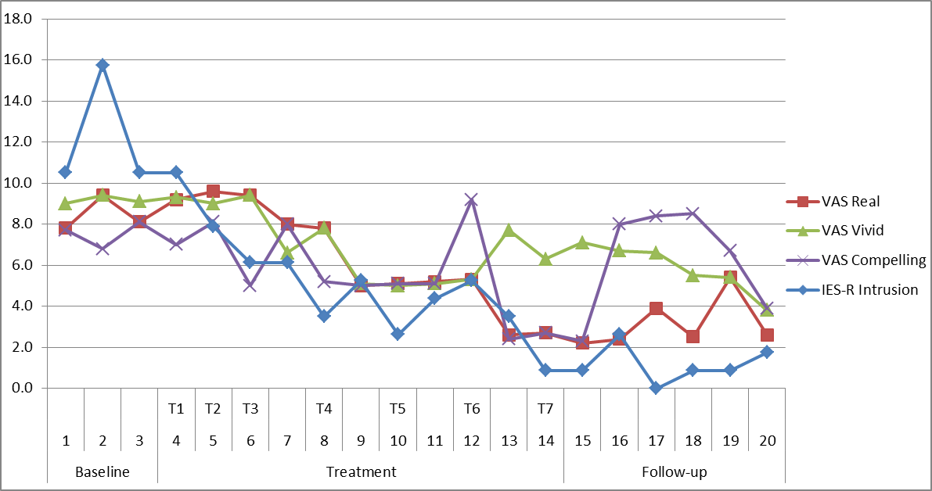
a)
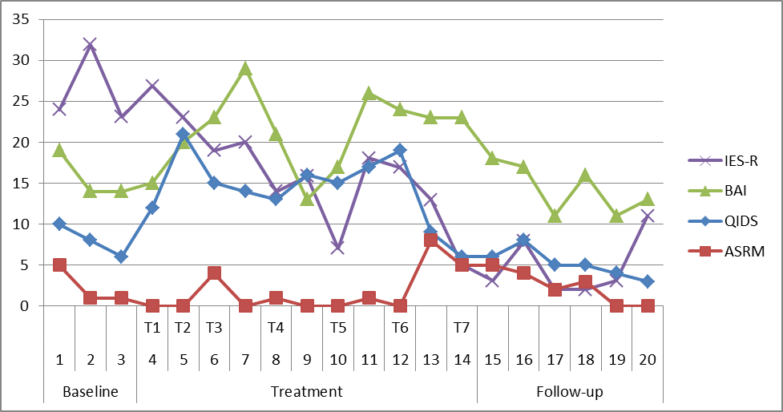
b)

Figure 1. Weekly measures of a) imagery characteristics and b) symptoms of PTSD, anxiety, depression and mania over baseline, treatment and follow-up periods. T1 to T7 indicate the timing of the seven treatment sessions, with in-session use of the imagery-disrupting task taking place in treatment session 2. VAS = visual analogue scale (rated 0 to 10); IES-R Intrusion = Impact of Event Scale-Revised intrusion subscale (indicating intrusion distress); IES-R = Impact of Event Scale-Revised total score (including intrusion subscale); QIDS = Quick Inventory of Depression Symptoms; ASRM = Altman Self-Rating Mania Scale.

Figure 1b shows weekly scores on these outcome measures across the baseline, treatment and follow-up periods.

Ruth’s experience
Ruth reported that her use of the imagery-competing technique became more automatic throughout treatment. At the end of treatment she felt more in control of her images and her mood, and realised that “having an image did not mean it was real”. She reported increased self-confidence in work and social events and found she was less avoidant of some social situations.

Discussion
This case study demonstrates the use of a simple intervention technique within CBT, distilled from basic cognitive science, in a patient with bipolar disorder and comorbid PTSD symptoms. The technique is a brief intervention procedure which includes playing the visuospatial computer game Tetris to target a highly disruptive symptom – intrusive mental imagery. Results provide a preliminary indication that the technique can be used within session to reduce the vividness and emotionality of a selected image, as well as the frequency with which it intrudes over the subsequent week, consistent with preceding cognitive science studies (e.g., James et al., 2016; Kessler et al., 2020) and single case work with inpatients (Kessler et al., 2018). Further, use of the technique as an adaptive strategy to disrupt multiple images in daily life was associated with reductions in ratings of imagery realness, vividness and compellingness, and distress from intrusions. The patient’s subjective account indicated that use of the technique led to her imagery feeling “vague and dim” and “like a painting”, and to the understanding that “having an image did not mean it was real”. These changes in image quality and appraisal appeared to be linked with the reduction in her distress.
A corresponding reduction in IES-R scores from baseline to follow-up suggested that targeting imagery may have had downstream beneficial effects on psychological symptoms, consistent with theoretical models of imagery in psychological disorders (Ehlers & Clark, 2000; Holmes et al., 2011) and recent case series (Hales et al., 2018; Holmes et al., 2016). Anxiety, depression and mania symptom scores were low at baseline. Slight increases in anxiety and depression symptoms during treatment coincided with a family fall-out and increased work pressure.
The computer-game based intervention technique including computer-game play may offer a simple, low-stigma and engaging addition to traditional cognitive techniques (such as imagery rescripting, imaginal reliving, or metacognitive approaches) by directly targeting the properties of intrusive images instead of addressing their content and meaning. This may be particularly useful when formulation indicates that other approaches may not be suitable as a first treatment option, or when the patient experiences multiple, highly compelling images that are difficult to disengage from, as in this case. Indeed, drawing on basic cognitive science may offer new avenues to improve and develop psychological treatments (Holmes, Craske, & Graybiel, 2014). Whilst this patient used the visuospatial computer game Tetris as part of the intervention, other visuospatial tasks may also be effective, including activities the person already finds engaging, such as doing art or jigsaw puzzles. However, these other tasks, unlike the Tetris-based procedure, have not yet been tested in experimental studies.
In this study, we did not seek to evaluate the specific impact of the imagery-targeting technique on overall outcome, as it was used as part of a broader imagery-focused CBT treatment. Other imagery-focused techniques within the therapy, as well as other unknown confounders, may have impacted the outcome. Further research to evaluate the technique might involve a multiple-baseline design using different target images, and diary-based assessment of daily intrusion frequency, vividness and distress.

Acknowledgments
We would like to thank “Ruth” for giving us permission to publish an account of her work with us, and the OxMAPP clinical team for peer supervision during this work.

Ethics statements
This work was conducted in line with the Ethical Principles of Psychologists and Code of Conduct as set out by the American Psychological Association (2017). The work described in this case study was part of the patient’s routine clinical care. The patient provided their written informed consent for the authors to submit an anonymised account of our work with them for publication as a case study in a scientific journal. Any information which could potentially identify the patient has been removed or disguised.

Conflict of interest

SAH, KY and EAH have published a book entitled “Imagery-based cognitive therapy for bipolar disorder and mood instability” (Holmes, Hales, Young & Di Simplicio, 2019). LI and SEB have no conflict of interest with respect to this publication.

Financial support
This work was supported by the National Institute of Health Research (LI, grant number NIHR-DRF- 2011-04-076) and the Wellcome Trust (EAH, grant number WT088217; also supporting SAH and KY).

References
Altman, E. G., Hedeker, D., Peterson, J. L., & Davis, J. M. (1997). The Altman self-rating mania scale. Biological Psychiatry, 42(10), 948-955. doi: 10.1016/S0006-3223(96)00548-3.
Andrade, J., Kavanagh, D. J., & Baddeley, A. D. (1997). Eye-movements and visual imagery: A working memory approach to the treatment of post-traumatic stress disorder. British Journal of Clinical Psychology, 36(2), 209-223. doi: 10.1111/j.2044-8260.1997.tb01408.x.
Beck, A. T., Brown, G., Epstein, N., & Steer, R. A. (1988). An inventory for measuring clinical anxiety - psychometric properties. Journal of Consulting and Clinical Psychology, 56(6), 893-897.
Creamer, M., Bell, R., & Failla, S. (2003). Psychometric properties of the Impact of Event Scale–Revised. Behaviour Research and Therapy, 41, 1489-1496. doi: 10.1016/.brat.2003.07.010.
Ehlers, A., & Clark, D. M. (2000). A cognitive model of posttraumatic stress disorder. Behaviour Research and Therapy, 38(4), 319-345. doi: 10.1016/S0005-7967(99)00123-0.
Engelhard, I. M., van den Hout, M. A., Janssen, W. C., & van der Beek, J. (2010). Eye movements reduce vividness and emotionality of "flashforwards". Behaviour Research and Therapy, 48(5), 442–447. doi: 10.1016/j.brat.2010.01.003.
First, M. B., Spitzer, R. L., Gibbon, M., & Williams, J. B. W. (2002). Structured Clinical Interview for DSM-IV-TR Axis I Disorders, Research Version, Patient Edition. (SCID-I/P). New York: Biometrics Research, New York State Psychiatric Institute.
Hackmann, A., Bennett-Levy, J., & Holmes, E. A. (2011). Oxford Guide to Imagery in Cognitive Therapy. Oxford: Oxford University Press.
Hales, S. A., Di Simplicio, M., Iyadurai, L., Blackwell, S. E., Young, K., Fairburn, C. G., . . . Holmes, E. A. (2018). Imagery-focused cognitive therapy (ImCT) for mood instability and anxiety in a small sample of patients with bipolar disorder: a pilot clinical audit. Behavioural and Cognitive Psychotherapy, 46(6), 706-725. doi: 10.1017/s1352465818000334.
Holmes, E. A., Bonsall, M. B., Hales, S. A., Mitchell, H., Renner, F., Blackwell, S. E., . . . Di Simplicio, M. (2016). Applications of time-series analysis to mood fluctuations in bipolar disorder to promote treatment innovation: a case series. Translational Psychiatry, 6, e720. doi: 10.1038/tp.2015.207.
Holmes, E. A., Craske, M. G., & Graybiel, A. M. (2014). Psychological treatments: a call for mental-health science. Nature, 511(7509), 287-289. doi: 10.1038/511287a.
Holmes, E. A., Deeprose, C., Fairburn, C. G., Wallace-Hadrill, S. M. A., Bonsall, M. B., Geddes, J. R., & Goodwin, G. M. (2011). Mood stability versus mood instability in bipolar disorder: A possible role for emotional mental imagery. Behaviour Research and Therapy, 49(10), 707-713. doi: 10.1016/j.brat.2011.06.008.
Holmes, E. A., Hales, S. A., Young, K., & Di Simplicio, M. (2019). Imagery-Based Cognitive Therapy for Bipolar Disorder and Mood Instability. New York, NY: Guilford Press.
Holmes, E. A., James, E. L., Coode-Bate, T., & Deeprose, C. (2009). Can playing the computer game "Tetris'' reduce the build-up of flashbacks for trauma? A proposal from cognitive science. PLoS One, 4(1), e4153. doi: 10.1371/journal.pone.0004153.
Holmes, E. A., James, E. L., Kilford, E. J., & Deeprose, C. (2010). Key steps in developing a cognitive vaccine against traumatic flashbacks: visuospatial Tetris versus verbal Pub Quiz. PLoS One, 5(11), e13706. doi: 10.1371/journal.pone.0013706.
Horsch, A., Vial, Y., Favrod, C., Harari, M. M., Blackwell, S. E., Watson, P., . . . Holmes, E. A. (2017). Reducing intrusive traumatic memories after emergency caesarean section: a proof-of-principle randomized controlled study. Behaviour Research and Therapy, 94, 36-47. doi: http://doi.org/10.1016/j.brat.2017.03.018.
Iyadurai, L., Blackwell, S. B., Meiser-Stedman, R., Watson, P. C., Bonsall, M. B., Geddes, J. R., . . . Holmes, E. A. (2018). Preventing intrusive memories after trauma via a brief intervention involving Tetris computer game play in the emergency department: a proof-of-concept randomized controlled trial. Molecular Psychiatry, 23, 674-682. doi: 10.1038/mp.2017.23.
Iyadurai, L., Visser, R. M., Lau-Zhu, A., Porcheret, K., Horsch, A., Holmes, E. A., & James, E. L. (2019). Intrusive memories of trauma: A target for research bridging cognitive science and its clinical application. Clinical Psychology Review, 69, 67-82. doi: 10.1016/j.cpr.2018.08.005.
Jacobson, N. S., & Truax, P. (1991). Clinical significance: a statistical approach to defining meaningful change in psychotherapy research. Journal of Consulting and Clinical Psychology, 59, 12-19. doi: 10.1037/0022-006X.59.1.12.
James, E. L., Bonsall, M. B., Hoppitt, L., Tunbridge, E. M., Geddes, J. R., Milton, A. L., & Holmes, E. A. (2015). Computer game play reduces intrusive memories of experimental trauma via reconsolidation update mechanisms. Psychological Science, 26(8), 1201-2015. doi: 10.1177/0956797615583071.
James, E. L., Lau-Zhu, A., Clark, I. A., Visser, R. M., Hagenaars, M. A., & Holmes, E. A. (2016). The trauma film paradigm as an experimental psychopathology model of psychological trauma: intrusive memories and beyond. Clinical Psychology Review, 47, 106-142. doi: 10.1016/j.cpr.2016.04.010.
Kavanagh, D. J., Freese, S., Andrade, J., & May, J. (2001). Effects of visuospatial tasks on desensitization to emotive memories. British Journal of Clinical Psychology, 40(3), 267-280. doi: 10.1348/014466501163689.
Kessler, H., Holmes, E. A., Blackwell, S. E., Schmidt, A. C., Schweer, J. M., Bücker, A., . . . Kehyayan, A. (2018). Reducing intrusive memories of trauma using a visuospatial interference intervention with inpatients with posttraumatic stress disorder (PTSD). Journal of Consulting and Clinical Psychology, 86(12), 1076-1090. doi: 10.1037/ccp0000340.
Kessler, H., Schmidt, A-C., James, E. L., Blackwell, S. E., von Rauchhaupt, M., Harren, K., … Holmes, E. A. (2020). Visuospatial computer game play after memory reactivation delivered three days after a traumatic film reduces the number of intrusive memories of the experimental trauma. Journal of Behavior Therapy and Experimental Psychiatry, 67, 101454. doi: 10.1016/j.jbtep.2019.01.006.
Krakow, B., & Zadra, A. (2006). Clinical management of chronic nightmares: imagery rehearsal therapy. Behavioural Sleep Medicine, 4(1), 45-70. doi: 10.1207/s15402010bsm0401_4.
Lilley, S. A., Andrade, J., Turpin, G., Sabin-Farrell, R., & Holmes, E. A. (2009). Visuospatial working memory interference with recollections of trauma. British Journal of Clinical Psychology, 48(3), 309-321. doi: 10.1348/014466508X398943.
McGaugh, J. L. (2000). Memory - a century of consolidation. Science, 287(5451), 248-251. doi: 10.1126/science.287.5451.248.
Rush, J. A., Trivedi, M. H., Ibrahim, H. M., Carmody, T. J., Arnow, B., Klein, D. N., . . . Keller, M. B. (2003). The 16-item quick inventory of depressive symptomatology (QIDS), clinician rating (QIDS-C), and self-report (QIDS-SR): A psychometric evaluation in patients with chronic major depression. Biological Psychiatry, 54(5), 573-583. doi: 10.1016/S0006-3223(02)01866-8.
van den Hout, M. A., & Engelhard, I. M. (2012). How does EMDR work? Journal of Experimental Psychopathology, 3(5), 724-738. doi: 10.5127/jep.028212
van den Hout, M. A., Muris, P., Salemink, E., & Kindt, M. (2001). Autobiographical memories become less vivid and emotional after eye movements. British Journal of Clinical Psychology, 40(2), 121-130. doi: 10.1348/014466501163571.
Weiss, D. S. (2004). The Impact of Event Scale - Revised. In J. P. Wilson & T. S. Keane (Eds.), Assessing Psychological Trauma and PTSD (2nd ed.) (pp.168-189). New York: Guilford Press.
Weiss, D. S., & Marmar, C. R. (1997). The Impact of Event Scale - Revised. In J. P. Wilson & T. M. Keane (Eds.), Assessing Psychological Trauma and PTSD (pp. 399-411). New York: Guilford Press.

A Reliable Change Index of -29.48 was calculated based on a standard deviation of 1.09 and an internal consistency of Cronbach’s alpha = 0.94 (Creamer, Bell, & Failla, 2003), using the formula proposed by (Jacobson & Truax, 1991).
A Reliable Change Index of -76.01 was calculated based on a standard deviation of 1.00 and an internal consistency of Cronbach’s alpha = 0.96 (Creamer et al., 2003), using the formula proposed by (Jacobson & Truax, 1991). It was not appropriate to calculate clinically significant change for the IES-R, as there are no “cut-off” points, and the measure is not intended to determine clinical versus non-clinical status (Weiss, 2004).

