Title
Assessing Functioning in adolescents with Chronic Fatigue Syndrome: Psychometric properties and Factor Structure of the School and Social Adjustment Scale and the Physical Functioning Subscale of the SF36

Figure S1. Scree plot for Physical Functioning Subscale
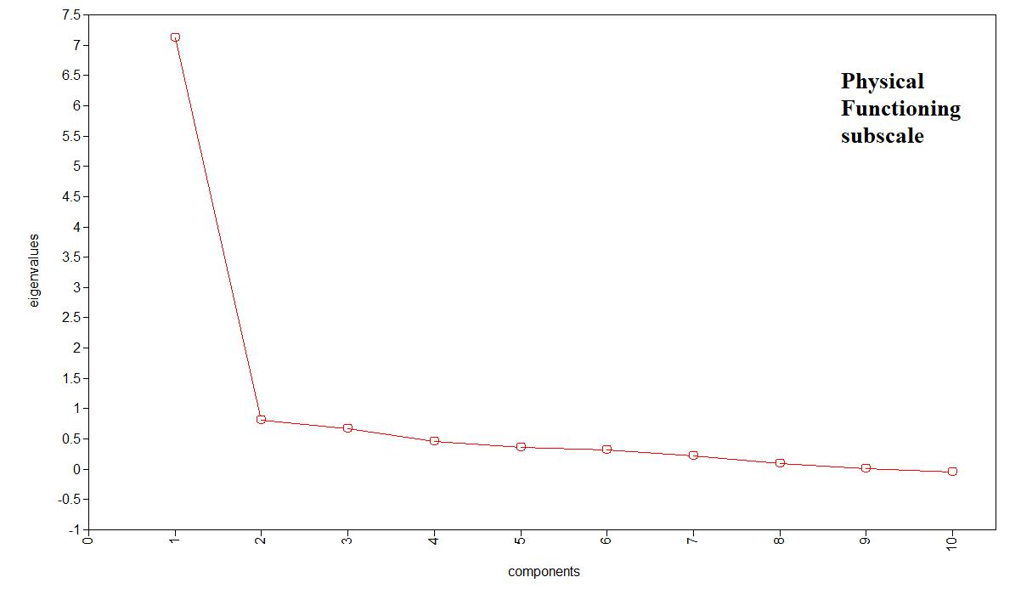

Figure S2. Scree plot for School and Social Functioning Scale
