Supplemental file

Title: Sleep restriction therapy can be effective for people with insomnia and depressive complaints: Evidence from a case series

Authors: Lancee, J., Maric, M., & Kamphuis, J.H.

In this supplemental file we give more detailed information about the procedure of the present case series. The methods section below is more elaborate than in the main manuscript but, in to be able order to be understood by itself, also includes parts that were already reported there. We also provide additional information about the results, both on the group and individual level.

Method

Inclusion and exclusion criteria
Inclusion criteria were: (1) 18 years or older, (2) a clinical insomnia diagnosis based on SCID-5-RV, (3) Insomnia Severity Index score ≥ 10, (4) Sleep efficiency score ≤ 85 (based on screener and later psychologist assessment), (5) Patient Health Questionnaire depression scale (PHQ9_D) ≥ 10, (6) Beck Depression Inventory II (BDI-II) ≥ 14, (7) Availability for ten consecutive weeks. All questionnaire cutoffs were required on both the screener and the intake assessment (see ‘measurements’). Exclusion criteria that were assessed by means of the screener: (1) Previous CBTI (lifetime), (2) Start of psychotherapy < 6 months ago, (3) prescribed psychotropic medication, (4) Pregnancy/ breastfeeding (5) shift work, (6) severe depressive complaints (BDI-II score ≥ 29), (7) Probable sleep apnea (screener Wilson et al., 2010), (8) alcohol or marijuana misuse, (9) concrete suicidal ideation (i.e. concrete plans but not thoughts were an exclusion criteria). All these exclusion criteria were also assessed face-to-face. In the face-to-face assessment, the following additional exclusion criteria were checked: (10) Lifetime hypomanic/ manic period (SCID), (11) current alcohol or drug abuse (SCID section), (12) current psychosis/schizophrenia (screener/ SCID). Other psychiatric or somatic comorbidities were allowed.

Participants
A total of 1236 interested volunteers completed the Insomnia Severity Index online. Of these, 254 progressed to the remainder of the online screener, of whom 43 were eligible for the face-to face assessment. Of these 43, another 17 volunteers were not seen for an intake assessment because we were unable to reach them for an appointment, or because they refused participation prior to the face-to-face intake (e.g. because they were only available in the evenings). A final 26 individuals were assessed face-to-face and seven of these patients were included in the study (please see Supplemental Figure 1 for a Flowchart of the study including reasons for exclusion of the remaining volunteers). The final sample consisted of four women and three men, ranging in age from 28 to 60 years (mean 45.7). All participants met criteria for a current diagnosis of insomnia and none had a current depressive episode or any other current comorbid

1091 interested
- 41 excluded on ISI
- 796 did not start rest screener

254 started rest online screener

Excluded: n = 201
- 4 started psychotherapy <6 months ago,
- 6 alcohol use
- 5 marijuana use
- 8 insomnia < 3 months
- 4 shift work
- 2 previous CBTI
- 12 sleep efficiency > 85%
- 15 did not complete screener
- 113 depression too low (PHQ < 10)
- 32 depression too high
- 4 probable sleep apnea
- 6 SSRI

43 eligible for face-to-face intake
Excluded: n = 36
- 14 depression score below cutoff at intake
- 2 other primary complaint (nightmares/ phase-delay)
- 1 depression score above cutoff at intake
- 1 medication use
- 1 hypomanic episode in past
- 6 decided not to participate (e.g. started other therapy/ was only available at night)
- 11 could not be reached/ no appointment could be made

7 included
1 dropout
6 completed all assessments

Supplemental Figure 1 – Flowchart of the study
axis I disorder. None of the participants had received prior psychological treatment. All were born and raised in the Netherlands.

Procedure

Participants were recruited through Facebook ads and a popular-science website about insomnia (www.insomnie.nl). Online information on the study was made available for interested individuals, which led up to an online screener. If Pp fulfilled the criteria on the online screener, they were invited for a face-to-face assessment in which eligibility was established and informed consent signed. We also formally asked patients for specific consent regarding the more individual data in this supplemental section. Four patients agreed upfront, the other two wanted to read and check this section specifically (and then gave consent). Based on the face-to-face intake assessment, a final decision on enrolment was made by the first and last authors (JL, JHK). Participants were not blinded to the specific goals of the study. Participants were informed via telephone/ e-mail about their inclusion, an Actiwatch was send by postal service, and the sleep diary/questionnaires by email. When participants were included, a four-week wait period followed. During this period, Pp were asked to complete a daily sleep diary, to wear an Actiwatch to monitor sleep, and to complete several questionnaires (please see Supplemental Figure 2 for an overview of the study design). These measurements were also implemented during the treatment phase. Suicidal tendencies were monitored weekly, based on five items of the suicidality section of the MINI (up to the post-test). If patients were to screen positive for suicidality, they would be excluded from the study (of note, none of the participants screened positive at any stage of the trial).

Supplemental Figure 1 – Schematic overview of the study

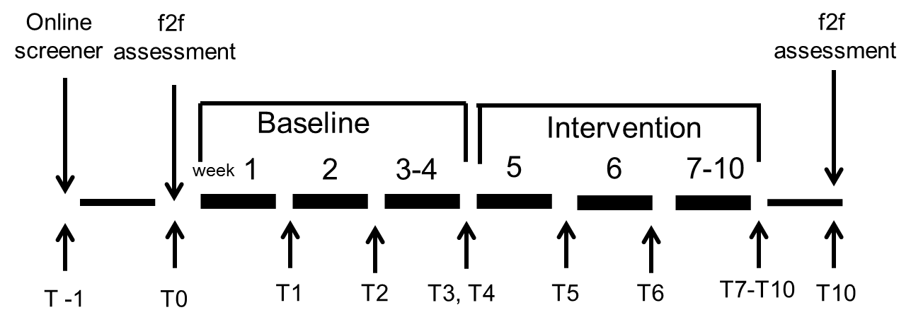
Note. This figure only depicts the baseline and treatment phase. Assessments were weekly and T10 constitutes the post-test (three- and six-month follow-ups are not depicted in this Figure).

After the waiting-period, but prior to the start of the treatment, participants completed an additional BDI questionnaire and were administered the SCID interview for insomnia and depressive disorder to check whether any diagnoses were changed. The treatment phase consisted of six weeks of single component SRT (please see below for a description). The post-test, which included a face-to-face assessment, was administered one week after completing the SRT protocol. At three- and six-months follow-up assessments were administered which included phone-administered SCID interviews for current depression and insomnia. The study was approved by the University of Amsterdam Ethics Review Board (2017-CP-8305) and was registered at the Netherlands Trial Register (NTR6867).

Treatment
After the waiting period, participants received six weeks of SRT (including a sleep diary and weekly assessments) (Kyle et al., 2015; Spielman, Saskin, & Thorpy, 1987). The goal of SRT is to increase the homeostatic sleep drive by restricting time in bed and strengthening circadian patterning of sleep-wake through regular bedtime and rising time. SRT was administered by the therapist who also conducted the intake assessment. SRT started with a face-to-face session (week 1) explaining the rationale of SRT. Next, five more weeks were used for titration of the bedtimes. In week two, four, five and six of the intervention, contact was restricted to phone calls. In week three of the intervention, another face-to-face session was scheduled. The therapist time was in total about 90 minutes delivered face-to-face and 40-60 minutes delivered by phone. Therapists (first author and two therapists with 2-3 years post-master experience) were instructed to strictly keep to the SRT protocol and not engage in any other treatment activities (e.g. cognitive therapy).
The following rules were applied during the treatment: time in bed was initially set as the average sleep time of the past four-week wait-period, with a minimum of five hours. If, based on clinical evaluation, patients were very reluctant to restrict their bedtimes, ‘time in bed’ of ‘total sleep time’ plus up to one hour was allowed (as long as time in bed was restricted with at least one hour). After bedtimes were set, the following rules applied for the following weeks: if sleep efficiency < 85%, bedtime was decreased by 15 minutes (minimum five hours); if sleep efficiency = 85-89%, there was no change in bedtimes; if sleep efficiency ≥ 90, bedtimes were increased by 15 minutes. Participants could choose their own bed- and rising times as long as these followed the rules of sleep restriction and were kept stable over time (1h deviation was allowed in the weekends). Of note, in the treatment session none of the participants explicitly made use of the extra bedtime hour.

Assessment occasions
PHQ-9, ISI, and BADS-F (not reported here) were measured weekly until post-test and at the follow-up assessments. BDI-II and SCID were administered at baseline, mid-treatment, post-treatment, and the follow-up assessments. All questionnaires were measured online before the actual appointment. Face-to-face assessments before treatment were administered by the therapist delivering the treatment; post-test assessment was carried out by a therapist not involved in the treatment. The sleep diary and Actiwatch were measured daily from the start of the wait-period until the post-test.

Primary outcome measure
Our primary measure was the Patient Health Questionnaire (PHQ) for depressive symptoms. The PHQ is a 9-item questionnaire, with a range of scores of 0–27 and strong internal consistency (Cronbach’s α = 0.89) (Spitzer, Kroenke, & Williams, 1999). The PHQ-9 is scored on a five-point Likert score ranging from 0 (never) to 4 (almost daily). To document possible confounding, we also report the PHQ-9 score without the sleep item; we labeled this the Patient Health Questionnaire-9 without sleep item (PHQ-WS) score. On the full questionnaire, a score of 10 or higher is considered indicative of moderate depression, whereas clinical improvement is defined as a drop of 50% or more, resulting in a score of less than 10.

Secondary outcome measures
We also used the Beck Depression Inventory II (Van der Does, 2002) to assess depressive symptoms. The BDI-II is a widely used 21-item questionnaire comprising items on a four-point Likert scale (range 0-63). A score of 14 or higher is considered indicative of mild depression and a score of 29 or higher is considered indicative of a severe level of depression.
Insomnia was measured with the 7-item Insomnia Severity Index (range 0-28) (Bastien, Vallières, & Morin, 2001). The ISI is scored on a 5-point Likert scale with scores ranging from 0 to 28; higher scores indicating more severe insomnia. A score of 10 is considered an adequate cut-off for clinical insomnia, and a change of eight or more points on this scale is considered clinically relevant (Morin, Belleville, Belanger, & Ivers, 2011).
Subjective sleep indices were measured with the consensus sleep diary (Carney et al., 2012). The Carney consensus sleep diary was slightly adjusted to fit our study purpose and reduce participant burden. Specifically, participants reported when they went to bed to sleep, and when they got up (Time in bed – TIB), sleep onset latency (SOL), awake after sleep onset (WASO), how long they slept in total, and mood on a visual analogue scale (higher scores indicating better mood). We calculated TST (TST: TIB–SOL–WASO), and then calculated the sleep efficiency, SE (SE = (TST/TIB) × 100). Two items of the original Carney diary were left out: (1) the item distinguishing between the time patients went to bed and the time they switched off the light, and (2) the item distinguishing between final morning awakening and getting up.
Objective sleep data were collected with an Actigraph GT9X Link provided by ProCare, under Actigraph Actilife 6 SmEnterprise licenses. Actigraphic watches, accelerometers recording motion over short epochs, are non-invasive small devices worn on the nondominant wrist 24 hours a day. We used the Actilife software (http://www.actigraphcorp.com/solutions-andproducts/software/actilife/) to extract the data from the actigraphic watches. We used the Cole-Kripke algorithm to calculate the different sleep estimates: sleep onset latency, wake after sleep onset, total sleep time, sleep efficiency. We manually added bed- and rising times based on the subjective sleep diary.
The SCID-I is a standard semi-structured interview to assess DSMIV-TR disorders. The SCID-I was used to asses current Axis-I disorders (First, Spitzer, Gibbon, & Williams, 2002).

Statistical analysis
At an individual level we determined clinical improvement for the PHQ-9 (50% decrease) and the ISI (change of eight or more). At the group level, we conducted repeated measurement analyses (ISI, PHQ-9, PHQ-WS, BDI-II, SE, TWT, and TST) to examine whether a significant linear slope could be detected during the waiting-period and the intervention period, respectively. If the assumption of sphericity was violated, the Greenhouse-Geisser correction was applied. For the BDI-II we used t-tests because we only had measurements at pre, mid, and post assessments. Relative to the scores from the waiting period, we calculated Hedges g’s for the post-test and follow-up assessments (Hedges, 1981). Hedges g is the standardized mean difference (or Cohen’s d) adjusted for small sample sizes. For the sleep-diary variables we had 10 weeks of time-points at our disposal. Therefore we conducted a multilevel regression analysis modelled Maric and colleagues (Maric, de Haan, Hogendoorn, Wolters, & Huizenga, 2015) which allowed us to detect significant changes at the individual level. We report the observed individual scores in the supplemental file. Throughout study we followed a two-sided significance level of p < .05.

Results

Dropout and missing data
One participant (SRT9) dropped out from the study. After completing the wait-period, she followed two sessions of SRT but decided to terminate treatment because she considered the SRT protocol too strenuous.
At one time-point a PHQ-9 score of one patient was missing: SRT25 only filled out the ISI at the second wait-assessment. Furthermore, there were four individual items missing for the PHQ-9 (twice SRT14/SRT17). Since we had substantial information about the subjects available we decided to use ‘last observation carried forward’ for all these missing data, meaning the score from the week before was imputed.

Actigraphy data
We experienced several problems with the actigraphy data. Data for three persons were either not admissible or missing. Furthermore, two of the remaining participants seem to suffer from sleep misperception with 32.2% (SRT 15) and 41.3% (SRT 37) sleep efficiency discrepancy between sleep diary and actigraphy during the wait-period. We decided to refrain from statistically analyzing these actigraphy data. See below for the actigraphy findings on an individual level.

Effects at the group level
There were no significant group changes on any of the variables between the start and the end of the wait period (all p’s > .36). Relative to the end of the wait-period, all variables showed a significant change at post-test: PHQ: F(6, 30) = 4.12, p = .004; PHQ-WS: F(6, 30) = 3.64, p = .008; ISI: F(6, 30) = 7.67, p < .001; SE: F(6, 24) = 21.7, p < .001; TST: F(6, 24) = 5.28, p = .001; TWT: F(6, 24) = 31.0, p < .001. The only exception to this pattern of significant improvement was noted for the BDI at post-test, t(5) = 1.96, p = .11. However, BDI improvement at the first follow-up assessment (relative to the end of the waiting period) was significant, t(5) = 4.63, p = .006. The PHQ-9, t(5) = 6.03, p = .002, PHQ-WS, t(5) = 16.86, p < .001 and ISI, t(5) = 15.36, p < .001 change also remained significant at first follow-up. At the six-month follow-up: PHQ-9, t(5) = 8.30, p < .001, PHQ-WS, t(5) = 11.18, p < .001, BDI, t(5) = 3.25, p = .023, and ISI, t(5) = 2.79, p = .038. Please see Table 2 for the group means and corresponding Hedges g’s, and see Figure 1 for the effects over time for the PHQ-9, the ISI, sleep efficiency and total sleep time.

Adverse events
Adverse events were assessed by responses to an open-ended question at the post-test interview. Serious Adverse Events were events that resulted in death, illness requiring hospitalization, or events deemed life-threatening, resulting in significant disability or permanent damage. Adverse events were any unfavorable or unintended sign during the course of the treatment. An Adverse Event (AE) of the treatment was that SRT 9 dropped out of the treatment because she thought the SRT protocol was too demanding and arduous. No Serious Adverse Events (SAE) were reported.

Supplemental Table 1 – Observed effects on group level with corresponding hedges g effect sizes

 | Start wait M (SD) | End wait  M (SD) | Post  M (SD) | FU1  M (SD) | FU2  M (SD) | Effect size, hedges g relative to end wait period $ɸ$
 |  |  |  |  |  | Post | FU1 | FU2
Depressive Sx - PHQ-9 | 12.2 (2.32) | 12.5 (1.05) | 7.33 (4.18) | 4.17 (1.72) | 6.67 (2.16) | 1.66** | 5.40*** | 3.17***
Depressive Sx - PHQ-WS | 9.67 (1.97) | 9.83 (0.75) | 6.17 (3.66) | 3.67 (1.37) | 4.83 (1.67) | 1.28** | 5.16*** | 3.57***
Depressive Sx - BDI-II | 18.0 (2.10) | 19.2 (3.19) | 13.3 (4.93) | 7.67 (4.32) | 10.2 (5.12) | 1.30^{ns} | 2.80** | 1.95*
Insomnia Severity - ISI | 20.7 (2.88) | 18.8 (2.23) | 9.83 (5.42) | 7.67 (3.88) | 13.0 (4.43) | 1.89*** | 3.11*** | 1.53*
Sleep efficiency – diary (%) | 64.6 (13.3) | 67.8 (6.71) | 89.0 (6.75) | n.a. | n.a. | 2.84*** | n.a. | n.a.
Total sleep time – diary (hr) | 5.30 (1.11) | 5.37 (0.38) | 5.94 (0.87) | n.a. | n.a. | 0.77** | n.a. | n.a.
Total wake time – diary (min) | 174 (65.6) | 154 (39.0) | 44.5 (29.5) | n.a. | n.a. | 2.87*** | n.a. | n.a.
Note. For the questionnaires the sample size was n = 6; for the diary n = 5. FU1 = three-month follow-up; FU2 = six-month follow-up; *: p < .05; **: p < .01; ***: p <.001; $ɸ$The Hedges g may have been inflated due to small SD’s because of the sampling procedures. Therefore we also calculated FU1 hedges g’s for the PHQ-9 (SD =3.47) and ISI (SD = 4.10) scores based on the baseline SD derived from van der Zweerde et al,. 2019: post: PHQ-9, g = 1.38 ; ISI, g = 2.02; 3-month FU: PHQ-9, g = 2.22 ; ISI, g = 2.51; 6-month FU: PHQ-9, g = 1.55 ; ISI, g = 1.31.

Results on the individual level

SRT 9
SRT 9 was a 58-year-old woman who had completed higher education. SRT 9 was divorced, self-employed and lived alone, with children already out of the house. She had suffered from insomnia for 10 years. After completing the wait-period this woman followed two sessions of SRT but decided not to continue the treatment because she thought the SRT protocol was too strenuous. She reported the following scores at intake: PHQ-9: 10, BDI-2: 15, ISI: 24. At the end of the wait period, these score were: PHQ-9: 12, BDI-2: 11, ISI: 18. When she dropped, out she scored (last assessment was at session 2): PHQ-9: 16, ISI: 26. Because she dropped out early in treatment and most assessment data were missing, we decided to not impute her scores for later assessments nor include her in the aggregated results of the final sample.

SRT 14
SRT 14 was a 55-year-old woman who had completed higher education. SRT 14 was self-employed and lived with her partner and children. She had suffered from insomnia for ‘many’ years. From her sleep diary, we observed a significant difference between the end of the wait-period and the end of the treatment phase for ‘sleep efficiency’, b = 20.40, SE = 5.36, p = .001, ‘total wake time’, b = -111.0, SE = 27.47, p = .001, and ‘total sleep time’, b = 1.03, SE = 0.36, p = .008. SRT 14 only received the actigraph for the wait period and the first two weeks of the treatment. On the actigraph SRT 14 had a sleep efficiency of 87.1%, a total sleep time of 6h 58min, and a total wake time of 60min during the wait-period.

Reliable Change
Relative to the end of the wait-period, SRT 14 showed clinically reliable change on the PHQ (50% decrease) at the post-test, three-month follow-up and six-month follow-up. For the ISI clinically reliable change (≥ 8) was only evident at three-month follow-up.

 |  | Start wait | End wait | Post | 3-month FU | 6-month  FU
SRT 14 | PHQ-9 | 10 | 11 | 5 | 2 | 5
 | PHQ-WS | 9 | 9 | 4 | 2 | 4
 | BDI-II | 15 | 16 | 13 | 4 | 5
 | ISI | 17 | 15 | 9 | 6 | 12
 | SE_sub | 72.8% | 72.3% | 94.0% | n.a. | n.a.
 | TST_sub | 6h 7min | 5h 48min | 7h 1min | n.a. | n.a.
 | TWT_sub | 139min | 140min | 27min | n.a. | n.a.
PHQ-9 = Patient Health Questionnaire; PHQ-WS = PHQ-9 without sleep item; BDI-II = Beck Depression Inventory II; ISI = Insomnia Severity Index; SE_sub = sleep efficiency based on diary; TST_sub = total sleep time based on diary; TWT_sub = total wake time based on diary

Supplemental Figure – Changes over time for SRT 14

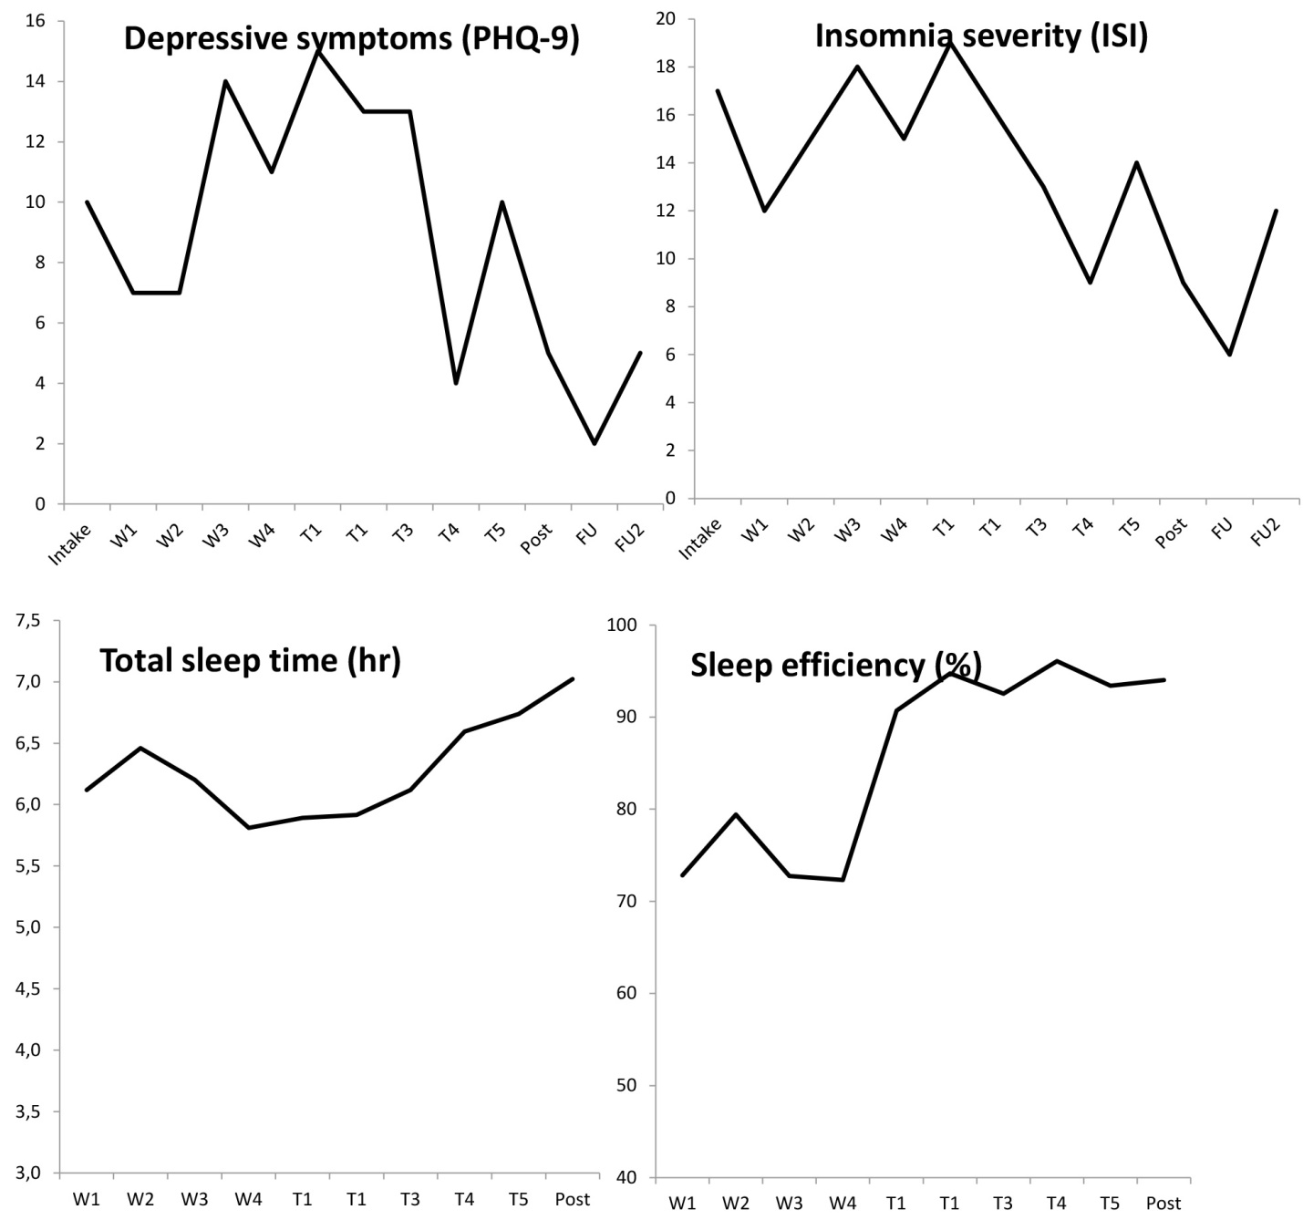
Supplemental Figure – Time in bed (dotted line) and prescribed time in bed for SRT 14

SRT 15
SRT 15 was a 60-year-old man with high education. SRT 15 was between jobs, living together with his partner. His children no longer lived at home. He had suffered from insomnia for 14 years. This participant had a history of unipolar depressive episodes and between the end of treatment and first follow-up had a daughter with psychiatric problems admitted to a psychiatric hospital. Additionally his father passed away around the time of the first follow-up. From his sleep diary, we observed a significant difference between the end of the wait-period and the end of the treatment phase for ‘sleep efficiency’, b = 22.17, SE = 7.32, p = .01, ‘total wake time’, b = -108.7, SE = 26.69, p = .002, and ‘total sleep time’, b = 1.29, SE = 0.38, p = .004. On the actigraph, SRT 15 had a sleep efficiency of 83.8%, a total sleep time of 6h 32min, and a total wake time of 76min during the wait-period. In the last week (post-test) SRT 15 had the following scores: SE = 78.1%, TST = 5h 34min, TWT = 94min.

Clinical improvement
Relative to the end of the wait-period, SRT 15 showed a clinically reliable change on the PHQ-9 (50% decrease) and the ISI (≥ 8), but only at three-month follow-up assessment.

 |  | Start wait | End wait | Post | 3-month FU | 6-month  FU
SRT 15 | PHQ-9 | 13 | 12 | 8 | 5 | 8
 | PHQ-WS | 10 | 10 | 6 | 4 | 6
 | BDI-II | 21 | 19 | 18 | 14 | 14
 | ISI | 25 | 19 | 18 | 14 | 18
 | SE_sub | 51.6% | 59.8% | 79.5% | n.a. | n.a.
 | TST_sub | 4h 01min | 4h 53min | 5h45 | n.a. | n.a.
 | TWT_sub | 228min | 197min | 92min | n.a. | n.a.
PHQ-9 = Patient Health Questionnaire; PHQ-WS = PHQ-9 without sleep item; BDI-II = Beck Depression Inventory II; ISI = Insomnia Severity Index; SE_sub = sleep efficiency based on diary; TST_sub = total sleep time based on diary; TWT_sub = total wake time based on diary.

Supplemental Figure – changes over time for SRT 15

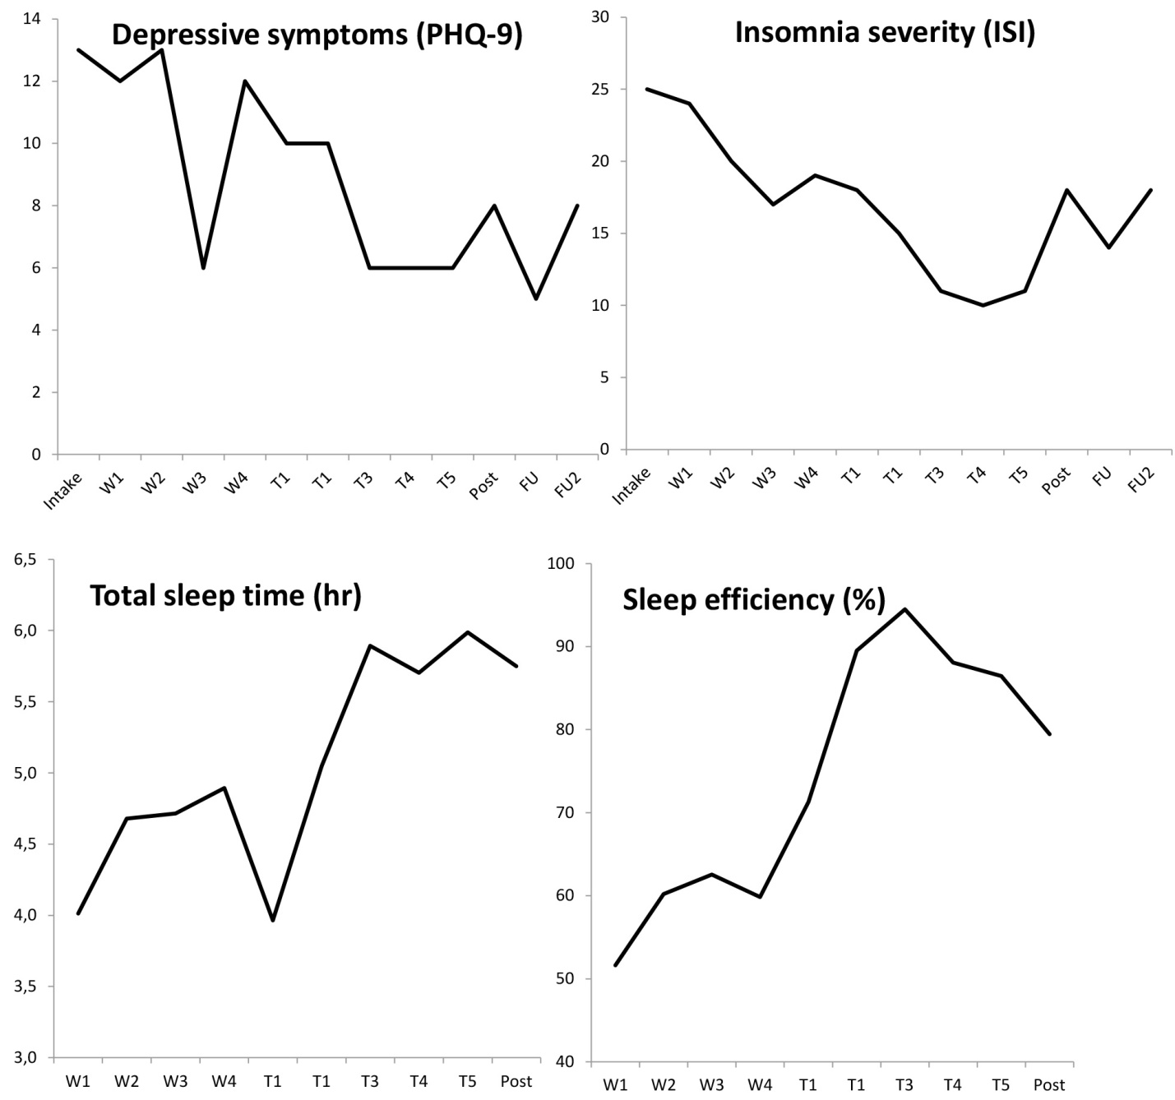

Supplemental Figure – Time in bed (dotted line) and prescribed time in bed for SRT 15

SRT 19
SRT 19 was a 29-year-old woman who had completed higher education. SRT 19 was employed and lived together with housemates, and had no children. She had suffered from insomnia for 3-4 years. Because of the required discontinuation of melatonin, the wait period of this patient started a week after face-to-face intake. From her sleep diary, we observed a significant difference between the end of the wait-period and the end of the treatment phase for ‘sleep efficiency’, b = 32.22, SE = 4.12, p < .001, ‘total wake time’, b = -155.3, SE = 21.43, p < .001, and ‘total sleep time’, b = 1.30, SE = 0.46, p = .008. Due to a clerical error the actigraph was not send out to this individual during the wait period. Furthermore, the last actigraph only recorded four days. We therefore decided not to report on her actigraphy data.

Clinical improvement
Relative to the end of the wait-period, SRT 19 showed clinically reliable change on the PHQ-9 (50% decrease), but only at the three-month follow-up assessment. For the ISI she had a clinical reliable change (≥ 8) at all assessment occasions.

 |  | Start wait | End wait | Post | 3-month FU | 6-month  FU
SRT 19 | PHQ-9 | 13 | 14 | 10 | 7 | 8
 | PHQ-WS | 10 | 11 | 9 | 6 | 6
 | BDI-II | 17 | 17 | 11 | 7 | 9
 | ISI | 19 | 21 | 10 | 9 | 9
 | SE_sub | 81.5% | 71.6% | 96.6% | n.a. | n.a.
 | TST_sub | 6h 42min | 5h 23min | 6h31min | n.a. | n.a.
 | TWT_sub | 91min | 126min | 14min | n.a. | n.a.
PHQ-9 = Patient Health Questionnaire; PHQ-WS = PHQ-9 without sleep item; BDI-II = Beck Depression Inventory II; ISI = Insomnia Severity Index; SE_sub = sleep efficiency based on diary; TST_sub = total sleep time based on diary; TWT_sub = total wake time based on diary

Supplemental Figure – changes over time for SRT 19

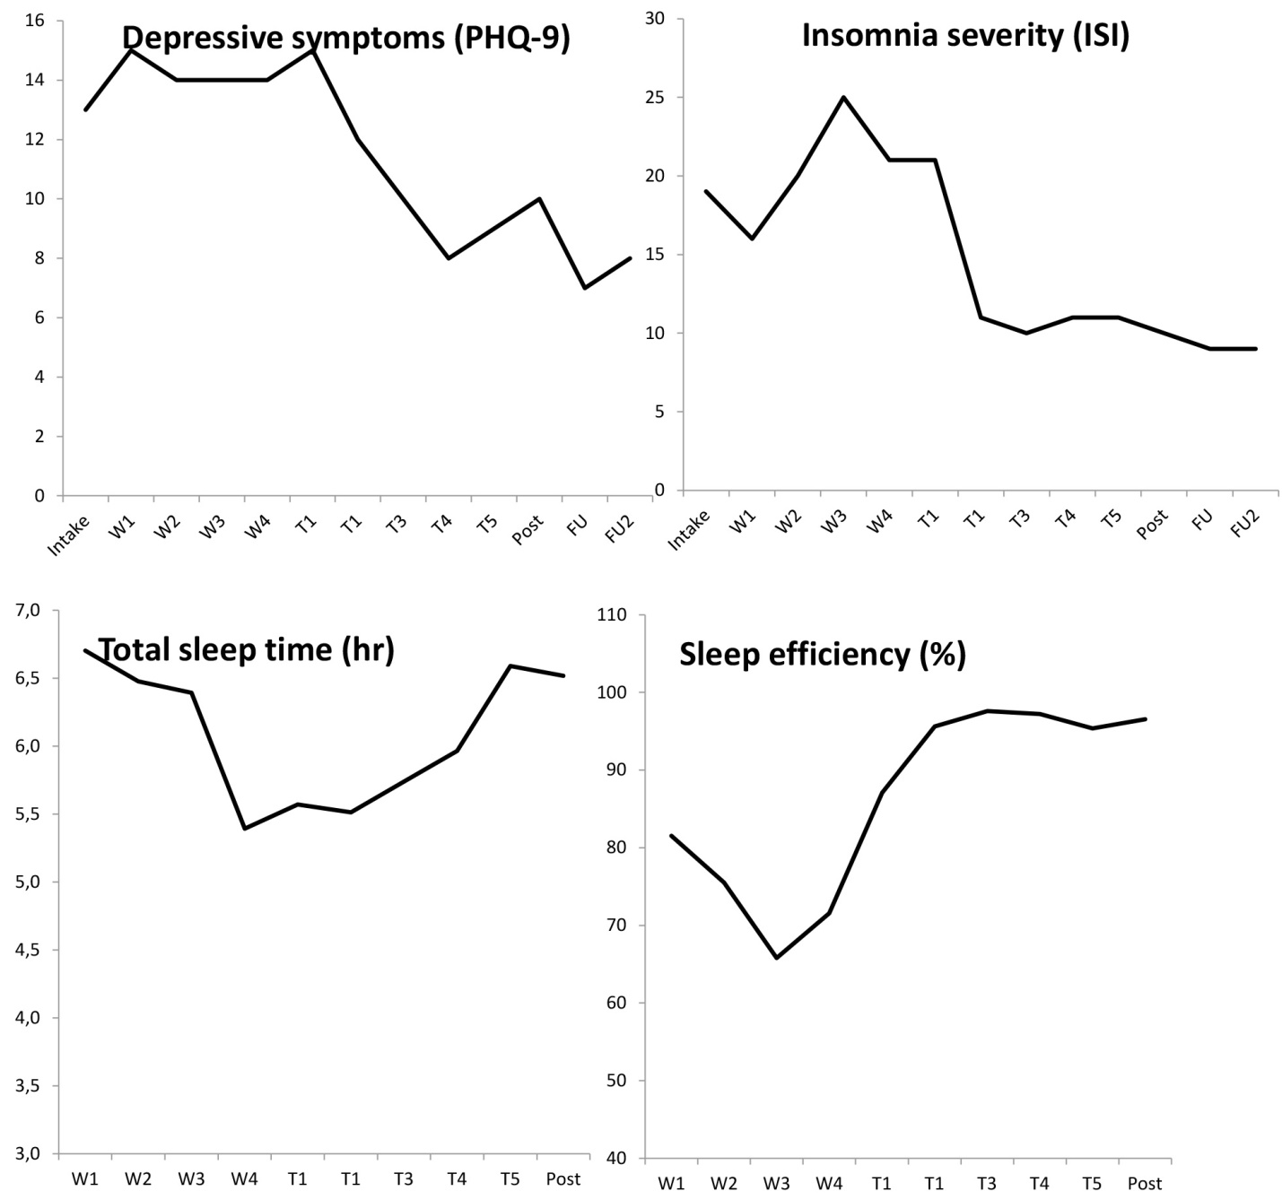
Supplemental Figure – Time in bed (dotted line) and prescribed time in bed for SRT 19

SRT 21
SRT 21 was a 44-year-old male who had completed medium level education. SRT 21 was employed and lived together with his partner and three children. He had suffered from insomnia for five years. During the start of the treatment he was in a labor dispute that resulted in him terminating the job around session 5-6. From his sleep diary, we observed a significant difference between the end of the wait-period and the end of the treatment phase for ‘sleep efficiency’, b = 13.16, SE = 4.98, p = .014, ‘total wake time’, b = -62.95, SE = 21.29, p = .007, but not for ‘total sleep time’, b = -1.23, SE = 0.42, p = .772. On the actigraph, SRT 21 had a sleep efficiency of 81.9%, a total sleep time of 6h 18min, and a total wake time of 83min during the wait-period. In the last week (post-test) SRT 21 had the following scores: SE = 88.9%, TST = 5h 34min, TWT = 41min.
It proved very hard to collect the six-month follow-up assessment of SRT 21. Ultimately, he only completed the questionnaire but was not available for follow-up assessment by phone. As it turned out, his mother and uncle (who had no other family left) were in the hospital at that time. Furthermore, SRT 21 had just landed a new job which involved alternating shifts between morning and afternoon. According to his report, the assessment would have been completely different if it had occurred before these life events. SRT 21 was confident that if the stress would settle down that his sleep would improve again. This of course remains an empirical question but it is tempting to believe that his current scores are a conservative estimate of potential improvement without these life events.

Clinical improvement
Relative to the end of the wait-period, SRT 21 showed clinically reliable change on the PHQ-9 (50% decrease), but only at three-month follow-up assessment. For the ISI he showed clinically reliable change (≥ 8) at both the time of the post-test and the three-month follow-up assessment.

 |  | Start wait | End wait | Post | 3-month FU | 6-month  FU
SRT 21 | PHQ-9 | 16 | 13 | 10 | 3 | 8
 | PHQ-WS | 13 | 10 | 9 | 3 | 6
 | BDI-II | 17 | 20 | 15 | 10 | 12
 | ISI | 19 | 21 | 11 | 3 | 15
 | SE_sub | 65.9% | 74.1% | 88.9% | n.a. | n.a.
 | TST_sub | 5h 09min | 5h 38 | 5h 40min | n.a. | n.a.
 | TWT_sub | 91min | 114min | 43min | n.a. | n.a.
PHQ-9 = Patient Health Questionnaire; PHQ-WS = PHQ-9 without sleep item; BDI-II = Beck Depression Inventory II; ISI = Insomnia Severity Index; SE_sub = sleep efficiency based on diary; TST_sub = total sleep time based on diary; TWT_sub = total wake time based on diary.

Supplemental Figure – changes over time for SRT 21

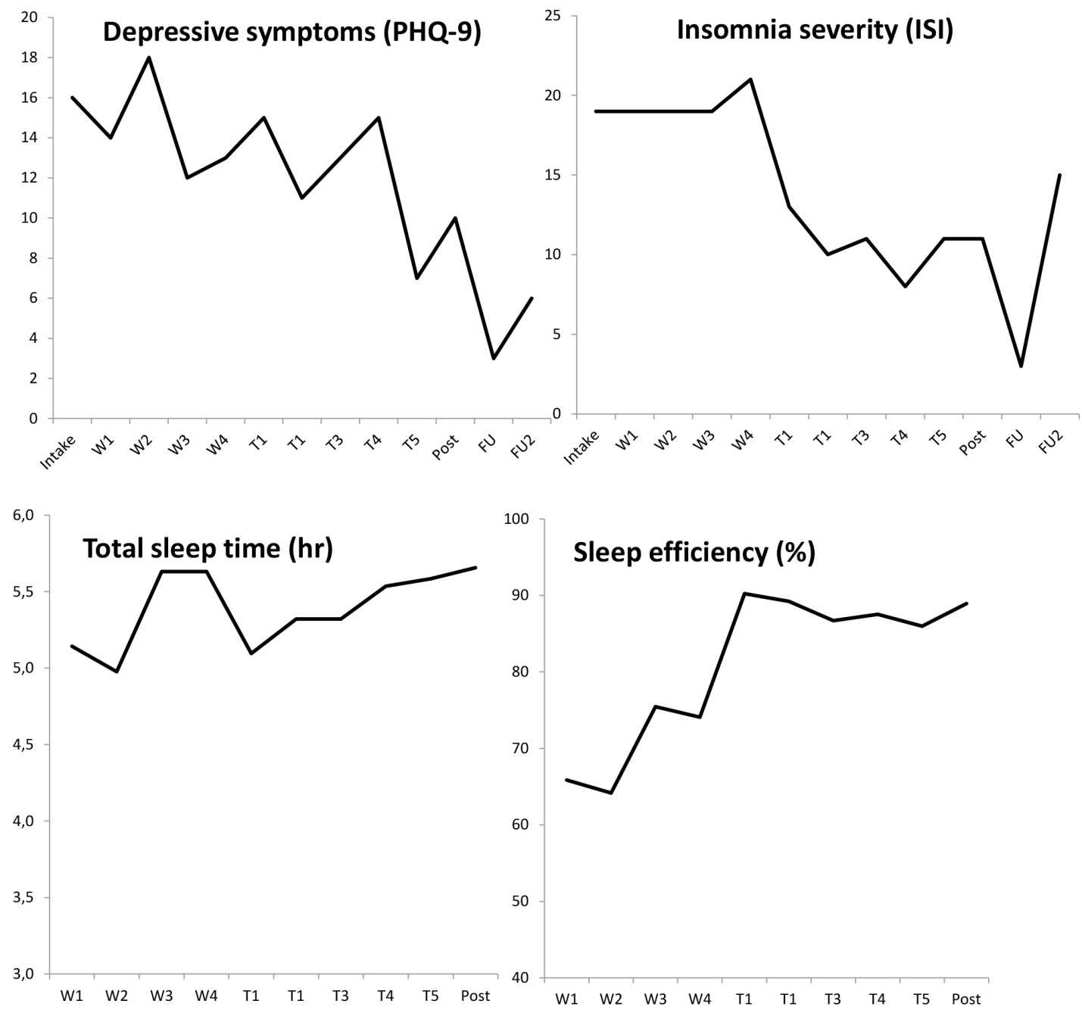
Supplemental Figure – Time in bed (dotted line) and prescribed time in bed for SRT 21

SRT 25
SRT 25 was a 28-year-old man who had completed high education. SRT 25 was employed and lived alone and had no children. He suffered from insomnia ‘as long as he could remember’. During treatment it became clear that he did not adequately follow the sleep-diary instructions. Therefore the sleep diary data were not admissible from him. Since his sleep diary was not admissible we could not impute his bed- and rising times for the actigraph data. Moreover, SRT 25 appears to have taken off the actigraph a number of times.

Clinical improvement
Relative to the end of the wait-period, SRT 25 showed a clinically reliable change on the PHQ-9 (50% decrease) and the ISI (≥ 8) on all assessment occasions.

 |  | Start wait | End wait | Post | 3-month FU | 6-month  FU
SRT 25 | PHQ-9 | 11 | 12 | 0 | 4 | 3
 | PHQ-WS | 9 | 9 | 0 | 4 | 2
 | BDI-II | 19 | 25 | 5 | 2 | 4
 | ISI | 22 | 19 | 1 | 5 | 7
 | SE_sub | n.a. | n.a. | n.a. | n.a. | n.a.
 | TST_sub | n.a. | n.a. | n.a. | n.a. | n.a.
 | TWT_sub | n.a. | n.a. | n.a. | n.a. | n.a.
PHQ-9 = Patient Health Questionnaire; PHQ-WS = PHQ-9 without sleep item; BDI-II = Beck Depression Inventory II; ISI = Insomnia Severity Index; SE_sub = sleep efficiency based on diary; TST_sub = total sleep time based on diary; TWT_sub = total wake time based on diary

Figure – changes over time for SRT 25

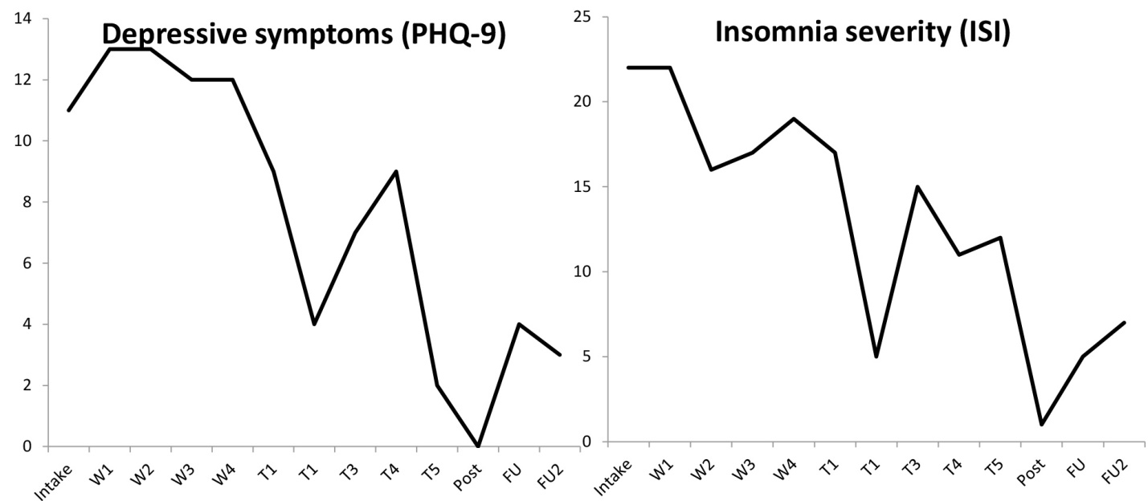
SRT 37
SRT 37 was a 36 years old woman who had completed medium level education. SRT 37 was employed and lived alone and had no children. She had suffered from insomnia for 10 years. From her sleep diary we observed a significant difference between the end of the wait-period and the end of the treatment phase for ‘sleep efficiency’, b = 21.93, SE = 4.12, p = .001, ‘total wake time’, b = -129.1, SE = 30.64, p < .001, but not for ‘total sleep time’, b = -0.39, SE = 0.57, p = .50. On the Actigraph, SRT 37 had a sleep efficiency of 90.3%, a total sleep time of 7h 20min, and a total wake time of 48min during the wait-period. In the last week (post-test) SRT 37 had the following scores: SE = 92.4%, TST = 5h 7min, TWT = 25min.

Clinical improvement
Relative to the end of the wait-period, SRT 37 showed a clinically reliable change on the PHQ-9 (50% decrease), but only at three-month follow-up assessment. For the ISI she showed a clinically reliable change (≥ 8) on the post-test and the three-month follow-up assessment.

 |  | Start wait | End wait | Post | 3-month FU | 6-month  FU
SRT 37 | PHQ-9 | 10 | 13 | 11 | 4 | 8
 | PHQ-WS | 7 | 10 | 9 | 3 | 5
 | BDI-II | 19 | 18 | 18 | 9 | 17
 | ISI | 22 | 18 | 10 | 9 | 17
 | SE_sub | 51.1% | 61.2% | 85.9% | n.a. | n.a.
 | TST_sub | 4h 30min | 5h 6min | 4h 45min | n.a. | n.a.
 | TWT_sub | 250min | 195min | 47min | n.a. | n.a.
PHQ-9 = Patient Health Questionnaire; PHQ-WS = PHQ-9 without sleep item; BDI-II = Beck Depression Inventory II; ISI = Insomnia Severity Index; SE_sub = sleep efficiency based on diary; TST_sub = total sleep time based on diary; TWT_sub = total wake time based on diary.

Supplemental Figure – changes over time for SRT 37
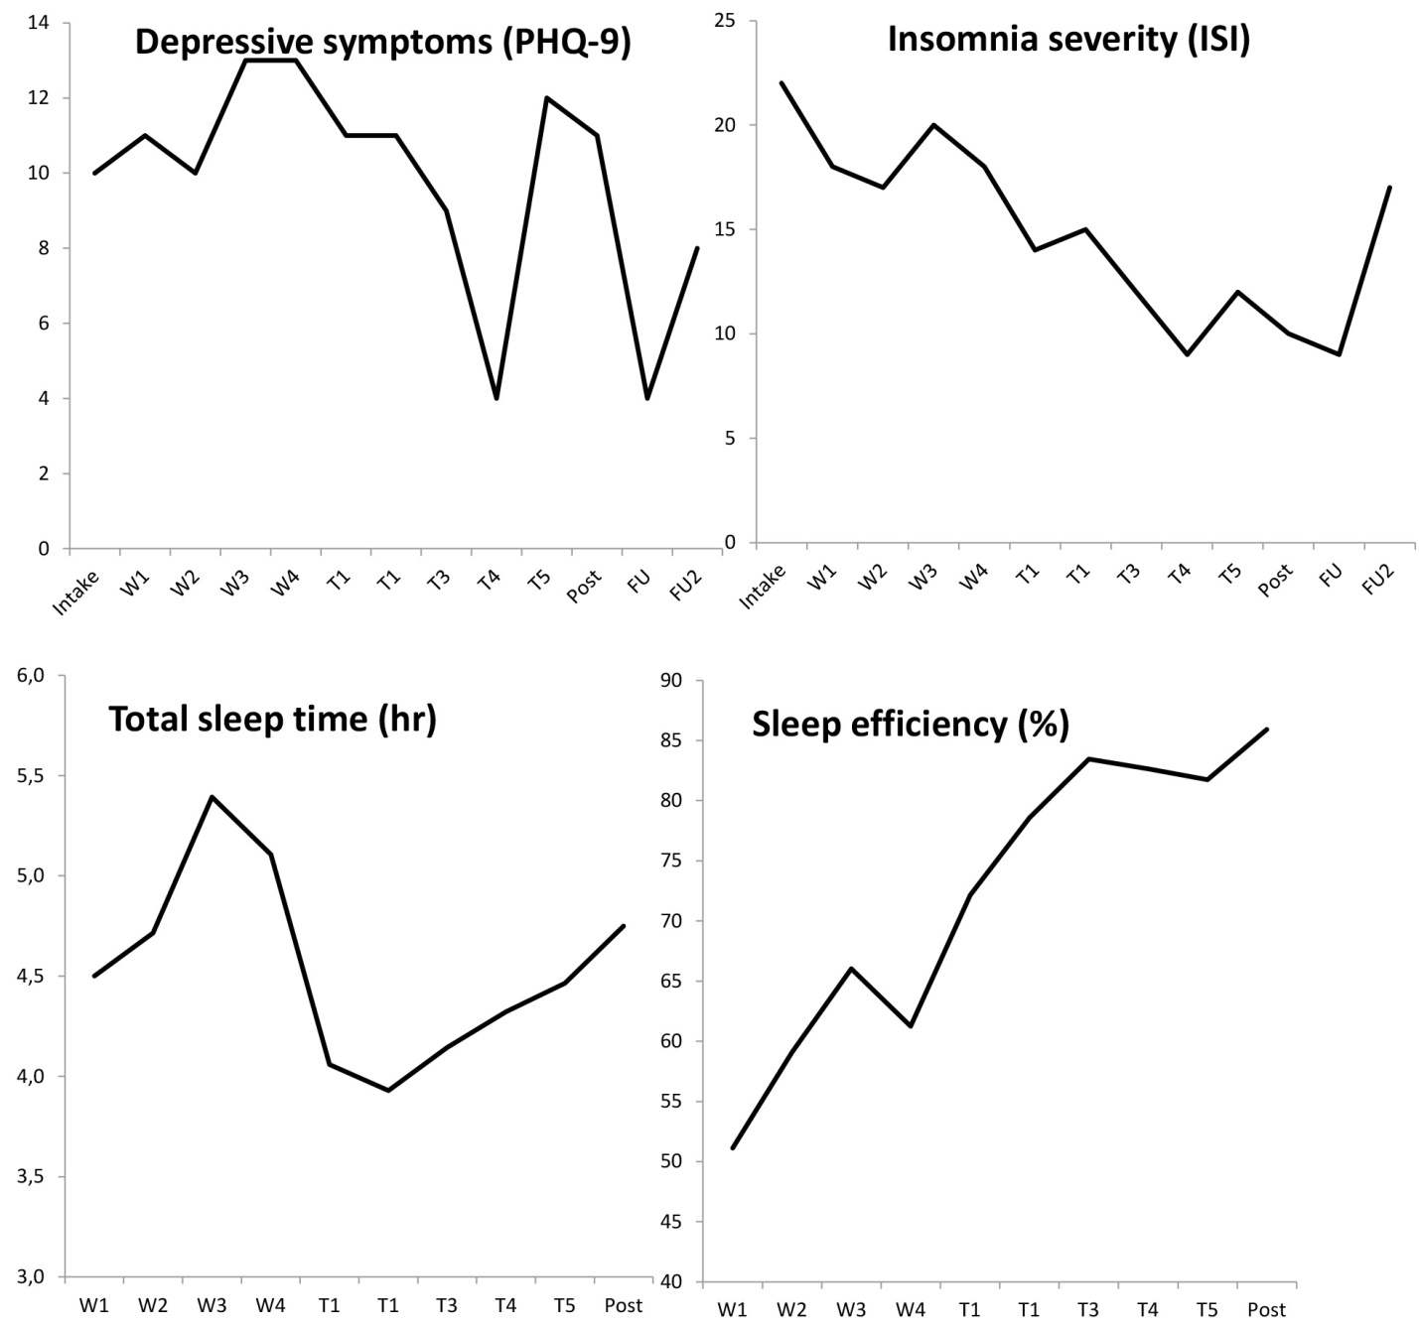

Supplemental Figure – Time in bed (dotted line) and prescribed time in bed for SRT 37

References
Bastien, C. H., Vallières, A., & Morin, C. M. (2001). Validation of the Insomnia Severity Index as an outcome measure for insomnia research. Sleep Medicine, 2, 297-307. doi:10.1016/S1389-9457(00)00065-4
Carney, C. E., Buysse, D. J., Ancoli-Israel, S., Edinger, J. D., Krystal, A. D., Lichstein, K. L., & Morin, C. M. (2012). The consensus sleep diary: standardizing prospective sleep self-monitoring. Sleep, 35(2), 287-302. doi:10.5665/sleep.1642
First, M. B., Spitzer, R. L., Gibbon, M., & Williams, J. B. W. (2002). Structured clinical interview for DSM-IV axis I disorders, clinician version (SCID-CV). New York: Biometrics Research, New York State Psychiatric Institute.
Hedges, L. V. (1981). Distribution theory for glass's estimator of effect size and related estimators. Journal of Educational Statistics, 6(2), 107-128. doi: 10.2307/1164588
Kyle, S. D., Aquino, M. R., Miller, C. B., Henry, A. L., Crawford, M. R., Espie, C. A., & Spielman, A. J. (2015). Towards standardisation and improved understanding of sleep restriction therapy for insomnia disorder: A systematic examination of CBT-I trial content. Sleep Medicine Reviews, 23, 83-88. doi:10.1016/j.smrv.2015.02.003
Maric, M., de Haan, E., Hogendoorn, S. M., Wolters, L. H., & Huizenga, H. M. (2015). Evaluating statistical and clinical significance of intervention effects in single-case experimental designs: An SPSS method to analyze univariate data. Behavior Therapy, 46(2), 230-241. doi:10.1016/j.beth.2014.09.005
Morin, C. M., Belleville, G., Belanger, L., & Ivers, H. (2011). The Insomnia Severity Index: psychometric indicators to detect insomnia cases and evaluate treatment response. Sleep, 34(5), 601-608.
Spielman, A. J., Saskin, P., & Thorpy, M. J. (1987). Treatment of chronic insomnia by restriction of time in bed. Sleep, 10(1), 45-56.
Spitzer, R. L., Kroenke, K., & Williams, J. B. (1999). Validation and utility of a self-report version of PRIME-MD: The PHQ primary care study. Primary Care Evaluation of Mental Disorders. Patient Health Questionnaire. Journal of the American Medical Association, 282(18), 1737-1744.
Van der Does, A. J. W. (2002). De Nederlandse versie van de Beck Depression Inventory - 2nd edition [Dutch version of the Beck Depression Inventory 2nd edition]. Lisse: Harcourt Test Publishers.

Please note that we recruited via Facebook and people were also filling in the ISI to see whether or not they had insomnia complaints. This may have led to a relatively large volume of people in this first stage.

