Supplementary materials:

1. Instruction letter

Dear participant,

First let me thank you for taking part in this research study. This study investigates how effective self-help books can be for tackling feelings such as:

• Low mood
• Unhappiness
• Sadness
• Depression

This pack contains your self-help book and an instruction leaflet called "Feeling worse, not better" - please refer to this leaflet for instructions on what to do should any feelings of sadness or depression worsen.

Each week you will receive an email outlining which of the chapters in the self-help book you should read - you are scheduled to receive the first of these emails on DATE. You will receive 8 of these emails in total and be asked to read 8 chapters of the self-help book over an 8 week period.

After this time, you will receive another email that will ask you to fill out a follow-up questionnaire - this questionnaire will assess if the self-help book has improved your mood, level of happiness etc. A further follow-up email will also be sent 1 month after the intervention period is over. This questionnaire will measure whether longer term improvements have been made to mood as a result of reading the self-help book. Participants who complete all of these questionnaires will be sent a £10 high street shopping voucher.

If you have any questions regarding the study or would like further information, please email me on the address provided below.

Many thanks

XXXXXXXXX
XXXXXXXXX
XXXXXXXXX
XXXXXXXXX

2. ‘Feeling worse not better’ leaflet

Feeling worse, not better?

If you are in crisis, despairing or suicidal, contacting one of the agencies below can make all the difference:

Your own GP or the Accident and Emergency department at your local hospital

The Samaritans (24 hours)
Telephone 0845 7 90 90 90 or Email: jo@samaritans.org

NHS Direct for England and Wales (24 hours)
Telephone 0845 4647

Breathing Space
6pm - 2am (Monday to Thursday)
6pm - 6am at weekends (Friday, Saturday, Sunday)
Telephone 0800 83 85 87

Lifeline Charity
Telephone: 0808 808 8000

3. Weekly emails

PP Group:

Week 1
First let me thank you for taking part in this research study. You should now have received your self-help book (if you have not yet received your self-help book please email me at XXXXXXXXX).

Each week you will receive an email to let you know which chapter we would like you to read that week. As you will notice there are more than eight chapters in the book, we will ask you to read eight of the content chapters (i.e. those that contain exercises designed specifically to help you start to tackle your low mood and negative feelings) but please feel free to read the other chapters (these are more theoretical but may also be beneficial).

This week we would like you to read chapter 3 – Positive Emotions: The upward spiral to well-being. This chapter outlines the role emotions play in how we think and feel and why positive emotions can help us cope in stressful or depressing time. This chapter contains an exercise called the "playlist" which is designed to help you build more positive emotions into your day and help you overcome feelings of sadness, unhappiness or depression. Please read this chapter and complete the exercise outlined on page 51.

If you have any questions please feel free to get in touch.

Best Wishes

XXXXXXXXX
XXXXXXXXX
XXXXXXXXX
XXXXXXXXX

note: If at any point you begin to feel worse, or are worried please see the “Feeling Worse, Not Better” instructions which can be found on a separate sheet within your self-help book (if you lose these or cannot find them please contact me at XXXXXXXXX for a further copy).

Week 2
First let me thank you for taking part in this research study. You should now have read though one chapter of the book and completed the exercises in that chapter. I hope you have found this beneficial so far.

This week we would like you to read chapter 4 – Savouring the Moment. This chapter outlines how when we are feeling low we often fail to notice the good in our lives. Savouring is the opposite of this; it is noticing and appreciating the good things in our lives even if they are relatively small or minor. By doing so, we can build the positive emotions we feel and reduce the negative. This chapter contains an exercise called the "savouring schedule" which is designed to help you build more positive emotions into your day and help you overcome feelings of sadness, unhappiness or depression. Please read this chapter and complete the exercises described.

If you have any questions please feel free to get in touch.

Best Wishes

XXXXXXXXX
XXXXXXXXX
XXXXXXXXX
XXXXXXXXX

note: If at any point you begin to feel worse, or are worried please see the “Feeling Worse, Not Better” instructions which can be found on a separate sheet within your self-help book (if you lose these or cannot find them please contact me at XXXXXXXXX
for a further copy).

4. MANOVA Assumptions

Univariate outliers:

Boxplots identified a number of univariate outliers in the data set for BDI, PA, NA, PWB – Autonomy, PWB – Environmental Mastery, PWB - Purpose in Life and PWB- Self-Acceptance. See tables 1-7. No outliers were found for SWL, SHS, PWB Personal Growth, & PWB Positive Relations.

Table 1: Boxplot analysis for BDI scores at Baseline, Post-Test & Follow-Up

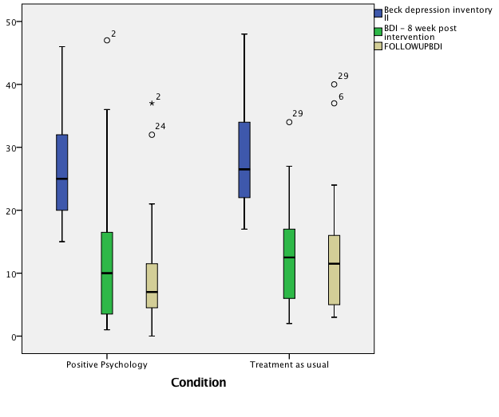
Table 2: Boxplot analysis for PA scores at Baseline, Post-Test & Follow-Up

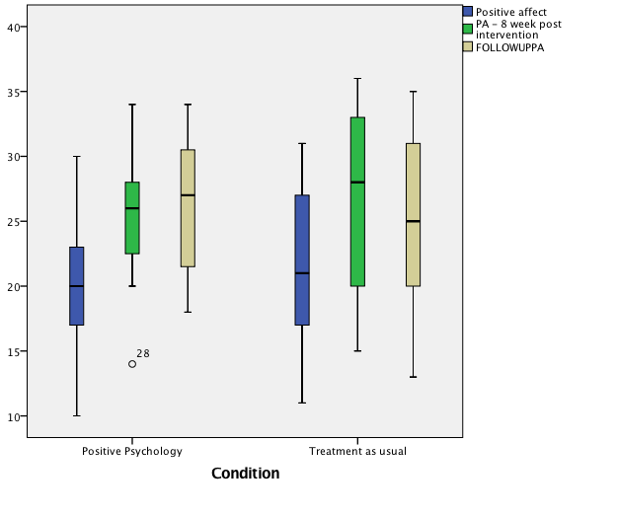

Table 3: Boxplot analysis for NA scores at Baseline, Post-Test & Follow-Up

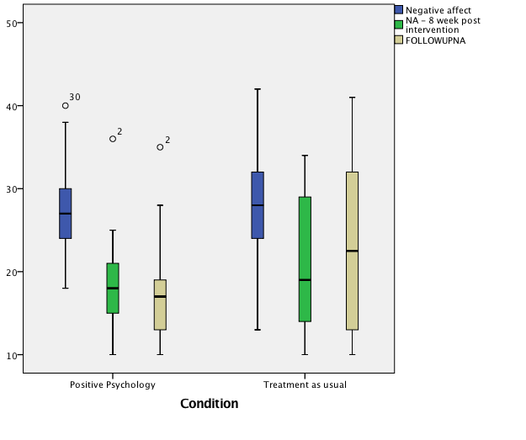
Table 4: Boxplot analysis for PWB Autonomy scores at Baseline, Post-Test & Follow-Up

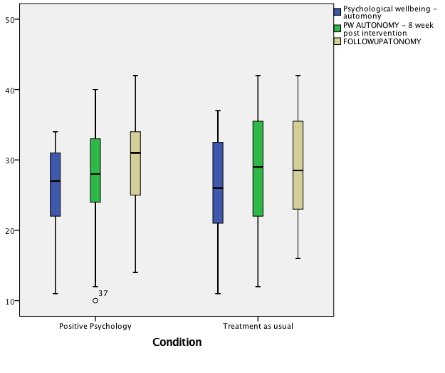

Table 5: Boxplot analysis for PWB Environmental Mastery scores at Baseline, Post-Test & Follow-Up

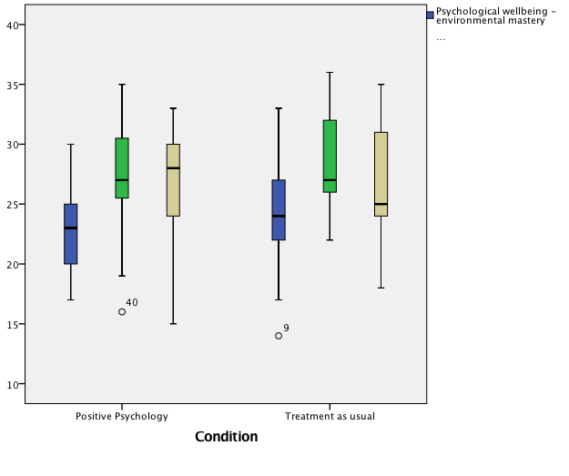

Table 6: Boxplot analysis for PWB Purpose in Life scores at Baseline, Post-Test & Follow-Up

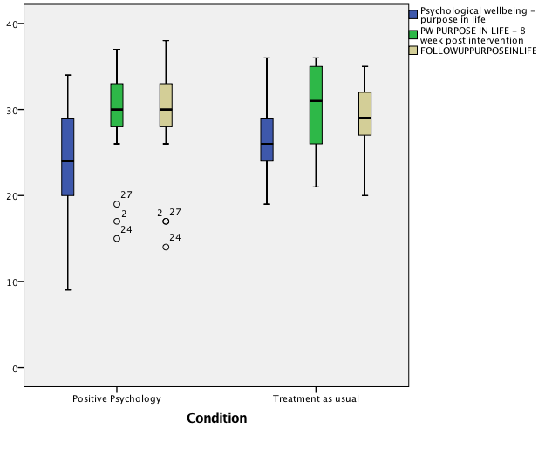

Table 7: Boxplot analysis for PWB Self-Acceptance scores at Baseline, Post-Test & Follow-Up

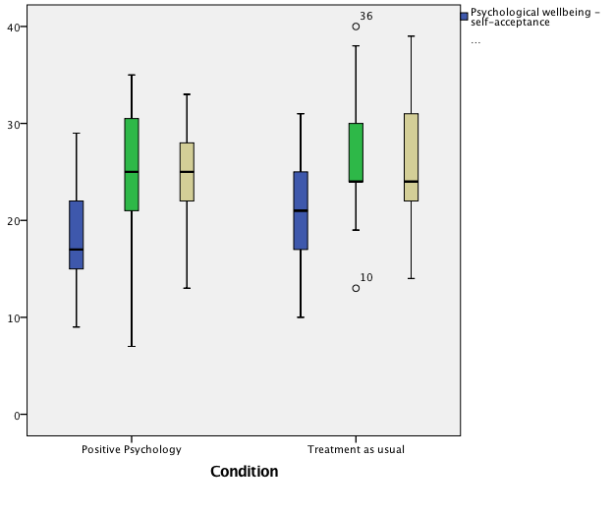
The baseline MANOVA was run with and without the outliers to establish their impact upon the results. Both tests found no significant differences between the two groups at baseline (p < 0.05 in both cases) in terms of their depression and well-being scores.

As a result of the above findings, the decision was taken not to remove or transform the outliers identified in the boxplots.

Multivariate outliers:

There were no multivariate outliers in the data, as assessed by Mahalanobis distance (all values under the critical value of 31.26).

Normality:

Depression and well-being scores were predominantly normally distributed with skewness (SE) and kurtosis (SE) reported in Table 8. However, at post-test the PP group violated kurtosis for BDI (Z score = -2.74) and at follow-up the PP group violated skewness for BDI (Z score = -3.01). However, as ANOVA’s are considered to be robust to violations, especially in relation to normality when the sample size is equal (Howell, 2012) the decision was taken not to transform the data.

Table 8: Skewness and Kurtosis Test Results for each Dependant Variable (Depression and Well-being scores) by each level of the Independent Variable (PP group vs. CBT group)

Measure Group Time Skewness (SE) Kurtosis (SE)
BDI PP Baseline 0.773 (0.512) -0.144 (0.992)
CBT 1.287 (0.564) 1.491 (1.091)
PP Post-Test 1.330 (0.550) 2.909 (1.063)
CBT 0.222 (0.616) -1.223 (1.191)
PP Follow-Up 1.656 (0.550) 2.225 (1.063)
CBT 1.149 (0.564) 0.842 (1.091)
SHS PP Baseline 0.424 (0.512) 0.797 (0.992) CBT -0.507 (0.564) -0.267 (1.091)
PP Post-Test 0.419 (0.550) -0.954 (1.063)
CBT 0.574 (0.616) -0.409 (1.191)
PP Follow-Up 0.316 (0.550) -0.313 (1.063)
CBT -0.376 (0.564) -0.403 (1.091)
SWL PP Baseline -0.082 (0.564) -0.908 (0.512) CBT -0.082 (0.564) -0.133 (1.091)
PP Post-Test -0.934 (0.550) 0.241 (1.063)
CBT -0.434 (0.616) -0.827 (1.191)
PP Follow-Up -0.419 (0.550) -0.228 (1.063)
CBT -0.575 (0.564) -0.448 (1.091)
PA PP Baseline 0.314 (0.512) 0.151 (0.992)
CBT -0.276 (0.564) -1.083 (1.091) PP Post-Test 0.295 (0.550) 1.044 (1.063) CBT -0.569 (0.616) -0.571 (1.191 PP Follow-Up 0.086 (0.550) -1.337 (1.063 CBT -0.104 (0.564) -0.923 (1.091)
Table 8: Skewness and Kurtosis Test Results for each Dependant Variable (Depression and Well-being scores) by each level of the Independent Variable (PP group vs. CBT group)

Measure Group Time Skewness (SE) Kurtosis (SE)
NA PP Baseline 0.722 (0.512) 0.466 (0.992)
CBT 0.124 (0.564) -0.112 (1.091)
PP Post-Test -0.288 (0.550) -0.749 (1.063)
CBT 0.700 (0.616) -0.980 (1.191)
PP Follow-Up 1.215 (0.550) 1.525 (1.063)
CBT 0.501 (0.564) -0.879 (1.091)
PWB – Autonomy PP Baseline -0.653 (0.512) -0.583 (0.992)
CBT -0.260 (0.564) -0.237 (1.091)
PP Post-Test -0.729 (0.550) 0.544 (1.063)
CBT -0.664 (0.616) -0.024 (1.191)
PP Follow-Up -0.556 (0.550) -0.445 (1.063)
CBT -0.003 (0.564) -0.384 (1.091)
PWB – Environmental Mastery PP Baseline -0.012 (0.512) -0.402 (0.992) CBT -0.051 (0.564) -0.083 (1.091)
PP Post-Test -1.024 (0.550) 2.667 (1.063)
CBT 0.308 (0.616) -0.582 (1.191)
PP Follow-Up -0.939 (0.550) 1.027 (1.063)
CBT 0.051 (0.564) -1.006 (1.091)
PWB Personal Growth PP Baseline -0.740 (0.512) -0.162 (0.992) CBT -0.780 (0.564) 0.294 (1.091) PP Post-Test -0.397 (0.550) -0.984 (1.063) CBT 0.149 (0.616) -1.487 (1.191) PP Follow-Up -0.764 (0.550) 1.329 (1.063) CBT -0.622 (0.564) -0.903 (1.091)
Table 8: Skewness and Kurtosis Test Results for each Dependant Variable (Depression and Well-being scores) by each level of the Independent Variable (PP group vs. CBT group)

Measure Group Time Skewness (SE) Kurtosis (SE)
PWB Positive Relations PP Baseline 0.189 (0.512) -0.970 (0.992)
CBT 0.179 (0.564) 0.438 (1.091)
PP Post-Test 0.583 (0.550) -0.434 (1.063)
CBT 0.528 (0.616) -0.803 (1.191)
PP Follow-Up -0.190 (0.550) -0.435 (1.063)
CBT -0.447 (0.564) -1.141 (1.091)
PWB - Purpose in Life PP Baseline -0.464 (0.512) -0.521 (0.992) CBT 0.275 (0.564) -0.587 (1.091)
PP Post-Test -1.242 (0.550) 1.760 (1.063)
CBT 0.091 (0.616) -1.576 (1.191) PP Follow-Up -0.936 (0.550) 0.147 (1.063)
CBT -0.527 (0.564) 0.229 (1.091)
PWB- Self-Acceptance PP Baseline 0.433 (0.512) -0.786 (0.992)
CBT -0.168 (0.564) -0.446 (1.091)
PP Post-Test -0.266 (0.550) -1.016 (1.063)
CBT 1.407 (0.616) 1.447 (1.191)
PP Follow-Up -0.581 (0.550) -0.343 (1.063)
CBT -0.246 (0.564) -0.476 (1.091)

Multicollinearity:

There was no evidence of multicollinearity, as assessed by Pearson correlation (r > 0.09 in all cases).

Sample size:

The study has x10 dependent variables (depression and well-being measures) and x2 levels of the independent variable (PP vs. CBT). To conduct a MANOVA more than x10 participants are required in each group. This assumption is met.

Homogeneity of Variance-Covariance Matrices:

There was homogeneity of variance-covariances matrices, as assessed by Box's test of equality of covariance matrices (p > 0.05).

Homogeneity of Variances:

There was homogeneity of variances, as assessed by Levene's test of homogeneity of variance (p > .05 in all cases).

5. Mixed Between Within ANOVA Assumptions

Outliers:

Boxplots identified a number of univariate outliers in the data set for BDI, PA, NA, PWB – Autonomy, PWB – Environmental Mastery, PWB - Purpose in Life and PWB- Self-Acceptance. (See tables 1-7 above). No outliers were found for SWL, SHS, PWB Personal Growth, & PWB Positive Relations.

A series of mixed between within ANOVA’s were run with and without outliers to establish their impact upon the results. For BDI, PA, NA, PWB – Autonomy, PWB – Environmental Mastery, PWB - Purpose in Life and PWB- Self-Acceptance no differences were found when outliers were removed e.g there was still a main effect for time (p < 0.01) but not for condition (p > 0.05) and the interaction still remain non-significant (p > 0.05).

As a result of the above findings, the decision was taken not to remove or transform the outliers identified in the boxplots.

Normality:

Depression and well-being scores were predominantly normally distributed with skewness (SE) and kurtosis (SE) reported in Table 8 (see above). However, at post-test the PP group violated kurtosis for BDI (Z score = -2.74) and at follow-up the PP group violated skewness for BDI (Z score = -3.01). However, as ANOVA’s are considered to be robust to violations, especially in relation to normality when the sample size is equal (Howell, 2012) the decision was taken not to transform the data.

Homogeneity of Variances:

There was homogeneity of variances, as assessed by Levene's test of homogeneity of variance (p > .05 in all cases).

Homogeneity of Covariances:

There was homogeneity of covariances, as assessed by Box's test of equality of covariance matrices (p > 0.05 in all cases).

References:

Howell, D. C. (2012). Statistical methods for psychology. Belmont, CA. Cengage Learning.

