Supplementary material:

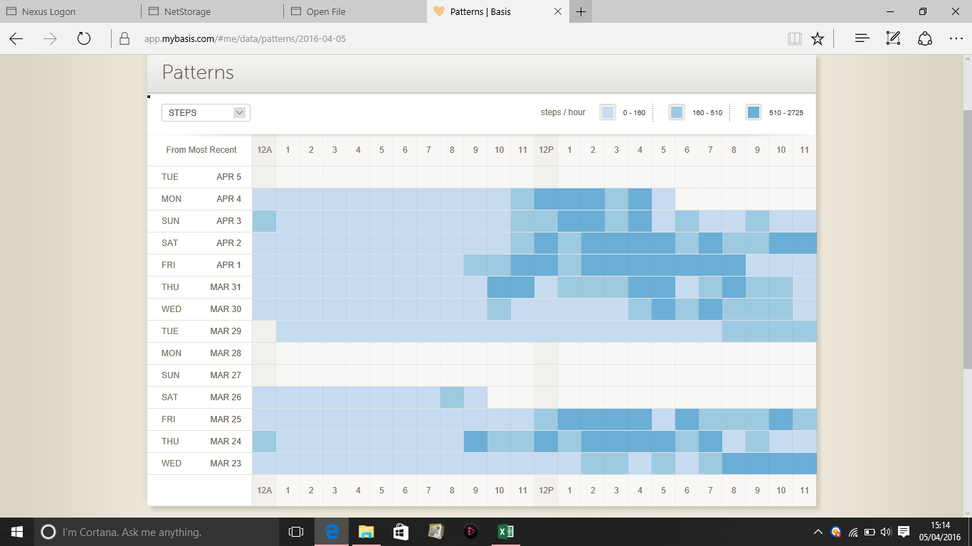
Darker colours represent increased activity.
Figure 1. Basis Peak watch output of step count for assessment of circadian rhythms.

