Therapist Characteristics and their Effect on Training Outcomes: What Counts?

Running Head: Therapist Characteristics and Training

Amanda Branson* PhD. and Roz Shafran PhD.
School of Psychology and CLS, University of Reading, Berkshire, United Kingdom.

*Corresponding Author
Address: School of Psychology and CLS, University of Reading, Earley Gate, Reading, Berkshire, RG14 6AL. Tel: +44 118 378 7531.
email address: a.branson@reading.ac.uk

This study was supported by the 2010 Research Grant from the British Association for Behavioural and Cognitive Psychotherapies (BABCP)
Acknowledgements
We would like to thank the IAPT Psychological Wellbeing Practitionersand High-Intensity therapists who participated in this study. We also thank the editor for helpful suggestions, in particular that restriction of range may account for the null finding.
Abstract
Background:Evidence exists for a relationship between individual characteristics and both job and training performance; however relationships may not be generalizable across occupational spheres. Little is known about the impact of therapist characteristics on performance in postgraduate therapist training programmes.
Aims: The aim of this study was to investigate associations between the grades of students on the Postgraduate Improving Access to Psychological Therapies (IAPT) training programmes and individual characteristics.
Methods: 59 therapists on the ‘High Intensity’ and 81 therapists on the ‘Low Intensity’ course completed measures of cognitive ability and personality, and provided access to clinical and academic grades, and demographic data including: prior academic attainment, age, gender and years of relevant experience.
Results: Prior academic attainment emerged as the only variable to be significantly associated with performance across assessments, and courses. Students achieving higher undergraduate degree classifications performed better clinically and academically than those who performed less well. Age was negatively associated with performance, though correlations were weak. Agreeableness emerged as the only dimension of personality to be associated (positively) with clinical skill, but only in High Intensity trainees. Experience and cognitive ability were unrelated to performance.
Conclusions: Relationships between individual characteristics and training outcomes are complex and are likely to be context specific. These results could have important implications for the selection and development of therapists for training and clinical practice.
Keywords: Training, Outcome, Cognitive Behavioural Therapy, IAPT
- Introduction
  - Background
A primary goal within the field of training and development has been to understand individual characteristics affecting academic and training performance (Herold, Davis, Fedor, & Parsons, 2002). Whilst a great deal of attention has been afforded to the role of trainee characteristics on performance across educational and occupational spheres there remains relatively little research regarding associations between characteristics and the outcomes of training in the field of psychotherapy. This is surprising, particularlyin light of the current interest in therapist training, and focus on factors other than clinical and technical skill thought essential within caring professions, that may not easily be taught (Rush & Cook, 2006).Characteristics of a therapist may exert a greater influence on patient outcome than the specific techniques taught during training (Okiishi, Lambert, Nielsen, & Olgles, 2003).
Evidence has accrued suggesting a strong relationship between cognitive ability and both job and training performance (Bertua, Anderson, & Salgado, 2005; Kuncel, Hezlett, & Ones, 2004), and between academic attainment and job/training performance (Cassidy, 2011; James & Chilvers, 2001; Richardson, Abraham, & Bond, 2012). Further to this body of literature, there is also evidence to suggest that personality can meaningfully be used in the prediction of performance(Dean, Conte, & Blankenhorn, 2006). Three of the Big-Five personality dimensions have been associated with job and training performance: conscientiousness (positive), openness (positive), and neuroticism (negative) (Ackerman & Heggestad, 1997). However, further to some evidence for the generalisability of conscientiousness , patterns of association do not appear to be generalizable across occupational sphere, or performance measurement criteria (Barrick & Mount, 1991). Agreeableness, for example, is not typically found to be important in job, training or academic performance, yet a small amount of research has found an association between agreeableness and aspects of Cognitive Behavioural Therapy (CBT) (Ackerman & Hilsenroth, 2003; Chapman, Talbot, Tatman, & Britton, 2009), which may reflect the importance of inter-personal skill in CBT.
Further to the role ofcognitive ability and personality, demographic variables such as age, experience and gender have been associated with training outcomes. Research suggests a positive relationship between age and academic performance (e.g. Cassidy, 2011; Ofori, 2000),and frequently emphasises the importance of experience (Huppert, Bufka, Barlow, Gorman, & Shear, 2001), however findings are mixed. Relationships may be confounded by factors such as such as: proactive interference, a phenomenon whereby previously acquired knowledge, skills and attitudes attenuate the acquisition of new information (Castro, Ortega, & Matute, 2002) and difficulty in achieving work/life balance (Kevern & Webb, 2004).The relationship between gender and performance is also not clearly understood, and may be discipline specific (Farsides & Woodfield, 2007).
A neglected area in the training literature is the prediction of performance in psychotherapy training.A small number of studies have explored the effect of demographic variables on performance on postgraduate therapist training programmes; however results have been mixed (Siqueland et al., 2000).James, Blackburn, Milne, and Reichfelt (2001) investigated the extent to which age, gender, and experience moderate trainee therapists’ (n=20) clinical competence. Onlygender and experience significantly predicted competence. Males, who started from a lower baseline score on the Cognitive Therapy Scale Revised (CTS-R: Blackburn et al., 2001), demonstrated significant improvement over the duration of the course, whilst women showed little improvement. Experience was measured in terms of years of experience and also number of patients previously treated using CBT; they found experience in CBT but not years of experience to be related (positively) to competence. Conversely McManus, Westbrook, Vazquez-Montes, Fennell, and Kennerley (2010) found a strong negative association between age and both clinical and academic assessments whilst gender was unrelated to any measure of competence.
Improving Access to Psychological Therapies (IAPT) affords avaluableopportunity to investigate the influence oftherapist characteristics on therapist training outcomes. IAPT offers low and high intensity evidence based psychological interventions for depression and anxiety disorders. In an effort to improve access, acommitment was made by the English Government to train 6000 therapists to provide psychological interventions, as recommended by the National Institute for Health and Care Excellence (NICE). Low and High intensity training follow nationally standardised course curricula (www.iapt.nhs.uk). Within the IAPT framework, low-intensity interventions are provided by Psychological Wellbeing Practitioners (PWPs) and CBT is provided by High-Intensity therapists.
  - Aims and Hypotheses
The aim of this study was to investigate the impact of individual characteristics on the academic and clinical performance of PWPs and High Intensity (HI) trainees.Based on findings from other areasit was predicted that:
Hypothesis 1a: cognitive ability would be positively associated withtraining performance (clinical and academic).
Hypothesis 1b: past performance (degree classification) would be associated with training outcomes; those achieving higher awards in their undergraduate degrees will achieve higher clinical and academic grades.
Hypothesis 2:dimensions of personality would be associated with training performance; conscientiousness,openness(positively) and neuroticism (negatively)to academic work and agreeableness (positively) to clinical work.
Hypothesis 3:age, and years of experience would be (positively) related to academic and clinical performance whilst gender would be unrelated to either aspect of performance.
- Method
  - Design
A quasi experimental design was employed to investigate associations between: training performance (clinical and academic) and: the Big-Five personality dimensions (Costa & McCrae, 1992), cognitive ability, academic attainment (degree classification), age, gender, and years of relevant experience. Data for five cohorts of PWPs and three cohorts of HIs trained at the University of Reading are included. Mean assessment grades are used to control for historic or maturation effects (Sackett & Mullen, 1993).
  - Sample
Participants were trainees enrolled on the Postgraduate Certificate (PWP) and Diploma (HI) at the University of Reading between 2008 and 2012. All trainees were invited to participate (n=124 and n=115 for PWP and HI respectively). One hundred and forty trainees (59%) consented to be involved (n=81 (65%) and n=59 (51%) for PWP and HI respectively). As data for three academic years were included, the generalisability of data was explored. One-Way ANOVAs found there to be no significant differences across cohorts of students in terms of age, years of experience and degree grade (p>0.05 for all), Similarly Chi Squared revealed there to be no significant differences in the proportion of males to females across cohorts (p>0.05 for all). However cohort effects did emerge in PWP OSCE (F(4,76)=13.61, p<0.001) and exam (F(4,76)=6.12, p<0.001); and HI CTS-R (F(2,56)=4.56, p=.02). Of those who consented to participate, 114trainees completed the measure of personality (NEO PI-R, n= 60 (74.1%) and n=52 (88.1%) for PWP and HI respectively) and 122 trainees completed the measure of cognitive ability (Ravens Progressive Matrices, n=68 (84%) and n=54 (91.5%) for PWP and HI respectively). Characteristics of trainees can be found in Table 1.
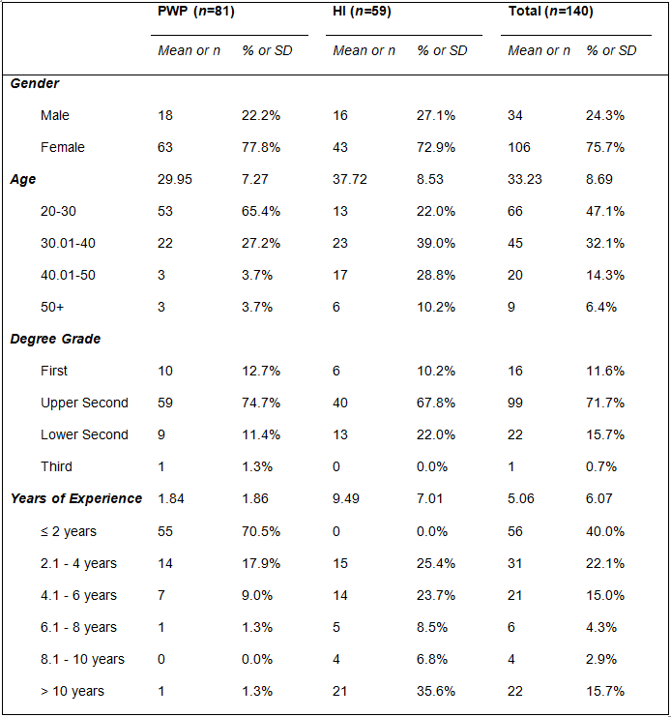
Table 1 Sample characteristics for PWP and HI cohorts
  - Measures and procedures
Assessments
Training data were collected, with consent, from student records. Clinical and academic work is rated by experienced CBT therapists. Intraclass correlations (ICCs) ranged from fair (ICC=.52, p=.04) to substantial (ICC=.84, p=.004)(Shrout, 1998) across assessment types, suggesting acceptable inter-rater reliability.
Clinical: Observed Standardised Clinical Examinations (OSCEs)were used to assess the clinical skill of PWPs. OSCEs were measured using standardisedrating scales provided in the National PWP curriculum (Reach Out: Richards & Whyte, 2009). PWPs undertake three OSCEs over the duration of the yearlong training programme.
Cognitive Therapy Scale Revised (CTS-R: Blackburn et al., 2001) was used to assess HI clinical skill. The CTS-R is a 12 item scale designed to measure competence; items are measured on a 7-point Likert scale ranging from incompetent (0) to expert (6). The threshold for competence on the CTS-R is 36. The CTS-R has been shown to have adequate inter-rater reliability and high internal consistency (Blackburn et al., 2001). HIs submit three audio recordings of CBT therapy sessions.
Academic: Reflective analyses, written examinations, and case reports were used to assess trainees’ understanding of clinical practice and the theoretical principles underpinning the course. Academic assessments were graded 0-100 using internal marking scales. Higher scores indicate greater academic knowledge; trainees were required to score≥50 to pass. Three reflective analyses of 1000 words (PWP and HI), three case reports of 2500 (HI), and four written examinations of 1.5 hour duration (PWP) are undertaken.
Personality:was measured using the NEO-PI-R (Costa & McCrae, 2006); a well-established 240 item self-report measure of the Big-Five personality dimensions of neuroticism, extraversion, openness to experience, agreeableness and conscientiousness. Items relate to normal behaviours, reactions and beliefs, which are rated on a 5-point Likert scale. It has good internal consistency with alphas ranging from .87 for agreeableness to .92 for neuroticism (Costa & McCrae, 2006).
Cognitive Ability:Ravens Progressive Matrices (Ravens; Raven, Raven, & Court, 1998) were implemented. Ravens is a measure of non-verbal reasoning which loads heavily on general cognitive ability in psychometric studies of intelligence (Carpenter, Just, & Shell, 1990 ; Ree & Cattetta, 2002). Ravens has been found to predict educational attainment (Kuncel et al., 2004) and training success (Salgado, Anderson, Moscoso, Bertua, & DeFruyt, 2003; Schmidt, 2002).Ravens matrices comprise five sets of 12 problems, resulting in a raw score between 0 and 60.
Academic Attainment: degree classification was collected from student records, and coded as 1=First Class, 2=Upper Second Class, 3=Lower Second Class, 4=Third.
Demographic data: participant age, gender andyears of relevant clinical (not specifically CBT) experience were collected from student records.
- Results
  - Descriptive Statistics
Distribution of trainee assessment grades are presented in Table 2 and Table 3. Mean scores on NEO PI-R and Ravens can be found in Table 4.
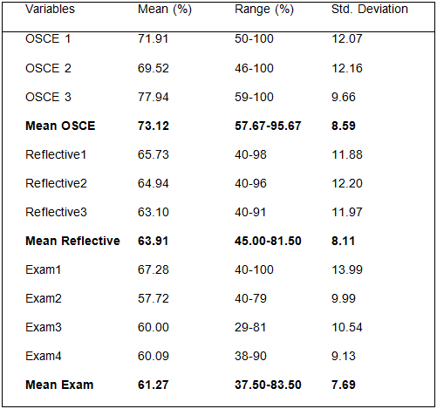
Table 2 PWP assessment scores (n=81)
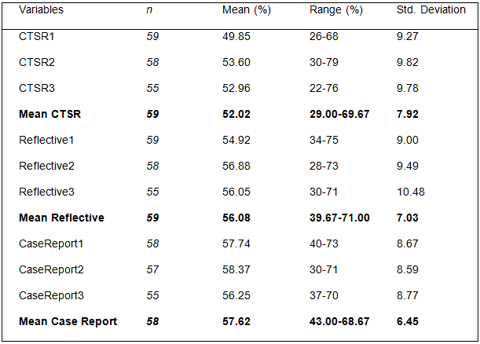
Table 3 HI assessment scores
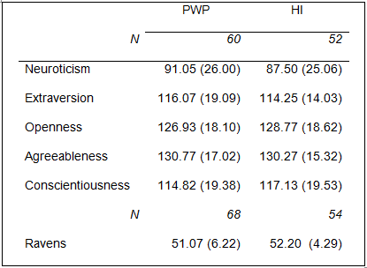
Table 4 Mean (SD) NEO PI-R and Ravens scores
  - Comparison of NEO PI-R scores with UK norms
PWP and HI personality data were compared using independent samples T-Tests. There were no significant differences between samples in neuroticism, extraversion, openness, agreeableness or conscientiousness (p>0.05 for all, )therefore data were combined in order to compare IAPT trainees with UK norms provided in the NEO PI-R manual (Costa & McCrae, 2006).IAPT trainees scored significantly higher on the neuroticism (M=89.4, SD=25.51, t(111)=10.86, p<0.001), openness (M=127.79, SD=18.28, t(111)=2.26, p=0.03) and agreeableness (M=130.54, SD=16.18, t(111)=5.07, p<0.001) scales, and lower on the extraversion (M=115.22, SD=16.88, t(111)=-6.88, p<0.001) and conscientiousness (M=115.89, SD=19.39, t(111)=-9.91, p<0.001) scales than the general population (neuroticism: M=63.22, SD=20.30, extraversion: M=126.20, SD=18.10, openness: M=123.94, SD=18.38, agreeableness: M=122.85, SD=15.8 and conscientiousness: M=134.05, SD=18.05) (see Figure 1 .

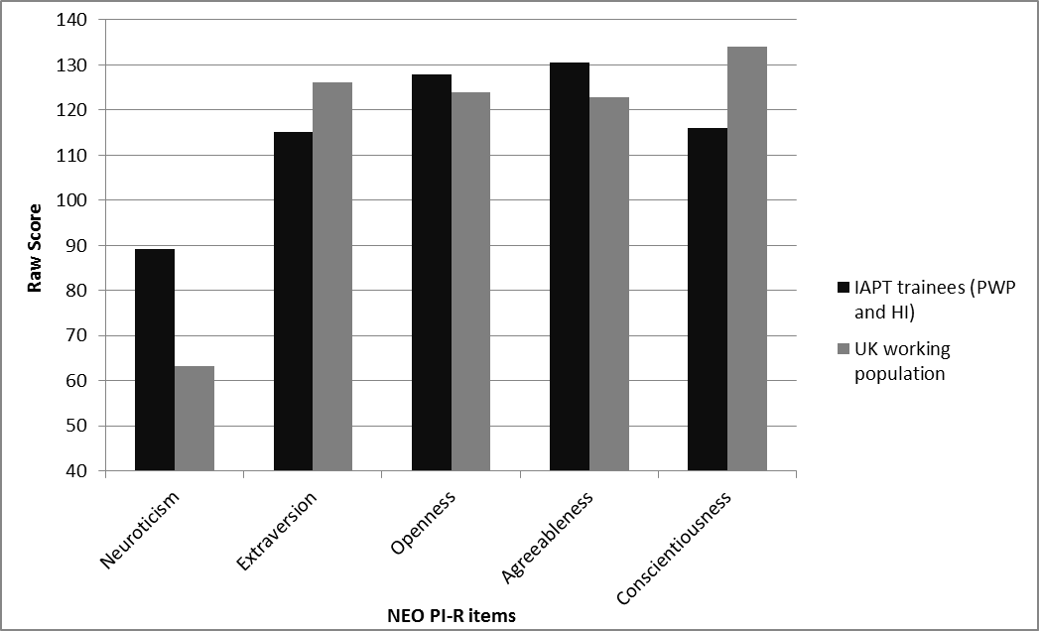
Figure 1NEO PI-R scores for IAPT trainees and UK population norms
  - Associations between variables
To investigate associations between assessments and therapist characteristics in PWPs and HIs, two Spearman’s Rho correlation matrices were generated.With alpha set at .01 to control for type 1 error, significant correlations were observed between all assessment types in PWP and HI samples (r_{s}=.50 to .77, p<0.001 for all)suggesting overlap in the knowledge and skills under evaluation.Howeverpatterns of association between therapist characteristics and performance were weak and inconsistent (seeTable 5).
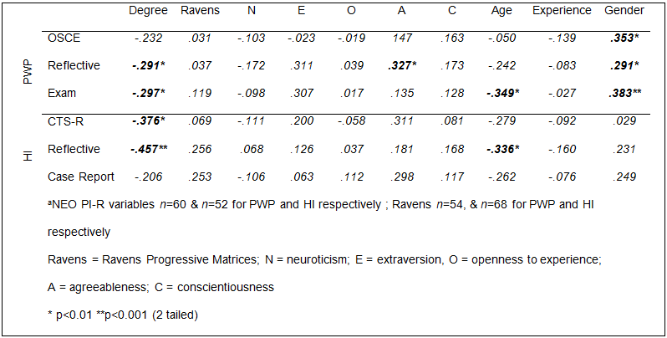
Table 5 Correlations between PWP and HI clinical and academic assessments and therapist characteristics
There was no support for hypothesis 1a, Ravens was largely unrelated to any assessment in PWPs or HIs. Support was however found for hypothesis 1b; degree classification was positively associated with academic work in PWP and HI samples, and with clinical work in HIs. Higher degree classifications were associated with higher assessment grades. This finding is explored further in section 3.4.
Results did not support hypothesis 2;agreeableness emerged as the only dimension of personality to be significantly related to performance (see table 5), and only with PWP reflective analysis(r_{s}=.33, p=0.01). Agreeableness was also associated with CTS-R, however this did not reach significance at the .01 level (r_{s}=.31, p=0.03).
There was limited support for Hypothesis 3.Age was negatively associated with all assessments in PWPs and HIs; however associations only reached significance for PWP exam (r_{s}=-.35, p=0.001), and HI reflective (r_{s}=-.34, p=0.009). Correlations between experience and all assessment types were negligible, and non-significant.Significant Point-Bisarial correlations between gender and PWP OSCE (r_{pb}=.35, p=.001), reflective (r_{s}=-.29, p=0.008) and exam (r_{s}=-.30, p=0.008)indicated that female PWPs outperformed their male counterparts, this was however not observed in HIs.
  - Relationship between past and present performance
In order to further explore the relationship between degree classification and performance a series of 1-Way ANOVAs (or Kruskal-Wallis non-parametric tests where assumptions of ANOVA were violated), with planned comparisons (α=.0167), were conducted. Degree classification was entered as the dependent variable with 3 levels (First Class pass (1st), Upper Second Class pass (2:1) and Lower Second Class pass (2:2), results are presented in Figure 2and Figure 3.
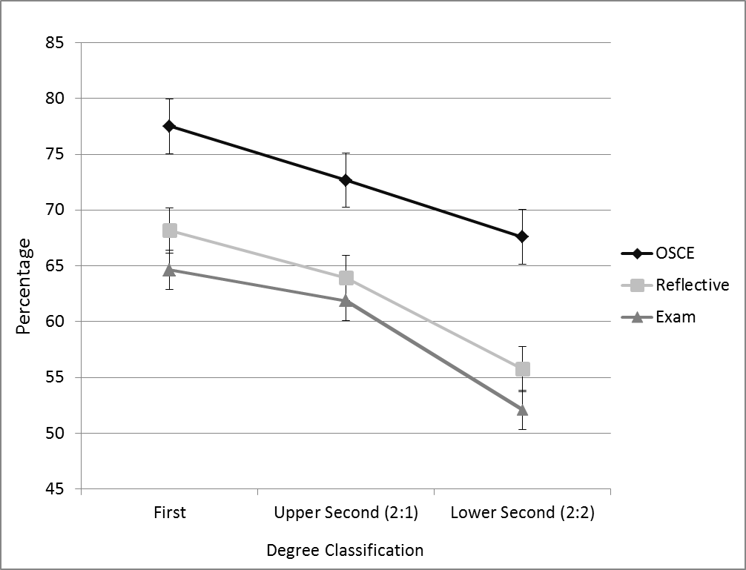
Figure 2 Graph of mean assessment grades by degree classification (PWP)

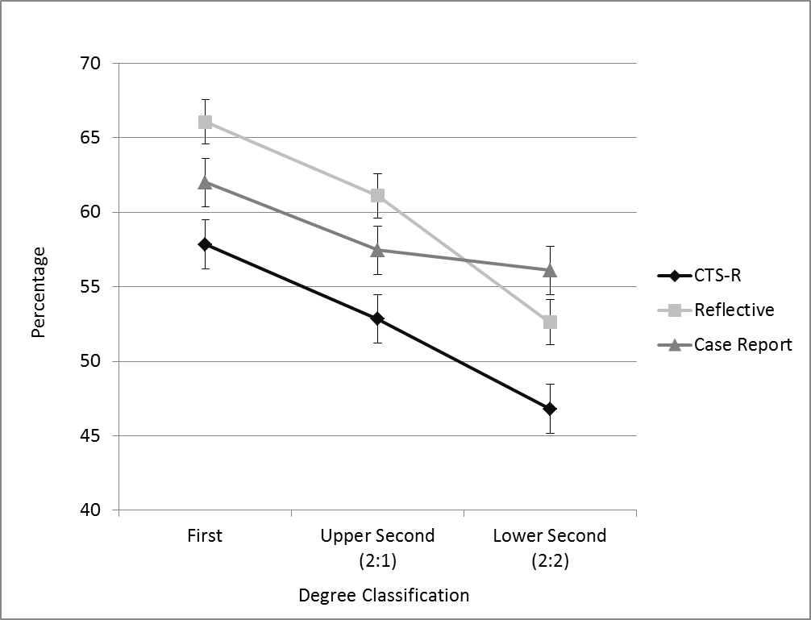
Figure 3 Graph of mean assessment grades by degree classification (HI)
Clinical: ANOVA revealed a significant effect of degree classification on mean OSCE grade, F(2,75)=3.51, MSE=66.3, p=0.04, Those awarded a 1st achieved a significantly higher mean OSCE grade (M 77.5, SD=10.3) than did trainees who were awarded a 2:2 (M 67.6, SD=9.3) (p=0.01, r=.29). The difference between 1st and 2:1 and between 2:1 and 2:2 was non-significant (p>0.05 for both).
There was also a significant effect of degree classification on CTS-R, F(2,56)=5.37, MSE=54.5, p=0.007, (seeFigure 3). Trainees’ awarded a 1st in their degree achieved a significantly higher mean CTS-R grade (M=57.8 SD=4.8) than did trainees’ who were awarded a 2:2 (M=46.8 SD=8.7) (p=0.004, r=.33); trainees with a 2:1 at degree also achieved a significantly higher mean CTS-R grade (M=52.8 SD=7.2) than did those with a 2:2 (p=0.01, r=.28).The difference between 1st class and 2:1 in reflective commentary grades did not reach significance (p=0.3).
Academic: ANOVA revealed a significant effect of degree classification on PWP exam grades, F(2,75)=10.12, MSE=43.81, p<0.001. Trainees awarded a 1st achieved significantly higher exam grades (M=68.2 SD=9.4) than did those who were awarded a 2:2 (M=55.8 SD=6.6) (p<0.001, r=.43), and those achieving a 2:1 performed significantly better (M=63.9 SD=7.2) than those with a 2:2 (p<0.001, r=.43). The difference between 1st and 2:1 on reflective commentary grades did not reach significance (p=0.3). A similar pattern emerged for PWP reflective analysis, F(2,75)=6.93, MSE=55.51 p=0.002. PWPs who achieved a 1st in their degree (M=68.2 SD=9.4) performed significantly better on reflective analysesthan did those who obtained a 2:2 (M=55.8 SD=6.6) (p=0.001, r=.39) and those with a 2:1 achieved better reflective commentary grades (M=63.9 SD=7.2) than did those with a 2:2 (p=0.003, r=.33). The difference between 1st class and 2:1 in reflective commentary grades did not reach significance (p=0.1).
In HIs, degree classification was found to significantly affected reflective analysisgrades (H(2)=12.29, p=0.002). Trainees who were awarded a 1st in their degree performed significantly better on their reflective commentary than did trainees with a 2:2 (U= 50.5, p=0.003, r=-.64). Those awarded a 2:1 had better grades than those achieving a 2:2 (U= 99.5, p=0.001, r=-.37). Due to the stringency of Bonferroni correction, the differences between 1st and 2:1 and was non-significant (p=0.019). Results were less robust for the HI case report; ANOVA was non-significant, F(2,55)=1.80, MSE=50.5, p=0.17, there was no effect of degree classification on mean case report grades. Although those awarded a 2:1 achieved lower mean case report grades than those with a 1st, and those with a 2:2 achieved a lower mean case report grade than did those with a 2:1, the differences were all non-significant (p>0.05 for all).

- Discussion
This study investigated relationships between therapist characteristics and performance in clinical and academic assessments. Results provided limited support for the hypotheses detailed in section 1.2.
A surprising finding of the current study was the lack of support for hypothesis 1a; performance on Ravens was not significantly associated with any assessment. The most likely explanation for this finding is a restriction of range. Chamorro-Premuzic and Furnham(2005) report correlations between cognitive ability and academic success decreasing in magnitude as academic level increased from Primary to Tertiary. As educational level progresses from compulsory (primary and secondary) to voluntary higher education, there is a more narrow range of intelligence. Thus in a postgraduate sample, this restricted range of intelligence may attenuate the strength of observed associations.
In support of hypothesis 1b, degree classification emerged as the only variable associated with clinical (HI only) and academic assessments in PWP and HI training programmes. Trainees achieving higher classifications in their degree do better in both clinical and academic work than those with lower classifications. Whilst not all comparisons reached significance, there were trends for mean clinical and academic assessment grades to be higher for those who achieved a First-Class pass than for those awarded an Upper-Second, who on average achieved higher mean grades than did those with a Lower-Second in their degree. This finding is in line with the extensive body of research observing a positive relationship between academic attainment and subsequent training across educational spheres and extends the limited literature including the prediction of postgraduate performance from undergraduate performance. The evidence to date suggests that the best predictor of future performance of a given kind is likely to be past performance (Sternberg & Williams, 1997).
Limited support was found for an association between training outcomes and therapist personality. Whilst this is surprising in light of the training literature more generally, it is similar to that of O'Donovan and Dyck (2005) who report no association between personality and clinical knowledge or skill in trainee clinical psychologists; furthermore the pattern of association varied across assessments and training groups, in support of research highlighting the inability of personality measures to generalise across settings (Murphy & Dzieweczynski, 2005; Ones, Dilchert, Viswesvaran, & Judge, 2007).However it is noted that whilst HI and PWP therapists did not differ significantly across the Big-Five personality dimensions, significant differences emerged between IAPT therapists and UK population norms on all dimensions; it is possible therefore that a restriction of range may have attenuated the relationship between personality and training outcomes.
Agreeableness, which is not typically associated with job or training outcomes, was the only personalitydimension to correlate moderately with training outcomes (though only PWP reflective analysis reached significance).This is consistent with the findings of Barrick and Mount (1991) who argue that agreeableness may be useful in the prediction of performance in occupations where interpersonal disposition is important. In a review of therapist characteristics and their effect on the therapeutic alliance, Ackerman and Hilsenroth(2003) found traits such as dependability, responsiveness, benevolence and empathy towards the patient to be important in a successful alliance, these are traits associated with higher scores on the agreeableness scale (Costa & McCrae, 2006), and key traits assessed by the interpersonal effectiveness item on the CTS-R (Blackburn et al., 2001). It was beyond the scope of the current study to explore relationships between therapist personality and individual items on the CTS-R, however it is possible that aspects of the agreeableness scale, and key traits assessed by the interpersonal effectiveness item on the CTS-R may be tapping into the same important therapist characteristics. Future research should explore this hypothesis with a larger therapist sample.It is surprising that PWP clinical work (OSCE) was not associated with agreeableness, even though inter-personal effectiveness is evaluated. Items evaluated under interpersonal effectiveness on the OSCE marking schemes include empathy; however other aspects include interviewing technique and acknowledgement/summarising of patient problems. One possible explanation for this is a disparity in the definition of interpersonal effectiveness across PWP and HI assessments; the interpersonal skill items may therefore be measuring a somewhat different though overlapping set of skills.
The current study found that older trainees perform less well than their younger counterparts. Correlations were predominantly small (r=-.05 to r=-28), except for PWP exam and HI reflective analysis, which were moderate (r=-.35 and r=-34 respectively). This partially replicates the findings of McManus et al (2010) who report a strong negative association between age and all assessment types in trainee therapists.
One possible explanation for this finding relates to proactive interference (Castro et al., 2002). Experience was also negatively (though non-significantly) associated with all assessment types, suggesting that those with greater experience perform less well. Though speculative, it is possible that existing knowledge and experience affects performance. A second explanation relates to role conflict; older trainees may be juggling work, training, and domestic roles; it is possible therefore that older trainees simply do not have the same amount, and/or quality of study time as younger trainees. Female trainees performed significantly better, both clinically and academically than males, but this was true only for PWPs - gender was unrelated to performance in HIs. The association was not consistent across cohorts, suggesting that the difference is not associated with subject type. This finding may reflect random variation in ability in male PWPs in the current sample. Future research should investigate the male-female performance gap across other IAPT courses to see if findings are replicated. A gender gap in performance would have implications for course developers and trainers in terms of determining how to optimise training to support male, as well as female trainees.
Experience was unrelated to clinical or academic performance in both PWP and HI samples. Previous studies have reported differing patterns of association, James et al. (2001) found experience to be associated with competence, but only experience in cognitive therapy, experience in years was unrelated. Brosan and Reynolds (2009) similarly found there to be no association between post qualification experience and competence. Therefore whilst some authors (e.g. Huppert et al., 2001; Martin, Slemon, Hiebert, Hallberg, & Cummings, 1989) argue for the importance of experience in therapy, it may be the type of experience, rather than experience per-se that is important in the prediction of performance.
  - Strengths, Limitations and Future Lines of Enquiry
A major strength of the current study is the range of therapist factors that were investigated and the inclusion of multiple samples of trainees across cohorts on the IAPT programmes.
Although the range of variables, and sample size were strengths, the uncontrolled retrospective nature of the study means that results cannot be conclusive. The sample includes only a subset of PWP and HI therapists trained at the University of Reading, therefore these data may not be representative, the possibility of this is highlighted through the existence of cohort effects in clinical performance and PWP examinations. Before conclusions can be drawn, researchers will need to have inclusive, representative samples and afford greater attention to therapist characteristics in training, and also patient outcome studies, in order to more fully understand how they impact performance. This will help to ensure that the most suitable people are selected for training with the ability to: a) develop the knowledge, skills and attitudes necessary to succeed academically, and b) to provide a level of clinical care comparable to that which would be expected from a randomised controlled trial.
Finding degree classification to be the most important correlate of training success is potentially important in terms of selection of candidates for postgraduate training. However, grading systems across institutions and disciplines are prone to variation, Assumptions of correlational and regression analyses require that data are either dichotomous, or continuous (Field, 2009). Although it has been argued that ordered categorical variables such as degree results can legitimately be added as predictors in such analyses (Tutz, 2012), a restriction of range may affect results. In order to more robustly evaluate the effect of degree performance on postgraduate training performance, researchers should use degree transcripts to gain a more accurate impression of trainee performance.
An interesting, and potentially concerning finding of this, and one other study (McManus et al., 2010) was the negative association between age and performance. Quantitative research methods provide only confirmation of a relationship, they do not allow for conclusions to be drawn on causal link. In order to ascertain where the barriers to superior performance may be for older trainees, a qualitative approach may offer a richer, more comprehensive understanding. This line of enquiry will help course developers, to provide adequate support to reduce the age gap.
  - Conclusions
The current study aimed to extend the limited body of research focusing on the effect of individual characteristics on performance in two postgraduate training programmes. With the exception of degree classification, no individual variable was associated with all assessment types and programmes. If individual characteristics are to be used in the selection of therapists for postgraduate programmes a range of therapist characteristics should be considered, particularly past performance. Whilst experience is a pre-requisite of entry onto the HI programme, the study indicates it would be unwise for course developers to make assumptions that experience necessarily equates to excellence.

References
Ackerman, P. L., & Heggestad, E. D. (1997). Intelligence, personality and interests: evidence for overlapping traits. Psychological Bulletin, 121, 219-245.
Ackerman, S. J., & Hilsenroth, M. J. (2003). A Review of Therapist Characteristics and Techniques Positively Impacting the Therapeutic Alliance. Clinical Psychology Review, 23(1), 1-33. doi: 10.1016/s0272-7358(02)00146-0
Barrick, M. R., & Mount, M. K. (1991). The Big Five Personality Dimensions and Job Performance: A Meta-Analysis. Personnel Psychology, 44, 1-26.
Bertua, C., Anderson, N., & Salgado, J. F. (2005). The Predictive Validity of Cognitive Ability Tests: A UK Meta-Analysis. Journal of Occupational and Organizational Psychology, 78(3), 387-409. doi: 10.1348/096317905x26994
Blackburn, I., James, I., Milne, D., Baker, C., Standart, S., Garland, A., & Reichelt, F. K. (2001). The Revised Cognitive Therapy Scale (CTS-R): Psychometric Properties. Behavoural and Cognitive Psychotherapy, 29(4), 431-446.
Carpenter, P. A., Just, M. A., & Shell, P. (1990 ). What one intelligence test measures: a theoretical account of the processing in the Raven Progressive Matrices test. Psychological Review, 97(404-431).
Cassidy, S. (2011). Exploring individual differences as determining factors in student academic achievement in higher education. Studies in higher education, 1-18. doi: 10.1080/03075079.2010.545948
Castro, L., Ortega, N., & Matute, H. (2002). Proactive Interference in Human Predictive Learning. International Journal of Comparative Psychology, 15(1).
Chamorro-Premuzic, T., & Furnham, A. (2005). Personality and Intellectual Competence. New York: Lawrence Erlbaum.
Chapman, B. P., Talbot, N., Tatman, A. W., & Britton, P. C. (2009). Personality Traits and the Working Alliance in Psychotherapy Trainees: An Organizing Role for the Five Factor Model? Journal of Social and Clinical Psychology, 28(5), 577-596.
Costa, P. T., & McCrae, R. R. (1992). Manual for the Revised NEO Personality Inventory (NEO-PI-R). Odessa, FL: Psychological Assessment Resources.
Costa, P. T., & McCrae, R. R. (2006). NEO Revised. NEO Personality Inventory (NEO PI-R) Manual (UK Edition ed.). Oxford: Hogrefe.
Dean, M. A., Conte, J. M., & Blankenhorn, T. R. (2006). Examination of the predictive validity of Big Five personality dimensions across training performance criteria. Personality and Individual Differences, 41(7), 1229-1239. doi: 10.1016/j.paid.2006.04.020
Farsides, T., & Woodfield, R. (2007). Individual and gender differences in 'good' and 'first-class' undergraduate degree performance. The British journal of psychology, 98(3), 467-483. doi: 10.1348/000712606x150246
Field, A. P. (2009). Discovering Statistics Using SPSS (3 ed.). London: Sage.
Herold, D. M., Davis, W., Fedor, D. B., & Parsons, C. K. (2002). Dispositional Influences on Transfer of Learning in Multistage Training Programs. Personnel Psychology, 55(4), 851-869. doi: 10.1111/j.1744-6570.2002.tb00132.x
Huppert, J. D., Bufka, L. F., Barlow, D. H., Gorman, J. M., & Shear, M. K. (2001). Therapists, Therapist Variables, and Cognitive-Behavioral Therapy Outcome in a Multicentre Trial for Panic Disorder. Journal of Consulting and Clinical Psychology, 69(5), 747-755.
James, D., & Chilvers, C. (2001). Academic and non-academic predictors of success on the Nottingham undergraduate medical course 1970–1995. Medical Education, 35(11), 1056-1064. doi: 10.1111/j.1365-2923.2001.01042.x
James, I. A., Blackburn, I. M., Milne, D. L., & Reichfelt, F. K. (2001). Moderators of Trainee Therapists' Competence in Cognitive Therapy. British Journal of Clinical Psychology, 40(2), 131-141. doi: 10.1348/014466501163580
Kevern, J., & Webb, C. (2004). Mature women's experiences of preregistration nurse education. Journal of Advanced Nursing, 45(3), 297-306. doi: 10.1046/j.1365-2648.2003.02890.x
Kuncel, N. R., Hezlett, S. A., & Ones, D. S. (2004). Academic Performance, Career Potential, Creativity, and Job Performance: Can One Construct Predict Them All? Journal of Personality and Social Psychology, 86(1), 148-161.
Kuyken, W., Padesky, C. A., & Dudley, R. (2009). Collaborative Case Conceptualization: Working Effectively with Clients in Cognitive-Behavioral Therapy. New York: Guilford Press.
Martin, J., Slemon, A. G., Hiebert, B., Hallberg, E., & Cummings, A. L. (1989). Conceptualizations of novice and experienced counselors. Journal of Counseling Psychology, 36, 395-400.
McManus, F., Westbrook, D., Vazquez-Montes, M., Fennell, M., & Kennerley, H. (2010). An Evaluation of the Effectiveness of Diploma-Level Training in Cogntive Behaviour Therapy. Behaviour Research and Therapy, 48, 1123-1132.
Murphy, K. R., & Dzieweczynski, J. L. (2005). Why Don't Measures of Broad Dimensions of Personality Perform Better as Predictors of Job Performance? Human Performance, 18(4), 343-357.
O'Donovan, A., & Dyck, M. J. (2005). Does a clinical psychology education moderate relationships between personality or emotional adjustment and performance as a clinical psychologist? Psychotherapy: Theory, Research, Practice, Training, 42(3), 285-296. doi: 10.1037/0033-3204.42.3.285
Ofori, R. (2000). Age and 'type' of domain specific entry qualifications as predictors of student nurses' performance in biological, social and behavioural sciences in nursing assessments. Nurse Education Today, 20(4), 298-310.
Okiishi, J. C., Lambert, M. J., Nielsen, S., & Olgles, b. (2003). Waiting for Supershrink: An Empirical analysis of Therapist Effects. Clinical Psychology & Psychotherapy, 10, 361-373.
Ones, D. S., Dilchert, S., Viswesvaran, C., & Judge, T. A. (2007). In Support of Personality Assessment in Organizational Settings. Personnel psychology, 60, 995-1027.
Raven, J. C., Raven, J., & Court, J. H. (1998). Manual for Raven's Progressive Matrices and Vocabulary Scales. Section 3, The Standard Progressive Matrices. Oxford: Oxford University Press.
Ree, M. J., & Cattetta, T. R. (2002). g2K. Human Performance, 15(1/2), 3-23.
Richards, D. A., & Whyte, M. (2009). Reach Out. National Programme Educator Materials to Support the Delivery of Training for Psychological Wellbeing Practitioners Delivering Low Intensity Interventions (2 ed.). London: Rethink.
Richardson, M., Abraham, C., & Bond, R. (2012). Psychological Correlates of University Students' Academic Performance: A systematic review and meta-analysis. Psychological Bulletin, 138(2), 353-387.
Rush, B., & Cook, J. (2006). What makes a good nurse? Views of patients and carers. British Journal of Nursing, 15(13), 382-385.
Sackett, P. R., & Mullen, E. J. (1993). Beyond formal experimental design: towards an expanded view of the training evaluation process Personnel Psychology, 46, 613-627.
Salgado, J. F., Anderson, N., Moscoso, S., Bertua, C., & DeFruyt, F. (2003). International Validity Generalization of GMA and Cognitive Ability: A European Community Meta-Analysis. Personnel Psychology, 56(573-605).
Schmidt, F. L. (2002). The Role of General Cogntive Ability and Job Performance: Why There Cannot be a Debate. Human Performance, 15(1), 187-211.
Shrout, P. E. (1998). Measurement reliability and agreement in psychiatry. [Article]. Statistical Methods in Medical Research, 7(3), 301-317.
Siqueland, L., Crits-Christoph, P., Barber, J. P., Butler, S. F., Thase, M., Najavits, L., & Onken, L. S. (2000). The role of therapist characteristics in training effects in cognitive, supportive-expressive, and drug counseling therapies for cocaine dependence. The Journal of psychotherapy practice and research, 9(3), 123-130.
Sternberg, R., & Williams, W. M. (1997). Does the Graduate Record Examination Predict Meaningful Success in the Graduate Training of Psychologists? American Psychologist, 52(6), 630-641.
Tutz, G. (2012). Regression for categorical data. Cambridge: Cambridge University Press.

