<H1> Supplemental Figures

The models presented in supplemental Figures 1 and 2 are direct replications of Figures 1 and 2 from Jonason et al. (2018).

Supplemental Figure 1. Impact of Dark Triad on Excitement
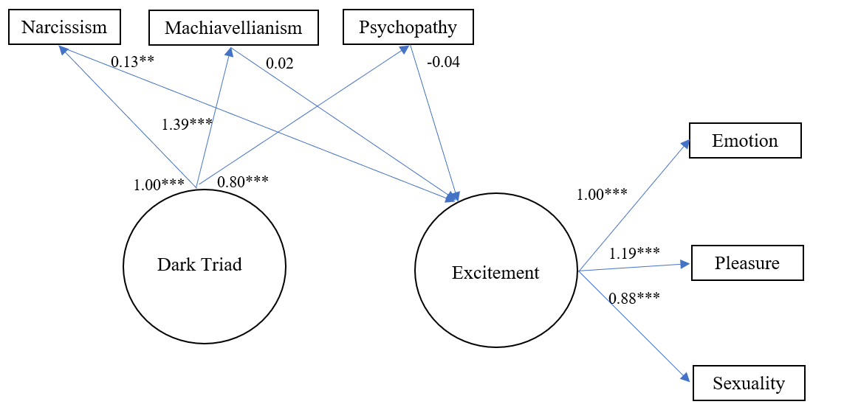
Note. CFI = .98, TLI = .97, RMSEA = .04. All fit indices are robust. No errors were allowed to correlate.

Supplemental Figure 2. Impact of Dark Triad on Promotion
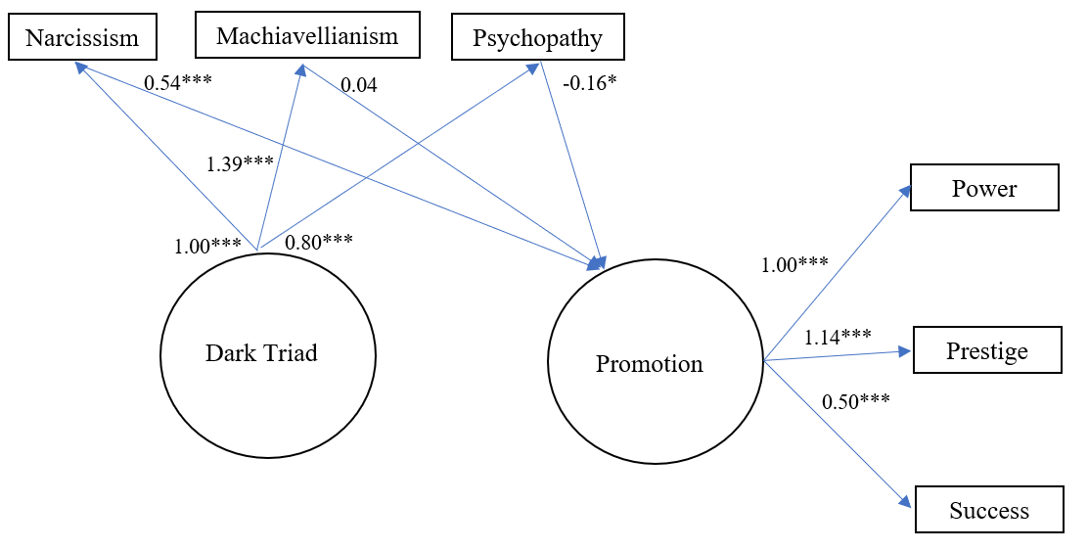
Note. CFI = .96, TLI = .89, RMSEA = .08. All fit indices are robust. No errors were allowed to correlate.

