Supplementary materials

Case-Control group comparisons across thresholds

Cortical thickness
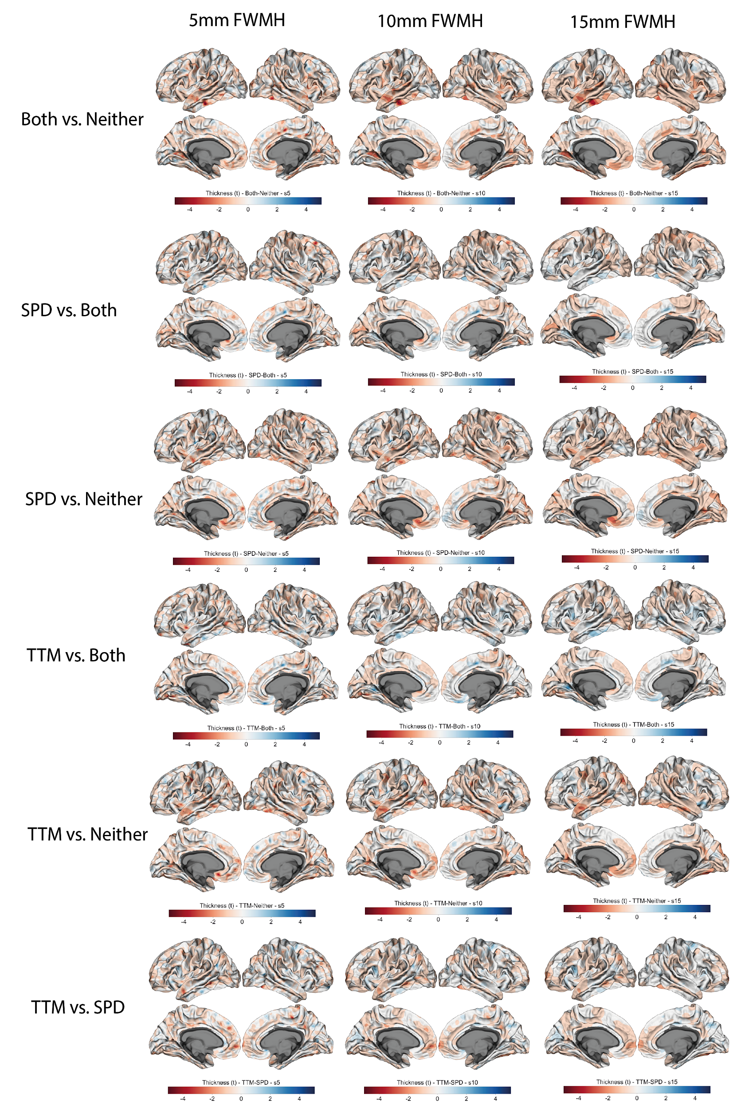

Surface area
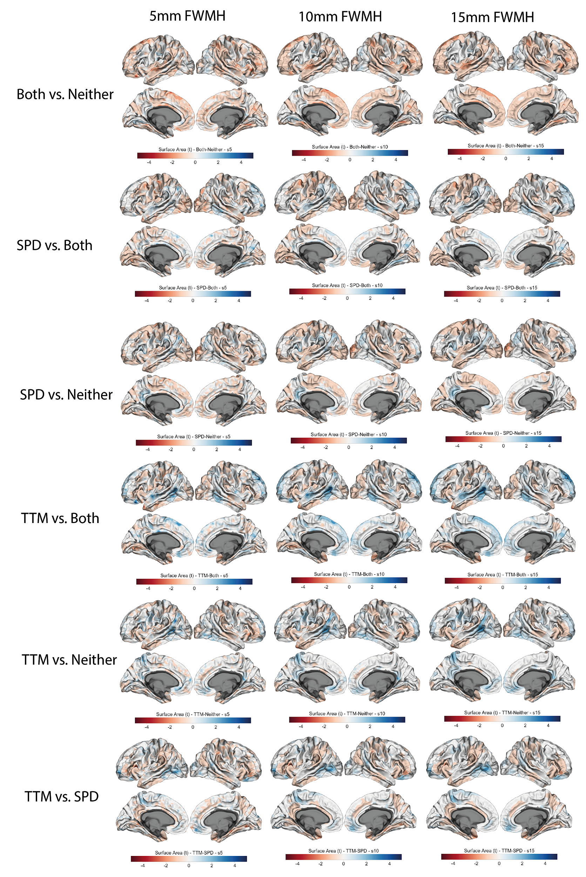

Volume
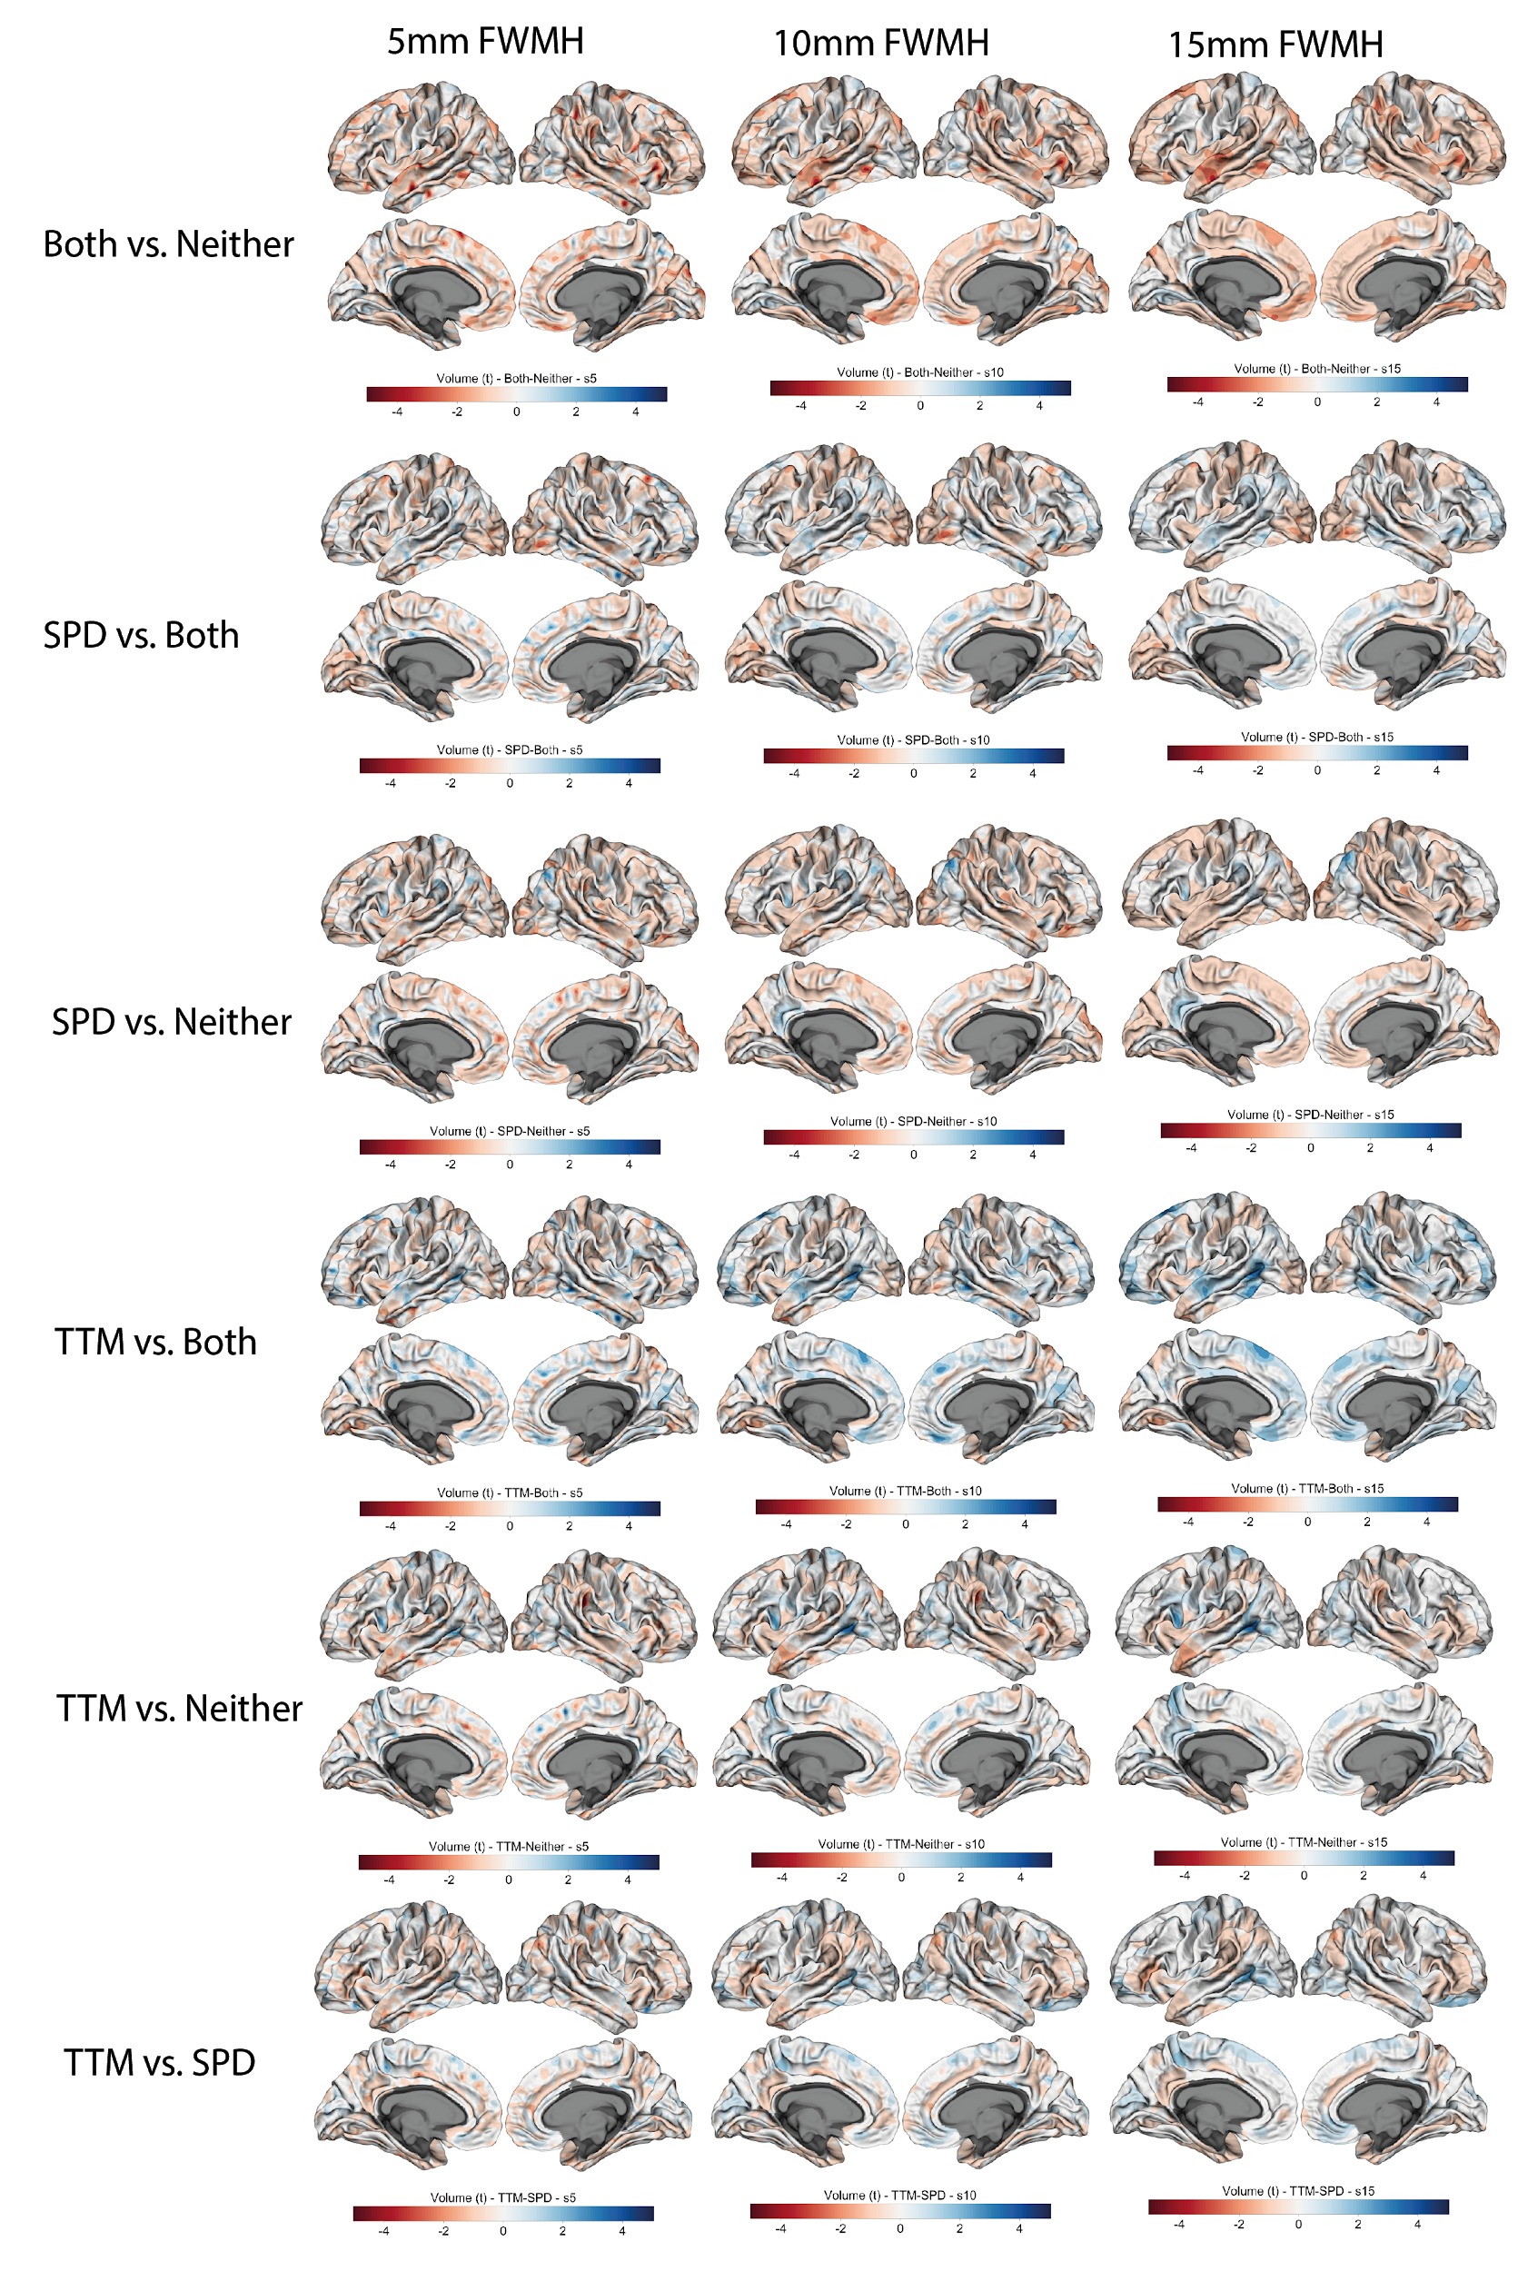

Puller subtype significant differences across 2 smoothness kernels
In some cases there were significant differences that did not appear across the different levels of smoothness but did survive cluster-correction at a smoothness of 5 and 10mm FWMH. For completeness those are reported below.

Surface area
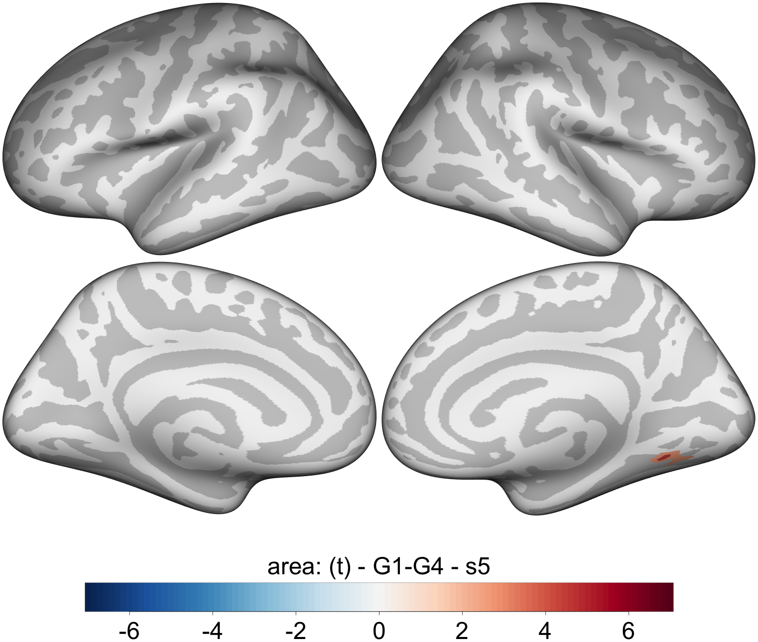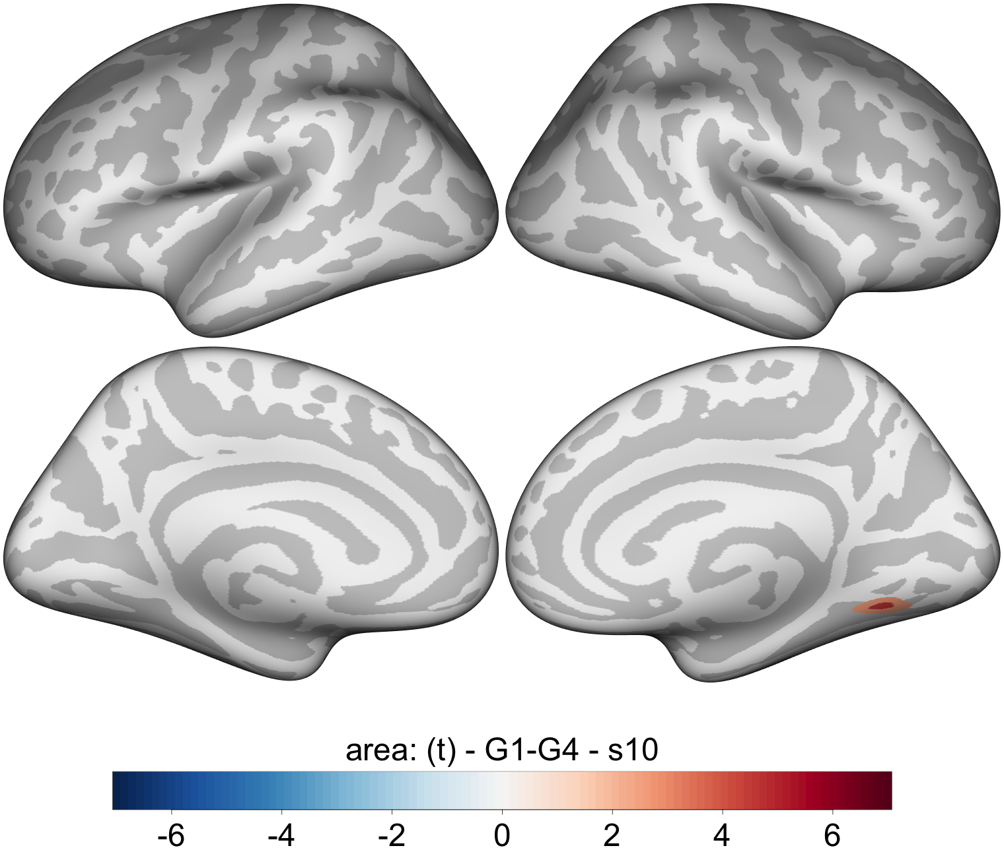

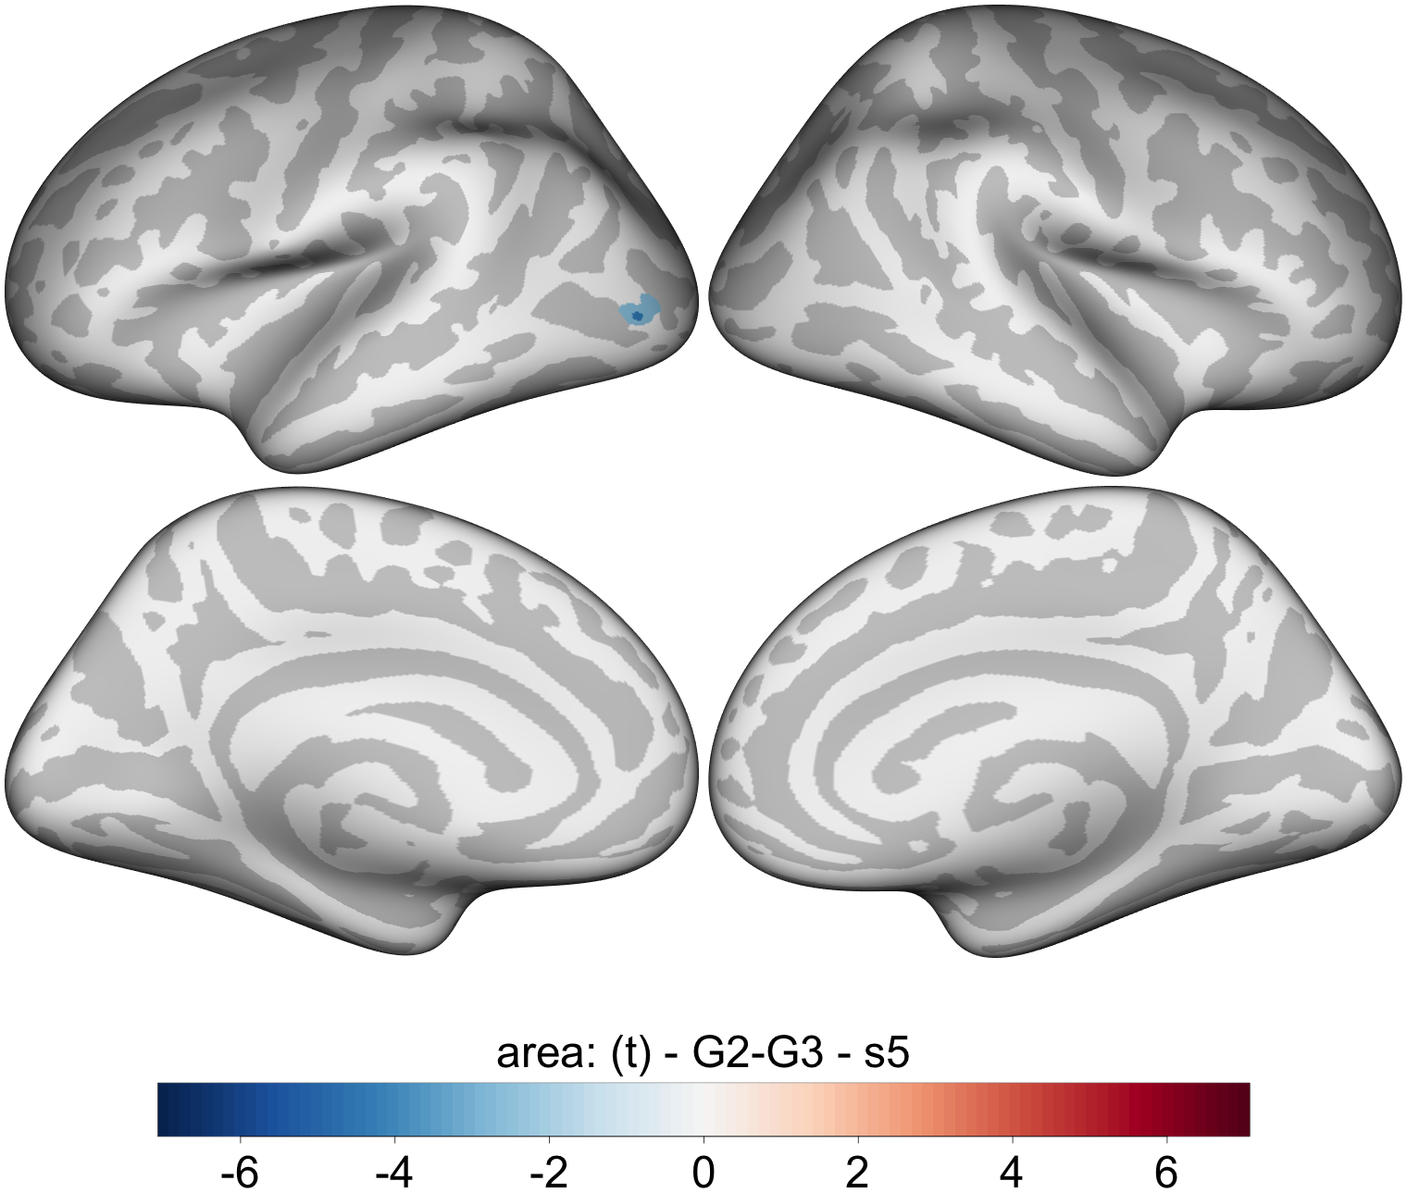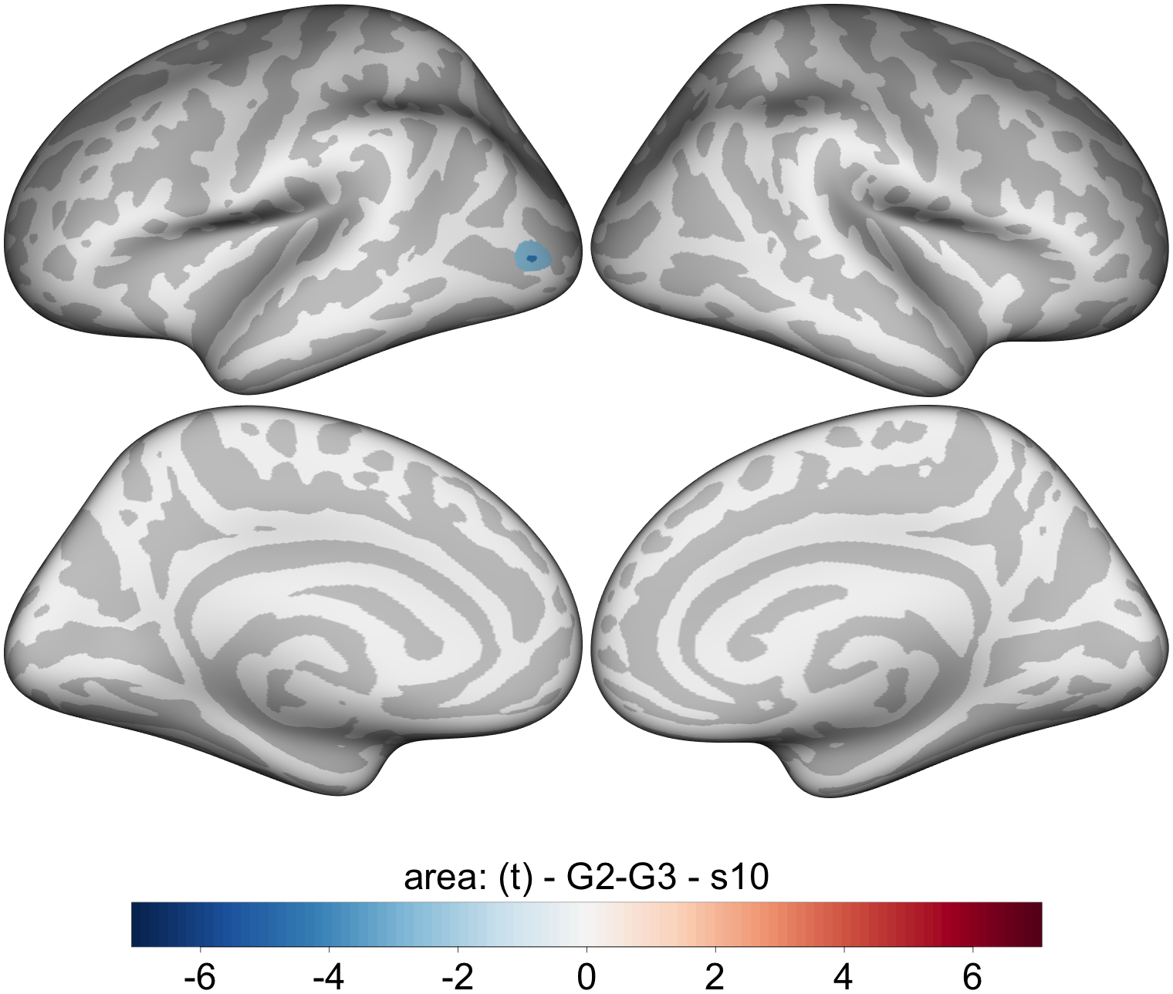

Volume

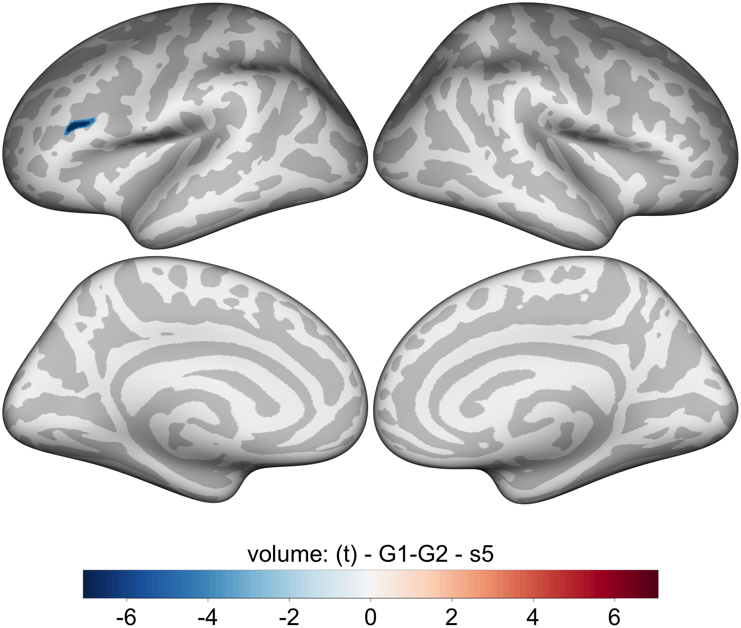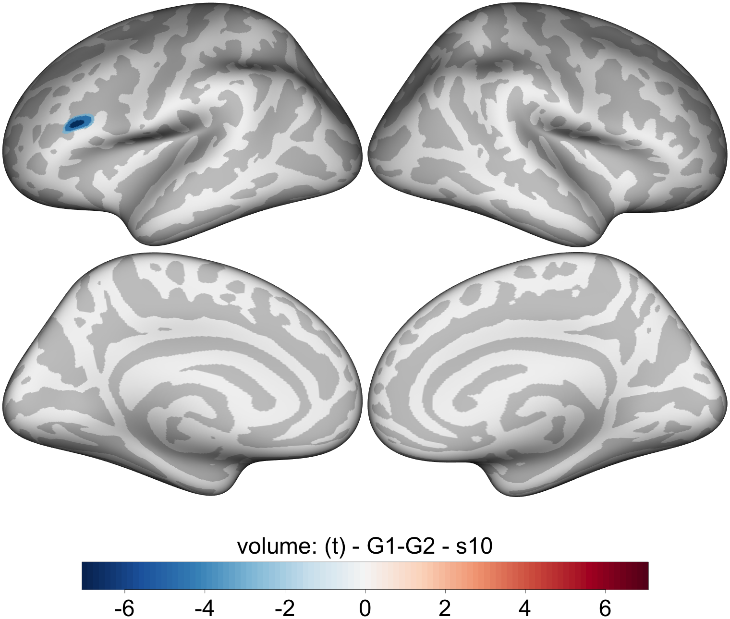

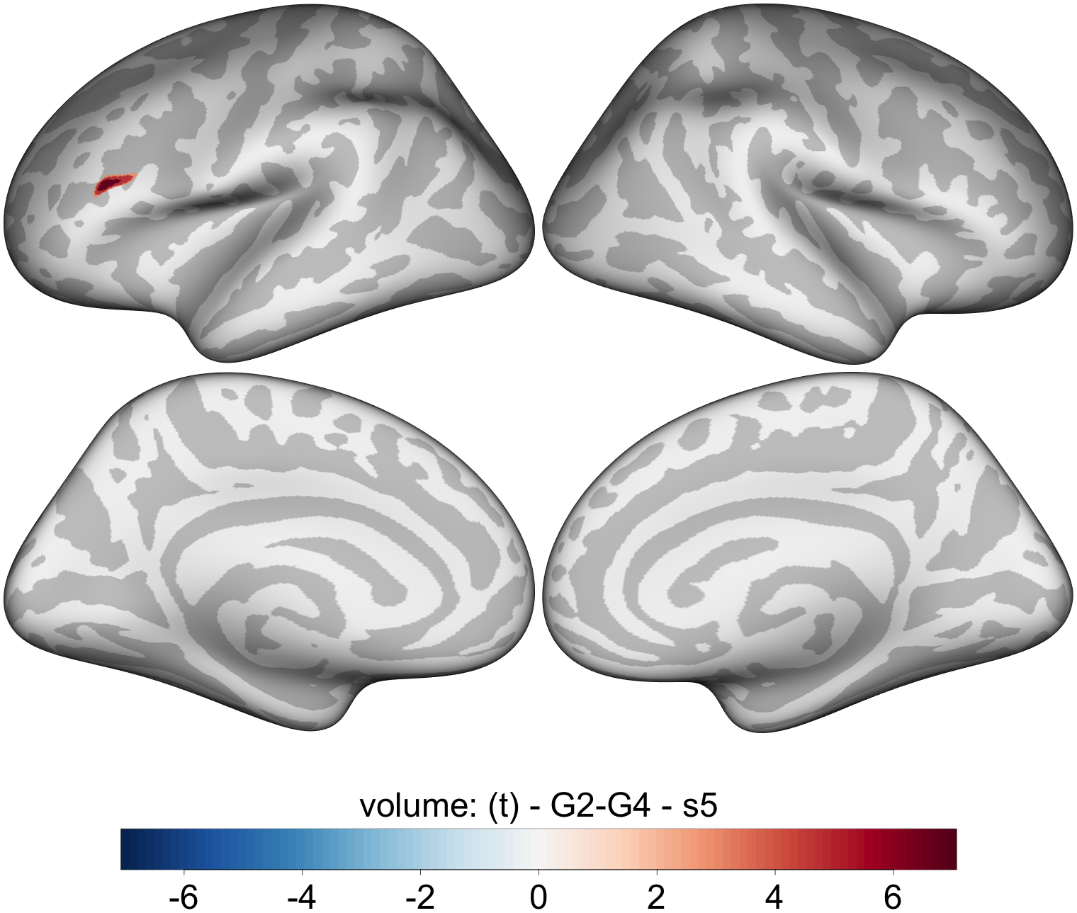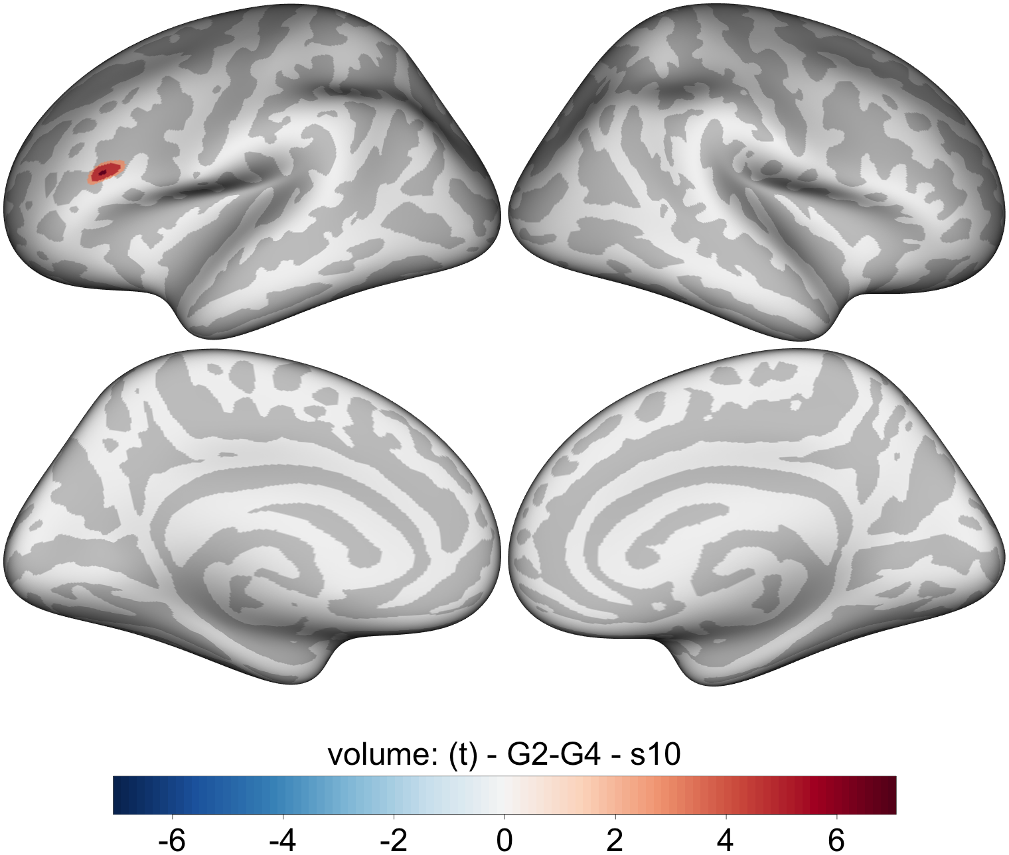

Picker subtype significant differences across 2 smoothness kernels
In some cases there were significant differences that did not appear across the different levels of smoothness but did survive cluster-correction at a smoothness of 5 and 10mm FWMH. For completeness those are reported below.

Volume
