Supplementary information
This document covers additional technical information to the main article:

Schneider et al. Motor Activity Patterns Can Distinguish Between Inter-Episode Bipolar Disorder Patients and Healthy Controls: A data-driven model based on a three-month longitudinal actigraphy study, 2020

Literature overview
Table S.1. summarizes properties and main findings of available actigraphy studies, based on a non-systematic literature review. The comparison of size and duration of these studies with our study is in figure S.1.

Table S.1 - Bipolar studies using actigraphy - size, duration, and main outcomes

Article | Subjects BD/HC (notes) | Actigraphy duration | Main findings (for BD patients compared to HC)
Boudebesse 2013¹ | 18/0 | aver. 7.83 days | - Algorithm yielded longer sleep duration than Visual inspection, Visual inspection showed shorter sleep latency than algorithm and diaries
Faedda 2016 | 48/42 | 3-5 days | - Measured in children without medication  - Observed abnormalities in sleep, circadian rhythmicity and hyperactivity  - Machine learning classification 83% acc. 64% sensitivity, 92% specificity
Geoffroy 2014² | 26/29 | 21 days | - Mean sleep duration higher in BD  - Mean sleep latency higher in BD  - Variability in sleep fragmentation higher in BD  - Differences in PSQI scores
Gershon 2012³ | 32/36 | 54 days | - Longer sleep onset latency  - Longer wakefulness after sleep onset (WASO)  - Lower sleep efficiency
Gershon 2016⁴ | 37/39 | 42 days | - Lower activity in depressive days  - Later activity onset on depressive days  - Midday elevation on depressive days
Grierson 2016⁵ | 60/0 | 14 days | - Concerning young population at risk  - Later activity peak associated with manic symptoms  - Lowering activity with illness duration  - Reduction of circadian rhythmicity with illness duration
Harvey 2005⁶ | 20/20 (insomnia patients) | 8 days | - Lower daytime activity in BD  - Lower sleep efficiency in BD  - Similar dysfunctional beliefs about sleep as insomnia group
Janney 2014⁷ | 60/0 | 7 days | - Lower overall activity  - Higher sedentary behaviour
Jones 2005⁸ | 19/19 | 7 days | - More variable circadian parameters in BD  - Lower overall activity in BD  - No differences in sleep
Kaplan 2012⁹ | 27/27 | 2 days | - No differences in sleep  - Concordance between actigraphy PSG and diaries is not affected by insomnia or medication used  - Actigraphy is a valid tool for sleep duration and fragmentation estimation compared to polysomnography
Kaplan 2015¹⁰ | 75/0 | 7 days | - Divide BD subjects, based on sleep, into two uncorrelated groups ‘long sleep - bedrest’ and ‘excessive sleepiness’  - Excessive sleepiness predicted mania/hypomania relapse
Krane-Gartiser 2014¹¹ | 30/28 | 1 day | - Actigraphy can distinguish mania and depression in hospitalized patients
Krane-Gartiser 2019¹² | 61/61 | 21 day | - Based on sleep and actigraphy features 75% BD and HC were correctly classified (MADRS score was included as a parameter, without it accuracy is 67%)  - Age was associated with misclassification in HC  - BD type (I. II.) was associated with misclassification in BD  - Sleep variability helps distinguish BD and HC (Mainly Fragmentation index and WASO)
McKenna 2014¹³ | 14/14 | 7 days | - Abnormalities in 1) Sleep efficiency 2) Rhythm robustness 3) Mesor
Merikangas 2019¹⁴ | 54 BD/91 MDD/ 97 HC | 14 days | - Motor activity affects future mood, but activity is not significantly affected by the previous mood  - Activity may be better intervention target than the mood  - Instability of energy and attention but not mood is associated with BDI  - There are differences between BDI vs BDII and MDD
Millar 2004¹⁵ | 19/19 | 5 days | - Higher sleep onset latency (based on diaries)  - Higher sleep duration (based on diaries)  - The higher variability of sleep duration (actigraphy)  - The higher variability of night wake time (actigraphy)
Ritter 2012¹⁶ | 22/28 | 6 days | - Longer sleep latency  - Longer sleep duration  - Symptoms were present in a high-risk population too (9 subjects)
Salvatore 2008¹⁷ | 36/0 | 3 days | - Later activity peak (2.1 hours on average in mania, 1.8 hours in euthymic)  - A higher percentage of nocturnal sleep  - Lower average daily activity
Shou 2017¹⁸ | 64 BD/52 MDD/ 223 HC | 14 days | - BDI Has lover activity from noon and evening with higher variation from day to day  - BDI. are similar to HC with a slightly slower decline of activity in the evening  - No observed association between psychotropic medication and levels of activity  - HC were relatives of the patients
St-Amand 2013¹⁹ | 14/13 (insomnia patients) | 14 days | - Including 13 subjects with insomnia  - Sleep was similar to HC, and differ from the insomnia group  - BD presented sleep complaints similar to the insomnia group  - Lesser activity in the daytime (as in insomnia)  - More variable activity peak time  - More reported daytime sleepiness
Verkooijen 2017²⁰ | 107 BD / 74 BD siblings / 80HC | 14 days | - sleep differences (longer duration, later sleep onset) are caused only by mood difference (not in euthymic patients)

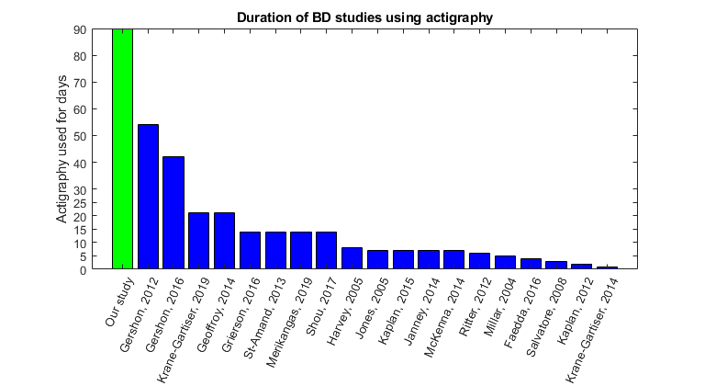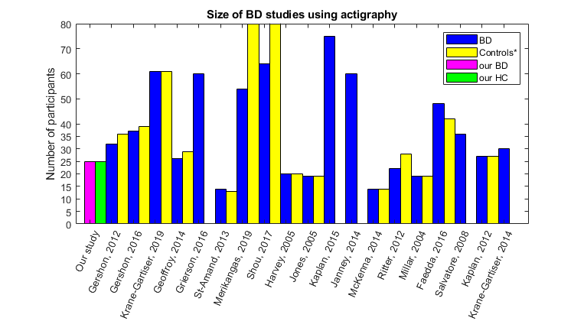
Figure S.1 - Duration and sample size of BD actigraphic studies. The first bars (green/pink) represent our study, showing that the duration is one of the longest and the sample size is comparable to other studies. It may be seen that the duration is negatively associated with sample size and that newer studies tent to be longer or bigger.

Actigraphy features
The actigraphy wearable employed (MINDPAX) uses internal three-axis accelerometer measurement with an internal sampling frequency of 6 Hz, aggregated into 30-second epochs.

In several cases in our data, the sleep may not be present on a specific day due to two basic reasons: 1) the person wasn’t sleeping on that day, or 2) there is too much missing data for sleep detection to work. In case of complete data without detected sleep, the sleep duration (SDur) was set to 0 and the other sleep features were set to unknown, in case of missing data all sleep features were set to unknown.

Concerning restless and immobile sleep. The threshold for restless sleep was based on two Gaussian mixture fit on activity data during detected sleep activity data during sleep. For immobile sleep the two lowest bits were used for detection of immobile sleep - see figure S.2.
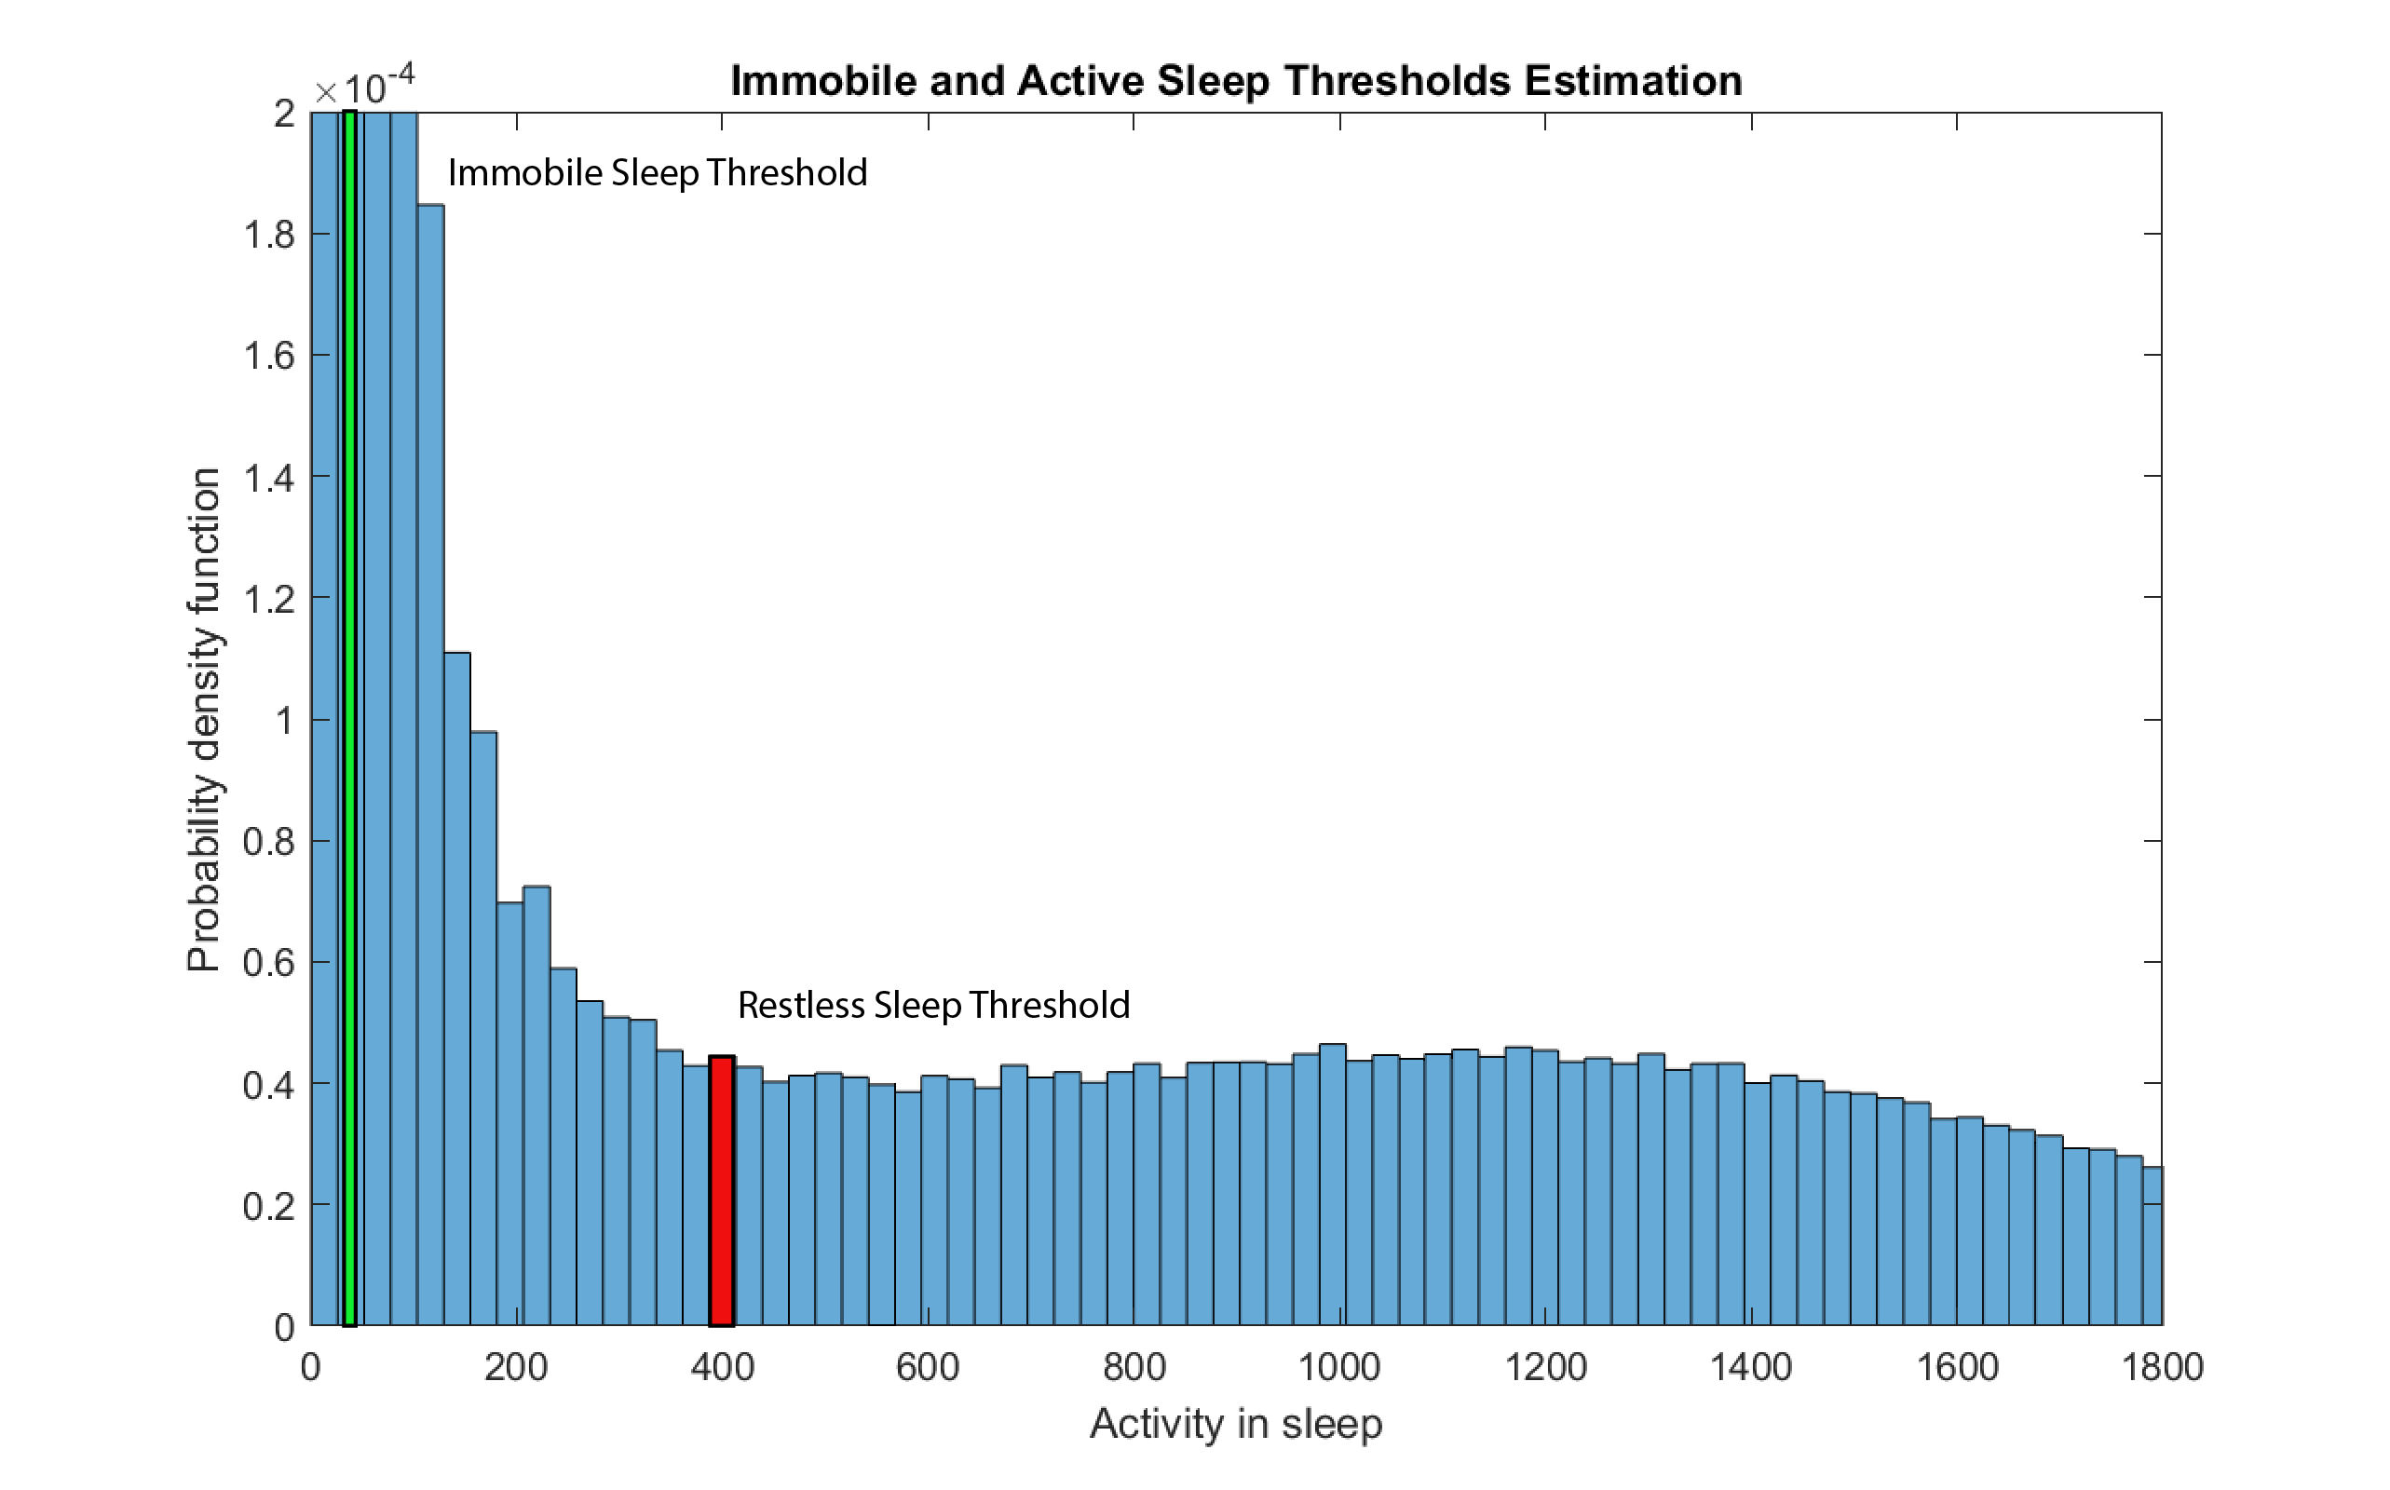
Figure S.2 - Histogram of activity during detected sleep through all of the study (subjects and days) with thresholds for the immobile (upper bound - green) and active (lower bound - red) sleep.
Estimation of circadian daily features
The features M10 and L5 were calculated based on each day with 10 hours for M10 (or 5 hours for L5) overlap to the previous day and the future day - in such a way the M10-time and L5 time (the time of the middle of the detected window) may reach values from 0-24 hours. The ADA and AQA1-4 were calculated based on each calendar day (midnight to midnight).

Feature normalisation
The features were tested for normality using the Jarque-Bera²¹ test. Per-group mean value was subtracted before performing the normality test (expecting that the variance in both groups is similar). Where normality was disproved, a transformation to normal distribution was done based on visual inspection of the Q-Q plot after applying transformation functions depicted in Table S.2.
The actigraphy measures included in the study, together with the normalization/transformations, is presented in Table S.2. The normalisation was used only for statistical comparison. All machine learning models were trained using the original values.
Table S.2 - Feature overview and normalisation

Feature | Variant | BD value‡ | HC value‡ | Transformation | Normality achieved
Activity daily (ADA) | average | 605 (SD 110) | 778 (SD 92) | - | Yes
 | LTTV | 103 (SD 32) | 94 (SD  25  ) | sqrt(x) | Yes
Circadian quotient (CQ) | average | 0.78 (SD 0.12) | 0.66 (SD 0.07) | x^2 | No
 | LTTV | 0.07 (SD 0.02) | 0.06 (SD 0.02) | sqrt(x) | Yes
IS | average | 0.53 (SD 0.09) | 0.53 (SD 0.06) | x^2 | Yes
 | LTTV | 0.06 (SD 0.02) | 0.06 (SD 0.02) | ln(x) | Yes
IV | average | 0.49 (SD 0.11) | 0.46 (SD 0.06) | - | Yes
 | LTTV | 0.07 (SD 0.02) | 0.05 (SD 0.01) | - | Yes
Lest active 5 hours (L5) | average | 73 (SD 24) | 73 (SD 19) | sqrt(x) | Yes
 | LTTV | 31 (SD 23) | 38 (SD 23) | ln(x) | Yes
Lest active 5 hours - time (L5time) | average | 2.85 (SD 0.94) | 2.85 (SD 0.89) | ln(x) | Yes
 | LTTV | 1.80 (SD 0.55) | 1.44 (SD 0.47) | ln(x) | No
Daily peak activity (M10) | average | 994 (SD 179) | 1179 (SD 137) | - | Yes
 | LTTV | 166 (SD 50) | 148 (SD 42) | sqrt(x) | Yes
Time of daily peak activity (M10time) | average | 14.68 (SD 1.27) | 14.89 (SD 1.34) | - | Yes
 | LTTV | 2.11 (SD 0.79) | 2.61 (SD 0.51) | ln(x) | No
MSF (chronotype) | - | 3.71 (SD 1.00) | 3.62 (SD 1.05) | - | No
Activity after sleep onset | average | 102 (SD 26) | 80 (SD 17) | - | Yes
 | LTTV | 218 (SD 49) | 232 (SD 50) | sqrt(x) | Yes
Activity prior sleep onset | average | 758 (SD 184) | 937 (SD 126) | - | Yes
 | LTTV | 71 (SD 32) | 57 (SD 30) | sqrt(x) | Yes
Restless sleep (RSL) | average | 2.6 (SD 0.9) | 2.1 (SD 0.6) | sqrt(x) | Yes
 | LTTV | 1.78 (SD 0.79) | 1.54 (SD 1.00) | ln(x) | Yes
Sleep duration | average | 8.98 (SD 1.22) | 7.40 (SD 0.51) | x^2 | No
 | LTTV | 1.69 (SD 0.58) | 1.32 (SD 0.33) | sqrt(x) | Yes
‡ Before normalisation

The comparison of individual features typical for ether BD or HC is shown in Table S.2 in the features that were set for comparison and Table S.3 for features used only for machine learning.

Table S.3 - Feature (not used in the main statistical comparison) overview and normalisation

Feature | Variant | BD value‡ | HC value‡ | Statistical comparison
Acrophase | average | 14.84 (SD 1.08) | 15.01 (SD 1.06) | p = 0.985, Z = 0.02
 | LTTV | 0.51 (SD 0.21) | 0.43 (SD 0.19) | p = 0.162, Z = 1.40
Amplitude | average | 465 (SD 110) | 503 (SD 70) | p = 0.187 , Z = -1.32
 | LTTV | 56 (SD 23) | 49 (SD 16) | p = 0.332, Z = 0.97
Mesor | average | 579 (SD 109) | 768 (SD 94) | p < 0.001, Z = -4.81
 | LTTV | 50 (SD 26) | 43 (SD 20) | p = 0.332, Z = 0.97
Residua cosinor | average | 41.2 (SD 8.7) * 10⁴ | 52.4 (SD 9.6) * 10⁴ | p < 0.001 , Z = -3.76
 | LTTV | 2.5 (SD 1.1) * 10⁴ | 3.4 (SD 1.9) * 10⁴ | p = 0.095 , Z = -1.67
Relative amplitude (RA) | average | 0.859 (SD 0.046) | 0.871 (SD 0.026) | p = 0.614 , Z = -0.50
 | LTTV | 0.058 (SD 0.029) | 0.053 (SD 0.024) | p = 0.628 , Z = 0.48
AQA1 | average | 260 (SD 204) | 491 (SD 244) | p < 0.001, Z = -3.51
 | LTTV | 82 (SD 47) | 98 (SD 63) | p = 0.103, Z = -1.63
AQA2 | average | 691 (SD 171) | 935 (SD 177) | p < 0.001 , Z = -4.19
 | LTTV | 194 (SD 60) | 191 (SD 62) | p = 0.816, Z = 0.23
AQA3 | average | 922 (SD 179) | 1083 (SD 128) | p = 0.003, Z = -3.03
 | LTTV | 201 (SD 53) | 187 (SD 55) | p = 0.260 , Z = 1.13
AQA4 | average | 680 (SD 180) | 915 (SD 165) | p < 0.001 , Z = -4.11
 | LTTV | 185 (SD 68) | 208 (SD 68) | p = 0.20, Z = -1.27
Sleep onset time | average | 22.88 (SD 1.00) | 23.63 (SD 1.11) | p = 0.005 , Z = -2.79
 | LTTV | 1.37 (SD 0.59) | 1.23 (SD 0.46) | p = 0.200 , Z = 1.28
Sleep offset time | average | 7.84 (SD 1.18) | 7.00 (SD 0.96) | p = 0.002, Z = 3.07
 | LTTV | 1.43 (SD 0.64) | 1.20 (SD 0.40) | p = 0.682, Z = 1.05
Sleep midtime | average | 3.79 (SD 1.03) | 3.46 (SD 1.00) | p = 0.222, Z = 1.22
 | LTTV | 1.92 (SD 1.92) | 1.40 (SD 1.09) | p = 0.222 , Z = 1.22
RMSSD | average | 13.9 (SD 3.6) * 10⁴ | 15.8 (SD 4.6) * 10⁴ | p = 0.200, Z = -1.28
 | LTTV | 4.2 (SD 2.3) * 10⁴ | 4.2 (SD 1.0) * 10⁴ | p = 0.207, Z = -1.26
Immobile sleep (ISL) | average | 0.75 (SD 0.09) | 0.79 (SD 0.05) | p = 0.040 , Z = -2.05
 | LTTV | 0.06 (SD 0.03) | 0.06 (SD 0.03) | p = 0.11, Z = 1.57
Wake after sleep onset (WASO) | average | 46 (SD 34) | 34 (SD 18) | p = 0.522, Z = 0.64
 | LTTV | 59 (SD 41) | 63 (SD 27) | p = 0.342, Z = -0.95
Social jet-leg (SJL) | - | 0.75 (SD 0.52) | 0.98 (0.39) | p = 0.044, Z = -2.02

Random forest classifier details
The RF is a learning method that aggregates the classification output of multiple decision trees.^{22,23} The hyper-parameters of the random forest were chosen based on out-of-bag (OOB) sample classification from nested cross-validation within the first training sample.²³ The number of selected features in each split was set to the square root of the number of input features. The number of trained trees in the forest was set to n = 200.
Utilizing the inherent possibilities of an RF we have evaluated the importance of the features using internal OOB randomization; When each tree is grown, the drop in prediction accuracy on OOB is recorded for each feature and compared to accuracy using permuted samples. The feature importance is then calculated over all trees as an average drop in accuracy between original and permuted samples.^{22,23}

Power analysis
To estimate the false-negative rate (type-II error) of the presented study, we undertook a power analysis based on differences found in literature mainly Geoffroy 2015²⁴.
The effects were divided into a medium and a low effect size groups according to the previously reported differences. The medium effect size group was defined as 0.5 std. mean difference (SMD) and the low effect size group as 0.3 SMD. The medium effect size group is represented by sleep latency (here approximated by AASO) with 0.51 SMD and sleep duration 0.57 SMD. The sleep efficiency (here approximated by restless sleep) with 0.38 SMD represents the low effect group. The power results are for the t-test (that may be taken as an upper-bound approximation even for the Wilcoxon rank-sum test). For the medium effect, the estimated power is 0.54 (α = 0.05) [0.68 (α = 0.1)], for the low effect the estimated power is 0.27 (α = 0.05) [0.41 (α = 0.1)].

Evaluation of model misclassification
The models were tested repeatedly to explore stability and identify the consistently misclassified subjects. As a threshold for consistent misclassification, we have chosen ⪰ 50 misclassifications out of 100 repetitions. Three BD patients were consistently misclassified (by all of the models), all them BDI type, two with a full-time and one with a part-time job. None of the HC was misclassified by all of the models. For model A there were consistently misclassified four BD patients, the three described previously and one BDII type patient with a part-time job. In model B (the variability model) there were 5 misclassified BD patients, the three and 1 BDI and 1BDII both with a part-time job. Model C misclassified also 5 BD patients, the three, the BDII misclassified by model B and one unique BDI patient with a part-time job. For all the models there were 7 consistently misclassified subjects 5 DBI and 2 BDII, 5 with part-time work (42%) and 2 working on full time (33%). The misclassified BD patients had in general higher M10 score and shorter sleep. Six HC consistently misclassified (2 by model A, 3 by model B, and 5 by model C), 5 of them had a full-time job (23%), and 1 had a part-time work (33%). The misclassified HC had smaller peak activity M10 were less active in the evening APSO lesser activity before sleep, and had higher LTTV in IV.

The dependency of features on the employment status

The table S.3 summarizes the results of linear models, evaluating the effect of employment status on individual features.
The model described in chapter 2.6 of the article used BD/HC as a categorical variable and employment status (ES) as numeric [0 - pensioned, 0.5 part-time workings, 1 full-time working]. This way the dependence of each feature and the difference between groups, and not-working and working individuals were estimated. The features that are considered as significantly dependent on either BD/HC or ES are those with coefficients that significantly differs from zero in a model that is better than a constant model.

Table S.4 - Feature dependency on BD/HC and employment status

Feature | BD/HC (categorical) |  |  | Employment status |  |  | Model
 | Estimate | SE‡ | p-value | Estimate | SE‡ | p-value | p-value  (> constant model)
AASO aver. | 18.69 | 7.779 | 0.020* | -5.1965 | 10.751 | 0.631 | 0.004**
AASO LTTV | 0.887 | 0.551 | 0.114 | 0.5268 | 0.762 | 0.492 | 0.260
ADA aver. | -120.1 | 39.23 | 0.004** | 113.83 | 54.213 | 0.041** | <0.001***
ADA LTTV | 0.65 | 0.532 | 0.228 | 0.3745 | 0.736 | 0.613 | 0.288
APSO aver. | -123.9 | 61.35 | 0.049* | 117.6 | 84.786 | 0.172 | 0.001**
APSO LTTV | -0.019 | 0.591 | 0.975 | 1.0223 | 0.816 | 0.217 | 0.257
CQ aver. | 0.141 | 0.046 | 0.003** | -0.162 | 0.063 | 0.014** | <0.001***
CQ LTTV | 0.021 | 0.014 | 0.145 | 0.0059 | 0.020 | 0.768 | 0.237
IS aver. | 0.004 | 0.030 | 0.892 | 0.0243 | 0.042 | 0.562 | 0.805
IS LTTV | 0.186 | 0.111 | 0.100 | 0.1678 | 0.153 | 0.279 | 0.244
IV aver. | -0.005 | 0.034 | 0.882 | -0.0761 | 0.046 | 0.107 | 0.144
IV LTTV | 0.014 | 0.005 | 0.005** | -0.0066 | 0.007 | 0.324 | <0.001***
L5 aver. | -0.221 | 0.485 | 0.650 | 0.8892 | 0.670 | 0.191 | 0.094
L5 LTTV | -0.147 | 0.219 | 0.503 | 0.0514 | 0.302 | 0.866 | 0.551
L5 time aver. | -0.021 | 0.012 | 0.083 | -0.0434 | 0.016 | 0.011** | 0.032*
L5 time LTTV | 0.096 | 0.085 | 0.264 | -0.2784 | 0.117 | 0.0213** | <0.001***
M10 aver. | -126.1 | 60.70 | 0.043* | 131.84 | 83.883 | 0.123 | <0.001***
M10 LTTV | 0.934 | 0.704 | 0.191 | 0.2497 | 0.973 | 0.799 | 0.314
M10 time aver. | -0.375 | 0.484 | 0.442 | -0.7897 | 0.668 | 0.243 | 0.496
M10 time LTTV | -0.274 | 0.092 | 0.004** | 0.0232 | 0.127 | 0.856 | <0.001***
MSFcs | -0.268 | 0.350 | 0.448 | -0.9275 | 0.483 | 0.061 | 0.129
RSL aver. | 0.029 | 0.009 | 0.002** | 0.0304 | 0.013 | 0.020** | 0.009**
RSL LTTV | 0.344 | 0.167 | 0.045 | 0.286 | 0.230 | 0.221 | 0.117
SDur aver. | 26.78 | 3.997 | <0.001*** | -13.983 | 5.524 | 0.015** | <0.001***
SDur LTTV | 0.134 | 0.064 | 0.041* | 0.0456 | 0.088 | 0.608 | 0.061
Significance * < 0.05 ** <0.01 *** <0.001
‡Standard error of the estimated coefficient

References
1. Boudebesse C, Leboyer M, Begley A, et al. Comparison of Five Actigraphy Scoring Methods with Bipolar Disorder. Behav Sleep Med. 2013;11(4):275-282. doi:10.1080/15402002.2012.685997
2. Benard V, Etain B, Vaiva G, et al. Sleep and circadian rhythms as possible trait markers of suicide attempt in bipolar disorders: An actigraphy study. J Affect Disord. 2019;244(May 2018):1-8. doi:10.1016/j.jad.2018.09.054
3. Gershon A, Thompson WK, Eidelman P, McGlinchey EL, Kaplan K a., Harvey AG. Restless Pillow, Ruffled Mind: Sleep and Affect Coupling in Interepisode Bipolar Disorder. J Abnorm Psychol. 2012;121(4):863-873. doi:10.1037/a0028233
4. Gershon A, Ram N, Johnson SL, Harvey AG, Zeitzer JM. Daily Actigraphy Profiles Distinguish Depressive and Interepisode States in Bipolar Disorder. Clin Psychol Sci. 2016;4(4):641-650. doi:10.1177/2167702615604613
5. Grierson AB, Hickie IB, Naismith SL, Hermens DF, Scott EM, Scott J. Circadian rhythmicity in emerging mood disorders: state or trait marker? Int J bipolar Disord. 2016;4(1):3. doi:10.1186/s40345-015-0043-z
6. Harvey AG, Schmidt DA, Scarnà A, Semler CN, Goodwin GM. Sleep-related functioning in euthymic patients with bipolar disorder, patients with insomnia, and subjects without sleep problems. Am J Psychiatry. 2005;162(1):50-57. doi:10.1176/appi.ajp.162.1.50
7. Janney CA, Fagiolini A, Swartz HA, Jakicic JM, Holleman RG, Richardson CR. Are adults with bipolar disorder active? Objectively measured physical activity and sedentary behavior using accelerometry. J Affect Disord. 2014;152-154(1):498-504. doi:10.1016/j.jad.2013.09.009
8. Jones SH, Hare DJ, Evershed K. Actigraphic assessment of circadian activity and sleep patterns in bipolar disorder. Bipolar Disord. 2005;7(2):176-186. doi:10.1111/j.1399-5618.2005.00187.x
9. Kaplan KA, Talbot LS, Gruber J, Harvey AG. Evaluating sleep in bipolar disorder: Comparison between actigraphy, polysomnography, and sleep diary. Bipolar Disord. 2012;14(8):870-879. doi:10.1111/bdi.12021
10. Kaplan KA, McGlinchey EL, Soehner A, et al. Hypersomnia subtypes, sleep and relapse in bipolar disorder. Psychol Med. 2015;45(8):1751-1763. doi:10.1017/S0033291714002918
11. Krane-Gartiser K, Henriksen TEG, Morken G, Vaaler A, Fasmer OB. Actigraphic assessment of motor activity in acutely admitted inpatients with bipolar disorder. PLoS One. 2014;9(2). doi:10.1371/journal.pone.0089574
12. Krane-Gartiser K, Scott J, Nevoret C, et al. Which actigraphic variables optimally characterize the sleep-wake cycle of individuals with bipolar disorders? Acta Psychiatr Scand. 2019;139(3):0-2. doi:10.1111/acps.13003
13. McKenna BS, Drummond SPA, Eyler LT. Associations between circadian activity rhythms and functional brain abnormalities among euthymic bipolar patients: A preliminary study. J Affect Disord. 2014;164:101-106. doi:10.1016/j.jad.2014.04.034
14. Merikangas KR, Swendsen J, Hickie IB, et al. Real-time Mobile Monitoring of the Dynamic Associations among Motor Activity, Energy, Mood, and Sleep in Adults with Bipolar Disorder. JAMA Psychiatry. 2019;76(2):190-198. doi:10.1001/jamapsychiatry.2018.3546
15. Millar A, Espie CA, Scott J. The sleep of remitted bipolar outpatients: A controlled naturalistic study using actigraphy. J Affect Disord. 2004;80(2-3):145-153. doi:10.1016/S0165-0327(03)00055-7
16. Ritter PS, Marx C, Lewtschenko N, et al. The characteristics of sleep in patients with manifest bipolar disorder, subjects at high risk of developing the disease and healthy controls. J Neural Transm. 2012;119(10):1173-1184. doi:10.1007/s00702-012-0883-y
17. Salvatore P, Ghidini S, Zita G, et al. Circadian activity rhythm abnormalities in ill and recovered bipolar I disorder patients. Bipolar Disord. 2008;10(2):256-265. doi:10.1111/j.1399-5618.2007.00505.x
18. Shou H, Cui L, Hickie I, et al. Dysregulation of objectively assessed 24-hour motor activity patterns as a potential marker for bipolar I disorder: results of a community-based family study. Transl Psychiatry. 2017;7(8):e1211. doi:10.1038/tp.2017.136
19. St-Amand J, Provencher MD, Bélanger L, Morin CM. Sleep disturbances in bipolar disorder during remission. J Affect Disord. 2013;146(1):112-119. doi:10.1016/j.jad.2012.05.057
20. Verkooijen S, van Bergen AH, Knapen SE, et al. An actigraphy study investigating sleep in bipolar I patients, unaffected siblings and controls. J Affect Disord. 2017;208(August 2016):248-254. doi:10.1016/j.jad.2016.08.076
21. Jarque CM, Bera AK. A Test for Normality of Observations and Regression Residuals. Int Stat Rev / Rev Int Stat. 1987;55(2):163. doi:10.2307/1403192
22. Breiman L. Random Forests. In: Berkley: Statistics Department University of California; 2001:1-33. doi:doi.org/10.1023/A:1010933404324
23. Hastie T, Tibshirani R, Friedman J. The Elements of Statistical Learning The Elements of Statistical Learning.; 2017. doi:10.1198/jasa.2004.s339
24. Geoffroy PA, Scott J, Boudebesse C, et al. Sleep in patients with remitted bipolar disorders: A meta-analysis of actigraphy studies. Acta Psychiatr Scand. 2015;131(2):89-99. doi:10.1111/acps.12367

