Supplementary Materials – File S1.

Measurement information
PPU severity over the previous six months was measured using the Problematic Pornography Use Scale (PPUS)¹. The PPUS was developed using a framework of behavioural addiction and includes 12 items across four subscales: distress and functional impairment (e.g. “using pornography has created significant problems in my personal relationships with other people, in social situations, at work or in other important aspects of my life”), excessive use (e.g. “I spend too much time planning to and using pornography”), control difficulties (e.g. “I feel I cannot stop watching pornography”), and use for escape or to avoid negative emotions (e.g. “I watch pornographic materials when am feeling despondent”). Items are measured on a six-point Likert scale ranging from 0 (never true) to 5 (almost always true)”, with higher scores indicating greater severity of PPU symptoms. The PPUS demonstrates excellent psychometric properties, including internal consistency reliability, convergent validity and construct validity¹ and has been used in a number of studies throughout the literature²⁻⁴.
Two inventories were used to assess the cognitive-affective symptoms purportedly experienced by PPUs following pornography use^{5,6}. The first of these inventories was the Brunel Mood Scale (BRUMS)⁷, which is a shortened version of the widely-used Profile of Mood States (POMS)⁸. The BRUMS contains 24 items across six subscales that measure anger (e.g. “annoyed”), confusion (e.g. “mixed up“), depression (intended to measure depressed mood, not clinical depression; e.g. “downhearted”), fatigue (e.g. “exhausted”), tension (e.g. “panicky”), and vigour (e.g. “energetic”). Both the POMS and the BRUMS have been psychometrically validated in a range of populations, including adults⁹, adolescents¹⁰, clinical samples¹¹, athletes¹², and substance-addicted cohorts¹³. The second inventory regarding cognitive-affective symptoms was the short form of the Social Interaction Anxiety Scale (SIAS-6)¹⁴, which is a shortened version of the Social Interaction Anxiety Scale¹⁵. The SIAS-6 is a six-item univariate measure of social interaction anxiety (e.g. “I have difficulty making eye contact with others”). Previous work suggests that the SIAS-6 is appropriate for use in a clinical and non-clinical samples¹⁴.
Scoring and response timeframes for both the BRUMS and SIAS-6 were modified as to specifically gauge experiences following masturbation to pornography such that respondents indicated how they typically feel in the hours after orgasm to pornography as compared to how they felt before, with response options being 1 (strong decrease) to 5 (strong increase). This approach was preferred to asking participants to separately rate each item according to how they typically feel before and then after using pornography as this would require significant cognitive burden to assess items over multiple contexts. Using this modified scoring criteria, total scores were calculated for each of the six BRUMS subscales (possible range 4-20), BRUMS total score (24-120) and SIAS-6 total score (6-24), with higher scores indicating greater perceived cognitive-affective symptoms as a result of pornography use.
Sexual dysfunction was measured using the Arizona Sexual Experience Scale (ASEX)¹⁶. The ASEX is widely used in sex research and is appropriate for clinical¹⁷ and non-clinical patients ¹⁶. The ASEX was preferred to another prominently used scale, the International Index of Erectile Function¹⁸, as the latter places greater focus on penetrative sex (e.g. strength of erection after penetration), which is not applicable for solo masturbation to pornography.
As per Voon and colleagues¹⁹, two versions of the ASEX were administered: one modified for partnered sex (ASEXpartner) and the other for pornography use (ASEXporn). Example items include “How strong is your sex drive for partnered sex?” and “How easily are you sexually aroused (turned on) when consuming pornography?”. Each version contains five items rated on a six-point Likert scale (0 = not at all, 5 = extremely), with higher scores indicative of more severe sexual dysfunction. Whereas the response timeframe for the original ASEX is the past seven days, this reference period was modified for the current work. If the participant had engaged in pornography use or partnered sex within the past week, they were to answer in reference to their last sexual experience; conversely, if this was longer than one week, answers were to reflect typical sexual functioning. This was done for two reasons: firstly, much of the PPU cohort may be actively abstaining from pornography and may therefore not have used pornography in the previous week. Secondly, PPUs may experience reduced libido due to their pornography use and/or be sexually inactive with partners ²⁰. Indeed, only 33% of the final sample reported dyadic sexual activity within the previous week. Although relying on retrospective recall may have compromised reliability, this was preferred to excluding a large portion of individuals; moreover, sexual dysfunction is not assessed in the grouping tool that distinguishes PPUs from controls, meaning that the validity of group allocation was not affected by this amendment.
Pornography-related tolerance and escalation was measured with the tolerance subscale from the Problematic Pornography Consumption Scale ²¹, which, to the authors’ knowledge, is the only validated and PPU-specific subscale measuring escalation and tolerance available in the literature. The tolerance subscale contains three items, two regarding quantitative changes (e.g. “I felt that I had to watch more and more porn for satisfaction”) and one item regarding qualitative aspects (“I gradually watched more “extreme” porn, because the porn I watched before was less satisfying”). Items are rated on a seven-point Likert scale, ranging from 1 (never) to 7 (all the time), with higher scores indicating greater levels of tolerance and escalation. Whereas the original scale uses a timeframe of the previous six months, this reference point was modified as to report such changes since the point of regular pornography consumption given that many PPUs may have made such graduations some time ago.
Impulsivity was measured using the short version of the UPPS-P Impulsive Behaviour Scale ²². The 20-item SUPPS-P contains five subscales relating to positive urgency (e.g. “I tend to lose control when I am in a great mood”), negative urgency (e.g. “When I am upset, I often act without thinking”), sensation-seeking (e.g. “I quite enjoy taking risks”), lack of premeditation (e.g. “I usually think carefully before doing anything”), and lack of perseverance (e.g. “Unfinished tasks really bother me). Items are scored one a four-point Likert scale ranging from 1 (strongly agree) to 4 (strongly disagree), with higher scores indicating more impulsive tendencies. The SUPPS-P retains very similar psychometric properties to the original UPPS-P²², which has been used in numerous CSB-related studies e.g. ^{19,23}.
Compulsivity was assessed using the Cambridge–Chicago Compulsivity Trait Scale (CHI-T)²⁴, a 15-item unifactorial scale measuring a broad range of compulsive traits. Example items include “I’m most comfortable when things are done ‘just right’” and “I get stuck thinking about one thing repeatedly”. Items are scored on a four-point Likert scale ranging from 0 (strongly disagree) to 3 (strongly agree), with higher scores indicating greater compulsive tendencies. The CHI-T is designed to be a transdiagnostic measure for trait compulsivity and displays good psychometric properties for individuals with and without substance abuse and gambling disorder ²⁴.
Symptoms of depression and anxiety over the previous week were assessed using the Depression, Anxiety and Stress Scales (DASS-21)²⁵. The DASS-21 contains three seven-item factors that measure distress in three domains: depression (e.g. “I felt that life was meaningless”), anxiety (“I felt close to panic”), and stress (e.g. “I found it hard to wind down”). Items are measured on a four-point Likert scale ranging from 1 (Did not apply to me at all) to 4 (Applied to me very much, or most of the time), with higher scores indicating more severe symptoms. The DASS-21 has been used extensively in psychiatric research²⁶ including behavioural addictions such as internet gaming addiction^{27,28} and gambling disorder²⁹ while also retaining good psychometric properties in non-clinical samples³⁰.
The World Health Organization Adult ADHD Self-Report Scale (ASRS)³¹ was utilised to measure ADHD symptomatology in the past six months. The ASRS is an 18-item, single factor questionnaire that assesses a range of ADHD-like symptoms such as “How often are you distracted by activity or noise around you?” and “How often do you make careless mistakes when you have to work on a boring or difficult project?”. Items are rated on a 5-point Likert scale ranging from 0 (never) to 4 (very often), with higher scores indicating greater severity of ADHD symptoms. The ASRS has been used in a range of contexts including problematic video gaming among healthy controls³² and adults diagnosed with internet addiction³³.
To assess premorbid depression, a single-item question was included that read “Prior to experiencing problems with pornography, to what extent did you experience persistent problems with sadness, lack of initiative, or thoughts that life was not worth living to the point of impairment in everyday life?”, rated between 0 (Not at all) and 6 (To a very great extent).
Participants also indicated their current quantity of pornography use (hours per week), the age at which they began using pornography regularly, their frequency of masturbation without pornography (0 = never, 8 = daily or almost daily), if they had experienced any sexually intimate relations with a partner (e.g. intercourse or oral sex; dichotomous “yes” or “no”).
Four items assessed moral and religious disapproval of pornography ^{35,36}. Two items related to moral attitudes (e.g. “I believe that viewing pornography online is morally wrong”), scored on a seven-point Likert scale ranging from 1 (Not at all) to 7 (Extremely), and two items related to religious attitudes (e.g. “Viewing pornography online violates my religious beliefs”), scored between 0 (Not applicable) to 7 (Extremely). As such, higher scores indicated greater moral or religious disapproval of pornography use.
Three items were also included as ‘attention checks’ designed to identify spurious or random responses due to inattention ^{37,38}. Attention traps are individual items conceptually unrelated to the study that clearly state a specific response option is to be selected to demonstrate engagement ^{37,38}. In total, three attention traps were embedded throughout the survey. Each participant also rated their own engagement with the survey on a 1 (I answered every question carefully and honestly) to 5 (I randomly responded and/or did not respond honestly to any questions) scale, with any response >2 leading to exclusion from the study.

Table S1. Zero-order correlation matrix.
 | [1] | [2] | [3] | [4] | [5] | [6] | [7] | [8] | [9] | [10] | [11] | [12] | [13] | [14] | [15] | [16] | [17] |  | [18] |  | [19] |  | [20]
PPUS [1] | - | .39*** | -.34*** | .45*** | .44*** | .64*** | .53*** | .35*** | -.42*** | -.02 | -.10 | .03 | -.32*** | .50*** | .23** | .34*** | .13 | .24** |  | .04 |  | -.21**
ASEXpartner [2] |  | - | .01 | .25** | .27** | .38*** | .32*** | -.07 | -.17* | -.20* | -.15 | -.03 | -.22** | .22** | .20* | .07 | -.09 | .19* |  | -.03 |  | .02
ASEXporn [3] |  |  | - | -.10 | -.09 | -.27** | .04 | -.13 | .07 | .03 | .08 | .14 | -.08 | -.03 | .04 | <.01 | .09 | .04 |  | -.03 |  | .15***
BRUMS [4] |  |  |  | - | .64*** | .32*** | .32*** | .13 | -.27** | .06 | .02 | -.07 | -.15 | .27** | .13 | .59*** | .10 | -.07 |  | -.14 |  | -.09
SIAS-6 [5] |  |  |  |  | - | .29*** | .43*** | .17* | -.27** | -.09 | -.04 | .08 | -.22* | .32*** | .09 | .33*** | .06 | -.02 |  | -.08 |  | -.16
Tolerance [6] |  |  |  |  |  | - | .21* | .17* | -.28*** | -.03 | -.08 | .02 | -.24** | .29*** | .08 | .20* | -.10 | .23** |  | .04 |  | -.15**
DASS-21 [7] |  |  |  |  |  |  | - | .37*** | -.32*** | -.02 | -.11 | .07 | -.31*** | .62*** | .36*** | .21* | .13 | .06 |  | -.01 |  | .01
CHI-T [8] |  |  |  |  |  |  |  | - | -.20* | .40*** | .09 | .13 | -.30*** | .39*** | .08 | .18* | .10 | .05 |  | -.04 |  | <.01
SUPPSP_{NU} [9] |  |  |  |  |  |  |  |  | - | <.01 | .16 | .10 | .47*** | -.39*** | -.19* | -.17 | -.04 | -.11 |  | .02 |  | -.09
SUPPSP_{LPer} [10] |  |  |  |  |  |  |  |  |  | - | .23** | .05 | .04 | <.01 | -.04 | .14 | .02 | -.05 |  | -.05 |  | .05
SUPPSP_{LPr} [11] |  |  |  |  |  |  |  |  |  |  | - | .11 | .23** | -.18* | -.12 | .05 | .12 | -.09 |  | .10 |  | .05
SUPPSP_{SS} [12] |  |  |  |  |  |  |  |  |  |  |  | - | .12 | .04 | .03 | .01 | .05 | .07 |  | -.03 |  | .06
SUPPSP_{PU} [13] |  |  |  |  |  |  |  |  |  |  |  |  | - | -.44*** | -.18* | -.12 | -.06 | -.10 |  | .05 |  | -.05
ASRS [14] |  |  |  |  |  |  |  |  |  |  |  |  |  | - | .28*** | .22** | .17* | .18* |  | .12 |  | <.01
Prior depr. [15] |  |  |  |  |  |  |  |  |  |  |  |  |  |  | - | .13 | .05 | .06 |  | -.02 |  | -.04
Moral dis. [16] |  |  |  |  |  |  |  |  |  |  |  |  |  |  |  | - | .48*** | .02 |  | -.10 |  | -.01
Relig. dis. [17] |  |  |  |  |  |  |  |  |  |  |  |  |  |  |  |  | - |  | .05 |  | -.05 |  | .14
Current use [18] |  |  |  |  |  |  |  |  |  |  |  |  |  |  |  |  |  |  | - |  | .01 |  | .00
Offline MB [19] |  |  |  |  |  |  |  |  |  |  |  |  |  |  |  |  |  |  |  |  | - |  | -.03
Age begun [20] |  |  |  |  |  |  |  |  |  |  |  |  |  |  |  |  |  |  |  |  |  |  | -
Abbreviations: PPUS, Problematic Pornography Use Scale; ASEXpartner, Arizona Sexual Experiences Scale (partnered sex); ASEXporn, Arizona Sexual Experiences Scale (pornography use); BRUMS, Brunel Mood Scale; SIAS-6, Short form of the Social Interaction Anxiety Scale; DASS-21, Depression, Anxiety, and Stress scales; CHI-T, Cambridge-Chicago Compulsivity Trait Scale; SUPPSP_{NU}, negative urgency subscale of the Short UPPSP Impulsivity scale; SUPPSP_{LPer}, lack of perseverance subscale of the Short UPPSP Impulsivity scale; SUPPSP_{LPr}, lack of premeditation subscale of the Short UPPSP Impulsivity scale; SUPPSP_{SS}, sensation seeking subscale of the Short UPPSP Impulsivity scale; SUPPSP_{PU}, positive urgency subscale of the Short UPPSP Impulsivity scale; ASRS, The World Health Organization Adult ADHD Self-Report Scale; Prior depr., premorbid depression; Moral dis., moral disapproval of pornography; Relig. dis, religious disapproval of pornography; Offline MB, porn-free masturbation. *p<.05, **p<.01, ***p<.001. Bold indicates p<.05.

Table S2. Comparison of sexual functioning domains across partnered sex and pornography use.
 | ASEXpartner | ASEXporn | t | p
Sex drive | 3.04 (1.40) | 2.03 (1.19) | 6.02 | <.001
Sexual arousal | 3.01 (1.26) | 2.06 (1.11) | 7.14 | <.001
Erectile response | 3.17 (1.43) | 2.11 (1.06) | 7.16 | <.001
Orgasm difficulty | 3.13 (1.60) | 1.90 (1.10) | 8.14 | <.001
Orgasm satisfaction | 3.02 (1.51) | 2.85 (1.27) | 1.08 | .28
Abbreviations: ASEXparter, Arizona Sexual Experiences Scale modified for partnered sex; ASEXporn, Arizona Sexual Experiences Scale modified for pornography use.

Table S3. Comparison of measures split by participant relationship status.
 | Single | In a relationship/married | t
 | Mean (SD) | Mean (SD)
Age | 29.10 (9.83) | 34.47 (11.02) | -3.03*
Addiction-like symptoms
Sexual functioning (partners) | 16.56 (5.51) | 14.16 (5.63) | 2.53*
Sexual functioning (pornography) | 10.49 (3.35) | 11.41 (4.82) | -1.32
Cognitive-affective symptoms (BRUMS) | 88.99 (14.92) | 83.28 (13.24) | 2.32*
Cognitive-affective symptoms (SIAS-6) | 21.69 (3.81) | 20.32 (4.05) | 2.02*
Tolerance | 15.71 (4.22) | 14.41 (4.78) | 1.70
PPU severity | 49.57 (12.13) | 46.99 (13.82) | 1.17
Psychopathology
Psychological distress | 45.29 (14.47) | 39.65 (13.31) | 2.38*
Compulsivity | 43.36 (5.53) | 42.37 (6.08) | 1.00
ADHD symptomatology | 36.00 (11.90) | 33.25 (12.30) | 1.34
Impulsivity (negative urgency) | 8.99 (2.80) | 9.41 (2.40) | -0.96
Impulsivity (lack of perseverance) | 10.93 (1.32) | 11.21 (1.51) | -1.15
Impulsivity (lack of premeditation) | 11.06 (1.61) | 11.34 (1.27) | -1.13
Impulsivity (sensation seeking) | 9.13 (2.79) | 9.79 (2.78) | -1.41
Impulsivity (positive urgency) | 11.06 (2.80) | 11.91 (2.91) | -1.76
Premorbid depression | 3.27 (1.69) | 2.96 (1.63) | 0.27
Moral/religious disapproval
Moral disapproval | 9.83 (3.73) | 9.07 (3.32) | 1.26
Religious disapproval | 6.60 (5.32) | 6.56 (5.47) | 0.06
Natural history
Current use (hours/week) | 7.69 (7.73) | 8.58 (9.76) | -0.60
Masturbation without pornography | 3.14 (1.76) | 3.56 (1.93) | -1.318
Age begun using pornography | 14.71 (4.70) | 16.18 (7.86) | -1.333
Abbreviations: BRUMS, Brunel Mood Scale; SIAS-6, Short version of the Social Interaction Anxiety Scale.
*indicates p <.05

Figure 1. Scatter plots between main study variables.
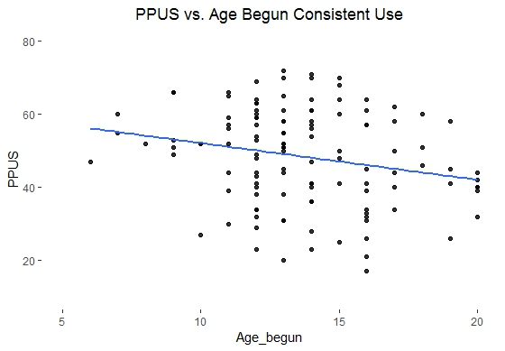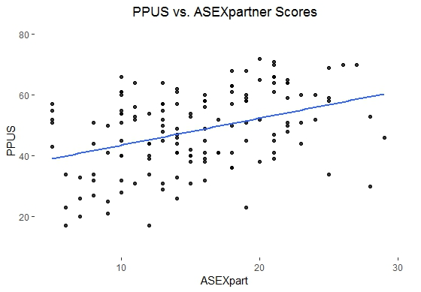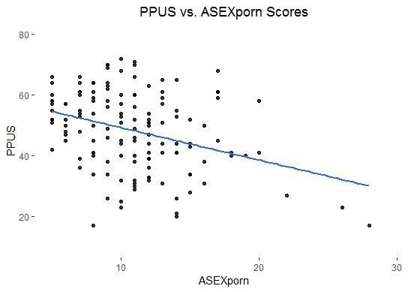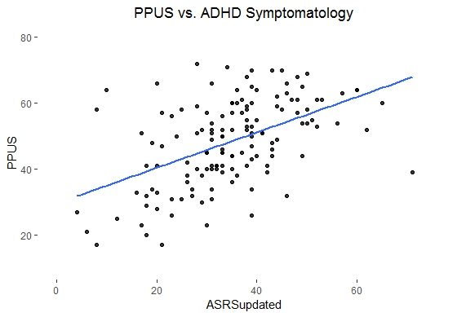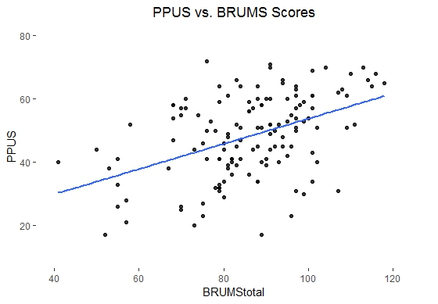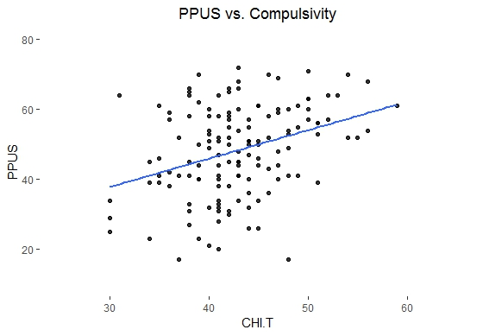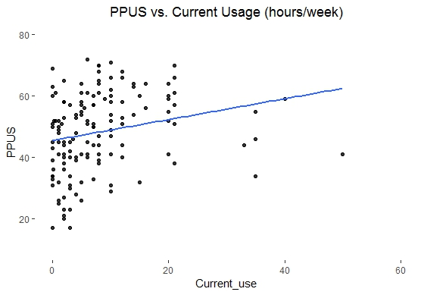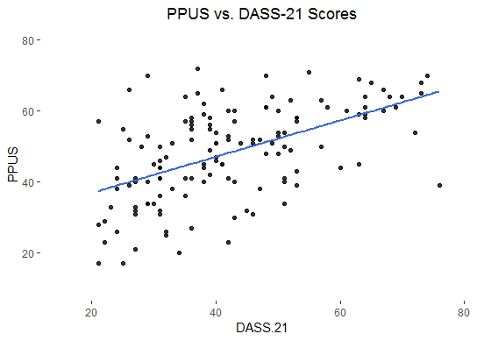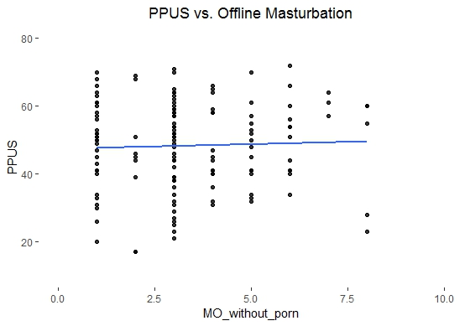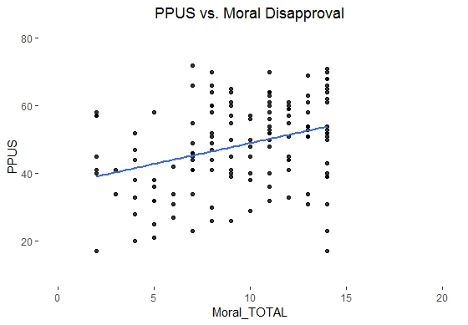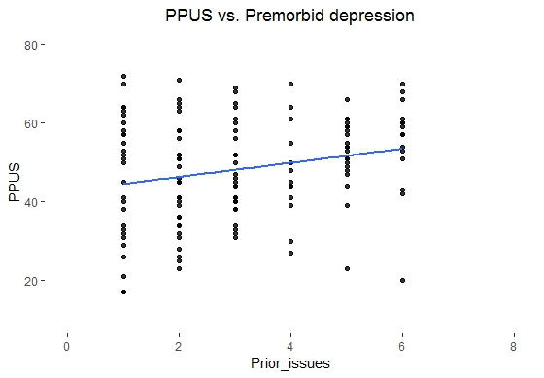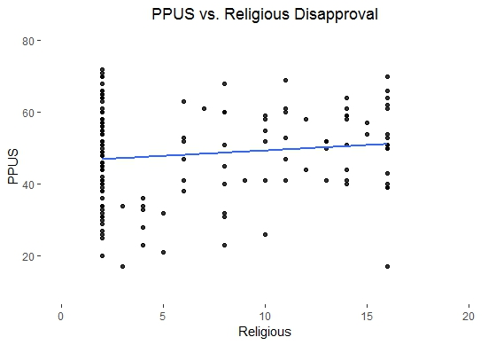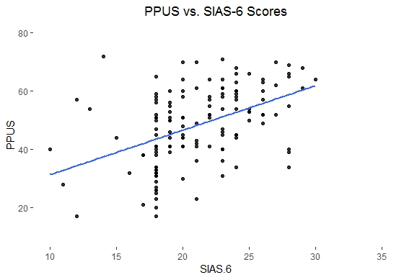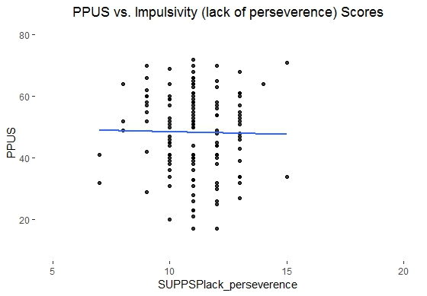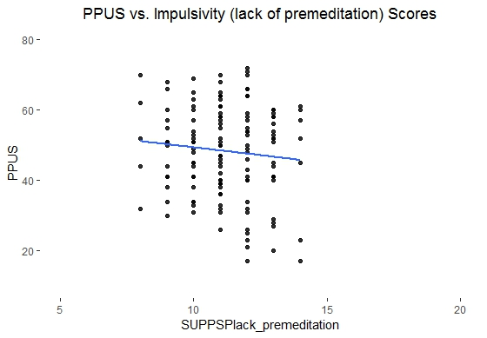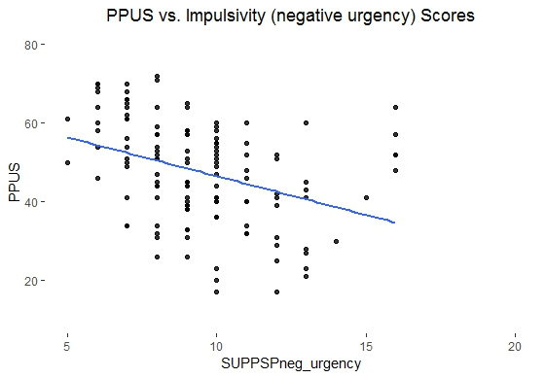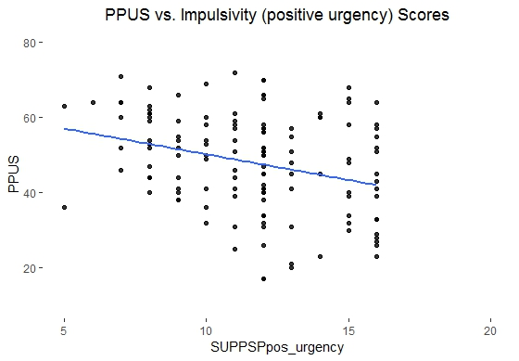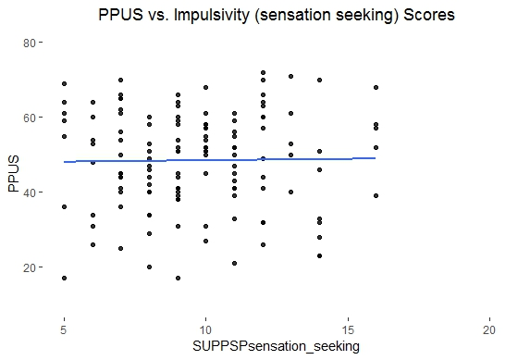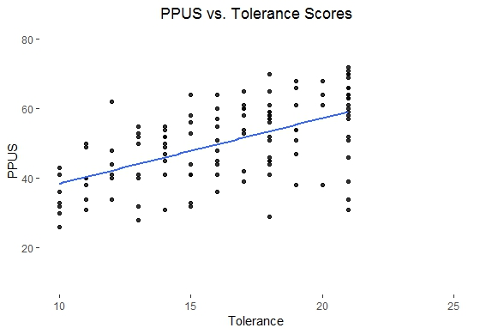
References
1. Kor A, Zilcha-Mano S, Fogel YA, Mikulincer M, Reid RC, Potenza MN. Psychometric development of the problematic pornography use scale. Addictive Behaviors. 2014;39(5):861-868. doi: 10.1016/j.addbeh.2014.01.027.
2. Borgogna NC, McDermott RC, Browning BR, Beach JD, Aita SL. How does traditional masculinity relate to men and women’s problematic pornography viewing? Sex Roles. 2019;80(11-12):693-706. doi: 0.1007/s11199-018-0967-8.
3. Allen A, Kannis-Dymand L, Katsikitis M. Problematic internet pornography use: The role of craving, desire thinking, and metacognition. Addct Behav. 2017;70:65-71. doi: 10.1016/j.addbeh.2017.02.001.
4. Sklenarik S, Potenza MN, Gola M, Kor A, Kraus SW, Astur RS. Approach bias for erotic stimuli in heterosexual male college students who use pornography. J Behav Addict. 2019;8(2):234-241. doi: 10.1556/2006.8.2019.31.
5. Cavaglion G. Cyber-porn dependence: voices of distress in an Italian internet self-help community. International Journal of Mental Health and Addiction. 2009;7(2):295-310. doi: 10.1007/s11469-008-9175-z.
6. Wilson G. Eliminate chronic internet pornography use to reveal its effects. Addicta. 2016;3:209-221. doi: 10.15805/addicta.2016.3.0107.
7. Terry P, Lane A. User guide for the Brunel mood scale (BRUMS). University of Southern Queensland, Australia, Toowoomba and University of Wolverhampton, Wolverhampton, UK. 2003.
8. McNair D, Lorr M, Droppelman L. San Diego, CA: Educational and Industrial Testing Service. Manual for the profile of mood states. 1971.
9. Terry PC, Lane AM, Fogarty GJ. Construct validity of the Profile of Mood States—Adolescents for use with adults. Psychol Sport Exerc. 2003;4(2):125-139.
10. Terry PC, Lane AM, Lane HJ, Keohane L. Development and validation of a mood measure for adolescents. Journal of sports sciences. 1999;17(11):861-872. doi: 10.1080/026404199365425.
11. Curran SL, Andrykowski MA, Studts JL. Short form of the profile of mood states (POMS-SF): psychometric information. Psychol Assess. 1995;7(1):80. doi: 10.1037/1040-3590.7.1.80.
12. Terry PC, Lane AM, Fogarty GJ. Construct validity of the Profile of Mood States—Adolescents for use with adults. Psychology of sport and exercise. 2003;4(2):125-139. doi: 10.1016/S1469-0292(01)00035-8.
13. Xu X, Ji H, Liu G, et al. A significant association between BDNF promoter methylation and the risk of drug addiction. Gene. 2016;584(1):54-59. doi: 10.1016/j.gene.2016.03.010.
14. Peters L, Sunderland M, Andrews G, Rapee RM, Mattick RP. Development of a short form Social Interaction Anxiety (SIAS) and Social Phobia Scale (SPS) using nonparametric item response theory: The SIAS-6 and the SPS-6. Psychol Assess. 2012;24(1):66. doi: 10.1037/a0024544.
15. Mattick RP, Clarke JC. Development and validation of measures of social phobia scrutiny fear and social interaction anxiety. Behav Res Ther. 1998;36(4):455-470. doi: 10.1016/S0005-7967(97)10031-6.
16. McGahuey CA, Gelenberg AJ, Laukes CA, et al. The Arizona sexual experience scale (ASEX): reliability and validity. Journal of Sex & Marital Therapy. 2000;26(1):25-40. doi: 10.1080/009262300278623.
17. Soykan A. The reliability and validity of Arizona sexual experiences scale in Turkish ESRD patients undergoing hemodialysis. Int J Impot Res. 2004;16(6):531. doi: doi.org/10.1038/sj.ijir.3901249.
18. Rosen RC, Cappelleri J, Smith M, Lipsky J, Pena B. Development and evaluation of an abridged, 5-item version of the International Index of Erectile Function (IIEF-5) as a diagnostic tool for erectile dysfunction. Int J Impot Res. 1999;11(6):319. doi: doi.org/10.1038/sj.ijir.3900472.
19. Voon V, Mole TB, Banca P, et al. Neural correlates of sexual cue reactivity in individuals with and without compulsive sexual behaviours. PloS One. 2014;9(7):e102419. doi: 10.1371/journal.pone.0102419.
20. Park B, Wilson G, Berger J, et al. Is Internet pornography causing sexual dysfunctions? A review with clinical reports. Behavioral Sciences. 2016;6(3):17. doi: 10.3390/bs6030017.
21. Bőthe B, Tóth-Király I, Zsila Á, Griffiths MD, Demetrovics Z, Orosz G. The development of the problematic pornography consumption scale (PPCS). The Journal of Sex Research. 2018;55(3):395-406. doi: 10.1080/00224499.2017.1291798.
22. Cyders MA, Littlefield AK, Coffey S, Karyadi KA. Examination of a short English version of the UPPS-P Impulsive Behavior Scale. Addictive Behaviors. 2014;39(9):1372-1376. doi: 10.1016/j.addbeh.2014.02.013.
23. Banca P, Morris LS, Mitchell S, Harrison NA, Potenza MN, Voon V. Novelty, conditioning and attentional bias to sexual rewards. Journal of Psychiatric Research. 2016;72:91-101. doi: 10.1016/j.jpsychires.2015.10.017.
24. Chamberlain SR, Grant JE. Initial validation of a transdiagnostic compulsivity questionnaire: the Cambridge–Chicago Compulsivity Trait Scale. CNS Spectrums. 2018;23(5):340-346. doi: 10.1017/S1092852918000810.
25. Lovibond PF, Lovibond SH. The structure of negative emotional states: Comparison of the Depression Anxiety Stress Scales (DASS) with the Beck Depression and Anxiety Inventories. Behavior Research and Therapy. 1995;33(3):335-343. doi: 10.1016/0005-7967(94)00075-u.
26. Osman A, Wong JL, Bagge CL, Freedenthal S, Gutierrez PM, Lozano G. The depression anxiety stress Scales—21 (DASS‐21): further examination of dimensions, scale reliability, and correlates. Journal of clinical psychology. 2012;68(12):1322-1338. doi: 10.1002/jclp.21908.
27. Loton D, Borkoles E, Lubman D, Polman R. Video game addiction, engagement and symptoms of stress, depression and anxiety: The mediating role of coping. International Journal of Mental Health and Addiction. 2016;14(4):565-578. doi: 10.1007/s11469-015-9578-6.
28. Pontes HM, Griffiths MD. Portuguese validation of the internet gaming disorder scale–short-form. Cyberpsychology, Behavior, and Social Networking. 2016;19(4):288-293. doi: 10.1089/cyber.2015.0605.
29. Williams AD, Grisham JR, Erskine A, Cassedy E. Deficits in emotion regulation associated with pathological gambling. British Journal of Clinical Psychology. 2012;51(2):223-238. doi: 10.1111/j.2044-8260.2011.02022.x.
30. Antony MM, Bieling PJ, Cox BJ, Enns MW, Swinson RP. Psychometric properties of the 42-item and 21-item versions of the Depression Anxiety Stress Scales in clinical groups and a community sample. Psychological assessment. 1998;10(2):176. doi: 10.1037/1040-3590.10.2.176.
31. Kessler RC, Adler L, Ames M, et al. The World Health Organization Adult ADHD Self-Report Scale (ASRS): a short screening scale for use in the general population. Psychological Medicine. 2005;35(2):245-256. doi: 10.1017/S0033291704002892.
32. Panagiotidi M. Problematic video game play and ADHD traits in an adult population. Cyberpsychology, Behavior, and Social Networking. 2017;20(5):292-295. doi: 10.1089/cyber.2016.0676.
33. Swingle MK. Electroencephalographic (EEG) brainmap patterns in a clinical sample of adults diagnosed with an Internet addiction, Fielding Graduate University; 2013.
34. Fernandez DP, Tee EY, Fernandez EF. Do Cyber Pornography Use Inventory-9 scores reflect actual compulsivity in internet pornography use? Exploring the role of abstinence effort. Sexual Addiction & Compulsivity. 2017;24(3):156-179. doi: 10.1080/10720162.2017.1344166.
35. Grubbs JB, Exline JJ, Pargament KI, Hook JN, Carlisle RD. Transgression as addiction: Religiosity and moral disapproval as predictors of perceived addiction to pornography. Archives of Sexual Behavior. 2015;44(1):125-136. doi: 10.1007/s10508-013-0257-z.
36. Wilt JA, Cooper EB, Grubbs JB, Exline JJ, Pargament KI. Associations of perceived addiction to internet pornography with religious/spiritual and psychological functioning. Sex Addict Compulsivity. 2016;23(2-3):260-278. doi: 10.1080/10720162.2016.1140604.
37. Chandler J, Mueller P, Paolacci G. Nonnaïveté among Amazon Mechanical Turk workers: Consequences and solutions for behavioral researchers. Behavior research methods. 2014;46(1):112-130.
38. Hauser DJ, Schwarz N. Attentive Turkers: MTurk participants perform better on online attention checks than do subject pool participants. Behavior research methods. 2016;48(1):400-407.

