Electronic Supplementary File-2

Schizophrenia phenomenology revisited: positive and negative symptoms are strongly related reflective manifestations of an underlying single trait indicating overall severity of schizophrenia.

Abbas F. Almulla ª, Hussein Kadhem Al-Hakeim ^{b}, Michael Maes* ^{c, d, e}

ª Medical Laboratory Technology Department, College of Medical Technology, The Islamic University, Najaf, Iraq. E-mail: abbass.chem.almulla1991@gmail.com.
^{b} Department of Chemistry, College of Science, University of Kufa, Iraq. E-mail: headm2010@yahoo.com.
^{c*} Department of Psychiatry, Faculty of Medicine, Chulalongkorn University, Bangkok, Thailand;
^{d} Department of Psychiatry, Medical University of Plovdiv, Plovdiv, Bulgaria;
^{e} IMPACT Strategic Research Centre, Deakin University, PO Box 281, Geelong, VIC, 3220, Australia.

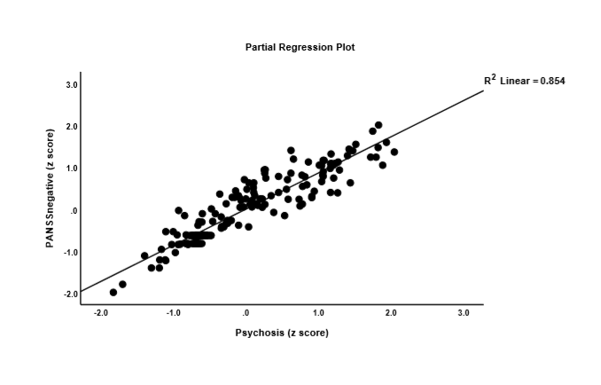

ESF-2, Figure 1. Partial regression plot between the PANSS negative subscale score and psychosis domain score in controls and patients with major neuro-cognitive psychosis or deficit schizophrenia (data were adjusted for education, sex and hostility).

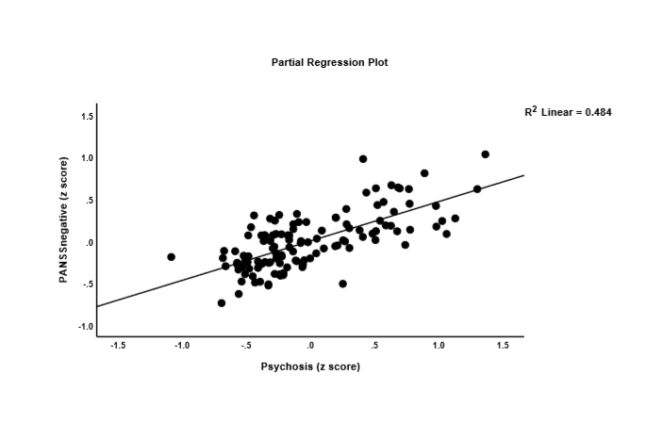
ESF-2, Figure 2. Partial regression plot between the PANSS negative subscale score and psychosis domain score in the restricted sample of patients major neuro-cognitive psychosis or deficit schizophrenia (data were adjusted for education, sex and hostility).

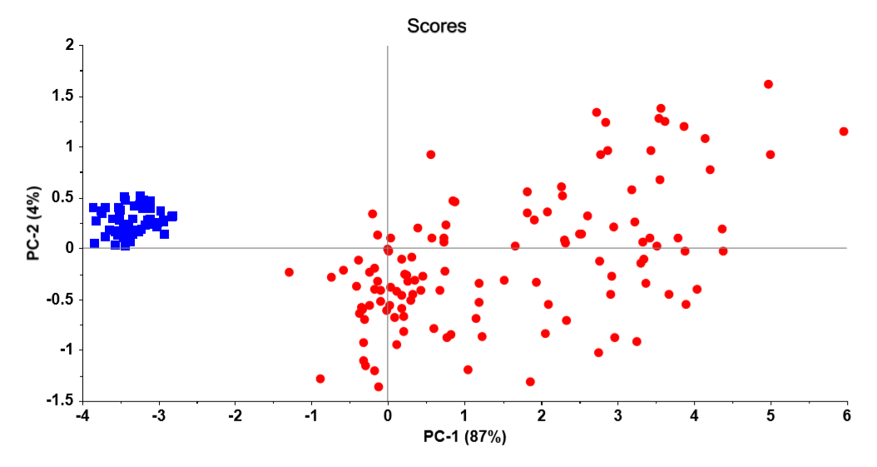

ESF-2, Figure 3. Principal Component (PC) plot, namely PC1 (explaining 87% of the variance) vs PC2 (explaining 4%) performed on 8 symptom domains, namely hostility, psychomotor retardation, excitation, mannerism, SANS total score, formal thought disorders, PANSS negative subscale score and psychosis. This plot displays the distribution of patients with major neuro-cognitive psychosis or deficit schizophrenia (red dots) and healthy controls (blue squares).

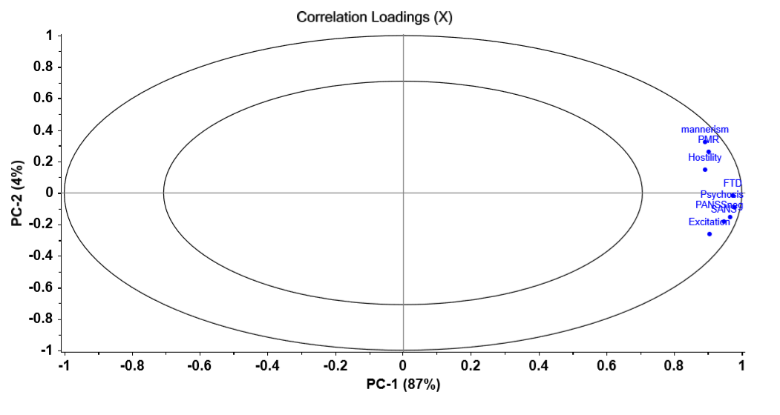

ESF-2, Figure 4. Correlation loading plot. The plot shows the correlation loadings of the 8 symptom domains used to perform principal component analysis (PCA) as shown in figure 3. All variables are located between both ellipses and group together.
PMR: psychomotor retardation
FTD: formal thought disorders
PANSSneg: total score on the PANSS negative subscale score
SANS: total score on the SANS

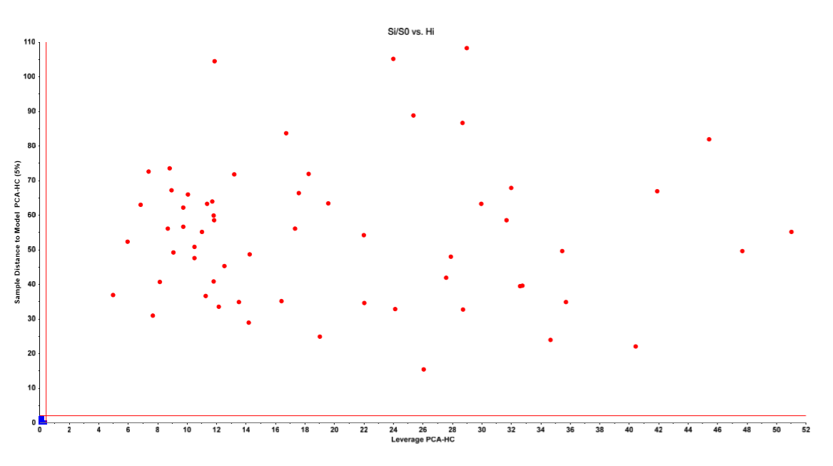

ESF-2, Figure 5. Si/S0 vs Hi plot obtained by SIMCA. SIMCA was performed with 8 symptom domains as modeling/discriminatory variables, namely hostility, psychomotor retardation, excitation, mannerism, SANS total score, formal thought disorders, PANSS negative subscale score and psychosis.
This plot shows the distances of all subjects allocated to the test set to the critical limits of the control class (blue squares) as well as their leverage to the same class. All healthy control subjects were correctly authenticated as belonging to the control target class while no patients with major neuro-cognitive psychosis or deficit schizophrenia intruded into the critical limits of the control class. All patients showed very large distances and leverages toward the class model and center, respectively.

