Supplemental Figure 2. By-Week Change in CGI-S Score From Baseline to Week 6 in Patients (A) With or (B) Without Manic Symptoms (MMRM)
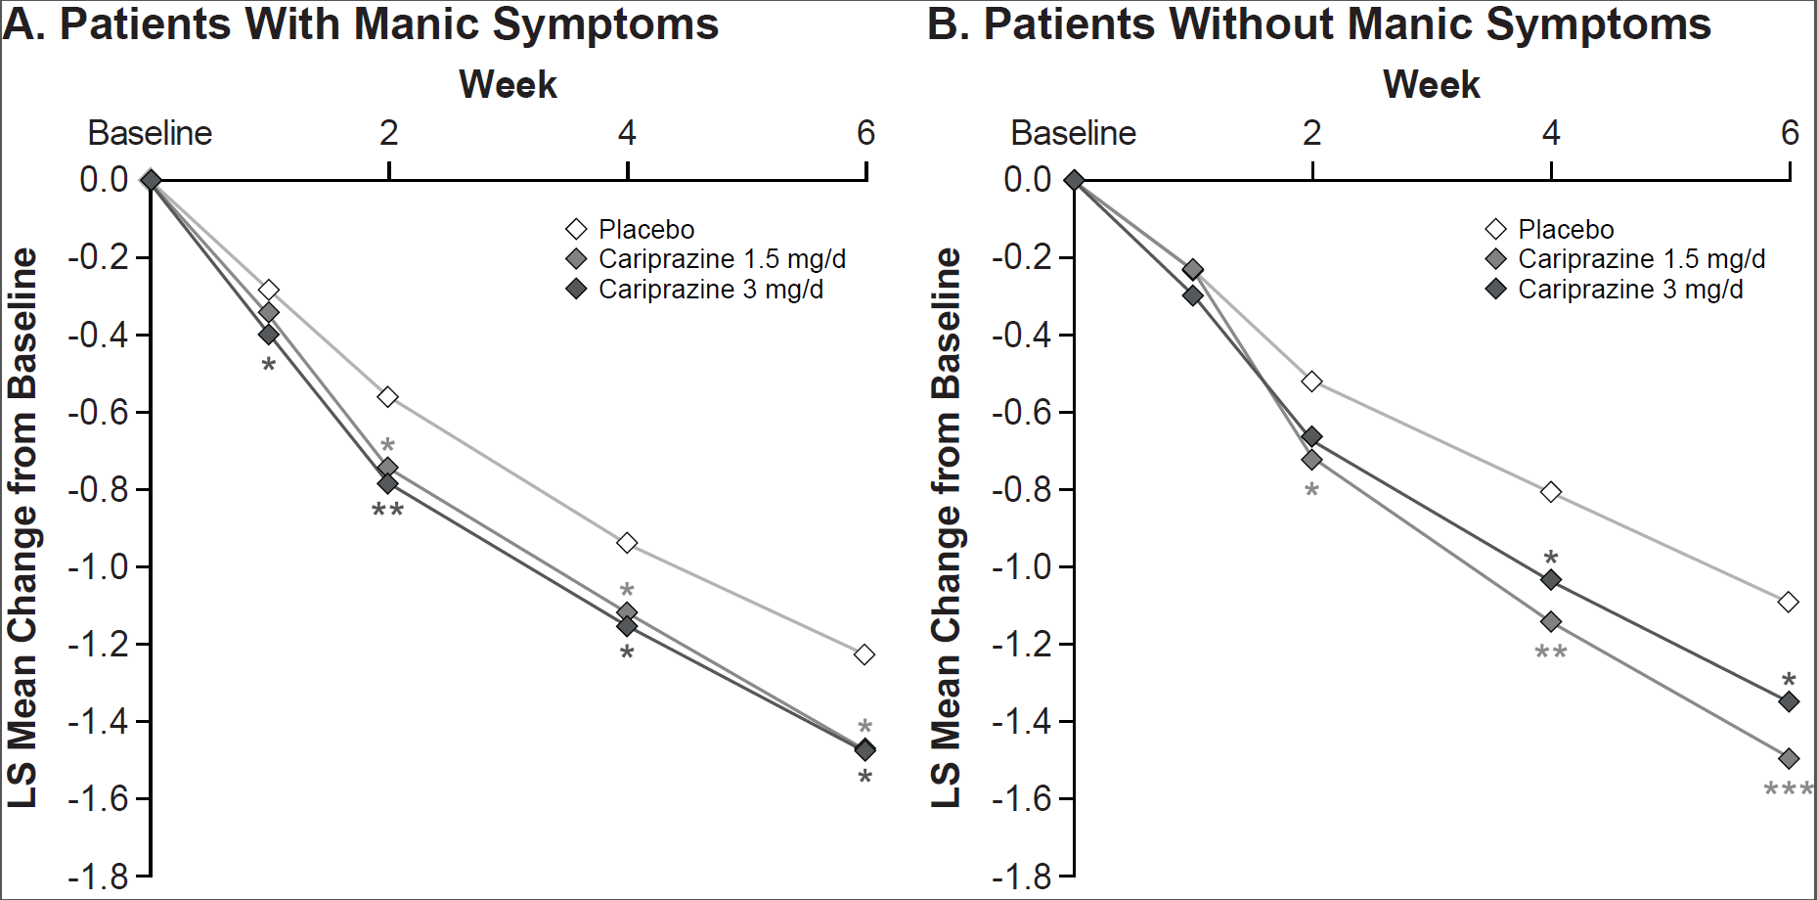
*P<.05, **P<.01, ***P<.001 vs placebo.
CGI-S, Clinical Global Impressions-Severity Scale; LS, least squares; MMRM, mixed-effects model for repeated measures.

