Supplemental Figure 1. By-Week Change in HAMD₁₇ Total Score From Baseline to Week 6 in Patients (A) With or (B) Without Manic Symptoms (MMRM)
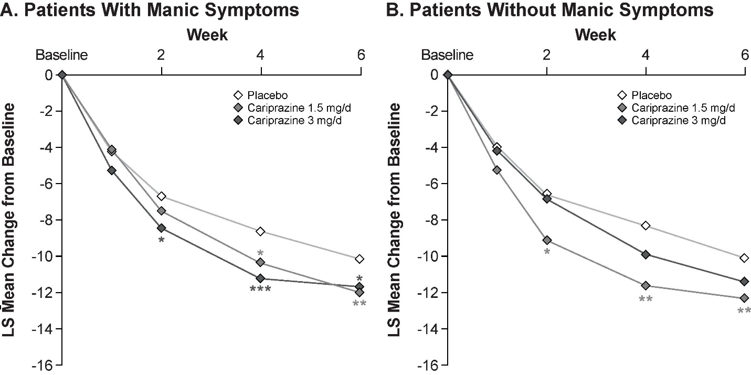
*P<.05, **P<.01, ***P≤.001 vs placebo.
HAMD₁₇, 17-item Hamilton Depression Rating Scale; LS, least squares; MMRM, mixed-effects model for repeated measures.

