Supplementary File

**Figure S1. Distribution of total scores on the EAI.**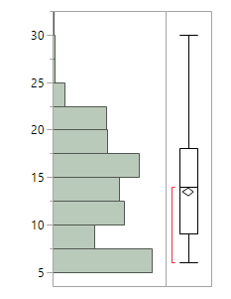

**Figure S2. Scree plot for factor analysis of EAI and eigenvalues for latent factors.**

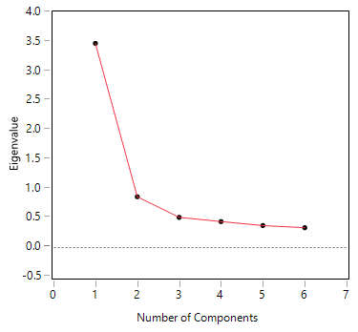

| **Number** | **Eigenvalue** | **Percent** |  | **Cum Percent** |
| --- | --- | --- | --- | --- |
| 1 | 3.4745 | 57.909 |  | 57.909 |
| 2 | 0.8633 | 14.388 |  | 72.297 |
| 3 | 0.5123 | 8.539 |  | 80.836 |
| 4 | 0.4404 | 7.340 |  | 88.176 |
| 5 | 0.3729 | 6.215 |  | 94.391 |
| 6 | 0.3365 | 5.609 |  | 100.000 |

**Figure S3. Distribution of responses for each EAI item.**

**EAI Exercise is the most important thing in life (Q1)**



**Frequencies**

| **Level** | **Count** | **Prob** |
| --- | --- | --- |
| 1 | 210 | 0.32710 |
| 2 | 215 | 0.33489 |
| 3 | 151 | 0.23520 |
| 4 | 54 | 0.08411 |
| 5 | 12 | 0.01869 |
| Total | 642 | 1.00000 |

**EAI Exercise causes conflicts (Q2)**



**Frequencies**

| **Level** | **Count** | **Prob** |
| --- | --- | --- |
| 1 | 405 | 0.63084 |
| 2 | 150 | 0.23364 |
| 3 | 47 | 0.07321 |
| 4 | 33 | 0.05140 |
| 5 | 7 | 0.01090 |
| Total | 642 | 1.00000 |

**EAI Use exercise to change mood (Q3)**



**Frequencies**

| **Level** | **Count** | **Prob** |
| --- | --- | --- |
| 1 | 169 | 0.26324 |
| 2 | 76 | 0.11838 |
| 3 | 118 | 0.18380 |
| 4 | 228 | 0.35514 |
| 5 | 51 | 0.07944 |
| Total | 642 | 1.00000 |

**EAI Escalation of exercise over time (Q4)**



**Frequencies**

| **Level** | **Count** | **Prob** |
| --- | --- | --- |
| 1 | 201 | 0.31308 |
| 2 | 149 | 0.23209 |
| 3 | 105 | 0.16355 |
| 4 | 152 | 0.23676 |
| 5 | 35 | 0.05452 |
| Total | 642 | 1.00000 |

**EAI Irritable when miss exercise (Q5)**



**Frequencies**

| **Level** | **Count** | **Prob** |
| --- | --- | --- |
| 1 | 274 | 0.42679 |
| 2 | 159 | 0.24766 |
| 3 | 109 | 0.16978 |
| 4 | 82 | 0.12773 |
| 5 | 18 | 0.02804 |
| Total | 642 | 1.00000 |

**EAI Difficulty cutting back (Q6)**



**Frequencies**

| **Level** | **Count** | **Prob** |
| --- | --- | --- |
| 1 | 229 | 0.35670 |
| 2 | 141 | 0.21963 |
| 3 | 155 | 0.24143 |
| 4 | 95 | 0.14798 |
| 5 | 22 | 0.03427 |
| Total | 642 | 1.00000 |