Overlapping dimensional phenotypes of impulsivity and compulsivity
explain co-occurrence of addictive and related behaviors
Supplementary Materials

Table S1
Summary of Fit Statistics for the Different Competing Confirmatory Factor Analysis Models for the UPPS-P in the Calibration Subsample
 | Model | df | χ² | p | RMSEA (90%CI) | CFI | WRMR
1 | Correlated Five-Factor 1¹ | 1638 | 2831.884 | <.001 | .055 (.051 - .058) | .947 | 1.442
2 | Correlated Five-Factor 2 ^{2,3} | 1639 | 2760.344 | <.001 | .053 (.050 - .056) | .950 | 1.442
3 | Correlated Five-Factor 3 ^{3,4} | 1640 | 2747.025 | <.001 | .053 (.049 - .056) | .951 | 1.444
4 | Four Factor ⁵ | 1644 | 3039.262 | <.001 | .059 (.056 - .062) | .938 | 1.604
5 | One Factor | 1652 | 6970.678 | <.001 | .115 (.112 - .118) | .763 | 2.927
6 | Bi-Factor 1 ⁶ | 1602 | 2188.091 | <.001 | .039 (.035 - .043) | .974 | 1.124
7 | Bi-Factor 2 ⁷ | 1606 | 2207.919 | <.001 | .039 (.035 - .043) | .973 | 1.143
Note. UPPS-P = UPPS-P Impulsive Behavior Scale + Positive Urgency Measure. Thirty-nine items were recoded so that higher scores on each of the factors represent greater levels of impulsivity. df = Degress of Freedom; χ² = Chi square value for test of model fit estimated using Weighted Least Squares Means and Variance Adjusted (WLSMV); p = significance value of the chi square test statistic; RMSEA = Root Mean Square Error of Approximation; CI = Confidence Interval; WRMR = Weighted Root Mean Residual; CFI = Comparative Fit Index. Calibration subsample n = 244.
¹ Included error covariance terms; ² Sensation Seeking and Perseverance intercorrelation constrained to zero; ³ Nested with respect to the theoretical model; ⁴ Sensation Seeking & Perseverance intercorrelation constrained to zero, PU & NU intercorrelation constrained to one; ⁵ Latent variable covariance (Psi) matrix was not positive definite, however logical values were obtained for all parameter estimates; ⁶ Bifactor model included 5 correlated group factors; ⁷ Bifactor model included 4 correlated group factors with a unitary ‘Urgency’ factor combining Positive and Negative Urgency items.
H index (UPPS-P-General = .96; Lack of Premeditation-Specific = .92; Urgency-Specific = .95; Sensation Seeking-Specific = .95; Lack of Perseverance-Specific = .89)
Explained Common Variance (ECV) = .33; Percentage of Uncontaminated Correlations (PUC) = .52.
Table S2
Summary of Fit Statistics for the Different Competing Confirmatory Factor Analysis Models for the Intolerance of Uncertainty Scale (IUS-12) in the Calibration Subsample
 | Model | df | χ² | p | RMSEA (90%CI) | CFI | WRMR
1 | Two-Factor ¹ | 53 | 314.527 | <.001 | .142 (.127 - .158) | .954 | 1.305
2 | One-Factor ² | 49 | 433.534 | <.001 | .179 (.164 - .195) | .933 | 1.545
3 | Bi-Factor | 43 | 102.216 | <.001 | .075 (.056 - .094) | .990 | .553
Note. IUS = Intolerance of Uncertainty Scale – 12-item version. df = Degress of Freedom; χ² = Chi square value for test of model fit estimated using Weighted Least Squares Means and Variance Adjusted (WLSMV); p = significance value of the chi square test statistic; RMSEA = Root Mean Square Error of Approximation; CI = Confidence Interval; WRMR = Weighted Root Mean Square Residual; CFI = Comparative Fit Index. Calibration subsample n = 244. Factor structure of models 1 and 3 were taken from the literature ³³.
¹ Included error covariances; ² Nested with respect to the theoretical model.
H index (IUS-General = .94; Desire for Predictability and an Active Engagement is Seeking Certainty = .65; Paralysis of Cognition and Action in the Face of Uncertainty = .68)
Explained Common Variance (ECV) = .69; Percentage of Uncontaminated Correlations (PUC) = .62.

Table S3
Summary of Fit Statistics for the Different Competing Confirmatory Factor Analysis Models for the OBQ-44 in the Calibration Subsample
 | Model | df | χ² | p | RMSEA (90%CI) | CFI | WRMR
1 | Correlated Three-Factor ¹ | 894 | 2964.185 | <.001 | .097 (.094 - .101) | .869 | 1.864
2 | Correlated Four-Factor ¹ | 891 | 3025.312 | <.001 | .099 (.095 - .103) | .865 | 1.876
3 | One-Factor | 902 | 4301.597 | <.001 | .124 (.121 - .128) | .785 | 2.397
4 | Bi-Factor 1^{2,3} | 856 | 2598.796 | <.001 | .091 (.087 - .095) | .890 | 1.619
5 | Bi-Factor 2 ^{1,4} | 850 | 2049.554 | <.001 | .076 (.072 - .080) | .924 | 1.338
Note. OBQ-44 = Obsessive Beliefs Questionnaire – 44-item version. df = Degress of Freedom; χ² = Chi square value for test of model fit estimated using Weighted Least Squares Means and Variance Adjusted (WLSMV); p = significance value of the chi square test statistic; RMSEA = Root Mean Square Error of Approximation; CI = Confidence Interval; WRMR = Weighted Root Mean Square Residual; CFI = Comparative Fit Index; Calibration subsample n = 244.
Competing models 1 and 2 were taken from the literature ^{27,31}; ¹ Included error covariance terms; ² Latent variable (psi) covariance matrix was not positive definite, but logical estimates were obtained for all parameters; ³ Bi-Factor model included four orthogonal group factors – Perfectionism and Intolerance of Uncertainty-Specific, Importance and Control of Thoughts-Specific, Responsibility-Specific, and Overestimation of Threat -Specific ³¹; ⁴ Bi-Factor model included three orthogonal group factors – Perfectionism-Specific, Importance and Control of Thought-Specific, and Responsibility and Threat Estimation-Specific ²⁷.
H index (OBQ-General = .97; Perfectionism and Intolerance of Uncertainty-Specific = .80; Importance and Control of Thought-Specific = .81; Responsibility and Threat Estimation-Specific = .77)
Explained Common Variance (ECV) = .69; Percentage of Uncontaminated Correlations (PUC) = .61.

Table S4

Results of Invariance Testing for the UPPS-P, IUS-12, and OBQ-44 in the Calibration and Validation Subsamples

 | Model | df | χ² | p | RMSEA (90%CI) | CFI | WRMR | Δdf | Δχ² | p
UPPS-P | Configural Invariance | 3215 | 4485.086 | <.001 | .040 (.037 - .043) | .970 | 1.657
 | Measurement Invariance | 3490 | 4410.821 | <.001 | .033 (.030 - .036) | .979 | 1.810 | 275 | 307.920 | .084
IUS-12 | Configural Invariance ¹ | 87 | 177.457 | <.001 | .065 (.052 - .079) | .992 | .739
 | Measurement Invariance | 153 | 196.358 | .010 | .034 (.017 - .047) | .996 | 1.324 | 66 | 83.150 | .075
OBQ-44 | Configural Invariance ² | 1704 | 3938.315 | <.001 | .073 (.070 - .076) | .926 | 1.442
 | Measurement Invariance ³ | 2059 | 2755.649 | <.001 | .037 (.034 -.041) | .977 | 2.090 | 355 | 390.451 | .095

Note. UPPS-P = UPPS Impulsive Behavior Scale + Positive Urgency Measure; OBQ-44 = Obsessive Beliefs Questionnaire – 44-item version. IUS -12 = Intolerance of Uncertainty – 12-item version. Delta degrees of freedom (Δdf) and delta chi square (Δχ²) obtained using the ‘DIFFTEST’ option of Mplus ⁴⁸. Calibration subsample n = 244; Validation subsample n = 243.
¹ Partial configural invariance - the validation subsample did not include secondary loadings of items 4 and 6 on the Desire for Predictability and an Active Engagement in Certainty Seeking-Specific group factor; ² Partial configural invariance - the validation subsample did not include a secondary loading of item 38 on the Perfectionism-Specific group factor; ³ Measurement invariance includes equality of the factor loadings (metric invariance) and item thresholds (scalar invariance). In the theta parameterization, item loadings and thresholds are constrained to equality in the same step and error variances cannot be directly compared ⁴⁸. Latent means and variances of categorical data are arbitrary, therefore comparison across groups is considered less meaningful ⁵².

Table S5
Intercorrelations Amongst the Variables for the Validation Subsample
 | 1 | 2 | 3 | 4 | 5 | 6 | 7 | 8 | 9 | 10 | 11 | 12 | 13 | 14 | 15 | 16 | 17 | 18
1. Age
2. Impulsivity | -.009
3. Urgency | -.055 | .136*
4. Sensation Seek | -.217** | .046 | .534***
5. Premeditation | -.088 | .077 | .417*** | .442***
6. Perseverance | -.017 | .059 | .199** | .045 | .371***
7. Intolerance | -.028 | .397*** | .006 | -.262*** | -.384*** | -.097
8. Paralysis | -.135* | .325*** | .216** | -.001 | .053 | .267*** | .115^
9. Predictability | .040 | -.238*** | -.165* | -.083 | -.301*** | -.285*** | .112^ | -.173**
10. Obsessive | -.103 | .378*** | .217*** | -.088 | -.225*** | -.048 | .652*** | .235*** | .201***
11. Control | .007 | .169** | .271*** | .031 | .158* | -.049 | .013 | .196** | -.205** | .080
12. Perfection | .127* | -.165* | -.067 | -.097 | -.249*** | -.244*** | .184** | -.075 | .209*** | .060 | -.143*
13. Threat | .072 | -.424*** | -.163* | .013 | -.077 | -.212** | -.121^ | -.354*** | .436*** | .022 | -.188** | .024
14. AUDIT | -.030 | .226*** | .304*** | .381*** | .135* | .062 | .022 | .058 | .051 | .078 | -.087 | .042 | -.064
15. PGSI | .010 | .174** | .274*** | .093 | .015 | -.099 | .070 | .151* | .006 | .229*** | .196** | .039 | -.128* | .164*
16. CBS ¹ | -.095 | -.493*** | -.249*** | -.062 | -.082 | -.142* | -.221** | -.223*** | .209** | -.280*** | -.264*** | .052 | .284*** | -.127* | -.282***
17. OCI-R ² | .034 | -.368*** | -.103 | .064 | .226*** | .101 | -.419*** | -.231*** | -.047 | -.489*** | -.140* | -.146* | .121^ | -.108^ | -.251*** | .338***
18. BES | -.022 | .505*** | -.016 | -.073 | -.034 | .057 | .306*** | .181** | .031 | .384*** | -.016 | -.009 | -.138* | .164* | .230*** | -.349*** | -.380***
19. GPIUS2 | -.204** | .493*** | .091 | .040 | -.059 | .144* | .286*** | .381*** | -.176** | .335*** | .106 | -.149* | -.309*** | .093 | .092 | -.394*** | -.296*** | .409***
Note. Impulsivity = Impulsivity-General (UPPS-P); Urgency = Negative and Positive Urgency-Specific (UPPS-P); Sensation Seek = Sensation Seeking-Specific (UPPS-P); Premeditation = Lack of Premeditation Specific (UPPS-P); Perseverance = Lack of Perseverance-Specific (UPPS-P); Intolerance = Intolerance of Uncertainty-General (IUS-12); Paralysis = Paralysis of Cognition and Action in the Face of Uncertainty-Specific (IUS-12); Predictability = Desire for Predictability-Specific (IUS-12); Obsessive = Obsessive Beliefs General (OBQ-44); Perfectionism = Perfectionism Specific (OBQ-44); Importance = Importance and Control of Thoughts Specific (OBQ-44);; Responsibility = Responsibility and Threat Assessment (OBQ-44); AUDIT = Alcohol Use Disorder Identification Test; PGSI = Problem Gambling Severity Index; CBS = Compulsive Buying Scale; OCI-R = Obsessive-Compulsive Inventory-Revised; BES = Binge Eating Scale; GPIUS2 = Generalized Pathological Internet Use Scale – Version 2. ¹ Lower scores are indicative of greater frequency / severity of symptoms; ² Variable underwent inverse transformation, thus lower scores indicate greater frequency / severity of symptoms. *** p < .001; ** p < .01; * p < .05; ^ p < .10. n = 244.
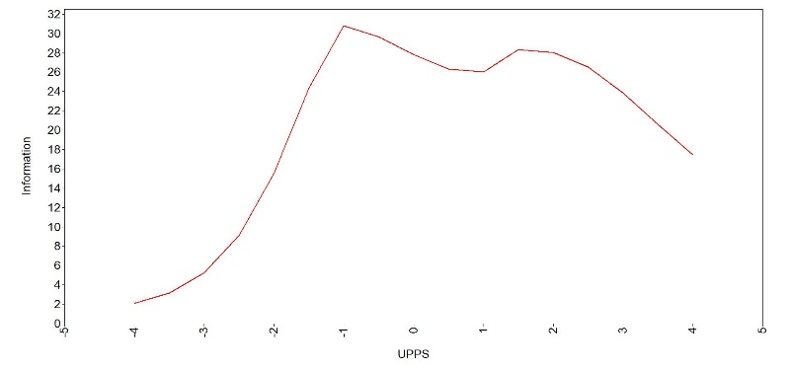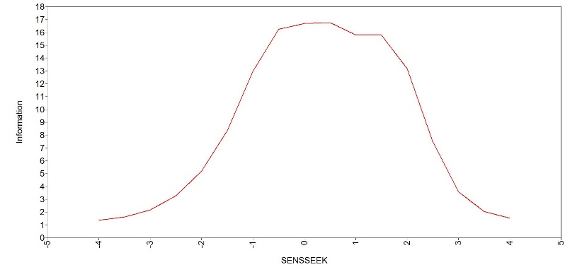
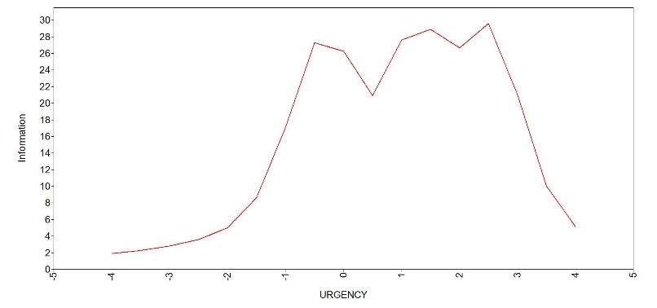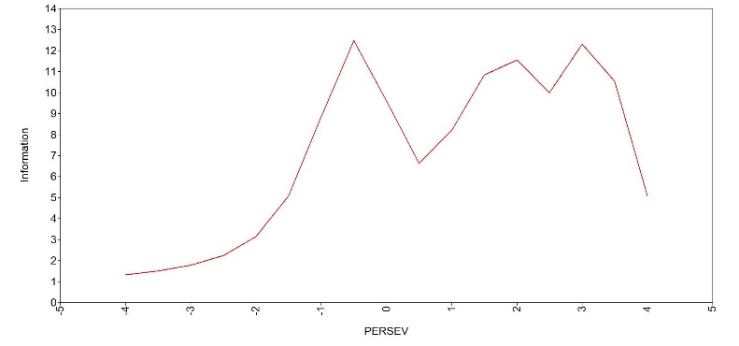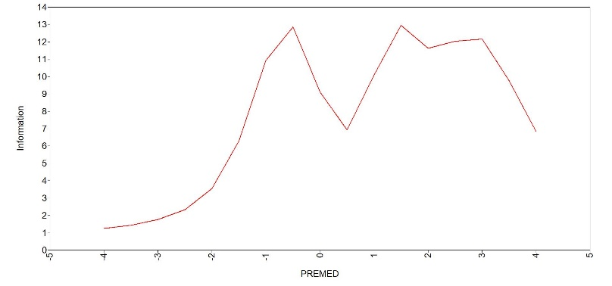
Figure 1. Information functions for the latent traits derived from the bi-factor model of the UPPS-P in the calibration subsample.
Note. UPPS = UPPS-P General; SENSEEK = Sensation Seeking-Specific; URGENCY = Urgency-Specific; PERSEV = Lack of Perseverance-Specific; PREMED = Lack of Premeditation-Specific.
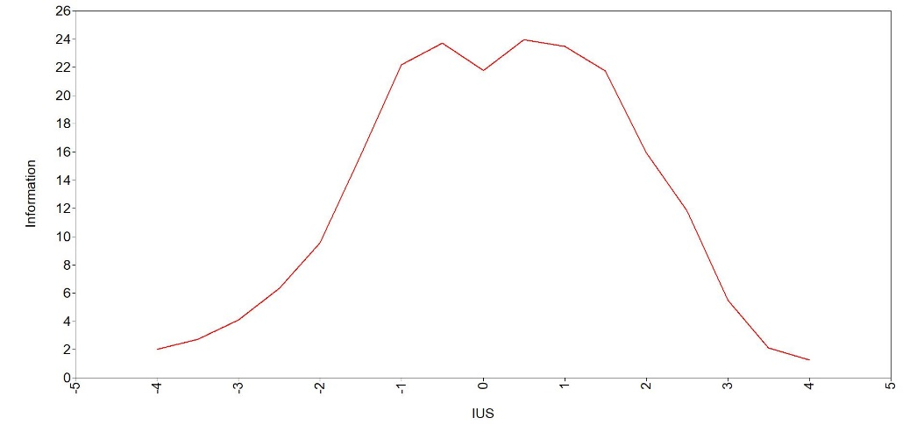
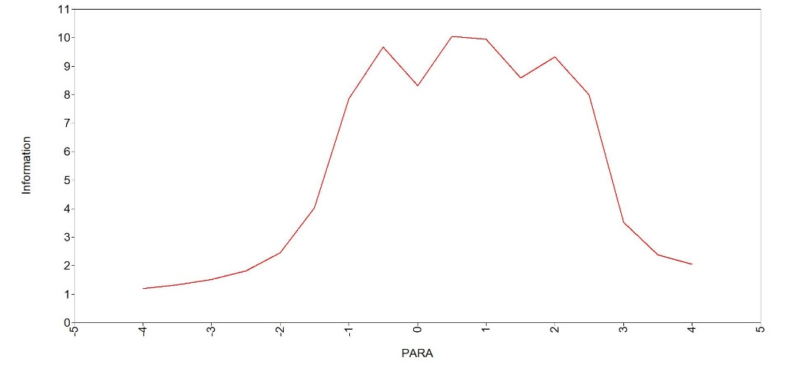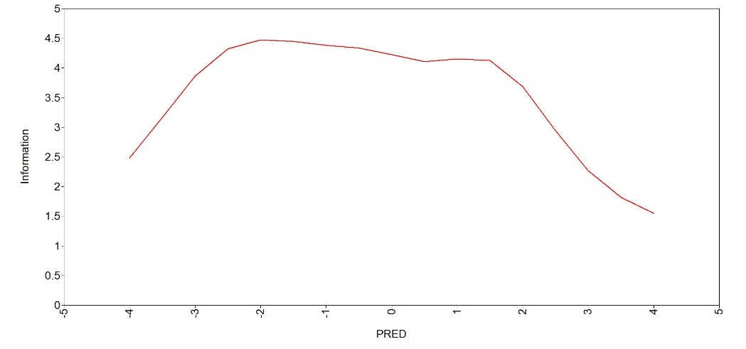
Figure 2. Information functions for the latent traits derived from the bi-factor model of the IUS-12 in the calibration subsample.
Note. IUS = IUS-12 General; PARA = Paralysis of Cognition and Action in the Face of Uncertainty-Specific; PRED = Need for Predictability and an Active Engagement in Seeking Certainty-Specific.

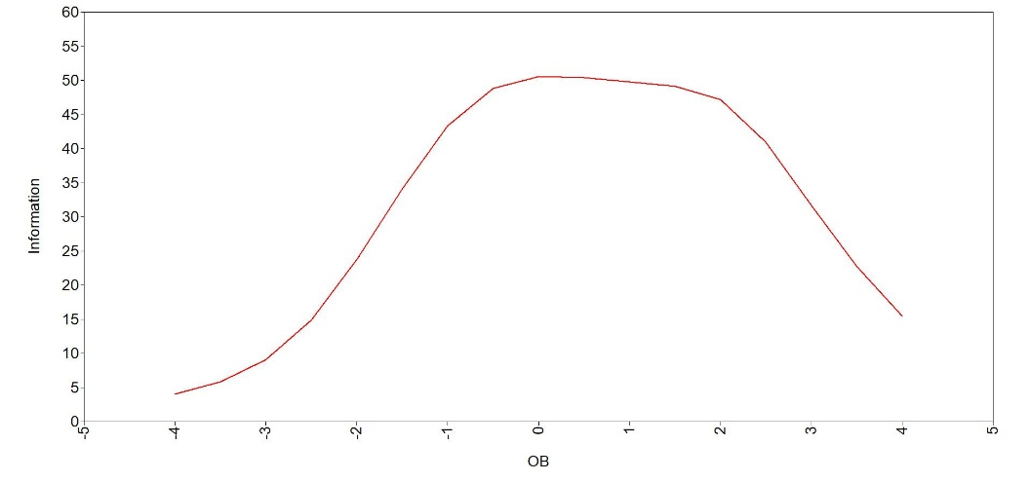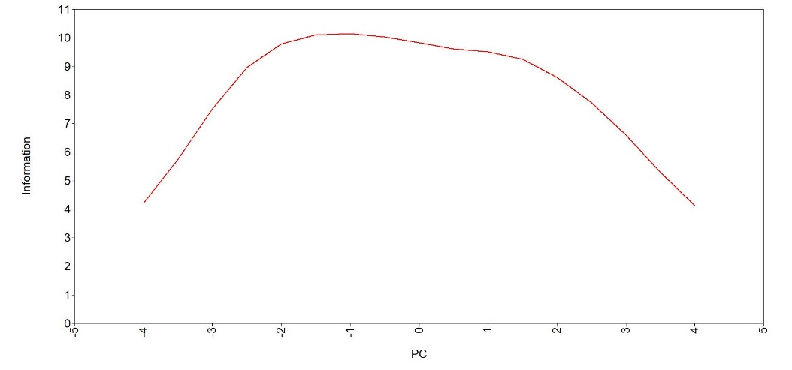
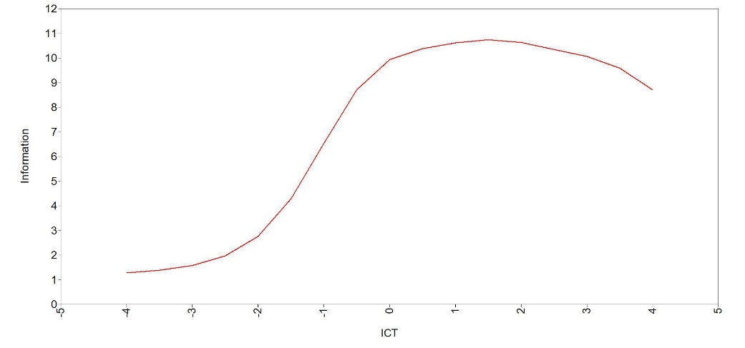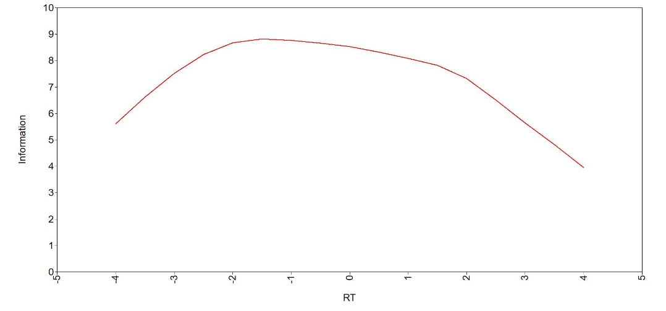
Figure 3. Information functions for the latent traits derived from the bi-factor model of the OBQ-44 in the calibration subsample.
Note. OB = OBQ-44 General; PC = Perfectionism-Specific; ICT = Importance and Control of Thoughts-Specific; RT = Responsibility and Threat Estimation-Specific.

