SUPPLEMENTAL MATERIALS (to be made available online)

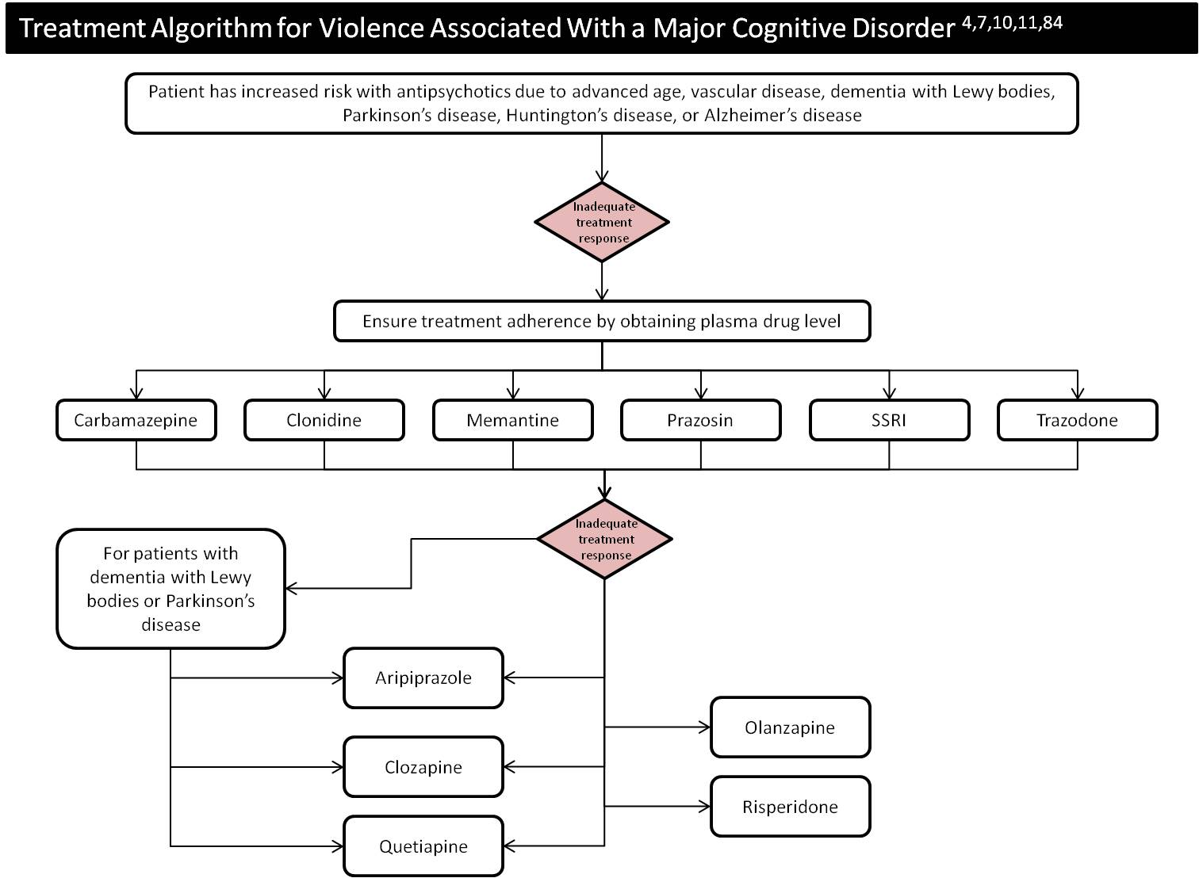
Supplemental Figure 1. Treatment Algorithm for Violence Associated With a Major Cognitive Disorder

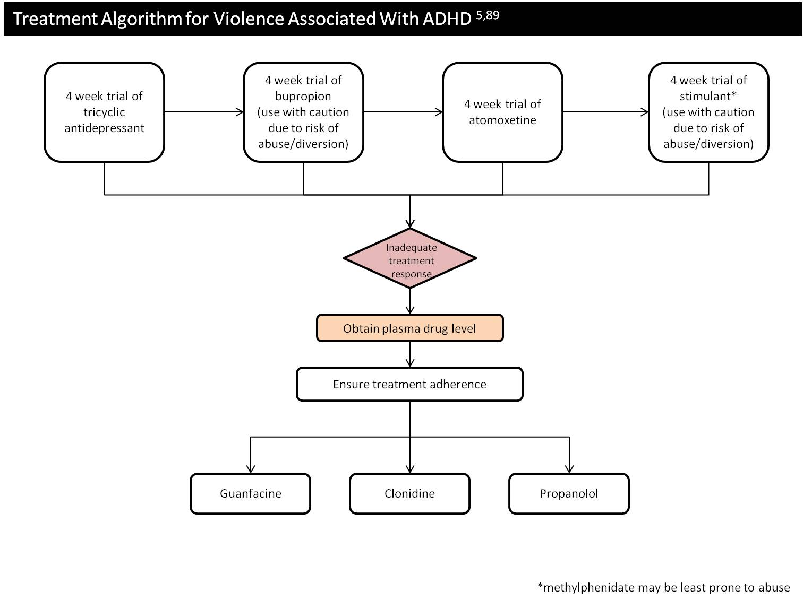
Supplemental Figure 2. Treatment Algorithm for Violence Associated With ADHD

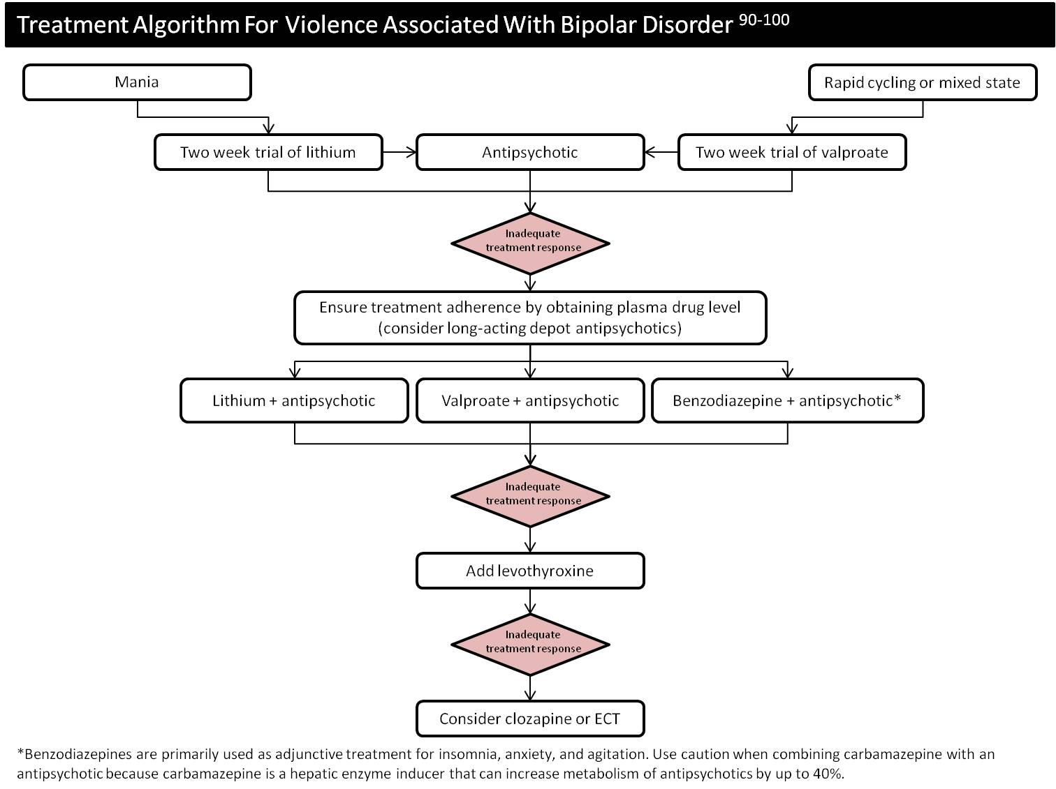
Supplemental Figure 3. Treatment Algorithm for Violence Associated With Bipolar Disorder

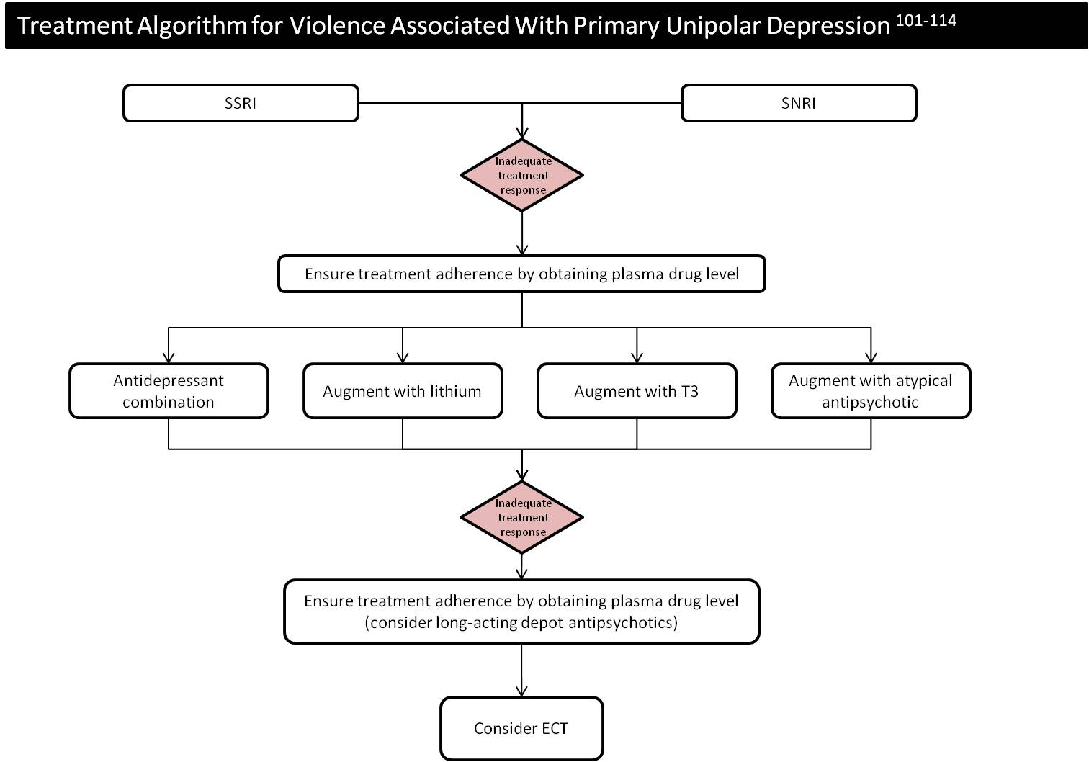
Supplemental Figure 4. Treatment Algorithm for Violence Associated With Primary Unipolar Depression

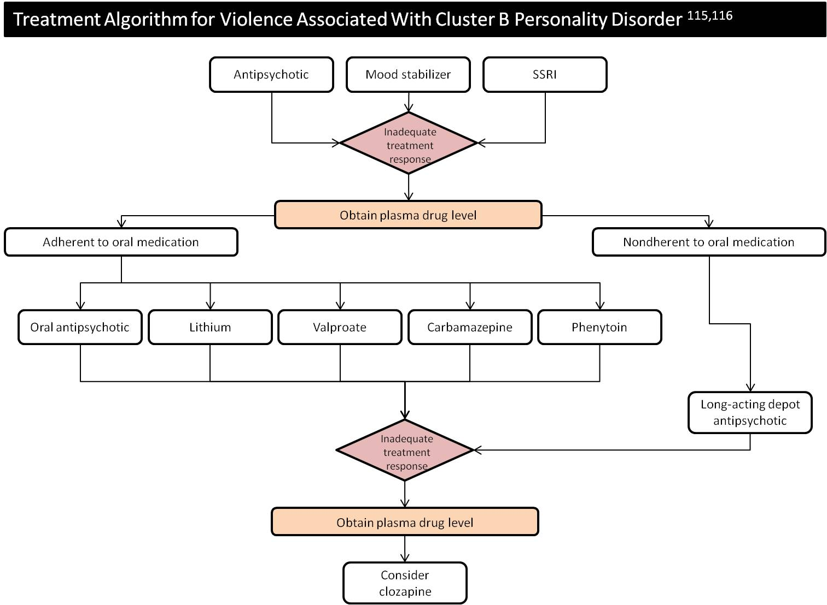
Supplemental Figure 5. Treatment Algorithm for Violence Associated With Cluster B Personality Disorder

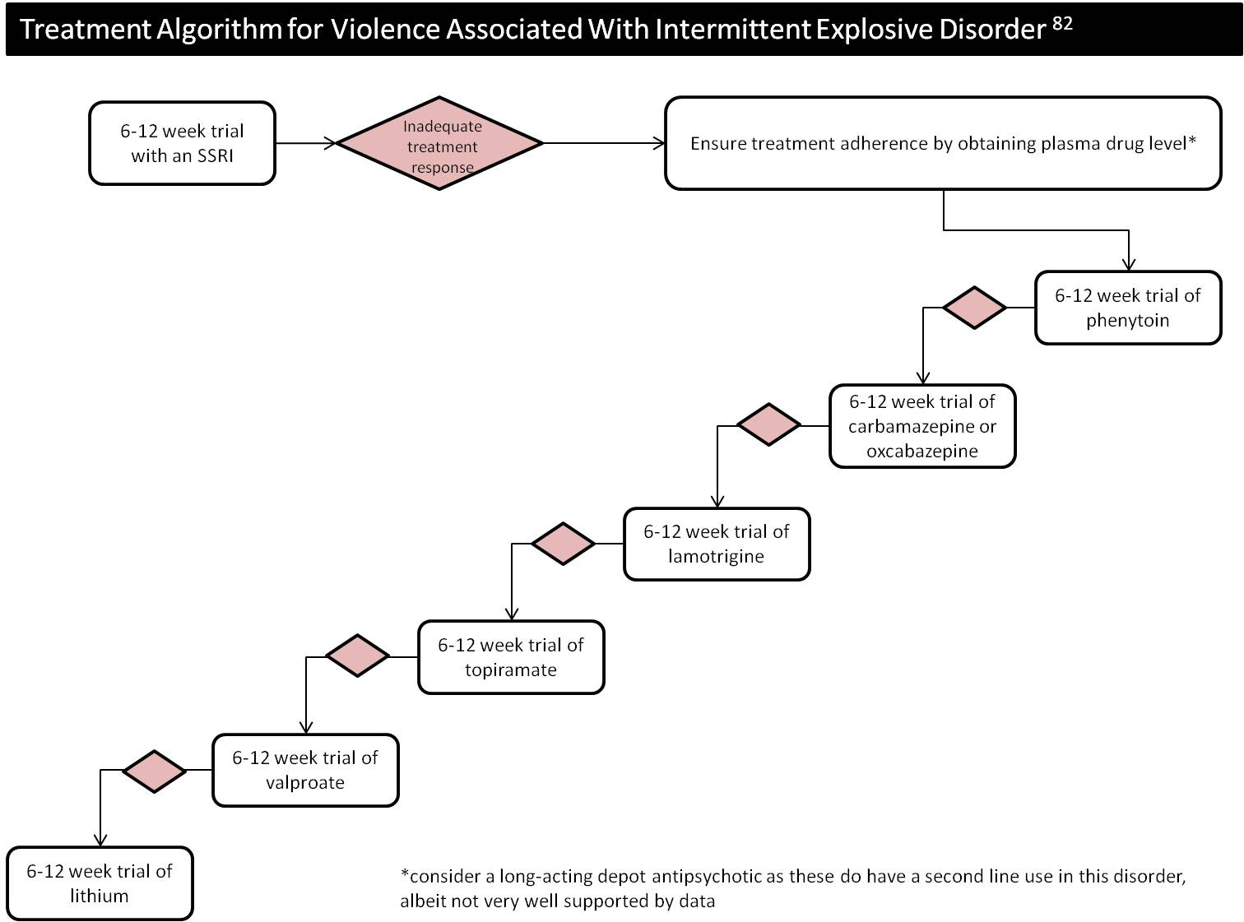

Supplemental Figure 6. Treatment Algorithm for Violence Associated With Intermittent Explosive Disorder

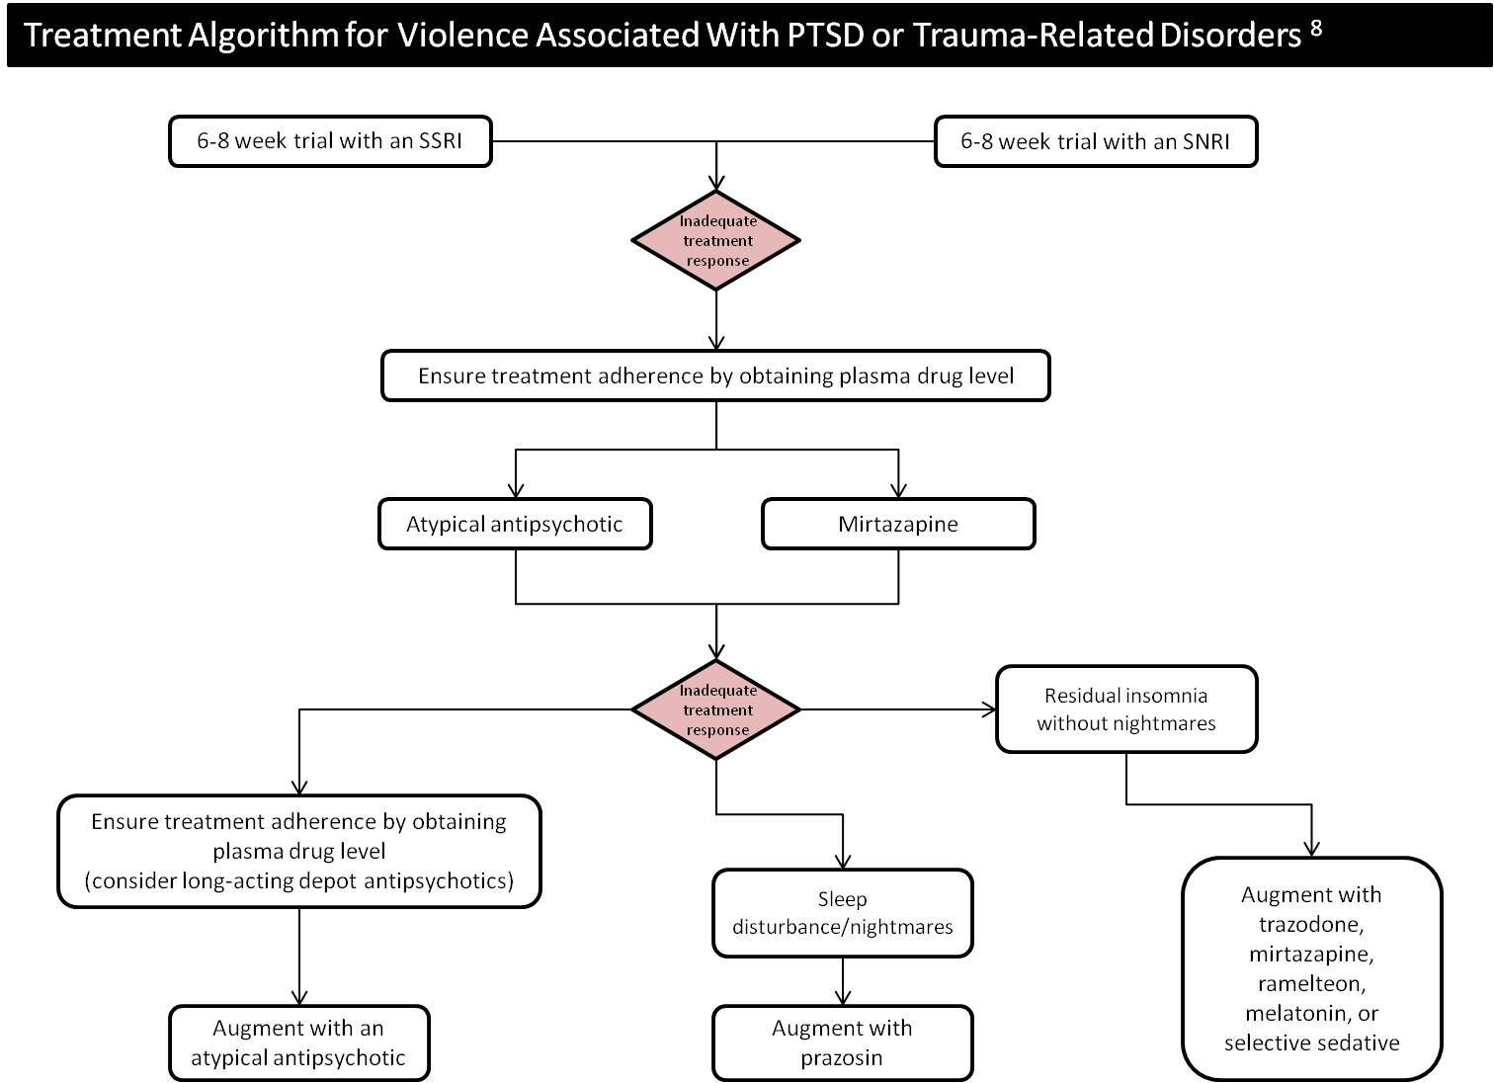
Supplemental Figure 7. Treatment Algorithm for Violence Associated With PTSD or Trauma-Related Disorders

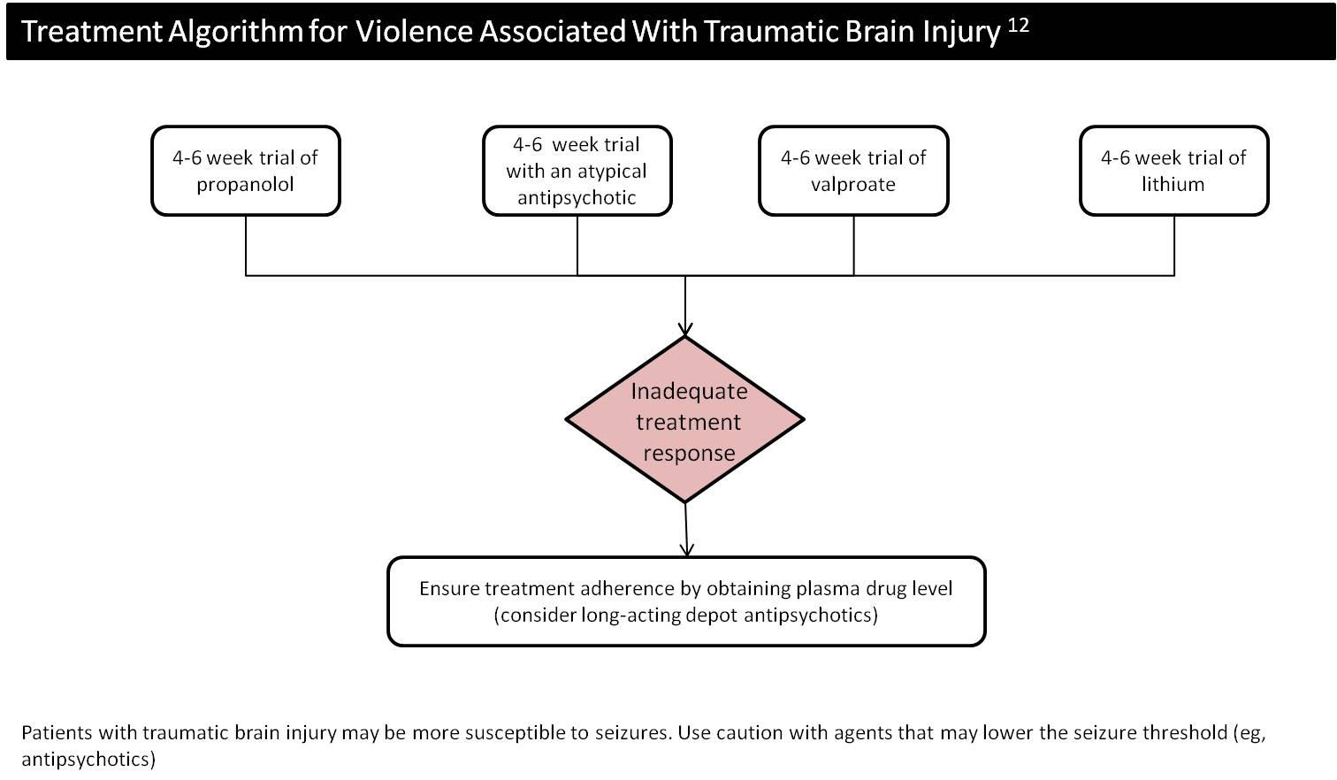
Supplemental Figure 8. Treatment Algorithm for Violence Associated With Traumatic Brain Injury

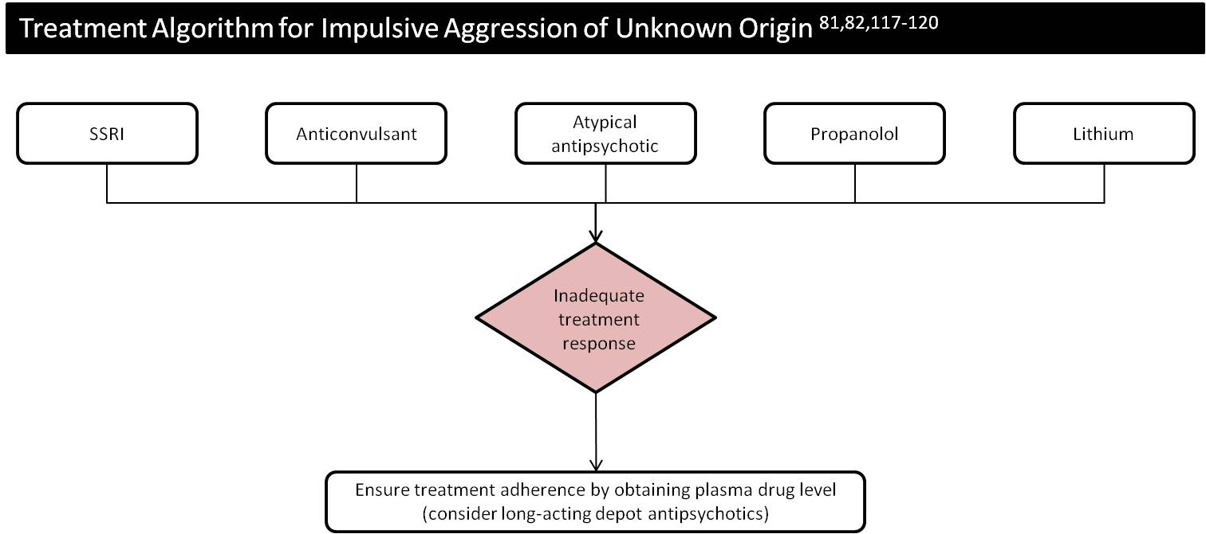
Supplemental Figure 9. Treatment Algorithm for Impulsive Aggression of Unknown Origin

Supplemental Table 1. Violence Risk Assessment
Decisions | Assessments
Psychosis present  - Yes, administer the BPRS  - No, continue | - BPRS  - Record Review  - Interview
Behavior suggests psychopathy  - Yes, administer the PCL-R, and review record for more sources of impulsivity  - No, continue | - PCL-R  - Record Review  - Interview
Substance Abuse or Dependence Diagnosis  - Yes, complete drug history and UDS and review record for more sources of impulsivity  - No, continue | - Record Review  - Interview  - Urine drug screen  - Consider substance use disorder treatment program consultation
Diagnosis of any cognitive disorder  - Yes, administer executive functioning measures and review record for more sources of impulsivity  - No, continue | - Trails A and B  - Wisconsin Card Sorting Test
Diagnosis of a mood disorder  - Yes, rate symptoms and review record for more sources of impulsivity  - No, continue | - Administer SCID if diagnosis unclear  - Depression Rating: Beck Depression Inventory, Hamilton Rating Scale for Depression  - Mania Rating: Young Mania Rating Scale
Diagnosis of PTSD or trauma related symptoms  - Yes, administer trauma symptom measure and review record for more sources of impulsivity  - No, continue | - Trauma Symptom Inventory (TSI-2)  - Interview
Diagnosis of TBI
  - Yes, and review record for more sources of impulsivity
  - No, Continue
ADHD diagnosis.  - Yes, Administer the Conners Adult ADHD Rating Scales and review record for more sources of impulsivity  - No, Continue | - Conners Adult ADHD Rating Scales
Cluster B personality disorder diagnosis  - Yes, administer structured interview if needed and review record for more sources of impulsivity  - No, continue | - SCID-II if diagnosis is unclear  - Interview

Supplemental Table 2. Violence Risk Assessment Instruments
Instrument | Category | Description
COVR  Classification of Violence Risk | Actuarial | Interactive “classification tree” method that assesses potential personal, historical, contextual and clinical factors.
DASA  Dynamic Appraisal of Situational Aggression: Inpatient Version | Structured professional judgment | Created for use with psychiatric and forensic psychiatric inpatients to identify their risk for inpatient aggression in the very short term (i.e., 24 hours to one week).
HCR-20v3  Historical Clinical Risk Management-20 (version 3) | Structured professional judgment | Applied risk assessment tool using the SPJ approach; it consists of three main areas: historical, clinical, and risk management.
PCL-R  Psychopathy Checklist – Revised | Actuarial | Although originally created to measure the personality construct of psychopathy, this measure is used to assess future recidivism and violent offending.
START  Short Term Assessment of Risk and Treatability | Structured professional judgment | Clinical guide for dynamic assessment of risks, strengths and treatability.
SOAS-R  Staff Observation Aggression Scale- Revised | Observational rating scale | An observational rating measure completed by staff that monitors the frequency, nature, and severity of aggressive incidents.
VRAG  Violence Risk Appraisal Guide | Actuarial | 12-item scale that assesses the risk of violence within a specific time frame following release in violent mentally disordered offenders.
V-RISK-10  Violence Risk Screening-10 | Structured professional judgment | Screening measure that includes 10 items regarding historical, clinical, and future stress.Developed for patients in an acute psychiatric hospital.
VRS  Violence Risk Scale | Actuarial | Designed to monitor changes in risk and motivation to change using 6 static and 20 dynamic factors.

Supplemental Table 3. Common Countertransference Reactions to Patients With Psychopathic Features
Reaction | Description
Therapeutic nihilism | Devaluing patients, condemnation of all patients with psychopathy as being untreatable
Illusory treatment alliance | Opposite reaction to therapeutic nihilism, illusion that there is a treatment alliance when none exists
Fear of assault or harm (sadistic control) | Autonomic arousal and visceral reactions
Denial and deception (disbelief) | Not believing that the patient has a criminal history
Helplessness and guilt | Helpless and guilty when a patient does not change, despite earnest efforts
Devaluation and loss of professional identity | Feel despicable and devalued; experiencing symptoms of depression and burnout due to treatment failures
Hatred and the wish to destroy | Have spontaneous homicidal fantasies
Assumption of psychological complexity | Belief that all patients care to understand the origins of their maladaptive behaviors

Supplemental Table 4.Burnout Symptoms In Mental Health Professionals Who Work With Patients With Personality Disorders.
Depersonalization | Negative and cynical attitudes about patients (seeing them as deserving of their troubles)
Emotional exhaustion | Physical fatigue and feeling emotionally drained from job demands and distress
Sense of insufficient personal accomplishment | Feelings of competence and professional achievement

Supplemental Table 5. Assessment of Reasons for Predatory Aggression
Decisions | Assessments
Violent behavior is predatory and goal-directed (e.g. desire for external reward, stalking, dominance, sex, revenge  Inflict harm on victim)  - Yes, continue with predatory violence assessments and proceed to items 2 to 6)  - No | Review prior history and assessments, including rap sheet  - Frequency of violence  - Severity of violence  - Context of violence  - Collateral information  - Use of weapons  - Possession of contraband that can inflict bodily injury
Risk of harm to identifiable third parties  - If yes, warn and reasonable care to protect  - No | - Risk Factors  - Harm  - Risk level
Violent behavior requires criminal arrest
- Yes
- No
High likelihood of future violence  - Yes  - No | - VRAG  - HCR-20 (V3)
Psychopathy  - Yes  - No | - PCL-R  - PCL-SV
Presence of psychiatric disorders that are associated with instrumental aggression  - Yes  - No | - Paraphilic Disorders  - Cluster B Personality Disorders  - Substance-Related and Addictive Disorders  - Bipolar and Related Disorders

Supplemental Table 6. The Central 8 Risk/Need Factors
 | Major Risk/Need Factor | Treatment intervention goals
The "Big" 4 | Antisocial Behavior | Build and reinforce nonviolence and noncriminal behaviors
 | Antisocial PersonalityPattern | Build self-control and delayed gratification;effective problem solving skills;teach anger management
 | Antisocial Cognition | Build flexible thinking, taking the viewpoint of others, values and moral reasoning; counter rationalizations with pro-social attitudes; build up a pro-social identity
 | Antisocial Associates | Gang intervention and prevention; address cognitions supportive of violence; replace pro-criminal friends and associates with pro-social friends and associates
The "Moderate" 4 | Family/Marital Circumstances | Teaching parenting skills, enhance warmth and caring
 | School/Work | Enhance work/study skills, nurture interpersonal relationships within the context of work and school; teach legitimate means of finding financial support
 | Leisure/Recreation | Encourage participation in pro-social recreational activities, teach pro-social hobbies and sports
 | Substance Abuse | Reduce substance abuse, enhance alternatives to substance use

Supplemental Table 7. Risk-Need-Responsivity Model
Principles |  | Assessment Approaches
Risk Principle | - Duration or dosage of  treatment  - Higher intensity interventions, four contact hours per day | PCL-R  COVR  VRAG
Need Principle | - Pro-criminal or pro-violence attitude  - Hostility (aggressive attribution styles)  - Treatment compliance  - Substance abuse  - Impulsivity  - Negative Attitudes  - Excessively high self-esteem (egocentrism, sense of entitlement)  - Sensation seeking | VRS  HCR-20  START  BIS-11  PAI
Responsivity Principles  - General  - Specific | - Structured cognitive behavioral therapy  - Personal, interpersonal, and social characteristics | - Self-Regulation  - Programs address patient characteristics such as personality, motivation, culture, language, learning styles, abilities, strengths  - Therapist flexibility, adjusting therapy to maximize change  - What is in it for me?

Supplemental Table 8. Measuring the Progress of Predatory Aggression Treatment
Program | Program Philosophy | Key Concepts | Goals
Reasoning and Rehabilitation | Cognition plays a decisive role in criminal behavior; maladaptive thinking is acquired via social and developmental experiences in the same way as pro-social behavior is learned | Focuses on interpersonal cognitive problem solving, social skills, negotiation skills, management of emotions, creative thinking, values enhancement, critical reasoning, skills in review and cognitive exercises. | Acquisition of adaptive thinking: developing skills to withstand ‘personal, situational, economic and interpersonal pressures towards illegal behavior.’ ¹²⁴
Enhanced Thinking Skills | How offenders think, including how they reason and solve problems, is an important factor in their criminal behavior. Introduce alternative ways of thinking and problem solving. | Training in impulse control, flexible thinking, taking the viewpoint of others, values and moral reasoning, general reasoning and interpersonal problem solving. | Developing awareness of how one reacts to problems and other people; learning a new thinking and problem solving approach can prevent offending.
Think First | Understanding the link between an individual’s offending behavior and cognitive skills; focuses first on the offending behavior and a complete analysis of criminal/violent event(s). | Target social problems, solving such issues as: problem awareness, alternative-solution thinking, consequential thinking, and perspective taking. | Acquisition of adaptive alternative-solution thinking.

