Appendix

Figure A1: Map of Trial Locations

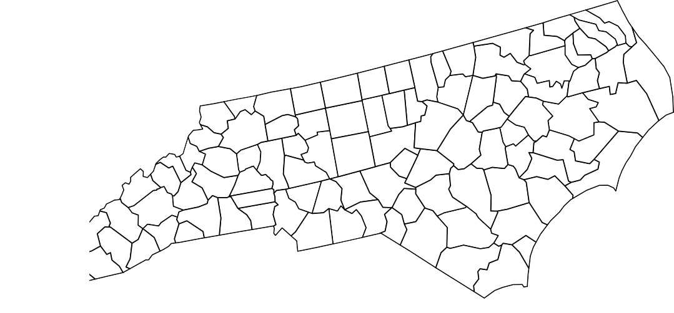
●
●
●
●
●
Location
- Clayton
- Kinston
- Oxford
- Reidsville
- Rocky Mount
- Rural Hall
- Whiteville
●
●

Figure A2: Histogram of Appearances in Official Variety Trials (OVT) by Variety

200

150

100
Count

50

0

0 10 20 30 40 50
Years in Official Variety Trials

Figure A3: Posterior Predictive Checks

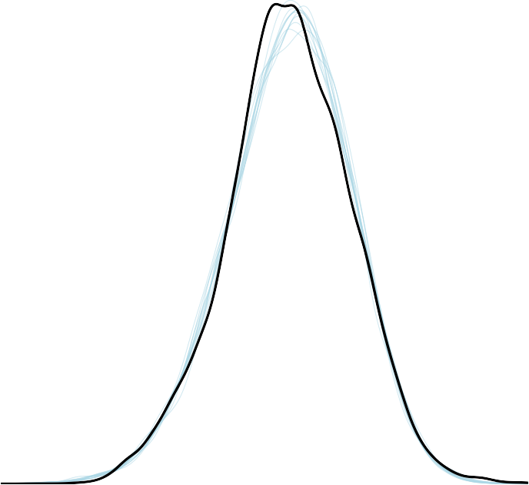Observed Yields Replicate Yields

1000 2000 3000 4000
Yield (lbs./ac.)

    - Yield Model

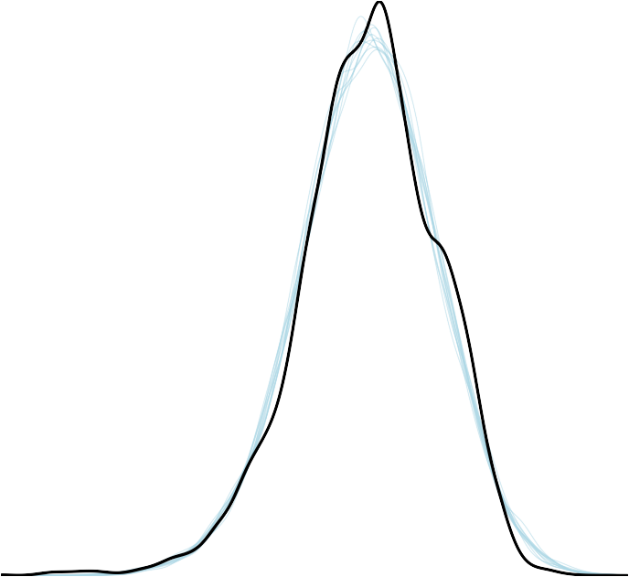Observed Ratios Replicate Ratios

−1 0 1 2 3
log(Sugars/Alkaloids)

    - Quality Model
Note: Replicates are drawn using the same data used to fit the models.

Figure A4: Trace Plots of Selected Yield Model Parameters

0.00020
0.00015
0.00010
0.00005
0.00000
b_Intercept

15000
10000
5000
b_Intercept

2500 5000 7500 10000 12500 0 500 1000 1500 2000 2500

b_prec
5
4
3
2
1
0
−0.2 0.0 0.2

0.2
0.0
−0.2
b_prec

0 500 1000 1500 2000 2500

Chain

0.4
0.3
0.2
0.1
0.0
b_low

−6 −4 −2
b_low 1
−2
−4 2
−6 3
0 500 1000 1500 2000 2500
4

1.0
0.5
0.0
b_med

2.0 2.5 3.0 3.5 4.0

4.0
3.5
3.0
2.5
2.0
b_med

0 500 1000 1500 2000 2500

0.20
0.15
0.10
0.05
0.00
b_high

0 5 10
b_high
10
5
0
−5
0 500 1000 1500 2000 2500

Table A1: Measured Contribution of Genetics to Change in Quality

Period | Genetics | Technology | Relative Contribution
AGC
1963-1981 | 0.02 | -0.31 | 6.06%
1981-2000 | -0.02 | 0.32 | 5.88%
2000-2017 | 0.01 | 0.07 | 12.5%
MGC
1963-1981 | 0.03 | -0.31 | 8.82%
1981-2000 | -0.03 | 0.32 | 8.57%
2000-2017 | 0.04 | 0.07 | 36.36%
Note: Columns 1 and 2 denote sugars/alkaloids ratio changes in average genetic contribution or maximum genetic contribution between varieties introduced at the beginning and end of the time periods. Column 3 measures relative contribution of genetics as percentage of change due to genetics and technology.

