**Appendix**

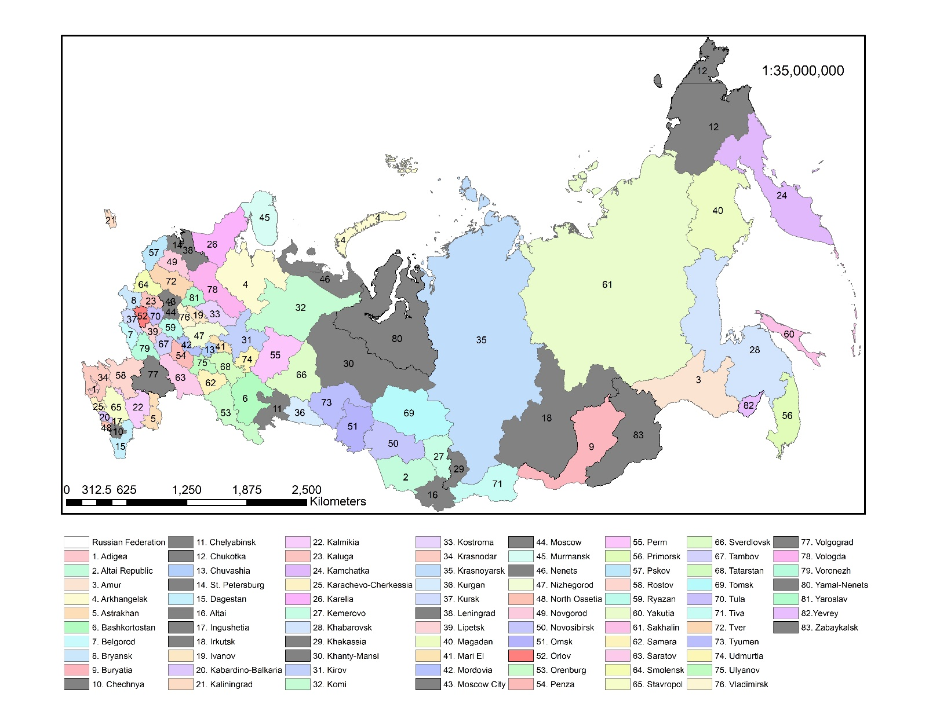

**Figure A.1.** Russian provinces, autonomous republics, and other regions in our sample.

***Note:*** *The gray color indicates provinces omitted from the analysis because of limited data.*

 

**Panel A**. Meat consumption distribution (kg) **Panel B**. Income distribution (1,000 Rubles)

**Figure A.2.** Meat consumption and income distribution over 2006-2016.

***Note 1:*** *Blue, purple and pink colors indicate consumption and income distributions for 2006, 2010 and 2016, respectively.*

***Note 2:*** *The horizontal axis in Panel A measures meat consumption, and in Panel B income distribution, while the vertical axis represents the fraction of the meat-consuming and income-earning population.*

***Source:*** *Household Income and Food Expenditure Survey, Russian FSSS.*

Table A.1. Effects of the Omission of Pre-committed Demand, Regional Fixed Effects, and Supply Side of the Price Determination Mechanism on Elasticity Estimates

|  |  |  |  |  |  |  |  |  |
| --- | --- | --- | --- | --- | --- | --- | --- | --- |
|  | Elasticity estimates from the general model | | Effects of ignoring pre-committed demand | | Effects of ignoring regional fixed effects | | Effects of ignoring supply | |
| Commodity | Own-price | Income | Own-price | Income | Own-price | Income | Own-price | Income |
| Meats | -1.032 | 0.833 | 0.058 | -0.058 | 0.067 | 0.075 | -0.126 | -0.057 |
|  | *(0.058)* | *(0.084)* | *(0.001)* | *(0.001)* | *(0.001)* | *(0.001)* | *(0.002)* | *(0.003)* |
| Veg. | -0.949 | 0.626 | 0.002 | 0.017 | 0.022 | 0.034 | 0.053 | -0.029 |
|  | *(0.069)* | *(0.083)* | *(0.001)* | *(0.001)* | *(0.011)* | *(0.001)* | *(0.004)* | *(0.002)* |
| Cereals | -1.114 | 0.829 | 0.350 | -0.377 | 0.220 | -0.437 | 0.055 | -0.033 |
|  | *(0.069)* | *(0.084)* | *(0.001)* | *(0.002)* | *(0.001)* | *(0.002)* | *(0.001)* | *(0.005)* |
| Eggs | -0.998 | 0.661 | 0.032 | -0.023 | 0.042 | -0.048 | 0.013 | 0.082 |
|  | *(0.054)* | *(0.068)* | *(0.001)* | *(0.001)* | *(0.001)* | *(0.001)* | *(0.003)* | *(0.003)* |
| Fats/Oil | -1.122 | 0.799 | 0.129 | -0.139 | 0.231 | -0.231 | -0.052 | -0.036 |
|  | *(0.040)* | *0.077)* | *(0.001)* | *(0.001)* | *(0.001)* | *(0.001)* | *(0.002)* | *(0.002)* |
| Sugar | -1.010 | 0.685 | 0.128 | -0.115 | 0.144 | -0.133 | 0.026 | -0.062 |
|  | *(0.074)* | *(0.085)* | *(0.001)* | *(0.001)* | *(0.001)* | *(0.001)* | *(0.004)* | *(0.011)* |
| Dairy | -0.884 | 0.615 | 0.009 | 0.001 | 0.014 | 0.022 | 0.033 | -0.005 |
|  | *(0.073)* | *(0.067)* | *(0.001)* | *(0.001)* | *(0.001)* | *(0.014)* | *(0.001)* | *(0.001)* |
| Other | -1.006 | 1.052 | -0.001 | 0.021 | -0.022 | 0.046 | 0.000 | 0.045 |
|  | *(0.042* | *(0.010)* | *(0.000)* | *(0.000)* | *(0.010)* | *(0.000)* | *(0.000)* | *(0.003)* |

***Note 1*:** The standard errors are in parenthesis.  identify parameter estimates that are statistically different from 0 at the 0.01, 0.05, and 0.10 significance levels, respectively.



**Figure A.3.** Per capita average annual Compensating Variation estimate across the Russian provinces over 2006-2016.