Appendix A: attribute information

Best Aquaculture Practices
Best Aquaculture Practices (BAP) is an international, third-party certification system that verifies environmentally and socially responsible processes under which finfish, crustaceans, and mussels are produced. BAP certification standards contain the key elements of responsible aquaculture, including environmental responsibility, social responsibility, food safety, animal health and welfare, and traceability. BAP certification defines the most important elements of responsible aquaculture and provides quantitative, science-based guidelines by which to evaluate adherence to those practices.
Source: http://bap.gaalliance.org/.
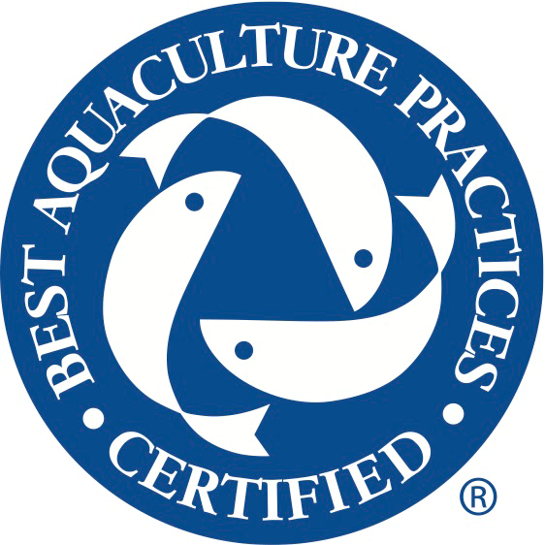

Community-Supported Fishery
Community-Supported Fishery (CSF) programs are arrangements between fishers/seafood farmers and consumers in which consumers provide up-front payments to fishers/seafood farmers in exchange for scheduled deliveries. This program aims to help fishers/seafood farmers receive higher prices for their product, which helps to ensure a more stable income, and can activate political and regulatory support through direct innovation with consumers. Consumers are provided with access to high-quality novel types of fish and benefit from interactions with the producers of their food.
Source: Brinson, Lee, and Rountree (2011).

Homegrown by Heroes
The Homegrown by Heroes label allows farmers and/or agricultural producers who have served in any branch of the U.S. military to use the logo on their agribusiness signage and/or agricultural products. The marketing initiative intends to assist consumers in proudly supporting their veteran-farmers when shopping for various food products.
Source: http://hgbh.org/.
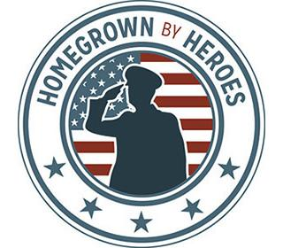

Appendix B: true or false questions

Each survey participant saw only one statement under each attribute and was asked to determine whether it is true or false. The first statement under each attribute is the true statement, and the second statement is false. The statement that appeared in the survey for each respondent was randomized during the survey.

  - Best Aquaculture Practices
    - True statement: The Best Aquaculture Practices certification verifies environmentally and socially responsible production.
    - False statement: The Best Aquaculture Practices certification verifies responsible production based strictly on the highest U.S. standards.

  - Community-Supported Fishery
    - True statement: The Community-Supported Fishery program is to let consumers pay up-front and receive scheduled deliveries of seafood.
    - False statement: The Community-Supported Fishery program requires consumers to participate in the actual seafood production process.

  - Homegrown by Heroes
    - True statement: The Homegrown by Heroes program is to support veteran-farmers.
    - False statement: The Homegrown by Heroes program is established to donate food to veterans.

Appendix C: survey instrument
Note: Because the actual survey was conducted online, the format may not be optimal to display in print. The survey was designed to fulfill multiple research goals. Questions irrelevant to this study are not shown.

- Are you the primary grocery shopper for the household?
  - Yes ○ No

- About how much PER WEEK does your household spend on the following?

Grocery $/WEEK (enter only numbers) _______
Seafood $/WEEK (enter only numbers) _______

- In the summer months (typically May–September), how often do you visit a farmers’ market?
- Less than 1 time a month
- 1–2 times a month
- 3–4 times a month
- 5–6 times a month
- 7–8 times a month
- More than 8 times a month
- Have you or your household ever been a member of a community-supported agriculture, known as the CSA?
- Yes ○ No ○ Don’t know/Not sure

- Where do you or your household consume seafood?
- Mostly at home
- Mostly at restaurants
- At home and restaurants
- My household does not consume seafood

- How often do you consume seafood?
- More than once a week
- Every week
- Every other week
- Once a month
- Once or twice every 6 months
- Seasonal (e.g., religious purpose)

- Within the past 2 months (60 days), which of the following seafood species have you purchased at your residence (please select all that apply)?

- Freshwater shrimp

- Saltwater shrimp

- Farm-raised salmon (e.g., Atlantic salmon)
- Wild-caught salmon (e.g., sockeye, king, coho)
- Catfish
- Canned tuna
- Mussels
- Crab
- Clams
- Oysters
- Wild-caught tuna
- Tilapia
- Cod
- Scallops
- Crawfish
- Sardines
- Other (specify) ________

- Please answer YES, NO, or NOT SURE to the following questions.

 | Yes | No | Not Sure
Have you noticed local/regional labeling on seafood products when making purchasing decisions?
Have you noticed labels specifying whether seafood is farm-raised (aquaculture) or wild caught?
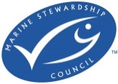
Do you recognize the MSC (Marine Stewardship Council) label/certification on seafood products?

Do you recognize the BAP (Best Aquaculture Practices) label/certification on seafood products?

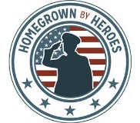
Have you ever seen the Homegrown by Heroes label below on agricultural products?

Have you heard of a Community-Supported Fishery (CSF)?
Would you be interested in joining a Community-Supported Fishery?
Have you or any direct family members participated in any military service?
Have you ever heard of Homegrown by Heroes?

- Please answer YES, NO, or NOT SURE to whether you have consumed the following categories of SEAFOOD within the past year.

 | Yes | No | Not Sure
[This logo is changed to “Certified South
Carolina” logo for South Carolina
participants]
Marine Stewardship Council
Best Aquaculture Practices

Wild-caught
Farm-raised
Homegrown by Heroes

Appendix D: mixed logit model estimation result without interaction terms

Variable | Coefficient | Standard error | WTP | Variable | Coefficient | Standard error
Main effect |  |  |  | Standard deviation of main effect
Kentucky
No choice | −3.933*** | 0.280 | −24.17 | No choice-SD | 3.785*** | 0.275
Fresh | 1.106*** | 0.075 | 6.80 | Fresh-SD | 0.944*** | 0.094
Local | 0.613*** | 0.063 | 3.77 | Local-SD | 0.906*** | 0.076
BAP | 0.462*** | 0.048 | 2.84 | BAP-SD | 0.193* | 0.103
CSF | −0.055 | 0.056 | −0.34 | CSF-SD | 0.016 | 0.109
HBH | 0.582*** | 0.060 | 3.58 | HBH-SD | 0.559*** | 0.101
Price | −0.163*** | 0.009
South Carolina
No choice | −3.740*** | 0.248 | −22.25 | No choice-SD | 3.006*** | 0.204
Fresh | 1.318*** | 0.081 | 7.84 | Fresh-SD | 1.111*** | 0.098
Local | 0.573*** | 0.057 | 3.41 | Local-SD | 0.756*** | 0.081
BAP | 0.353*** | 0.046 | 2.10 | BAP-SD | 0.093 | 0.149
CSF | −0.118** | 0.055 | −0.70 | CSF-SD | 0.028 | 0.133
HBH | 0.521*** | 0.058 | 3.10 | HBH-SD | 0.478*** | 0.101
Price | −0.168*** | 0.009

Notes: Asterisks (*, **, and ***) indicate significance at the 10%, 5%, and 1% significance levels, respectively. BAP, Best Aquaculture Practices; CSF, Community-Supported Fishery; HBH, Homegrown by Heroes; SD, standard deviation; WTP, willingness to pay.

