Appendix

Table A1. Characteristics of the most important varieties released by ARC-Grain Crops Institute
Variety | % Yield Increase | Bean common mosaic necrosis virus | Rust | Angular leaf spot disease | Halo blight disease | Common bacterial blight
Large seeded (red speckled sugar)
Bonus (SA) (standard) | 0 | S | S | S | S | S
Kranskop | 5-8 | R | I | S | S | S
Kranskop-HR 1 | 14-26 | R | I | I-S | R | S
OPS-RS 1 | 12 | R | I | S | S | S
Werna* | 27* | R | R-I | R | S | R
OPS-RS 2 | 0-5 | R | I | S | S | S
OPS-RS 4 | 22-27 | R | I | I | S | S
OPS-RS 5 | 7 | S | I | S | S | S
OPS-RS 6 | 18 | R | I | S | S | S
Jenny | 11-16 | R | I | S | S | S
Sederberg | 14-24 | R | R | R | S | S
Tygerberg* | 33* | R | R | R | S | S
Small seeded (small white canning and carioca)
Teebus (standard) | 0 | R | S | R-I | I | S
Kamberg** | <25** | R | R | R | I | S
Helderberg** | <29** | R | R | R | I | S
OPS-KW 1 | 11-17 | R | R | R | I | S
Teebus-RR 1 | 19-30 | R | R | R-I | I | S
Teebus-RCR 2 | 20 | R | R | R-I | I | R
CAR-2008 | 21* | R | R | R | I | I
I-S – Intermediate susceptible
R-I – Intermediate resistant
S – Susceptible
I – Intermediate

Source: ARC 2014b.

Table A2. Average Yield by Variety and Location
Variety | Bean type | Year Released  to Public |  | Average Yield (kg/ha) |  |  |  |  |  | Yield Ratio ª |  |  |  |  |  | Number of Observations
 |  |  |  | FS | NW | KZN | MP | LP |  | FS | NW | KZN | MP | LP |  | FS | NW | KZN | MP | LP
Bonus | Red speckled | 1972 |  | 1989.50 | 1963.74 | 1500.26 | 2087.19 | 1524.50 |  | - | - | - | - | - |  | 111 | 113 | 107 | 104 | 4
Teebus | Small white canning | 1976 |  | 2066.75 | 2101.28 | 1719.83 | 2288.00 | 2262.25 |  | 1.04 | 1.07 | 1.15 | 1.10 | 1.48 |  | 101 | 110 | 104 | 92 | 4
Kamberg | Small white canning | 1982 |  | 2121.93 | 2576.61 | 2079.26 | 2580.81 | 2301.00 |  | 1.07 | 1.31 | 1.39 | 1.24 | 1.51 |  | 55 | 67 | 53 | 53 | 2
Helderberg | Small white canning | 1990 |  | 1924.54 | 2399.06 | 2278.06 | 2282.56 | - |  | 0.97 | 1.22 | 1.52 | 1.09 | - |  | 28 | 32 | 54 | 41 | 0
Stomberg | Red speckled | 1990 |  | 1799.46 | 1830.23 | 1455.78 | 1851.02 | - |  | 0.90 | 0.93 | 0.97 | 0.89 | - |  | 37 | 44 | 68 | 47 | 0
Kranskop | Red speckled | 1993 |  | 1837.92 | 1434.65 | 2342.78 | 1709.79 | 2027.20 |  | 0.92 | 0.73 | 1.56 | 0.82 | 1.33 |  | 37 | 17 | 27 | 28 | 5
jenny | Red speckled | 1995 |  | 1902.66 | 1795.84 | 2162.56 | 1933.86 | 2944.67 |  | 0.96 | 0.91 | 1.44 | 0.93 | 1.93 |  | 61 | 55 | 82 | 59 | 3
OPS GH1 | Red speckled | 1996 |  | 2242.44 | 2520.62 | 2515.40 | 2413.69 | - |  | 1.13 | 1.28 | 1.68 | 1.16 | - |  | 9 | 13 | 15 | 13 | 0
OPS RS1 | Red speckled | 1996 |  | 1942.44 | 1753.51 | 2248.13 | 2019.82 | 2949.00 |  | 0.98 | 0.89 | 1.50 | 0.97 | 1.93 |  | 50 | 47 | 61 | 49 | 1
OPS-KW 1 | Small white canning | 1997 |  | 1818.08 | 1829.17 | 2551.82 | 2126.90 | - |  | 0.91 | 0.93 | 1.70 | 1.02 | - |  | 38 | 35 | 44 | 40 | 0
OPS-RS 3 | Red speckled | 1999 |  | 1995.00 | 2429.56 | 1903.76 | 2150.38 | - |  | 1.00 | 1.24 | 1.27 | 1.03 | - |  | 8 | 9 | 21 | 13 | 0
OPS RS 4 | Red speckled | 2001 |  | 2103.78 | 1593.93 | 2868.05 | 2055.07 | 2655.00 |  | 1.06 | 0.81 | 1.91 | 0.98 | 1.74 |  | 37 | 29 | 40 | 27 | 2
RS 5 | Red speckled | 2002 |  | 1917.25 | 1368.71 | 2451.14 | 1823.26 | 3350.20 |  | 0.96 | 0.70 | 1.63 | 0.87 | 2.20 |  | 36 | 28 | 36 | 27 | 5
Teebus RR1 | Small white canning | 2002 |  | 2169.36 | 1554.81 | 2984.74 | 1986.08 | 2814.50 |  | 1.09 | 0.79 | 1.99 | 0.95 | 1.85 |  | 28 | 21 | 27 | 24 | 2
Kranskop HR1 | Red speckled | 2003 |  | 2136.30 | 1507.94 | 2539.74 | 2022.85 | 2760.67 |  | 1.07 | 0.77 | 1.69 | 0.97 | 1.81 |  | 30 | 16 | 27 | 20 | 3
Teebus RCR2 | Small white canning | 2005 |  | 1788.76 | 1472.00 | 2447.20 | 1620.67 | - |  | 0.90 | 0.75 | 1.63 | 0.78 | - |  | 17 | 11 | 10 | 15 | 0
Sederberg | Red speckled | 2006 |  | 1833.39 | 1337.70 | 2491.21 | 1945.00 | 2296.00 |  | 0.92 | 0.68 | 1.66 | 0.93 | 1.51 |  | 18 | 10 | 14 | 11 | 2
RS 6 | Small white canning | 2008 |  | 2147.73 | 1522.67 | 2516.88 | 2069.40 | 3094.00 |  | 1.08 | 0.78 | 1.68 | 0.99 | 2.03 |  | 11 | 6 | 16 | 5 | 3
Tygerberg | Red speckled | 2010 |  | 2212.50 | - | 3027.00 | - | - |  | 1.11 | - | 2.02 | - | - |  | 2 | 0 | 2 | 0 | 0
Kamiesberg | Red speckled | 2011 |  | 2130.50 | 1009.75 | 2545.67 | 2018.00 | 2764.00 |  | 1.07 | 0.51 | 1.70 | 0.97 | 1.81 |  | 4 | 4 | 12 | 2 | 2
RS 7 | Red speckled | 2012 |  | 2284.50 | 1196.50 | 2735.00 | 3273.00 | 1258.00 |  | 1.15 | 0.61 | 1.82 | 1.57 | 0.83 |  | 2 | 2 | 8 | 1 | 1
Location; FS = Free State; NW = North West; KZN = KwaZulu Natal; MP = Mpumalanga; LP = Limpopo
ª Mean values of the ratio of the yield of each variety to the yield of the control variety (Bonus) for all location years. A larger value indicates a higher yield relative to the control variety.

Table A3. Year Fixed Effects Regression Results from OLS and Just Pope Production Function
Year | OLS Yield | Just Pope Yield | Just Pope Variance |  | Year | OLS Yield | Just Pope Variance | Just Pope Variance
1982 | 185.78  (92.12)** | 193.77 (57.93)*** | 0.36  (0.55) |  | 1999 | -13.40  (131.01) | 1.48 (115.04) | -0.42  (0.32)
1983 | 166.13  (93.73)** | 173.01 (56.93)*** | 0.67  (0.57) |  | 2000 | 79.90  (129.50) | 93.42 (113.64) | -0.41  (0.31)
1984 | -411.75  (198.93)* | -392.60 (149.63)** | -0.63  (0.48) |  | 2001 | 348.83  (133.74)** | 367.22 (105.34)*** | -0.41  (0.32)
1985 | 576.04  (187.49)** | 590.09 (147.35)*** | -0.34  (0.45) |  | 2002 | 205.50  (123.95) | 221.15 (121.81)* | -0.56  (0.30)
1986 | 198.91  (161.29) | 212.43 (148.22) | -0.23  (0.39) |  | 2003 | -72.83  (142.52) | -54.79 (119.67) | -0.59  (0.34)
1987 | -95.80  (175.17) | -79.25 (130.26) | -0.98  (0.42)* |  | 2004 | 302.82  (134.47)* | 326.00 (112.07)*** | -0.59  (0.32)
1988 | 59.95  (170.06) | 73.72 (154.42) | -0.69  (0.41) |  | 2005 | 79.35  (124.35) | 99.08 (117.16) | -0.57  (0.30)
1989 | 422.92  (166.02)* | 435.16 (105.08)*** | -0.24  (0.40) |  | 2006 | -86.29  (132.38) | -75.42 (138.72) | -0.33  (0.32)
1990 | 440.13  (161.68)** | 451.46 (107.02)*** | 0.39  (0.39) |  | 2007 | -1018.36  (133.31)** | -1002.70 (128.23)*** | -1.76  (0.32)***
1991 | 727.97  (195.03)** | 745.87 (160.77)*** | -0.80  (0.47) |  | 2008 | -71.10  (139.71) | -59.42 (100.44) | -0.83  (0.34)*
1992 | -694.85  (162.70)*** | -672.10 (123.80)*** | -0.79  (0.39)* |  | 2009 | -47.12  (167.92) | -39.57 (107.17) | -0.37  (0.40)
1993 | 258.25  (131.32)* | 269.76 (120.81)** | -0.48  (0.32) |  | 2010 | 4.85  (154.28) | 26.60 (106.29) | -1.22  (0.37)**
1995 | -611.21  (139.26)** | -593.89 (115.35)*** | -0.94  (0.34)** |  | 2011 | -256.01  (144.57) | -232.76 (53.71)*** | 0.10  (0.35)
1996 | 165.09  (133.40) | 174.28 (122.34) | -0.07  (0.32) |  | 2013 | 408.10  (140.62)** | 435.40 (20.65)*** | 0.45  (0.34)
1997 | -198.14  (135.86) | -180.23 (110.44) | -1.41  (0.33)***
1998 | 48.52  (133.70) | 60.94 (130.50) | -0.52  (0.32)
Significance levels: *p<0.1 ** p<0.05, ***p<0.0.
Standard errors are in parenthesis.

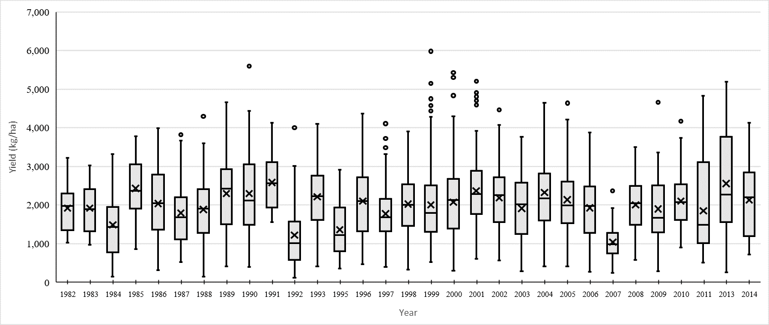

Figure A1. Yearly dry bean yield variation for ARC’s varieties, (1982-2014) for all locations and bean types.

