Appendix A
Appendix Figure A1: Baseline Graphs Presented to North Island Survey Respondents
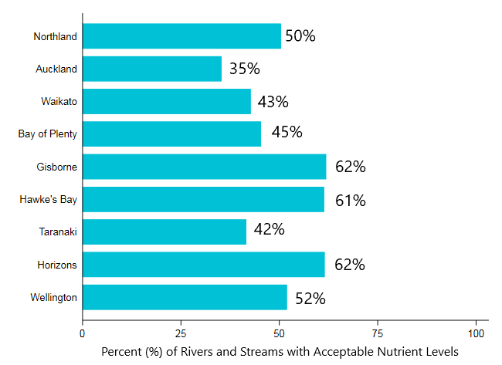
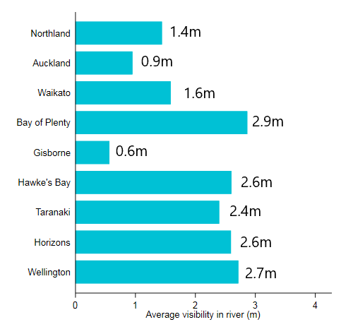
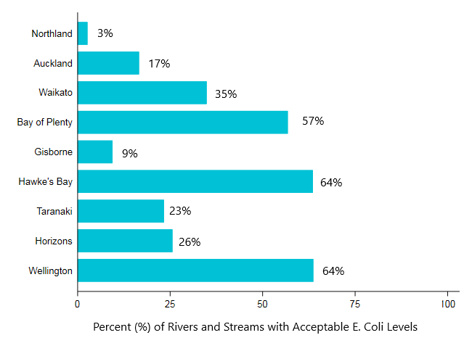
Appendix Figure A2: Baseline Graphs Presented to South Island Survey Respondents
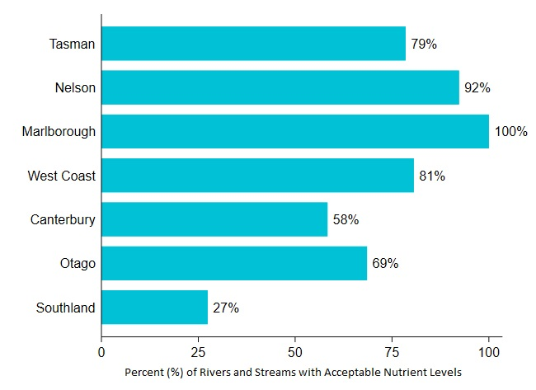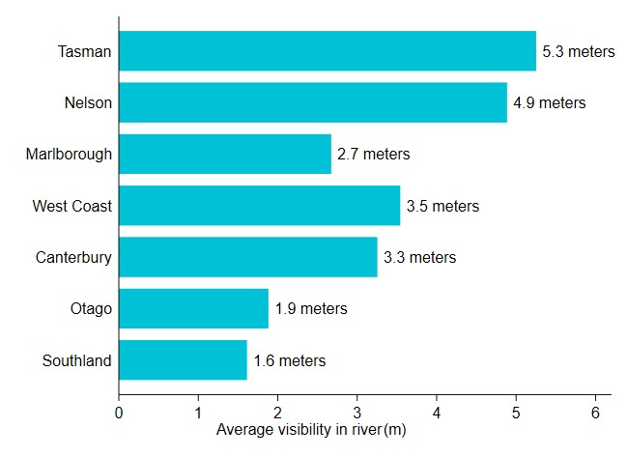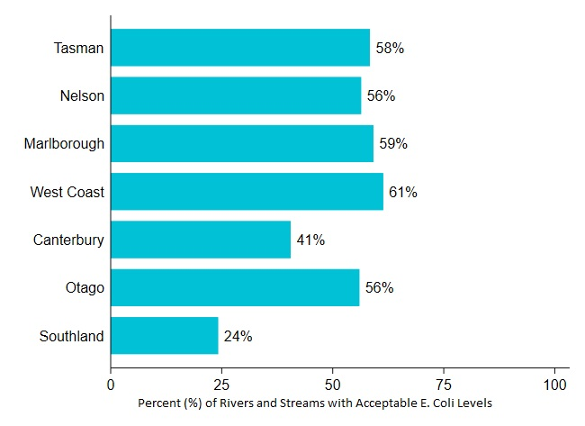

Appendix Table A1: River Lengths and Baseline Levels
Region | River lengths (1000 km) | Baseline Nutrients | Baseline Clarity | Baseline E.Coli
Auckland | 6.798 | 35 | 0.9 | 17
Bay of Plenty | 19.283 | 45 | 2.9 | 57
Canterbury | 70.41 | 58 | 3.3 | 41
Gisborne | 12.655 | 62 | 0.6 | 9
Hawke's Bay | 22.798 | 61 | 2.6 | 64
Manawatu-Whanganui | 36.725 | 62 | 2.6 | 26
Marlborough | 14.466 | 100 | 2.7 | 59
Nelson | 0.598 | 92 | 4.9 | 56
Northland | 18.558 | 50 | 1.4 | 3
Otago | 50.269 | 69 | 1.9 | 56
Southland | 43.604 | 27 | 1.6 | 24
Taranaki | 12.666 | 42 | 2.4 | 23
Tasman | 14.311 | 79 | 5.3 | 58
Waikato | 39.641 | 43 | 1.6 | 35
Wellington | 12.786 | 52 | 2.7 | 64
West Coast | 35.051 | 81 | 3.5 | 61
Notes: Data obtained from Land Air Water Aotearoa, at https://www.lawa.org.nz/. LAWA is a collaboration between NZ’s Central government and local government.

Appendix B
Appendix Table B1: Models with SQC Interactions

 | (1) | (5)
Cost | -0.0058*** | -0.0053***
 | (0.0008) | (0.0008)
sqc_Northland | 2.5399 | 2.2464
 | (1.9700) | (2.2253)
sqc_Auckland | 3.2003* | 2.9884
 | (1.7965) | (2.0815)
sqc_Waikato | 4.4512** | 4.3536**
 | (1.8474) | (2.1170)
sqc_BayPlenty | 3.7248** | 3.7226*
 | (1.8785) | (2.1649)
sqc_Gisborne | -0.2231 | -0.8694
 | (2.2502) | (2.7254)
sqc_Taranaki | 1.7027 | 1.6121
 | (1.9723) | (2.7327)
sqc_HawkesBay | 3.6780* | 4.1742*
 | (2.0234) | (2.2789)
sqc_Horizons | 2.6085 | 2.7368
 | (1.9132) | (2.1820)
sqc_Wellington | 2.3900 | 2.7666
 | (1.8312) | (2.1242)
sqc_Tasman | 1.3684 | 2.1373
 | (2.7878) | (2.4778)
sqc_Nelson | 3.4376 | 3.7416
 | (2.2115) | (2.4079)
sqc_Marlbo | 3.8113* | 3.7917
 | (2.0998) | (2.3107)
sqc_Canterb | 3.0001 | 3.0355
 | (1.8278) | (2.1090)
sqc_WestCoast | 1.5211 | 0.7471
 | (2.2542) | (2.2591)
sqc_Otago | 2.4958 | 2.6134
 | (1.9159) | (2.2780)
Nutr | 0.2145*** | 0.0409
 | 0.1427*** | (0.0718)
Clar | (0.0257) | 0.7184**
 | 0.6633*** | (0.3175)
E.coli | (0.1699) | 0.0178
 | 0.1492*** | (0.0447)
Nutrients*Contact User |  | 0.0031
 |  | (0.0366)
Clarity*Contact User |  | -0.0648
 |  | (0.2156)
E.Coli*Contact User |  | -0.0353
 |  | (0.0322)
Nutrients*NonContact |  | -0.1023**
User |  | (0.0430)
Clarity*NonContact |  | -0.4678*
User |  | (0.2657)
Ecoli*NonContact |  | -0.0934**
User |  | (0.0368)
Nutrients*Passive User |  | 0.0108
 |  | (0.0354)
Clarity*Passive User |  | 0.2965
 |  | (0.2002)
E Coli*Passive User |  | 0.0446
 |  | (0.0312)
Nutr*bachelors |  | 0.0124
 |  | (0.0339)
Clar*bachelors |  | 0.3590*
 |  | (0.2005)
Ecoli*bachelors |  | 0.0418
 |  | (0.0303)
Nutr*aware |  | 0.0821**
 |  | (0.0343)
Clar*aware |  | -0.3900**
 |  | (0.1889)
Ecoli*aware |  | 0.0893***
 |  | (0.0338)
Nutr*Baseline |  | 0.0002
 |  | (0.0014)
Clar*Baseline |  | 0.1607
 |  | (0.1141)
E.coli*Baseline |  | 0.0017**
 |  | (0.0008)
Nutr_river1000km |  | 0.0023**
 |  | (0.0010)
Clar_river1000km |  | -0.0110**
 |  | (0.0050)
E.coli_river1000km |  | 0.0001
 |  | (0.0008)
sqc | -5.1223*** | -4.9782**
 | (1.8170) | (2.1100)
SD
nutr | 0.3363*** | 0.3100***
 | (0.0289) | (0.0288)
clar | 1.2709*** | 1.0794***
 | (0.2228) | (0.2271)
ecoli | 0.2448*** | 0.2201***
 | (0.0363) | (0.0379)
sqc | -3.8366*** | 3.8988***
 | (0.3119) | (0.3292)
Observations | 12219 | 12177
ll | -1.23E+07 | -1.17E+07
Standard errors in parentheses
="* p<0.10 | ** p<0.05 | *** p<0.01"

Appendix Table B2: Average Marginal WTP values from Model (5)
 | Nutrients | Clarity | E Coli
Auckland | 4.78 | 157.81** | 5.18
 | (7.57) | (63.75) | (7.28)
Bay of Plenty | 7.64 | 184.86*** | 13.67
 | (7.81) | (65.17) | (8.56)
Canterbury | 31.61*** | 88.72 | 11.30
 | (12.11) | (55.95) | (9.68)
Gisborne | 7.17 | 128.37** | 1.54
 | (8.75) | (63.79) | (7.67)
Hawkes Bay | 10.32 | 169.73*** | 16.00*
 | (8.63) | (61.18) | (9.08)
Horizons | 15.63* | 135.19** | 5.12
 | (9.15) | (56.35) | (7.47)
Marlborough | 4.68 | 180.05*** | 11.00
 | (16.10) | (69.24) | (9.38)
Nelson | 2.78 | 295.78*** | 13.20
 | (14.87) | (102.81) | (9.22)
Northland | 7.99 | 137.49** | -1.09
 | (7.84) | (59.76) | (8.20)
Otago | 22.68** | 85.58 | 14.23
 | (10.54) | (54.36) | (8.71)
Southland | 19.09* | 89.81* | 6.10
 | (10.86) | (54.08) | (7.57)
Taranaki | 8.22 | 189.33*** | 6.24
 | (7.42) | (63.84) | (6.95)
Tasman | 6.06 | 273.61*** | 12.26
 | (11.69) | (100.32) | (8.92)
Waikato | 16.66* | 99.61* | 8.76
 | (9.00) | (55.78) | (7.56)
Wellington | 6.92 | 204.36*** | 17.93*
 | (7.77) | (67.21) | (9.46)
West Coast | 10.00 | 152.18** | 8.04
 | (12.71) | (71.68) | (9.81)
Observations | 11,835 | 11,835 | 11,835
Notes: *p<0.10, ** p<0.05, *** p<0.01. Standard errors in parentheses.

Appendix C

Appendix Figure C1: National Freshwater Targets for Primary Contact
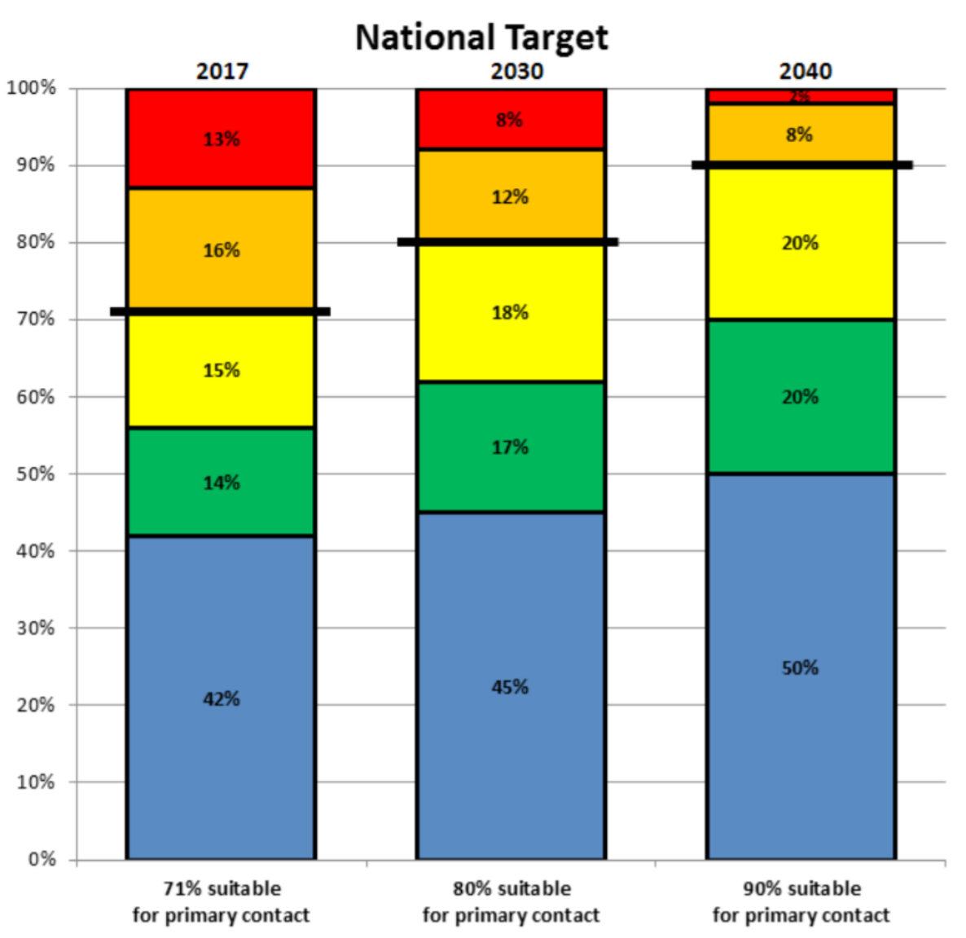
Note: From the National Policy Statement on Freshwater Management, 2020 https://environment.govt.nz/assets/Publications/Files/national-policy-statement-for-freshwater-management-2020.pdf

Appendix D - Full Example Survey Instrument
North Island Rivers and Streams

The next part of the survey is about the water quality of rivers and streams in the North Island, and asks some questions about your experiences with these rivers and streams. Your answers will help inform policymakers.

The information described in this survey was provided by the Ministry for the Environment and regional councils. Please keep in mind this survey is only about flowing rivers and streams, so please do not consider lakes or the sea when answering questions.

North Island Rivers
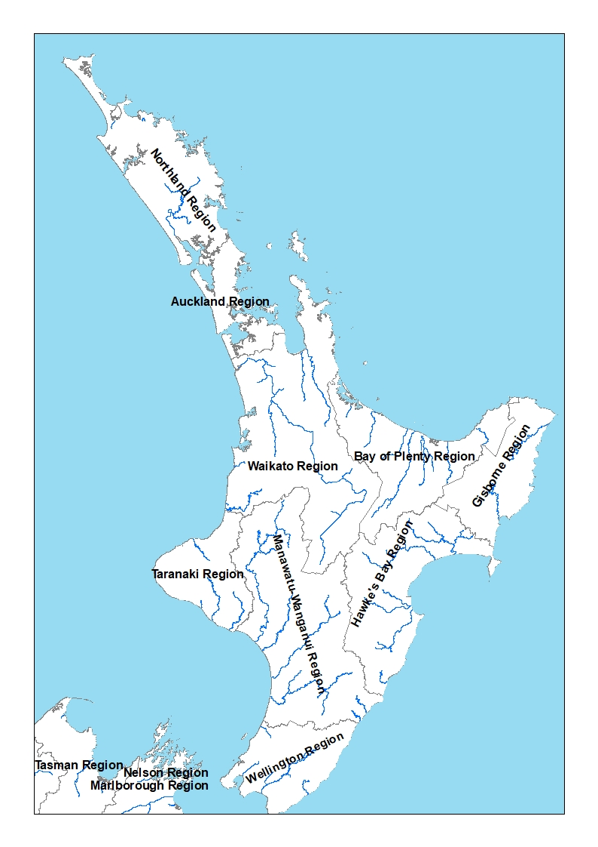
Major rivers are coloured in dark blue, and Regional Council boundaries appear in grey.
- Over the last 12 months, have you done any of the following activities in or near rivers and streams in the regional council area where you live? Tick all that apply

Swimming or wading

Fishing

Boating, including sailing, and motor boating

Water skiing, jet skiing, or kayaking

Actively viewing nature (for example: bird watching)

Biking or walking on trails/paths alongside the water

I didn’t visit rivers or streams in my regional council area in the last 12 months

Other activity: _________________________
_________________________

- How much do you agree or disagree with each of the following statement?
Strongly Strongly
Disagree Agree
I would be more likely to visit rivers and streams in my regional council area if the water quality was better. | 1 2 3 4 5 6 7

River and Stream Water Quality in the North Island
Some information appears below about three key things that affect water quality in rivers and streams: nutrients, water clarity, and E. coli.

This survey will ask you to consider different programmes to improve water quality in your regional council area. It’s important to first read the information below because it will help you when answering questions later.

- Before taking this survey, were you aware of the negative effects that nutrients can have on aquatic plants and animals?
Nutrients. Nitrogen and phosphorous are naturally occurring nutrients, but too much can lead to excessive algae growth that harms underwater habitat, affecting fish, aquatic plants, and other organisms. Sources of excessive nutrients include fertilizers, livestock manure, and wastewater treatment plants. Regional councils set nutrient limits to reduce algae growth and protect aquatic animals and plants. Waters with nutrient levels above these limits can look and smell bad, and/or be unhealthy for aquatic animals and plant life.

How is it measured?
Regional councils report the percentage of rivers and streams meeting nutrient limits. The following figure shows the percent of rivers and streams in each region that have acceptable nutrient levels. For example, 61% of rivers and streams (or 6 out of 10) in Hawke’s Bay have acceptable nutrient levels. A larger bar means that rivers and streams are better for aquatic animals and plant life.

Rivers and Streams with Acceptable Nutrient Levels
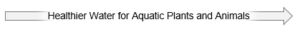
- Yes
- No
a
Water clarity. Excessive pollution makes the water murky or cloudy, and may make the water look less pleasing.

How is it measured?
Water clarity is measured by how far you can see in the water, in metres. At one metre of clarity you can see your feet if standing up to your waist in the water. The following figure shows average water clarity levels (in metres) across different regions. A larger bar means that, on average, rivers and streams are clearer.

Water Clarity
- How does water clarity in your regional council area compare to your impressions before taking this survey?
- Lower (worse) than I expected
- About what I expected
- Higher than I expected
- I had no expectations about water clarity

E. coli are bacteria found in sewage and human and animal excrement. It is natural for rivers and streams to have small amounts of E. coli, but too much can lead to a higher chance of getting sick if you swim or wade in that water, or eat fish that live there. Regional councils set E. coli limits in order to better ensure that rivers and streams are suitable for swimming, wading, and fishing.

How is it measured?
Regional councils report the percentage of rivers and streams that meet E. coli limits and are suitable for swimming, wading, and fishing. The following figure shows the proportion of rivers and streams in each regional council that meet E. coli limits. For example, 35% of rivers in Waikato are suitable for swimming, wading, and fishing. A larger bar indicates more rivers and streams are safe to swim or fish in.

Rivers and Streams with Acceptable E. Coli Levels for Swimming, Wading, and Fishing

- Before taking this survey, were you aware of the negative effects that E. coli can have on the suitability of rivers and streams for swimming, wading, and fishing?

- Yes
- No

Improvements in River and Stream Water Quality in your Regional Council Area

To achieve water quality goals in your region, your regional council and the central government would need to implement and fund new and/or improved programmes to reduce water pollution and improve water quality. If implemented, programme changes would be gradually phased in and be in full effect by the year 2025.

Such programmes could, for example, require and/or fund:

- Planting natural vegetation in areas along rural and urban stream and river banks.
- More advanced water treatment technologies at sewage plants.
- Reduce the amount of paved surface when developing new residential or commercial areas, to decrease stormwater runoff
- More environmentally friendly fertilizers for your garden and lawn care at home.
- Tree planting in urban or eroded areas.
- Programmes for farmers to better manage their soil or use some of their land to plant natural vegetation.

The design of the programme can cause it to have different effects on nutrients, water clarity, and E. coli.

Funding Water Quality Programmes

If implemented, the changes required under such programmes would result in higher costs, and some of these costs would be passed on to your household.

Costs to Your Household
Some of the basic things people spend money on would become slightly more expensive. For
example:

- Homeowners will experience increased requirements and maintenance costs for sewage and septic systems,
- Homeowners and renters will get higher rates or costs on their sewage and water bills.
- Renters will experience increased rent.
- Prices for some products like food or other goods you buy will also increase, due to increased costs to businesses as a result of the programmes.

Programmes to improve water quality, if implemented, would permanently increase the cost of living for your household starting next month.

Even though the increase in the cost of living to your household would begin next month, it will take some time for the programmes to be fully implemented. The improvements described would be fully achieved by 2025.

Deciding Future Outcomes

Each of the next few questions presents three different potential outcomes for the water quality of rivers and streams in your regional council area water quality and costs to your household. Each question asks you to choose the outcome you like the best. Your responses will guide future policy decisions and programmes that would, if implemented, actually improve the quality of rivers and streams in your regional council area. They would also increase costs to your household.

When choosing the outcome you like best, please take time to consider both the benefits and the costs to your household. Ask yourself if the outcomes for rivers and streams in your regional council area are worth the additional cost to your household.

We urge you to respond as though costs for your household really would go up as described under each outcome, and that the environmental improvements described (and only those improvements) really would occur. Paying the costs means you would have less money to spend on other things such as food, clothes, going on trips, and even towards resolving other environmental problems you care about.

If you choose an outcome that results in a cost to your household, you would be making a commitment to pay the additional cost every month from now on, so please choose carefully.

Remember that:
- The results of this survey will inform regional council and central government policymakers about actual policies.
- Improvements in water quality apply only to flowing rivers and streams in your regional council area.
- Improvements in water quality would be fully achieved by the year 2025.
- Your household costs would increase starting next month.

Please study the table below.
Question 1.
Which outcome do you prefer for rivers and streams in your regional council area?

 | Outcomes by 2025
 | Outcome A | Outcome B | Outcome C
Nutrients  Increase in the percent of rivers and streams with acceptable levels.  For example, a change from 25% of rivers and streams to 27% is a change of +2 percentage points | No change | + 6 percentage points | + 2 percentage points
Water Clarity  Increase in average visibility in rivers and streams | No change | + 1 metre | + 0.4 metre
E. coli  Increase in the percent of rivers and streams suitable for swimming. wading, and fishing.  For example, a change from 32% of rivers and streams to 35% is a change of +3 percentage points | No change | + 5 percentage points | + 7 percentage points
Permanent Increase in the Cost of Living for your Household | $0 per month | $6 per month  ($72 per year) | $2 per month  ($24 per year)
Your Choice
Please select your preferred outcome | Outcome A  (No change) | Outcome B | Outcome C

Thanks for answering the first question. You will next see two more questions about different programmes. As you answer the next questions please remember:

  - Each question presents a new set of outcomes.

  - Consider each question separately. Do not compare across questions.

  - Forget about the previous question, and now imagine that the listed outcomes in each of the next questions are the only ones you can choose from.

Please study the table below.
Question 2.
Which outcome do you prefer for rivers and streams in your regional council area?
 | Outcome by 2025
 | Outcome A | Outcome B | Outcome C
Nutrients  Increase in the percent of rivers and streams with acceptable levels.  For example, a change from 25% of rivers and streams to 27% is a change of +2 percentage points. | No change | + 5 percentage points | + 7 percentage points
Water Clarity  Increase in average visibility in rivers and streams | No change | + 1 metre | + 1.3 metre
E. coli  Increase in the percent of rivers and streams suitable for swimming. wading, and fishing.  For example, a change from 32% of rivers and streams to 35% is a change of +3 percentage points | No change | + 8 percentage points | + 12 percentage points
Permanent Increase in the Cost of Living for your Household | $0 per month | $7 per month  ($84 per year) | $20 per month  ($240 per year)
Your Choice
Please select your preferred outcome | Outcome A  (No change) | Outcome B | Outcome C

Please study the table below.
Question 3.
Which outcome do you prefer for rivers and streams in your regional council area?

 | Outcomes by 2025
 | Outcome A | Outcome B | Outcome C
Nutrients  Increase in the percent of rivers and streams with acceptable levels.  For example, a change from 25% of rivers and streams to 27% is a change in +2 percentage points | No change | + 15 percentage points | + 3 percentage points
Water Clarity  Increase in average visibility in rivers and streams | No change | + 1.6 metre | + 0.5 metre
E. coli  Increase in the percent of rivers and streams suitable for swimming. wading, and fishing.  For example, a change from 32% of rivers and streams to 35% is a change of +3 percentage points | No change | + 12 percentage points | + 4 percentage points
Permanent Increase in the Cost of Living for your Household | $0 per month | $25 per month  ($300 per year) | $5 per month  ($60 per year)
Your Choice
Please select your preferred outcome | Outcome A  (No change) | Outcome B | Outcome C

- Thinking about how you decided which outcomes to choose in the previous questions, please rate how much you agree or disagree with each of the following statements.
Strongly Strongly
Disagree Agree
I made my choices as if the water quality improvements described actually would be achieved. | 1 2 3 4 5 6 7
I made my choices as if my household actually would have to pay the additional monthly costs. | 1 2 3 4 5 6 7
When making my choices I only considered flowing rivers and streams in my regional council area. | 1 2 3 4 5 6 7
It is important to improve waters in my regional council area, no matter how high the costs. | 1 2 3 4 5 6 7
I am against any more regulations and/or government spending. | 1 2 3 4 5 6 7
I want better water quality, but my household should not have to pay to fund it. | 1 2 3 4 5 6 7
I believe the data collected with this survey will inform future policies to improve water quality. | 1 2 3 4 5 6 7

Appendix E – Water Quality Regressions
 | ln(TP) | ln(TN) | ln(E. Coli)
ln(Clarity) | -0.5333*** | -0.5054*** | -0.2827***
 | (0.0015) | (0.0019) | (0.0019)
Landcover Data Missing | 0.3365*** | 0.5668*** | -0.4756***
 | (0.0548) | (0.0312) | (0.0270)
Landcover Native | -0.3093*** | -0.5155*** | -0.3219***
 | (0.0021) | (0.0027) | (0.0022)
Landcover Other | -0.0697*** | -0.2025*** | -0.1217***
 | (0.0094) | (0.0116) | (0.0115)
Landcover Pastoral | 0.1299*** | 0.5798*** | 0.2622***
 | (0.0020) | (0.0026) | (0.0022)
Landcover Urban | 0.2945*** | 0.7816*** | 0.5169***
 | (0.0054) | (0.0066) | (0.0055)
Stream Order=2 | -0.0892*** | -0.0712*** | 0.0513***
 | (0.0013) | (0.0017) | (0.0015)
Stream Order =3 | -0.2249*** | -0.1685*** | 0.0595***
 | (0.0017) | (0.0021) | (0.0019)
Stream Order =4 | -0.3954*** | -0.2987*** | 0.0065**
 | (0.0024) | (0.0029) | (0.0027)
Stream Order =5 | -0.5065*** | -0.3921*** | -0.0179***
 | (0.0036) | (0.0043) | (0.0039)
Stream Order =6 | -0.6486*** | -0.6413*** | -0.1655***
 | (0.0050) | (0.0063) | (0.0054)
Stream Order =7 | -0.8029*** | -0.7170*** | -0.2860***
 | (0.0065) | (0.0094) | (0.0095)
Stream Order=8 | -1.1810*** | -1.3324*** | -0.4156***
 | (0.0167) | (0.0192) | (0.0160)
Elevation | -0.0010*** | -0.0010*** | -0.0017***
 | (0.0000) | (0.0000) | (0.0000)
nof swim=2 |  |  | 0.5045***
 |  |  | (0.0024)
nof swim=3 |  |  | 1.2165***
 |  |  | (0.0032)
nof swim=4 |  |  | 1.7509***
 |  |  | (0.0033)
nof swim=5 |  |  | 2.0637***
 |  |  | (0.0038)
Constant | 3.7353*** | 6.2039*** | 3.3444***
 | (0.0023) | (0.0031) | (0.0043)
Observations | 587,939 | 587,939 | 587,939
R² | 0.7799 | 0.7790 | 0.9216
Notes – all models include regional council fixed effects. Standard errors appear in parentheses. Standard errors appear in parentheses. ***, **, and * denote significance at the 99%, 95%, and 90% levels, respectively. The omitted dominant landcover category is exotic forest.

