Appendix
A) Current and Past United States Green Rooftop Policies and Programs
Chicago, Illinois
- 2014: Green Permit Program
  - Expedited building permit program
  - Project which meet sustainability guidelines may qualify for a waiver of consultant codes of $25,000
- 2017: Sustainable Development Policy
  - TIF funds available to multi-family housing project that meet 100 point system à Green roofs will earn 10 points if 50 to 100% of building net area is covered, and 20 points for 100% coverage
    - More than 5 million square feet of green roofs have been installed due to this policy
Denver, Colorado
- 2017: Green Building Ordinance
  - Any new buildings or updates to building roofs over 25,000 sq ft must have a cool roof and comply with one other Green Building Requirement
New York City, New York
- 2011: Green Infrastructure Grant Program
  - For private property owners, Roofs must be between 3500-20,000 square feet. At 1.5-1.99 inches of soil depth, projects receive $10/square foot; at 2-2.99 inches of soil depth projects receive $15/square foot; at 3-3.99 inches of soil depth, projects receive $25/square foot; and at 4+ inches of soil depth, projects receive $30/ square foot
- 2019: Green Factor for New Construction
  - New and existing buildings undergoing major renovations in particular occupancy are required to cover 100% of available roof space with sustainable roofing, is green rooftop
New York, State
- 2008, revised 2019 Green Roof Property Tax Abatement Program
- tax abatement of $5.23/square foot for the installation of a green roof, and in certain high need areas, as much as $15 per square foot. At least 50% of the roof must be covered with a vegetation layer
Onandaga County, New York
- 2018: Green Improvement Fund
  - Facility property owners are eligible for grants for the installation of green infrastructure for stormwater management, such as green roofs. Green roofs on high-priority sites can receive up to 30 cents/ gallon captured, medium-priority sites can receive up to 20 cents/gallon, and captured low-priority sites can receive up to 10 cents/gallon.
Syracuse, New York
- Green Improvement Fund
  - Funds available to project using green infrastructure solutions. Almost $4 millions awarded towards 37 different projects so far
Portland, Oregon
- 2018: EcoRoof Requirement
  - New buildings with areas of 20,000 square feet or more must have an ecoroof that covers 100% of the budling area
San Francisco, California
- 2017: Better Roofs Ordinance
  - New non-residential buildings with an area larger than 2,000 square feet are required to have 15% of roof as solar panels or 30% of the roof as green roofs
Washington, DC
- 2017: Green Area Ratio
  - All new buildings requiring a certificate of occupancy must meet the Green Area Ratio (GAR). The GAR can be meet by incorporating vegetated roofs.
- Green Roof Rebate Program
  - Funding between $7 and $10 per square foot of green rooftop installations
Milwaukee, Wisconsin
- 2019: Green Infrastructure Partnership
  - Receive credit for storm water capture, an eligible method includes green rooftops
- Regional Green Roof Initiative
  - $5 for each square food of approved green roof
Montgomery County, Maryland
- 2018: Raincapes Reward Rebate Program
  - $9 per square foot rebate, up to $7,500 for residential buildings install green rooftop and up to $20,000 for institutional/commercial properties installing green rooftop
Philadelphia, Pennsylvania
- Green Roof Tax Credit
  - A credit of up to 25% of all costs incurred to construct a green roof with a maximum of $100,000 per square feet
Nashville, Tennessee
- 2016: Green Roof Rebate Program
  - Property owners can receive a rebate of up to $10/square foot of green roof installed. The credit is applied over 5 years. The vegetation must cover 80% of the roof with hardy, drought resistant plants.
(Source: Green Rooftops for a Healthy City, How Your Community Will Benefit From Adopting Green Roof Policy, https://static1.squarespace.com/static/58e3eecf2994ca997dd56381/t/59dfd5db268b96c5a9ea66b1/1507841543362/2015+PolicyBrochure-HowYourCommunityWillBenefitFromGreenRoofPolicy.pdf)
B) Information presented in survey about GR Program

C) GR Program WTP question in survey
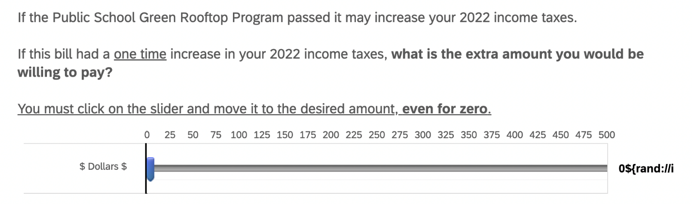

D) Green Rooftop Information Provided in Survey

Please Read
A green rooftop is a layer of vegetation planted on top of flat roofs. Green rooftops can vary in size and usage, as seen in the images below.
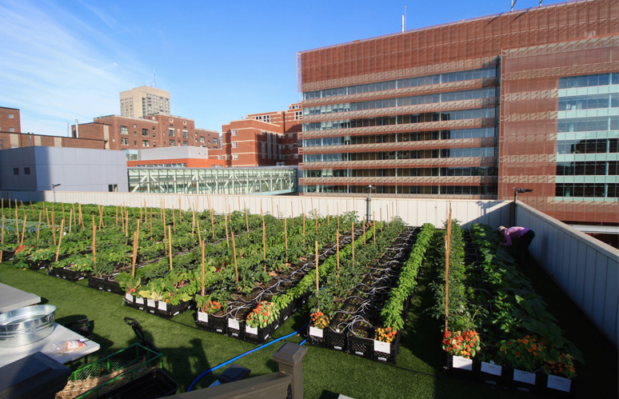
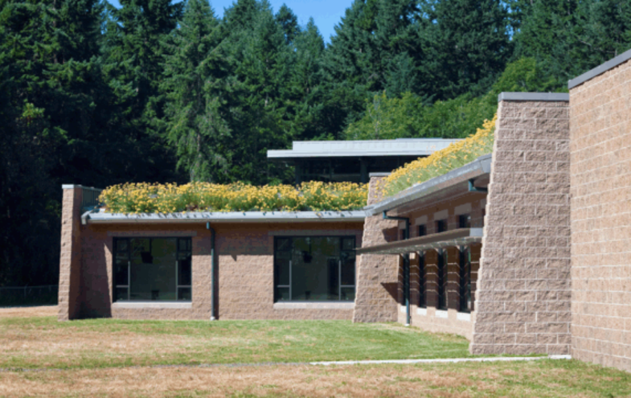

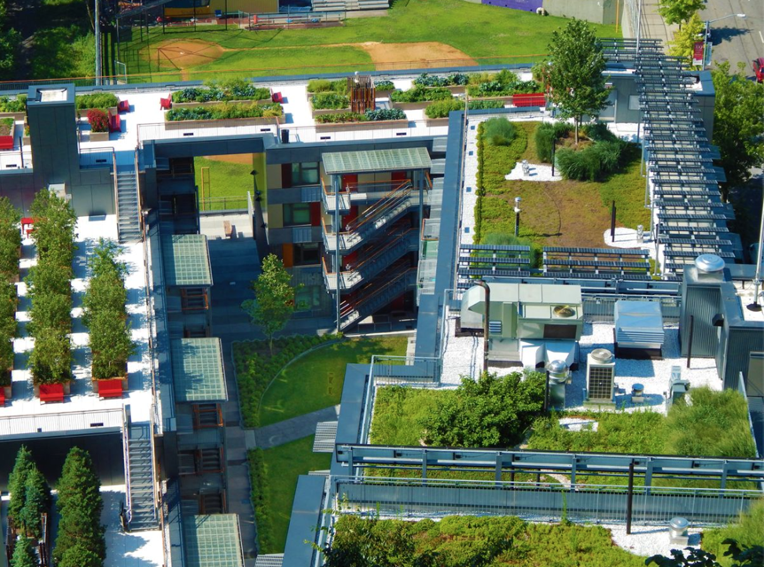
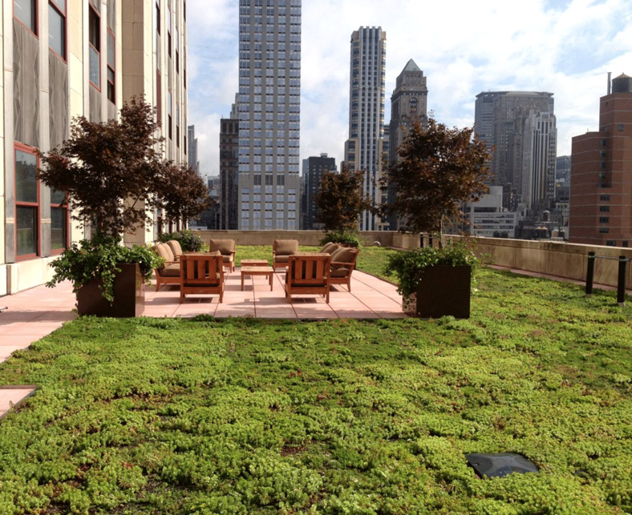

Please Read
Green rooftops benefit building owners and the surrounding community members. Benefits vary with the type, size, and location of green rooftops. View the tables below to learn about some of the annual average benefits.
Building Benefits | Cost Savings
Reduced energy cost | $0.23 per sq ft
Reduced storm water run off | $2 to $30 per sq ft
Increased property values | $12 to $60 per sq ft
Increased lifespan of roof | $30 per sq ft

Community Benefits | Quantified Benefits
Air quality improvements | 11 square feet of green roof could reduce the pollution  of one gasoline-powered car per year
Reduced urban heat island effect | Reduction of 0.3°F–0.9°F in neighborhood temperatures.
Increased access to healthy food | 2 lbs of fresh produce per sq foot (for intensive rooftops)
Increased access to  recreational space | Cost savings of $0.50 to $1.30 per sq foot
Habitat creation | $0.94 to $1.00 per sq foot
Reduced infrastructure improvements cost | Cost saving of $0.8 to $2.4 per sq foot
Increased economic activity | For every dollar spent on green roofs $0.75-0.85 goes towards local job creation
Please Read
Green roofs have three drawbacks.

Drawbacks | Cost Incurred
Increased installation costs | $10 to $40 more per sq ft
Increased maintenance | $0.06 to $1.25 per sq ft
Increased C02 and N02 emissions | $0.50 to $2.00 per sq ft

E) Choice experiment hypothetical bill information

F) Extended Results Regression Output

For vegetation, the reference group was changed to grass and shrubs/bushes was included directly into the regression, results changed as expected. Compared to grass, shrubs/bushes and produce gardens were negative and significant, while flower gardens were negative and insignificant. When the reference group was altered for amenities from shaded area to small ponds, walking paths and benches remained positive and significant while shaded area was negative and insignificant. When the model of choice was altered to a GMNL, all variables’ coefficients and significance remained consistent, with small variations in magnitude, with the exception of solar 10, which became insignificant. When controlling for heterogeneity differences among demographic groups, demographic controls for income, race, gender, and education were included directly in the regression (Appendix F, table 5). Income, gender, and education were found to be significant and negative, however when other controls were included such as political party affiliation and home ownership there were not significant differences amongst control variables (Appendix F, table 6).

Table One Mix logit: Choice Experiment Main Model with Vegetation Reference Group Changed
Variables | Coef. | S.E. | P - value | [95% Conf. | Interval]
No GR | -6.880 | 1.003 | 0.000 | -8.846 | -4.914
Vegetation (Grass)
Shrubs/Bushes | -0.422 | 0.096 | 0.000 | -0.611 | -0.233
Produce gardens | -0.499 | 0.106 | 0.000 | -0.706 | -0.292
Flowers gardens | -0.017 | 0.089 | 0.851 | -0.192 | 0.158
Amenities (Shaded Area)
Ponds | -0.014 | 0.084 | 0.871 | -0.178 | 0.151
Walking paths | 0.237 | 0.073 | 0.001 | 0.094 | 0.379
Benches | 0.458 | 0.109 | 0.000 | 0.245 | 0.672
Solar (None)
Solar 10 | 0.117 | 0.075 | 0.118 | -0.030 | 0.263
Solar 20 | 0.362 | 0.082 | 0.000 | 0.201 | 0.523
Community Access (Open)
Mix | -0.069 | 0.062 | 0.268 | -0.190 | 0.053
Limited | -0.263 | 0.078 | 0.001 | -0.416 | -0.110
Price (log) | -7.618 | 0.743 | 0.000 | -9.075 | -6.161
Notes: This table shows regression output when the vegetation reference group is changed from Shrubs/Bushes to Grass. All parameters are model as random parameters. All parameters are normally distributed except price is log-normally distributed. Attributes in the parenthesis are the reference category. All variables are dummy (0/1) except price is continuous. N = 8,472 , Log likelihood = -2325.62, Chi-squared = 86.13

Table Two Mix logit: Choice Experiment Main Model with Amenity Reference Group Changed
Variables | Coef. | S.E. | P - value | [95%Conf. | Interval]
No GR | -8.559 | 1.755 | 0.000 | -11.998 | -5.120
Vegetation (Shrubs/Bushes)
Grass | 0.355 | 0.089 | 0.000 | 0.179 | 0.530
Produce gardens | -0.100 | 0.088 | 0.252 | -0.272 | 0.071
Flower gardens | 0.353 | 0.074 | 0.000 | 0.209 | 0.498
Amenities (Ponds)
Shade | -0.035 | 0.075 | 0.646 | -0.183 | 0.113
Walking paths | 0.194 | 0.082 | 0.017 | 0.034 | 0.354
Benches | 0.408 | 0.104 | 0.000 | 0.204 | 0.612
Solar (None)
Solar 10 | 0.125 | 0.073 | 0.088 | -0.019 | 0.268
Solar 20 | 0.364 | 0.079 | 0.000 | 0.208 | 0.520
Community Access (Open)
Mix | -0.067 | 0.060 | 0.263 | -0.185 | 0.051
Limited | -0.241 | 0.076 | 0.002 | -0.390 | -0.092
Price (Log) | -6.687 | 0.492 | 0.000 | -7.651 | -5.723
Notes: This table shows regression output when the amenity reference group is changed from shaded area to ponds. All parameters are model as random parameters. All parameters are normally distributed except price is log-normally distributed. Attributes in the parenthesis are the reference category. All variables are dummy (0/1) except price is continuous. N = 8,472 , Log likelihood = -2326.99, Chi-squared = 83.38

Table Three Mix logit: Choice Experiment Main Model with Vegetation and Amenity Reference Group Changed
Variables | Coef. | S.E. | P – value | [95%Conf. | Interval]
No GR | -6.919 | 1.347 | 0.000 | -9.560 | -4.278
Vegetation (Grass)
Bushes | -0.425 | 0.095 | 0.000 | -0.611 | -0.240
Produce gardens | -0.496 | 0.103 | 0.000 | -0.697 | -0.295
Flower gardens | -0.016 | 0.086 | 0.852 | -0.185 | 0.153
Amenities (Ponds)
Shade | -0.038 | 0.077 | 0.622 | -0.190 | 0.114
Walking paths | 0.187 | 0.083 | 0.024 | 0.025 | 0.349
Benches | 0.450 | 0.105 | 0.000 | 0.243 | 0.657
Solar (None)
Solar 10 | 0.101 | 0.073 | 0.166 | -0.042 | 0.244
Solar 20 | 0.340 | 0.080 | 0.000 | 0.182 | 0.497
Community Access (Open)
Mix | -0.065 | 0.061 | 0.287 | -0.185 | 0.055
Limited | -0.254 | 0.076 | 0.001 | -0.403 | -0.105
Price (Log) | -7.831 | 0.766 | 0.000 | -9.332 | -6.329
Notes: This table shows regression output when the amenity and vegetation reference group is changed from shaded area to ponds and from shrubs/bushes to grass respectfully. All parameters are model as random parameters. All parameters are normally distributed except price is log-normally distributed. Attributes in the parenthesis are the reference category. All variables are dummy (0/1) except price is continuous. N = 8,472 , Log likelihood = -2321.83, Chi-squared = 93.70

Table Four Mix logit: Choice Experiment Main Model as Generalize Multinomial Logit Model
Variables | Coef. | S.E. | P – Value | [95%Conf. | Interval]
Price (Log) | -0.123 | 0.042 | 0.003 | -0.204 | -0.041
Vegetation (Bushes/Shrubs)
Grass | 0.400 | 0.088 | 0.000 | 0.227 | 0.573
Produce gardens | -0.079 | 0.086 | 0.359 | -0.248 | 0.090
Flower gardens | 0.335 | 0.073 | 0.000 | 0.191 | 0.479
Amenities (Shaded Area)
Ponds | -0.006 | 0.080 | 0.944 | -0.163 | 0.152
Walking paths | 0.260 | 0.071 | 0.000 | 0.120 | 0.400
Benches | 0.451 | 0.102 | 0.000 | 0.250 | 0.651
Solar (None)
Solar 10 | 0.114 | 0.074 | 0.122 | -0.030 | 0.259
Solar 20 | 0.353 | 0.079 | 0.000 | 0.197 | 0.508
Community Access (Open)
Mix | -0.072 | 0.060 | 0.230 | -0.189 | 0.046
Limited | -0.198 | 0.074 | 0.007 | -0.343 | -0.053
Notes: This table shows regression output. All parameters are model as random parameters. All parameters are normally distributed except price is log-normally distributed. Attributes in the parenthesis are the reference category. All variables are dummy (0/1) except price is continuous. N = 6,285 , Log likelihood = -2228.06, Wald Chi-squared = 97.79

Table 5 Mix logit: Choice Experiment Main Model with Demographic Controls
Variables | Coef. | S.E. | P – value | [95%Conf. | Interval]
No GR | -13.512 | 4.843 | 0.005 | -23.004 | -4.020
Vegetation (Shrubs/Bushes)
Grass | 0.525 | 0.111 | 0.000 | 0.308 | 0.742
Produce gardens | -0.075 | 0.117 | 0.522 | -0.304 | 0.154
Flower gardens | 0.458 | 0.092 | 0.000 | 0.278 | 0.639
Amenities (Shaded Area)
Ponds | -0.053 | 0.101 | 0.600 | -0.250 | 0.145
Walking Paths | 0.168 | 0.091 | 0.065 | -0.010 | 0.345
Benches | 0.559 | 0.134 | 0.000 | 0.296 | 0.821
Solar (None)
Solar 10 | 0.062 | 0.092 | 0.501 | -0.118 | 0.242
Solar 20 | 0.340 | 0.098 | 0.001 | 0.148 | 0.532
Community Access (Open)
Mix | -0.088 | 0.074 | 0.232 | -0.233 | 0.056
Limited | -0.375 | 0.098 | 0.000 | -0.567 | -0.184
Demographics
Low Income | -6.732 | 3.357 | 0.045 | -13.312 | -0.152
Race | 1.831 | 2.253 | 0.417 | -2.586 | 6.247
Gender | -3.653 | 1.517 | 0.016 | -6.627 | -0.680
Bachelors | -3.439 | 1.708 | 0.044 | -6.787 | -0.090
Price (Log) | -6.533 | 0.514 | 0.000 | -7.540 | -5.525
All parameters are model as random parameters. All parameters are normally distributed except price is log-normally distributed. Attributes in the parenthesis are the reference category. All variables from the choice scenario are dummy (0/1) except price is continuous. Income low (1 = Below $49,000 and 0 = $50,000 or above), Gender (1 = Female, 0 = Male), Race (1 = White, 0 = Nonwhite), Bachelors (1 = Bachelor’s degree, 0 = High school, associates) N = 5,852 , Log likelihood = -1578.42, Chi-squared = 106.0

Table 6 Mixed logit: Choice Experiment Main model with Demographic, Political Party Affiliation, and Home ownership controls
Variables | Coef. | S.E. | P- value | [95%Conf. | Interval]
No GR | -14.853 | 10.283 | 0.149 | -35.008 | 5.302
Vegetation (Shrubs/Bushes)
Grass | 0.536 | 0.118 | 0.000 | 0.306 | 0.767
Produce gardens | -0.059 | 0.122 | 0.631 | -0.297 | 0.180
Flower gardens | 0.454 | 0.098 | 0.000 | 0.263 | 0.645
Amenities (Shaded Area)
ponds | -0.066 | 0.107 | 0.536 | -0.276 | 0.143
Walking paths | 0.199 | 0.093 | 0.033 | 0.016 | 0.382
Benches | 0.551 | 0.140 | 0.000 | 0.277 | 0.825
Solar (None)
Solar 10 | 0.052 | 0.095 | 0.582 | -0.134 | 0.239
Solar 20 | 0.350 | 0.104 | 0.001 | 0.147 | 0.553
Community Access (Open)
Mix | -0.118 | 0.078 | 0.128 | -0.270 | 0.034
Limited | -0.372 | 0.100 | 0.000 | -0.568 | -0.175
Demographics
Low Income | -1.048 | 1.784 | 0.557 | -4.545 | 2.449
Race | -2.387 | 1.687 | 0.157 | -5.694 | 0.919
Gender | -2.038 | 1.453 | 0.161 | -4.887 | 0.810
Bachelors | 0.555 | 2.099 | 0.791 | -3.558 | 4.668
Republican | 6.421 | 11.591 | 0.580 | -16.298 | 29.139
Democrat | 8.421 | 10.947 | 0.442 | -13.034 | 29.877
Home Owners | -1.460 | 1.565 | 0.351 | -4.528 | 1.608
Price (Log) | -6.820 | 0.849 | 0.000 | -8.484 | -5.156
All parameters are model as random parameters. All parameters are normally distributed except price is log-normally distributed. Attributes in the parenthesis are the reference category. All variables from the choice scenario are dummy (0/1) except price is continuous. Income low (1 = Below $49,000 and 0 = $50,000 or above), Gender (1 = Female, 0 = Male), Race (1 = White, 0 = Nonwhite), Bachelors (1 = Bachelor’s degree, 0 = High school, associates) Democratic/Republican (Binary variables with Independent as the reference group), Homeowner (1 = Homeowner, 0 = Rent home, rent apartment, own apartment) N = 5,676 , Log likelihood = -1525.61, Chi-squared = 96.78

The following tables below explore how demographic characteristics impact habits around GRs and government support and WTP for the GR Program

Table 7: Logistic regression Awareness of GR
Aware of GR | Coef. |  | S.E. | p-value | [95% Conf | Interval] |  | Sig
Race | .427 |  | .453 | .345 | -.46 | 1.314
Income Low | -.074 |  | .249 | .766 | -.563 | .414
Gender | .085 |  | .243 | .726 | -.391 | .562
Married | -.728 |  | .365 | .046 | -1.444 | -.013 |  | **
Bachelors | -.288 |  | .442 | .514 | -1.154 | .577
Democrat | .167 |  | .395 | .672 | -.607 | .942
Republican | .304 |  | .434 | .484 | -.546 | 1.154
Urban | .689 |  | .276 | .012 | .149 | 1.23 |  | **
Homeowner | .547 |  | .273 | .045 | .011 | 1.082 |  | **
West | .264 |  | .3 | .379 | -.324 | .851
Northeast | -.119 |  | .406 | .769 | -.916 | .677
Midwest | .222 |  | .334 | .506 | -.433 | .878
Greenspace Freq | .179 |  | .259 | .491 | -.33 | .687
Constant | -.687 |  | .647 | .288 | -1.954 | .58
Mean dependent var |  | 0.515 |  | SD dependent var |  |  | 0.501
Pseudo r-squared |  | 0.046 |  | Number of obs |  |  | 305.000
Chi-square |  | 19.430 |  | Prob > chi2 |  |  | 0.110
Akaike crit. (AIC) |  | 431.124 |  | Bayesian crit. (BIC) |  |  | 483.208
Notes: Significance indicated by, *** p<.01, ** p<.05, * p<.1
Aware (1 = Yes, 0 = No or Unsure) Income low (1 = Below $49,000 and 0 = $50,000 or above), Gender (1 = Female, 0 = Male) Race (1 = White, 0 = Nonwhite), Urban (1 = Urban, 0 = Rural or Suburban) Homeowner (1 = Homeowner, 0 = Rent home, rent apartment, own apartment) Married (1 = Married, 0 = Single, widowed, divorced) Greenspace Freq (1 = visits green space weekly, 0 = visits green space less than weekly) Bachelors (1 = Bachelor’s degree, 0 = High school, associates) Democratic/Republican (Binary variables with independent as the reference group) West/Northeast/Midwest (Binary variable with South as the reference group)

Table 8: Logistic regression Visitation Frequency to a GR
Visiting Freq GR | Coef. |  | S.E. | p-value |  | [95% Conf | Interval] |  | Sig
Race | -.338 |  | 1.301 | .795 |  | -2.888 | 2.212
Income Low | .194 |  | .5 | .697 |  | -.785 | 1.174
Gender | .314 |  | .46 | .495 |  | -.587 | 1.216
Married | .656 |  | .745 | .379 |  | -.805 | 2.116
Bachelors | 1.766 |  | 1.165 | .13 |  | -.517 | 4.048
Democrat | .978 |  | .789 | .215 |  | -.569 | 2.525
Republican | 2.01 |  | .864 | .02 |  | .316 | 3.704 |  | **
Urban | 1.535 |  | .517 | .003 |  | .522 | 2.548 |  | ***
Homeowner | .207 |  | .555 | .709 |  | -.881 | 1.296
West | .367 |  | .588 | .533 |  | -.785 | 1.518
Northeast | -.612 |  | .783 | .435 |  | -2.146 | .923
Midwest | .099 |  | .618 | .873 |  | -1.112 | 1.31
Greenspace Freq | 1.223 |  | .48 | .011 |  | .283 | 2.163 |  | **
Constant | -4.664 |  | 2.239 | .037 |  | -9.052 | -.276 |  | **
Mean dependent var |  | 0.698 |  |  | SD dependent var |  |  | 0.461
Pseudo r-squared |  | 0.195 |  |  | Number of obs |  |  | 129.000
Chi-square |  | 30.875 |  |  | Prob > chi2 |  |  | 0.004
Akaike crit. (AIC) |  | 155.233 |  |  | Bayesian crit. (BIC) |  |  | 195.270
Notes: Significance indicated by, *** p<.01, ** p<.05, * p<.1
Visiting Freq GR, is the frequency the respondent reported visiting a GR (1 = Weekly or Biweekly, 0 = Less than biweekly, once a month, every few months, once a year, and once) Income low (1 = Below $49,000 and 0 = $50,000 or above), Gender (1 = Female, 0 = Male) Race (1 = White, 0 = Nonwhite), Urban (1 = Urban, 0 = Rural or Suburban) Homeowner (1 = Homeowner, 0 = Rent home, rent apartment, own apartment) Married (1 = Married, 0 = Single, widowed, divorced) Greenspace Freq (1 = visits green space weekly, 0 = visits green space less than weekly) Bachelors (1 = Bachelor’s degree, 0 = High school, associates) Democratic/Republican (Binary variables with independent as the reference group) West/Northeast/Midwest (Binary variable with South as the reference group)
Table 9: Linear regression WTP for GR Program Prior to Information
Payment for GR | Coef. |  | S.E. | p-value |  | [95% Conf | Interval] |  | Sig
Race | -43.196 |  | 24.284 | .076 |  | -90.992 | 4.599 |  | *
Income Low | 14.768 |  | 13.7 | .282 |  | -12.195 | 41.731
Gender | -28.584 |  | 13.336 | .033 |  | -54.831 | -2.338 |  | **
Married | 25.264 |  | 19.445 | .195 |  | -13.007 | 63.535
Bachelors | 69.24 |  | 24.112 | .004 |  | 21.784 | 116.697 |  | ***
Democrat | 29.518 |  | 21.545 | .172 |  | -12.885 | 71.921
Republican | 26.857 |  | 23.602 | .256 |  | -19.596 | 73.31
Urban | 17.13 |  | 15.028 | .255 |  | -12.448 | 46.708
Homeowner | -10.371 |  | 14.953 | .488 |  | -39.801 | 19.058
West | 27.352 |  | 16.318 | .095 |  | -4.764 | 59.468 |  | *
Northeast | 43.32 |  | 22.498 | .055 |  | -.96 | 87.6 |  | *
Midwest | .883 |  | 18.416 | .962 |  | -35.362 | 37.128
Greenspace Freq | 19.831 |  | 14.259 | .165 |  | -8.234 | 47.895
Constant | 63.732 |  | 34.842 | .068 |  | -4.842 | 132.306 |  | *
Mean dependent var |  | 153.902 |  |  | SD dependent var |  |  | 118.191
R-squared |  | 0.119 |  |  | Number of obs |  |  | 305.000
F-test |  | 3.012 |  |  | Prob > F |  |  | 0.000
Akaike crit. (AIC) |  | 3765.151 |  |  | Bayesian crit. (BIC) |  |  | 3817.236
Notes: Significance indicated by, *** p<.01, ** p<.05, * p<.1
Payment for GR (continuous $0 to $500) Income low (1 = Below $49,000 and 0 = $50,000 or above), Gender (1 = Female, 0 = Male) Race (1 = White, 0 = Nonwhite), Urban (1 = Urban, 0 = Rural or Suburban) Homeowner (1 = Homeowner, 0 = Rent home, rent apartment, own apartment) Married (1 = Married, 0 = Single, widowed, divorced) Greenspace Freq (1 = visits green space weekly, 0 = visits green space less than weekly) Bachelors (1 = Bachelor’s degree, 0 = High school, associates) Democratic/Republican (Binary variables with independent as the reference group) West/Northeast/Midwest (Binary variable with South as the reference group)

Table 10: Linear regression WTP for GR Program After Information
Payment for GR | Coef. |  | S.E. | p-value |  | [95% Conf | Interval] |  | Sig
Race | -39.362 |  | 25.194 | .119 |  | -88.949 | 10.225
Income Low | 8.279 |  | 14.253 | .562 |  | -19.774 | 36.331
Gender | -23.923 |  | 13.89 | .086 |  | -51.262 | 3.416 |  | *
Married | 21.222 |  | 20.412 | .299 |  | -18.953 | 61.397
Bachelors | 49.235 |  | 25.069 | .05 |  | -.106 | 98.576 |  | *
Democrat | 39.967 |  | 22.325 | .074 |  | -3.973 | 83.907 |  | *
Republican | 50.637 |  | 24.524 | .04 |  | 2.368 | 98.906 |  | **
Urban | 28.275 |  | 15.577 | .071 |  | -2.383 | 58.933 |  | *
Homeowner | -.071 |  | 15.598 | .996 |  | -30.771 | 30.629
West | 22.107 |  | 16.907 | .192 |  | -11.17 | 55.384
Northeast | 65.38 |  | 23.579 | .006 |  | 18.971 | 111.789 |  | ***
Midwest | -18.404 |  | 19.231 | .339 |  | -56.255 | 19.447
Greenspace Freq | 14.007 |  | 14.831 | .346 |  | -15.183 | 43.196
Constant | 76.138 |  | 36.114 | .036 |  | 5.059 | 147.217 |  | **
Mean dependent var |  | 168.964 |  |  | SD dependent var |  |  | 123.332
R-squared |  | 0.131 |  |  | Number of obs |  |  | 303.000
F-test |  | 3.363 |  |  | Prob > F |  |  | 0.000
Akaike crit. (AIC) |  | 3762.002 |  |  | Bayesian crit. (BIC) |  |  | 3813.995
Notes: Significance indicated by, *** p<.01, ** p<.05, * p<.1
Payment for GR (continuous $0 to $500) Income low (1 = Below $49,000 and 0 = $50,000 or above), Gender (1 = Female, 0 = Male) Race (1 = White, 0 = Nonwhite), Urban (1 = Urban, 0 = Rural or Suburban) Homeowner (1 = Homeowner, 0 = Rent home, rent apartment, own apartment) Married (1 = Married, 0 = Single, widowed, divorced) Greenspace Freq (1 = visits green space weekly, 0 = visits green space less than weekly) Bachelors (1 = Bachelor’s degree, 0 = High school, associates) Democratic/Republican (Binary variables with independent as the reference group) West/Northeast/Midwest (Binary variable with South as the reference group)

Table 11: Logistic regression Vote on GR Program Prior to Information
Vote | Coef. |  | S.E. | p-value |  | [95% Conf | Interval] |  | Sig
Race | -.071 |  | .522 | .891 |  | -1.094 | .951
Income Low | -.187 |  | .337 | .579 |  | -.847 | .473
Gender | .138 |  | .329 | .676 |  | -.508 | .783
Married | .342 |  | .429 | .426 |  | -.5 | 1.183
Bachelors | -.208 |  | .542 | .7 |  | -1.27 | .854
Democrat | .117 |  | .516 | .821 |  | -.895 | 1.129
Republican | -.618 |  | .554 | .264 |  | -1.703 | .467
Urban | .44 |  | .356 | .217 |  | -.259 | 1.138
Homeowner | .004 |  | .356 | .99 |  | -.693 | .701
West | .081 |  | .406 | .842 |  | -.715 | .877
Northeast | .212 |  | .572 | .71 |  | -.908 | 1.332
Midwest | -.172 |  | .438 | .695 |  | -1.03 | .686
Greenspace Freq | 1.12 |  | .344 | .001 |  | .446 | 1.793 |  | ***
Constant | .861 |  | .75 | .251 |  | -.609 | 2.331
Mean dependent var |  | 0.832 |  |  | SD dependent var |  |  | 0.374
Pseudo r-squared |  | 0.069 |  |  | Number of obs |  |  | 304.000
Chi-square |  | 18.930 |  |  | Prob > chi2 |  |  | 0.125
Akaike crit. (AIC) |  | 284.082 |  |  | Bayesian crit. (BIC) |  |  | 336.120
Notes: Significance indicated by, *** p<.01, ** p<.05, * p<.1
Vote (1 = Voted for, 0 = Voted against or unsure) Income low (1 = Below $49,000 and 0 = $50,000 or above), Gender (1 = Female, 0 = Male) Race (1 = White, 0 = Nonwhite), Urban (1 = Urban, 0 = Rural or Suburban) Homeowner (1 = Homeowner, 0 = Rent home, rent apartment, own apartment) Married (1 = Married, 0 = Single, widowed, divorced) Greenspace Freq (1 = visits green space weekly, 0 = visits green space less than weekly) Bachelors (1 = Bachelor’s degree, 0 = High school, associates) Democratic/Republican (Binary variables with independent as the reference group) West/Northeast/Midwest (Binary variable with South as the reference group)

Table 12: Logistic regression Vote on GR Program After Information
Vote | Coef. |  | S.E. | p-value |  | [95% Conf | Interval] |  | Sig
Race | -2.114 |  | 1.066 | .047 |  | -4.203 | -.026 |  | **
Income Low | .056 |  | .353 | .874 |  | -.636 | .748
Gender | -.044 |  | .349 | .899 |  | -.729 | .64
Married | -.004 |  | .483 | .993 |  | -.95 | .942
Bachelors | -.808 |  | .651 | .215 |  | -2.084 | .468
Democrat | .207 |  | .574 | .718 |  | -.919 | 1.333
Republican | -.858 |  | .601 | .153 |  | -2.035 | .319
Urban | .275 |  | .387 | .478 |  | -.484 | 1.034
Homeowner | .575 |  | .366 | .116 |  | -.142 | 1.292
West | -.414 |  | .42 | .324 |  | -1.237 | .409
Northeast | -1.116 |  | .514 | .03 |  | -2.122 | -.109 |  | **
Midwest | -.118 |  | .503 | .814 |  | -1.104 | .867
Greenspace Freq | .703 |  | .358 | .049 |  | .002 | 1.404 |  | **
Constant | 3.988 |  | 1.307 | .002 |  | 1.427 | 6.549 |  | ***
Mean dependent var |  | 0.849 |  |  | SD dependent var |  |  | 0.358
Pseudo r-squared |  | 0.093 |  |  | Number of obs |  |  | 305.000
Chi-square |  | 24.148 |  |  | Prob > chi2 |  |  | 0.030
Akaike crit. (AIC) |  | 262.570 |  |  | Bayesian crit. (BIC) |  |  | 314.655
Notes: Significance indicated by, *** p<.01, ** p<.05, * p<.1
Bill (1 = Voted for, 0 = Voted against or unsure) Income low (1 = Below $49,000 and 0 = $50,000 or above), Gender (1 = Female, 0 = Male) Race (1 = White, 0 = Nonwhite), Urban (1 = Urban, 0 = Rural or Suburban) Homeowner (1 = Homeowner, 0 = Rent home, rent apartment, own apartment) Married (1 = Married, 0 = Single, widowed, divorced) Greenspace Freq (1 = visits green space weekly, 0 = visits green space less than weekly) Bachelors (1 = Bachelor’s degree, 0 = High school, associates) Democratic/Republican (Binary variables with independent as the reference group) West/Northeast/Midwest (Binary variable with South as the reference group)

