Title: Econometric Identification of Crop Insurance Participation
Authors: Francis Tsiboe and Dylan Turner
Date: 04/06/2023
Note: The material contained herein is supplementary to the article named in the title and published in Agricultural and Resource Economics Review

Table S1: Means and Standard Deviations of Selected Variables on US County Level Corn Production and Insurance Crop (1975-2020)
Variables | Mean (Standard deviation)
Insured share | 0.518 (0.337)
Coverage level | 0.469 (0.312)
Premium per dollar of liability | 0.099 (0.056)
Subsidy per dollar of liability premium | 0.242 (0.106)
Projected price | 0.032 (0.011)
Planted area | 55,044 (57458)
Target rate [instrument] | 0.119 (0.097)
Number of counties | 2,117
Number of observations | 65,819
Note: The data was constructed by the authors using primary data from Risk Management Agency’s summary of business and cause of loss files, and NASS Quick Stats.

Figure S1. Lost Cost Ration Predictive Model Diagnostics
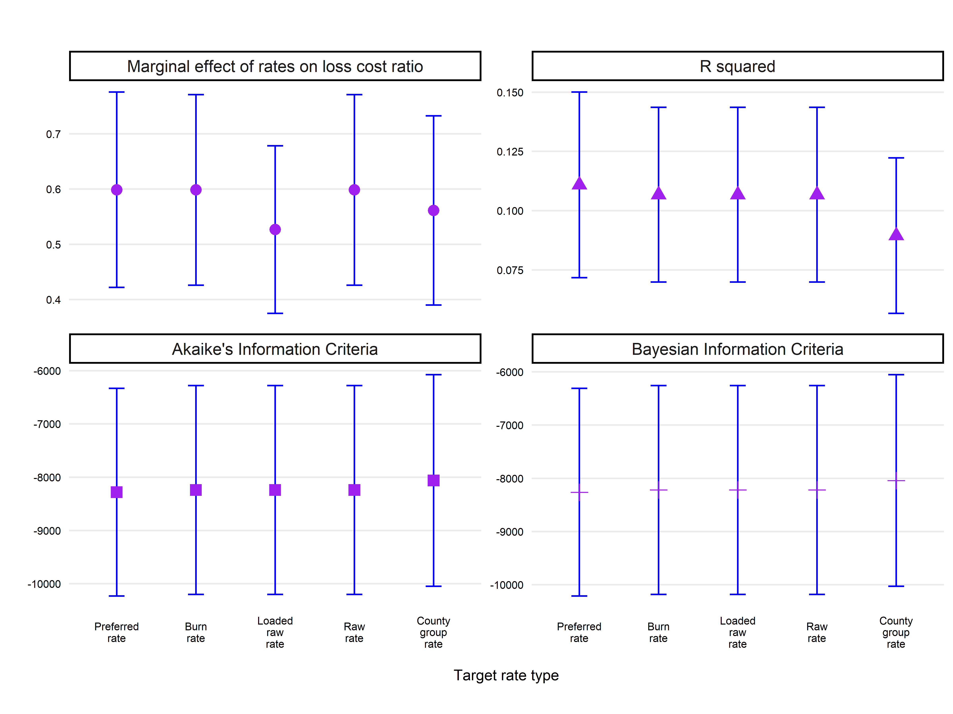
Notes: Graph shows model diagnostics of various approximations of USDA Risk Management Agency (RMA) crop insurance target rates (i.e., the sum of county reference rate and catastrophic fixed loading factor). The values are evaluated in terms of relative performance to the mean of RMA target rates for 2011-2020.

Figure S2. Ratio of Approximated Crop Insurance Target Rates to RMA set Target Rates
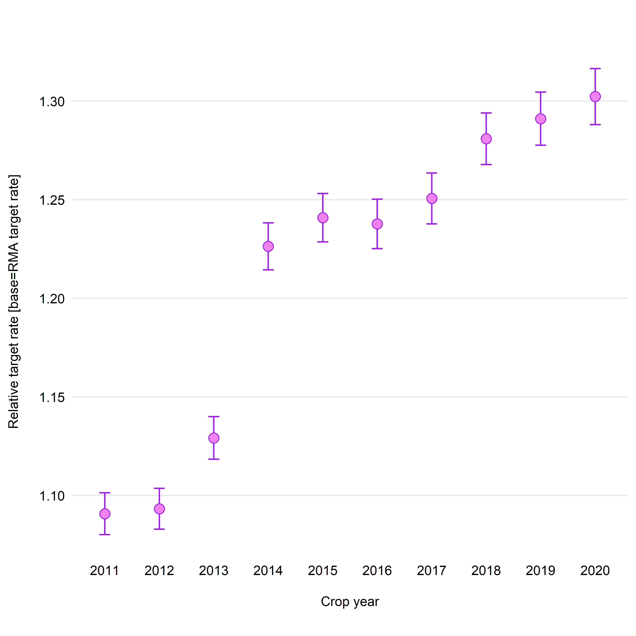
Notes: The graph shows the comparison of USDA Risk Management Agency (RMA) crop insurance target rates (i.e., the sum of county reference rate and catastrophic fixed loading factor) and the preferred approximation from the study.

Figure S3. Approximated Crop Insurance Target Rates: Yield vs Revenue Policies
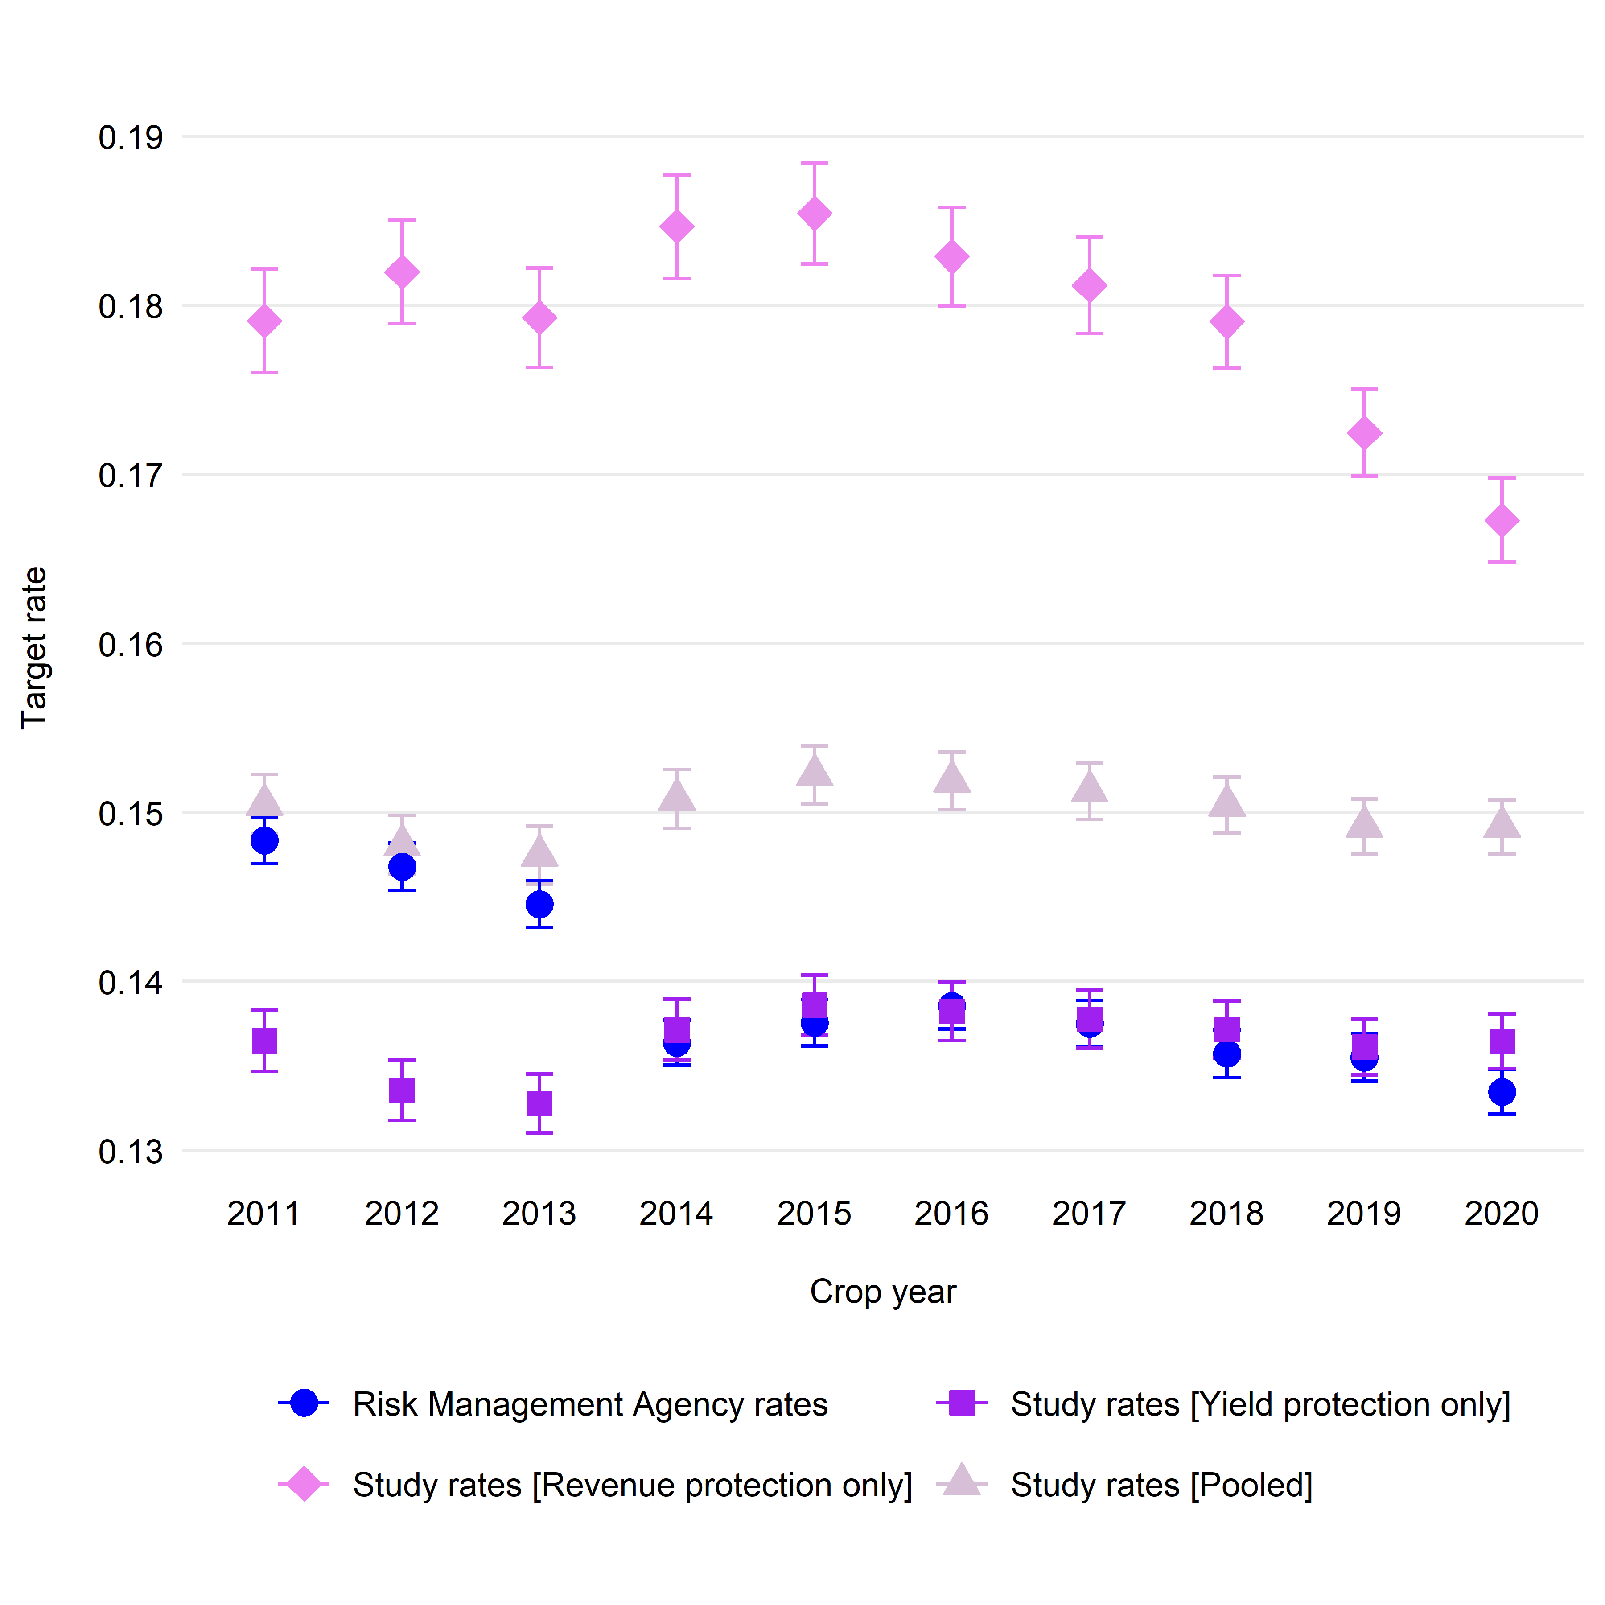
Notes: The graph shows USDA Risk Management Agency (RMA) crop insurance target rates (i.e., the sum of county reference rate and catastrophic fixed loading factor) and its preferred approximation from the study.

