Appendices

A.1. Species information
Table A1.1 provides an overview of the species’ breeding behavior in the first period (2000-2004) and habitat requirements (Johst et al. 2015). Relevant parameters regarding the breeding behavior include the probability of egg deposition in each QM, the probability and last possible timing of a replacement clutch when the original clutch has been destroyed, the critical reproduction phase (including eggs and nestlings), and the total reproduction phase (including the time until the offspring has fully fledged). While land use during the critical reproduction phase leads to a low survival probability of the offspring as the birds are immobile, land use during later phases induce lower mortalities. Regarding other habitat requirements, the species differ in their requirements regarding grass height, soil moisture and the presence of structural elements.

 | Black Grouse (Tetrao tetrix) | Black-tailed godwit (Limosa limosa) | Common Redshank (Tringa totanus) | Common Snipe (Gallinago gallinago) | Meadow Pipit (Anthus pratensis) | Northern Lapwing (Vanellus vanellus) | Skylark (Alauda arvensis) | Whinchat (Saxicola rubetra)
Probability of egg deposition (QM)
9 |  |  |  |  |  | 0.05
10 |  |  |  |  |  | 0.05
11 |  |  |  |  |  | 0.05
12 |  | 0.05 |  | 0.05 |  | 0.1
13 |  | 0.05 |  | 0.05 | 0.05 | 0.1
14 |  | 0.05 |  | 0.05 | 0.3 | 0.15
15 |  | 0.15 | 0.05 | 0.1 | 0.3 | 0.15 | 0.1
16 | 0.2 | 0.15 | 0.1 | 0.2 | 0.2 | 0.1 | 0.3
17 | 0.3 | 0.15 | 0.1 | 0.2 | 0.1 | 0.05 | 0.1 | 0.05
18 | 0.3 | 0.15 | 0.35 | 0.15 | 0.05 | 0.05 | 0.05 | 0.15
19 | 0.1 | 0.15 | 0.35 | 0.1 |  | 0.05 | 0.2 | 0.35
20 | 0.1 | 0.1 | 0.05 | 0.05 |  | 0.05 | 0.1 | 0.35
21 |  |  |  | 0.05 |  | 0.05 | 0.05 | 0.05
22 |  |  |  |  |  |  | 0.05 | 0.05
23 |  |  |  |  |  |  | 0.05
Probability replacement clutch | 0 | 0.5 | 0.5 | 0.5 | 0.5 | 0.5 | 0.5 | 0.5
Last timing replacement clutch (QM) |  | 19 | 23 | 21 | 18 | 21 | 23 | 25
Critical reproduction phase (QM) | 3 | 3 | 3 | 3 | 3 | 4 | 3 | 3
Total reproduction phase (QM) | 7 | 7 | 7 | 7 | 3 | 9 | 4 | 4
Grass height
Low (< 10 cm) | 1 | 0.5 | 1 | 0.5 | 1 | 1 | 1 | 1
Medium (10-30 cm) | 1 | 1 | 1 | 1 | 1 | 0.5 | 0.5 | 1
High (> 30 cm) | 0.5 | 0.5 | 0 | 0.5 | 0.5 | 0 | 0 | 1
Soil moisture
Dry | 0 | 0 | 0 | 0 | 0.5 | 0.5 | 1 | 0.5
Fresh | 1 | 1 | 1 | 0 | 1 | 0.5 | 0.5 | 1
Wet | 1 | 1 | 1 | 1 | 1 | 1 | 0 | 1
Structural elements
Forest | 0.5 | 0 | 0 | 0 | 0 | 0 | 0 | 0
Water bodies | 0 | 0 | 0 | 0.5 | 0 | 0 | 0 | 0
Settlements | 0 | 0 | 0 | 0 | 0 | 0 | 0 | 0
Table A1: Species-specific breeding behavior in the first period (2000-2004) and habitat requirements. Preferences for grass height, soil moisture and structural elements range from 0 (unsuitable) to 1 (preferred) (based on Johst et al. 2015).

A.2. CEE Model
Details of the climate model, vegetation model, harvest model, and agri-economic cost assessment are published as an open access article as Gerling et al. 2022a. Here, we provide further details on the ecological model and the simulation and optimization.
Ecological model
The ecological model determines the species-specific habitat quality of each grassland cell for each conservation measure (local habitat quality). The local habitat quality differs between species as each species may have different requirements in terms of the timing of land use as well as local environmental conditions. Regarding the conservation measure, the impact of land use depends on the timing of land use (mowing) relative to the timing of a species’ reproductive timing. The species’ reproduction is differentiated into a critical reproduction phase (in which the species is not mobile, i.e. the timing of eggs and early period after hatching) and a total reproduction phase (including, additionally, later stages in which the birds are more mobile but do not yet leave the habitat area). Mowing during a species’ critical reproduction phase leads to a total loss in offspring as the mowing process destroys the nests. During the later stages, based on expert opinion mortality is assumed to be reduced by 50% as the offspring is more mobile. Both the timing and the length of the critical and total reproduction phase differ between species (cp. Appendix A1).
Regarding local environmental conditions, species may have different habitat requirements regarding grass height (low, medium, high), soil moisture (dry, fresh, wet) and the presence of structural elements (forests, water bodies, settlements). Information on these characteristics is available for each grassland cell.
Based on the conservation measure and local environmental conditions, the local habitat quality is computed. This may take a value between 0 (reproduction is impossible) and 1 (ideal reproductive conditions). The local habitat quality values of all grassland cells are then summed up to determine the possible overall effective habitat area for a species depending on a specific spatio-temporal allocation of conservation measures.
Simulation and optimization
In the simulation, the effective habitat area for all species is simulated based on different spatio-temporal allocations of conservation measures. The spatio-temporal allocation of conservation measures considers that farmers are profit-maximizing. Hence, depending on the available conservation measures and their payments, the profit-maximizing land use is determined for each grassland cell. The decision problem of the farmer is hence to determine whether or not to implement a conservation measure, and if so, which measure to implement.
In order to determine the optimal AES, a large number of combinations of conservation measures and payments are simulated. The optimization hence relies on simulated annealing, and simulates the outcome of a combination of conservation measures and payments in order to compare it to previous outcomes of other combinations. While this step-wise process does not guarantee finding the global optimum, it reaches a near-optimal solution as it avoids getting “stuck” at local optima as it also simulates very different combinations to the ones previously tried.

A.3. Results of the RCP4.5 scenario
In the RCP4.5 scenario, the cost-effective AES consists of only one measure in each period. In both periods, measure M27/0 is included. However, the payment for this measure in period two is larger (at 800€/ha) than in period 1 (at 745€/ha). Figure A3.1 shows the overall area conserved in the two periods. Given that the payment in period 2 is higher, the conserved area for the fixed budget is smaller.
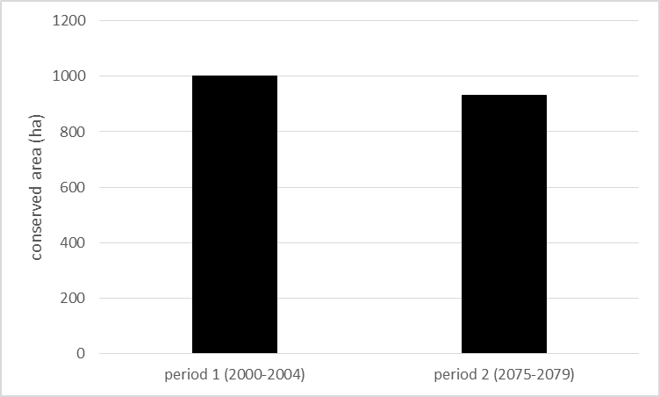
Figure A3.1: Area (ha) conserved in period 1 (2000-2004) and 2 (2075-2079) (RCP4.5)
Figure A3.2 shows the effective habitat areas for the eight species. For most species, the effective habitat area is very similar in the two periods as the same conservation measure is selected. However, the skylark, which is not conserved in period 1 is additionally conserved in period 2. This is due to the species’ phenological adaptation: the skylark has a relatively late reproduction phase (cp. Appendix A1), but its phenological adaptations are relatively large (Appendix A5). Thus, while the harvest in quarter month 27 results in no effective habitat area in period 1, a harvest in quarter month 27 allows for some effective habitat area in the second period.
Other species also experience increases in effective habitat area, while few species experience losses. Overall, the total effective habitat thus increases by 16% in period 2, despite the overall protected area decreasing (Figure A3.1).
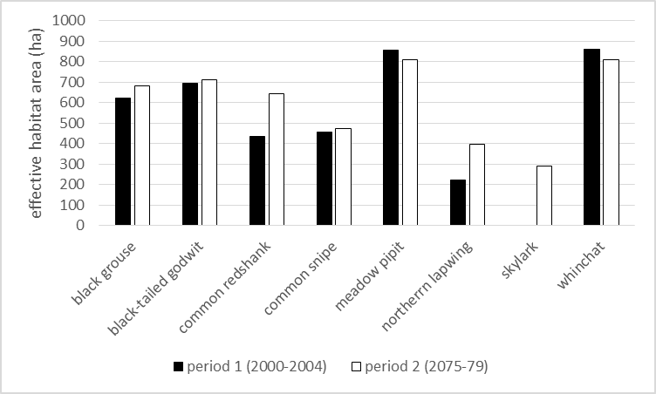
Figure A3.2: Effective habitat area (ha) for each species in period 1 (2000-2004) and 2 (2075-2079) (RCP4.5)

A.4. Detailed cost analyses
Figure A4.1 shows the mean costs of each conservation measure in both periods. It can be seen that most conservation measures generate higher costs in period 2 than in period 1. However, measures M19/8, M22/6 and M24/6 generate lower costs in period 2.
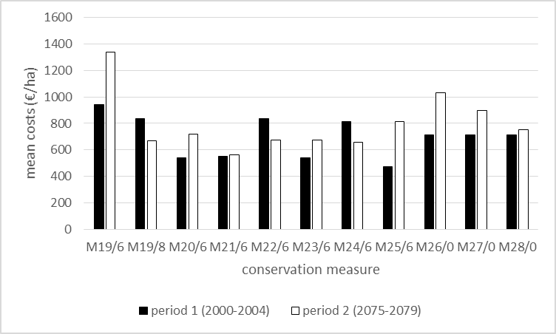
Figure A4.1: Mean costs per measure in period 1 (2000-2004) and 2 (2075-2079) (RCP8.5).
Considering the conservation measures ordered by decreasing costs (Fig. A4.2), it can be seen that the order changes. In period 1, some conservation measures that allow for an early harvest have relatively high costs. In period 2, measure M19/6 still has the highest costs, but is followed by measures that allow for only a single harvest.
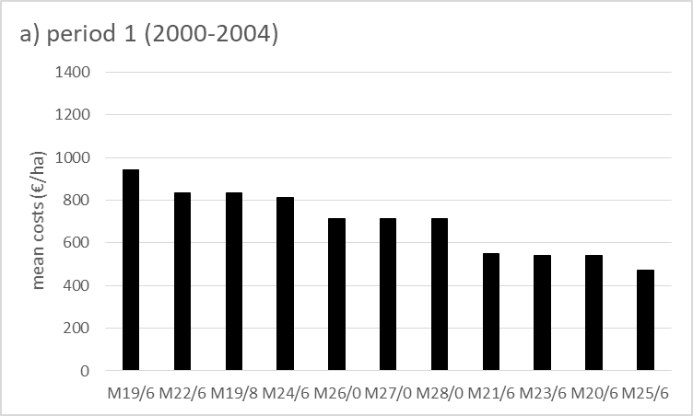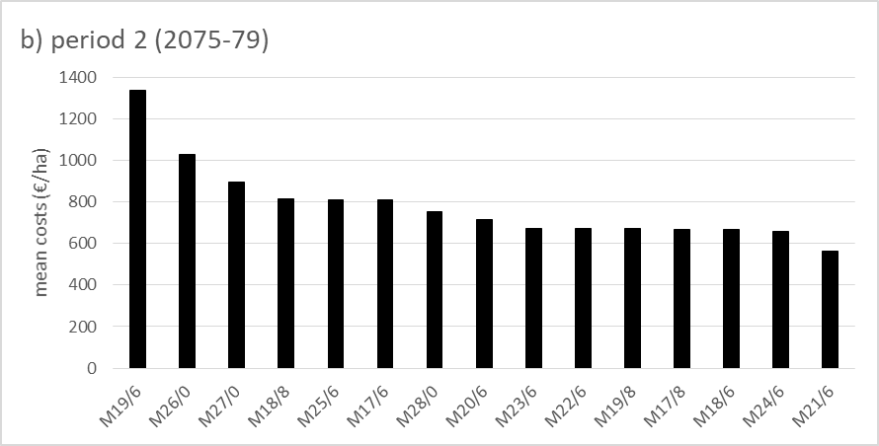
Figure A4.2: Measures ordered by decreasing mean costs in period 1 (2000-2004) (Fig. A4.2a) and 2 (2075-2079) (Fig. A4.2b) for RCP8.5.
The reason for the changes in the relative cost advantage lies in the occurrence of extreme events, in particular flooding. While short floods reduce the quality of the harvest, long floods lead to a total loss of revenue, as the harvest quality is too low to be used as fodder (cp. Gerling et al. 2020). Depending on the length and timing of inundations, the costs of a conservation measure may differ between years and the order of conservation measures according to costs may change. Overall, in period 1, the conservation measure selected (M25/6) is the measure with lowest mean costs in this period. The conservation measure selected in period 2 (M28/0) has medium costs, but low costs when compared to other measures that allow only a single harvest. Moreover, the payment for the measures allowing only a single harvest are low in RCP8.5 scenario when compared to the RCP4.5 scenario.
Figure A4.3 shows changes in mean costs of the selected measures M25/6 and M28/0 over time, considering the spatial dimension. Generally, areas along the Western edge of the case study area have relatively high costs for both measures, while costs in the center of the case study area are relatively low.
Moreover, the relative cost changes of the two measures can be observed in the spatial representation as well: Measure M25/6 (selected in the first period) has relatively low costs in period 1, but costs increase throughout the case study area in period 2. Measure M28/0 has higher costs in period 1, but costs remain relatively constant. Again, the changes are homogeneous throughout the case study area.

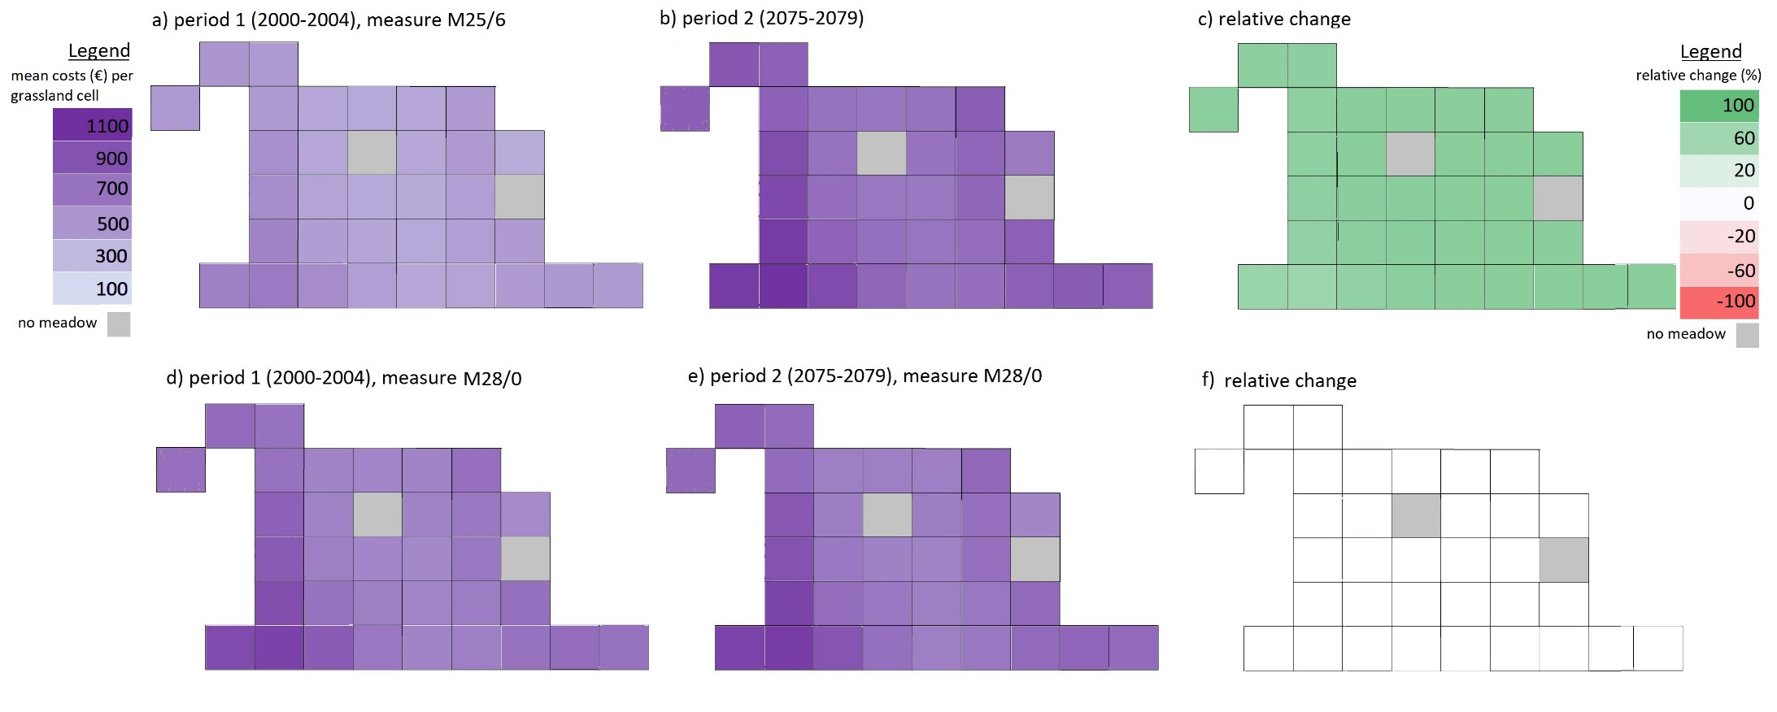
Figure A4.3: Mean costs (€/ grassland cell) of conservation measure M25/6 in period 1 (2000-2004) (Fig. A4.2a) and 2 (2075-2079) (Fig. A4.2b) and relative changes (Fig. A4.3c) and mean costs of conservation measure M28/0 in period 1 (2000-2004) (Fig. A4.2d) and 2 (2075-2079) (Fig. A4.2e) and relative changes (Fig. A4.3f) for RCP8. Colors represent a continuous scale.

A.5. Detailed ecological and climate analyses
To understand the increasing benefit of early conservation measures and the decreasing benefit of later conservation measures, we examine in how far the probability of egg deposition changes for the different species (Figure A5.1). Generally, we observe an advance in the species’ egg deposition (except for the black-tailed godwit, which is not expected to experience any phenological adaptation (cp. Table 2)). Regarding very early conservation measures (first harvest until quarter month 20), the ecological benefit increases in the second period as very early breeders have increasingly finished the critical reproduction period by then due to their phenological adaptations. Regarding conservation measures with medium timing (first harvest between quarter month 21-25), the ecological benefit decreases in the second period as in the first period, these measures still allow for the species to breed afterwards. As the species breed increasingly early, successful breeding after this time is reduced in the second period. Conservation measures with very late timing (from quarter month 26) have an equal benefit in both periods as the timing does not have significant impacts on the breeding periods of the species in either period for most species.

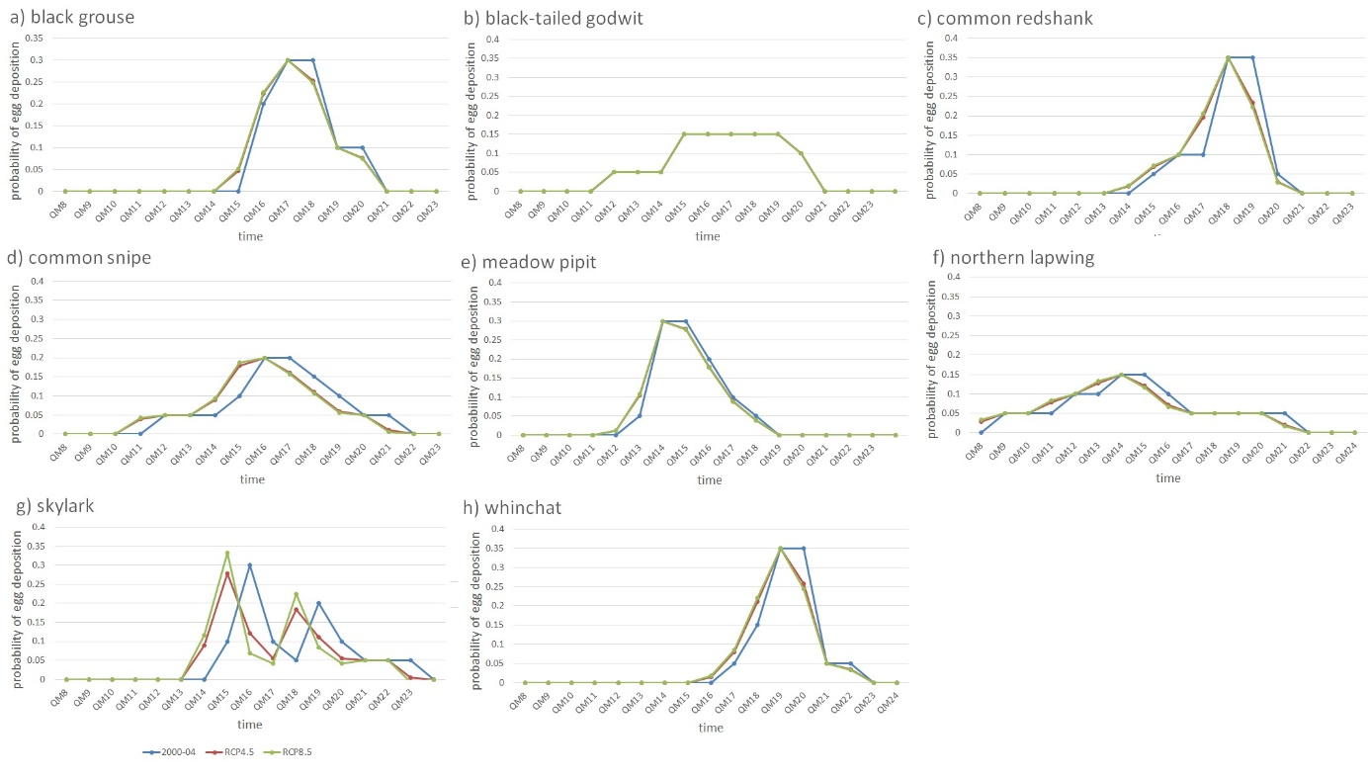
Figure A5.1: Phenological adaptations of the 8 species in quarter months (QM) for RCP4.5 and RCP8.5 scenario
However, while we observe a shift in the probability of egg deposition from 2000-2004 to 2075-2079, the differences between RCP4.5 and RCP8.5 are small. The reason for this is that the expected mean temperature increase for both RCP scenarios is similar: Figure A5.2 shows the mean temperature in March, April and spring (March – May as defined by Kluen et al. (2016)) in the first period (2000-2004) and the second period (2075-2079), considering both RCP scenarios. It can be seen that temperatures increase in all three cases, but the largest increase occurs between the first and the second period (while differences between the two RCP scenarios are small).
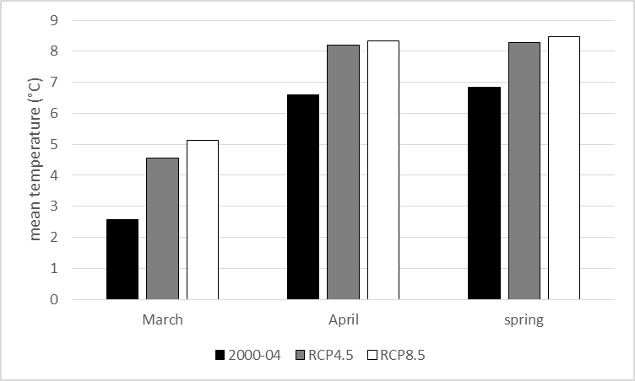
Figure A5.2: Mean temperature in March, April and spring (March- May) in period 1 (2000-2004) and 2 (2075-2079) for RCP4.5 and RCP8.5.
Our results show that the conservation measure selected in period 1 (M25/6) has a higher ecological benefit than the measure chosen in period 2 (M28/0) (cp. Figure 6). Hence, one may expect the conserved area in period 2 to be of higher quality than in period 1. Indeed, Figure A5.3 shows that the effective habitat area per 1ha of conserved area in period 2 is larger than in period 1. The only exception to this is the common redshank, which was already shown to experience the highest losses (Figure 4). This is due to a combination of a relatively late and long reproduction phase and a preference for short and medium grass length (which is typically not achieved with a single, late cut). The black-tailed godwit experiences the largest increase in effective habitat area per 1ha of conserved area. Again, the species was already shown to experience lowest losses (Figure 4). This is due to a combination of a relatively early reproduction phase (Appendix A1) and no phenological adaptations (Figure A5.1).
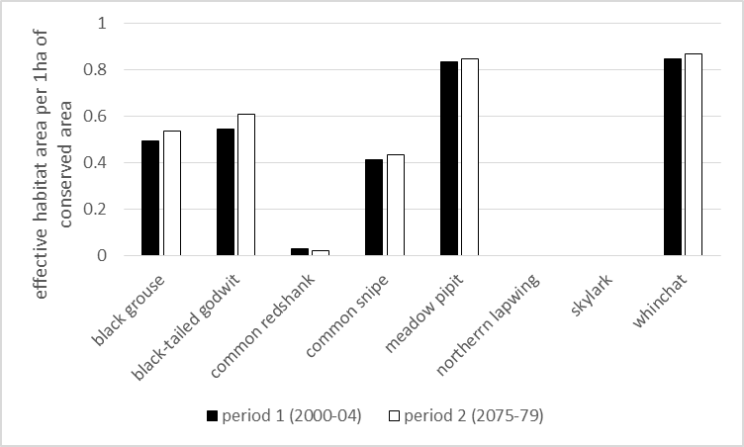
Figure A5.3: Effective habitat area per 1ha of conserved area for period 1 (2000-2004) and period 2 (2075-2079) (RCP8.5)
Considering the spatial dimension, Figure A5.4 shows the mean effective habitat area per grassland cell for the two conservation measures selected in the AES. It can be seen that the areas in the center of the case study area generate the largest mean effective habitat areas. These are the areas mainly participating in the AES (cp. Figure 5 in the main text). As discussed in the main text, there are few changes over time in the effectiveness of the conservation measures, and Figure A4.3 shows that this trend is homogeneous throughout the case study area.

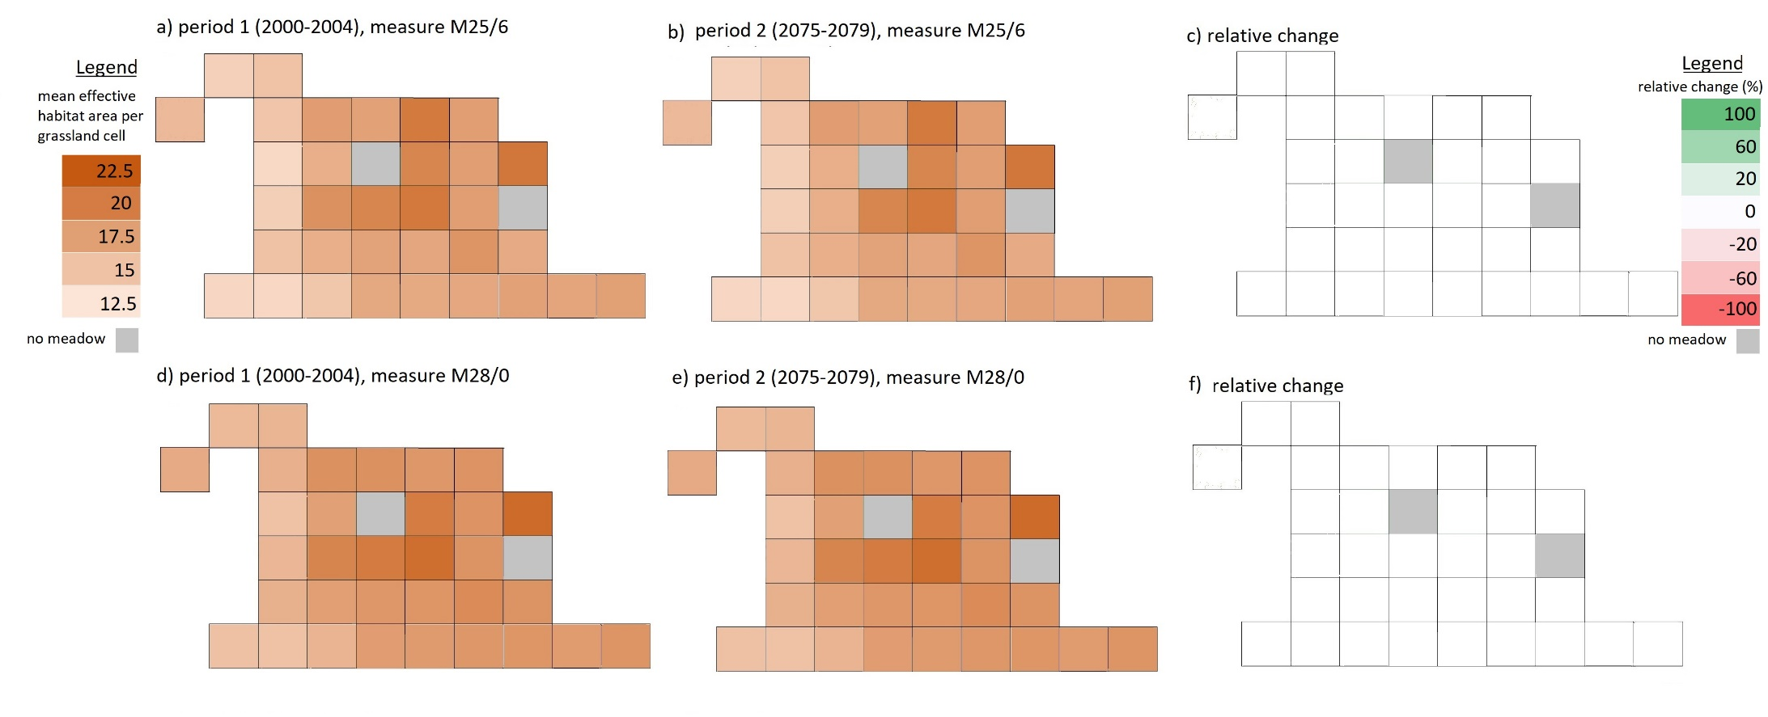
Figure A4.3: Mean effective habitat area per grassland cell of conservation measure M25/6 in period 1 (2000-2004) (Fig. A4.2a) and 2 (2075-2079) (Fig. A4.2b) and relative changes (Fig. A4.3c) and mean effective habitat area per grassland cell of conservation measure M28/0 in period 1 (2000-2004) (Fig. A4.2d) and 2 (2075-2079) (Fig. A4.2e) and relative changes (Fig. A4.3f) for RCP8.5. Colors represent a continuous scale.

Note that, as discussed in Appendix A3 and in the main text, an important difference between the two RCP scenarios lies in the occurrence of extreme events (rather than mean temperature increases) in the case study area.

