Appendix A. Additional Tables and Figures

Table 1A. Propensity Score Speciﬁcation $Pr⁡(T=1|X)$
Regressors | Coef. | s.e. | z-value | p-value
Age | -0.025 | 0.016 | -1.520 | 0.129
Male (binary) | 0.132 | 0.203 | 0.650 | 0.514
Education: high school (binary) | 0.831 | 0.329 | 2.530 | 0.011
Education: college/ university (binary) | 0.652 | 0.391 | 1.670 | 0.095
Education missing | 1.151 | 0.449 | 2.560 | 0.010
Household head’s occupation: agriculture (binary) | 0.006 | 0.196 | 0.030 | 0.975
Years in farming | 0.014 | 0.016 | 0.850 | 0.393
Household size | 0.061 | 0.077 | 0.790 | 0.431
Profitable farm ª | 0.397 | 0.165 | 2.410 | 0.016
Subsidy dependent ^{b} | -0.066 | 0.111 | -0.590 | 0.553
Frequency of cooperation ^{c} | -0.027 | 0.069 | -0.400 | 0.692
Share of agricultural production sold on a market | -0.009 | 0.006 | -1.450 | 0.147
Share of income from farming | -0.001 | 0.005 | -0.240 | 0.810
Capacity: farmed area (ha) | -0.085 | 0.091 | -0.930 | 0.351
Capacity: total livestock (number of heads) | -0.019 | 0.032 | -0.600 | 0.552
Household head’s occupation: missing (binary) | -0.342 | 0.660 | -0.520 | 0.604
Constant | -0.153 | 1.029 | -0.150 | 0.882
Notes: Statistics are from a probit regression. ªProfitable farm: 1=“very unprofitable;” 2=“moderately unprofitable;” 3=“break-even;” 4=“moderately profitable;” 5=“very profitable.” ^{b}Subsidy dependent: 1=“not dependent;” 2=“slightly dependent;” 3=“very dependent.” ^{c}Frequency of cooperation: 1=“never;” 2=“rarely;” 3=“not sure;” 4=“sometimes;” 5=“always.” Further binary indicators for the missing values are omitted from the specification due to multicollinearity.

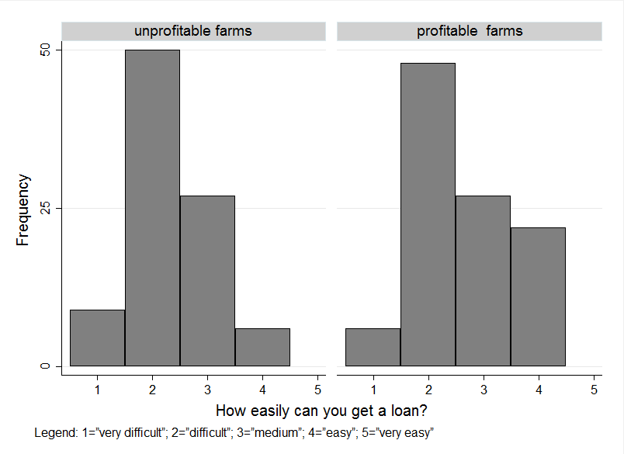

Figure 1A. Ease of Getting a Loan by Farm Profitability
Source: The 2015 survey of farmers conducted by the authors.
Notes: The graph is based on the evaluation sample. Observations with missing information on profitability (1 obs.) and loan accessibility (62 obs.) are excluded, resulting in 195 observations (92 unprofitable farms and 103 profitable farms).

Appendix B. Translation of the Brochure Content
AGENCY FOR FINANCIAL SUPPORT OF AGRICULTURE AND RURAL DEVELOPMENT
Every year the Government of the Republic of Macedonia prepares a program for the financial support of rural development.

GOALS
- Modernization and structural adjustment of the agrifood sector
- Support of economic activities related to the protection of natural, cultural and development values of rural areas
- Transition of the national agricultural policy towards EU policies
MEASURE 112 - SUPPORT OF YOUNG FARMERS IN STARTING AGRICUTURAL ACTIVITIES
- This measure is aimed at young farmers aged between 18 and 40 years who engage in agricultural activities for the first time by overtaking an existing farm or establishing a new one.

Beneficiaries
Physical and legal entities involved in an agricultural activity or agricultural households registered in the Single Farm Register (SFR) of Ministry of Agriculture, Forestry and Water Economy (MAFWE)

Criteria
- The application for support is to be submitted no later than 18 months from the date of registration of a change or a new farm in SFR
- The applicant is a holder of agricultural property
- The applicant has at least secondary education in agriculture or has gone through training to acquire the qualifications for an agricultural activity, except for the cases where the business plan foresees a training
- The applicant is to comply with good agricultural practices and measures for the protection of nature and animal welfare
MEASURE 121 - INVESTMENTS IN THE MODERNIZATION OF AGRICULTURAL HOUSEHOLDS
- 121.1: Purchase of cattle from recognized organizations of cattle breeders in the Republic of Macedonia
- 121.2: Purchase of bee queens from a registered bee breeder
- 121.3: Growing new vineyards and orchards and honey flora in new locations
- 121.4: Procurement of equipment for drip irrigation for corn and forage crops and wells for irrigation
- 121.5: Investments in agricultural equipment and mechanization for grain and industrial crops

Beneficiaries
Agricultural farms registered in SFR of MAFWE, in accordance with the Law of Agriculture and Rural Development

Criteria
- The applicant is a holder of agricultural property
- Submeasure 121.3 requires a minimum acceptable size of 0.5 hectares with a mandatory agrichemical analysis of soil and certified planting material
- Submeasure 121.4 requires suitable production capacities (from 2 to 10 ha) recorded in the production plan for the current year
MEASURE 122 - INVESTMENTS IN THE INCREASE OF THE ECONOMIC VALUE OF FORESTRY
- To increase the production efficiency by reducing the costs and improving the quality of forestry production

Beneficiaries
Physical and legal entities who are forest owners and/or associations of private forest owners
MEASURE 131 - SUPPORT OF ECONOMIC ASSOCIATIONS OF FARMS FOR JOINT AGRICULTURAL ACTIVITIES
- 131.1: Establishment and operation of agricultural cooperatives
- 131.2: Organization of information and promotional activities for agricultural products
- 131.3: Aid for insurance premiums in the form of partial reimbursement of the insurance cost
- 131.4: Investments for purchasing agricultural machinery that amount to 90% of the procurement value

Beneficiaries
Agricultural cooperatives registered in the Register of Agricultural Cooperatives of MAFWE in accordance with the Law of Agricultural Cooperatives

PROCEDURE
- Submission of the application
- Approval of the request
- Signing of the contract
- Realization of the obligations under the contract
- Filing for the payment
- Approval of the payment

Required documents and guidelines can be obtained on the website of Agency for Financial Support of Agriculture and Rural Development or at the local units of the National Extension Agency.

Check before submitting an application
It is necessary to verify the data for cadastral parcels and production facilities registered in SFR and check whether or not all liabilities are settled: those based on lease and use of state-owned land, state pastures, water bills, concessions for commercial and recreational fishing, concessions for issuing a permit to hunting areas, obligations regarding the contracts for the use of compensation funds from foreign assistance, taxes, and contributions for which the public revenue office is responsible.

INSTITUTIONS

Ministry of agriculture, forestry and water economy (MAFWE)

Amina Treti St. 2, 1000 Skopje Phone: 02/3134-477
www.mzsv.gov.mk

Agency for financial support of agriculture and rural development (AFPZRR)
3d Makedonska brigada 20, 1000 Skopje Phone: 02/3097-450
www.pardpa.gov.mk

National Extension Agency (NEA)

Kliment Ohridski St. 66, 7000 Bitola
www.agencija.gov.mk

