TWO DOCUMENTS ON THE FOUNDING OF THE ECONOMETRIC SOCIETY
EDITED BY
OLAV BJERKHOLT∗

The transcript of a letter addressed to thirty-one scholars in 1930, to solicit their opionion as to the organization of an international association for the advancement of economic theory, and the facsimile of the tentative draft constitution prepared for the organization meeting to found the Econometric Society in December 1930, are provided as an online appendix to accompany the editor’s analysis of them in “On the Founding of the Econometric Society” (Journal of the History of Economic Thought 39 (2).

The June Letter
460 Prospect Street,
New Haven, Conn. U.S.A.
June 17, 1930
The undersigned are writing to ask your opinion as to a project we have been considering, namely the organization of an international association for the advancement of economic theory. As we see it, the chief purpose of such an association would be to help in gradually converting economics into a genuine and recognized science. Such a purpose, we think, can only be realized by giving the association a theoretical scope. Only in this way, we believe, can one make sure that its work will proceed on truly disinterested lines, exempt from national, political and social prejudice. The word theory in this connection should, of course, not be interpreted as synonymous with abstract reasoning only, but as including also the analysis of empirical evidence suggesting or verifying theoretical laws.
According to our present ideas, membership should be subject to election by general vote of the association and should be limited to those who
(a) are thoroughly familiar with general economic theory,
(b) have a working knowledge of mathematics as applied to economic theory and statistics,
(c) have some knowledge of accounting,
(d) have published an original contribution to economic theory or to the analysis of such economic statistics or accounting as have a definite bearing on problems in economic theory.
Do you agree that such an association is desirable and if so, do you find that (a) to (d) give an adequate formulation of the requirements for eligibility, or would you suggest some other formulation? Do you think the requirement: “Have some experience in handling statistical data” should be added?
Do you consider yourself eligible for membership according to the conditions (a) to (d) and would you, if enough others do likewise, help form the association and become a charter member?
It is of special importance, of course, that the charter membership should consist only of those with undoubted qualifications. With a view to this we have considered it essential from the very start to have the advice and judgment of a selected group of economists, namely the following, to whom the present letter is being sent:
Luigi Amoroso, University of Rome, Italy
L. v. Bortkiewicz, University of Berlin, Germany
A. L. Bowley, London School of Economics, England
T. N. Carver, Harvard University, Cambridge, Mass., U.S.A.
Gustav Cassel, Stockholms Högskola, Sweden
J. B. Clark, 407 West 117th Street, New York City, U.S.A.
J. M. Clark, Columbia University, New York City, U.S.A.
C. Colson, École Nationale des Ponts et Chaussées, Paris, France
François Divisia, École Nationale des Ponts et Chaussées, Paris, France
G. C. Evans, Rice Institute, Houston, Texas, U.S.A.
Mordecai Ezekiel, Bureau of Agricultural Economics, Washington, D.C., U.S.A.
Irving Fisher, Yale University, New Haven, Conn., U.S.A.
Ragnar Frisch, Oslo University, Norway (pro tem Yale University)
Corrado Gini, University of Rome, Italy
John M. Keynes, University of Cambridge, England
Hans Mayer, University of Vienna, Austria
H. L. Moore, Columbia University, New York City, U.S.A.
Jacques Moret, 4 Rue d'Agnesseau, Paris, France
Bertil Ohlin, Handelshögskolan, Stockholm, Sweden
Warren M. Persons, 76 MacDougal Street, New York City, U.S.A.
A. C. Pigou, University of Cambridge, England
Umberto Ricci, University of Rome, Italy
Charles F. Roos, Cornell University, Ithaca, New York, U.S.A.
Jacques Rueff, Institut de Statistique, Université de Paris, France
Henry Schultz, Chicago University, Chicago, Illinois, U.S.A.
J. Schumpeter, University of Bonn, Germany
Eugen Slutsky, Institut fur Konjunkturforschung, Moscow, U.S.S.R.
Alfonso de Pietri Tonelli, University of Venice, Italy
Gustavo del Vecchio, R. Università Commerciale, Trieste, Italy
Harald Westergaard, University of Copenhagen, Denmark
Wl. Zawadski, University of Wilno, Poland

If we receive sufficient encouragement from this group, we expect to send a similar letter to a larger group. Will you please supply the names of persons who, according to your opinion, should be included in this larger group? It would be a great help if you could furnish some references to the publications of those whom you suggest to be included. Before we take any final step, a tentative list of the names thus suggested to us will be prepared, and the list submitted for criticism to those to whom the present letter is being sent.
You will notice that in the requirements for eligibility we have put a good deal of emphasis on the quantitative character of economic theory. As you know, the quantitative movement in economics started on an a priori basis through the introduction of mathematics into economic theory. Afterwards and independently, empirical studies in mathematical statistics were made. Still more recently, a beginning has been made to bridge the gap between these two approaches. These attempts at putting economics on a scientific and quantitative basis by introducing numerical and statistical observations into the theoretical structure we consider as one of the most promising developments in modern economics, and one to which the association should give considerable attention. In our opinion, it will be largely through a constant and close connection between the abstract-rational and the concrete-empirical points of view that the modern quantitative movement in economics will produce significant and lasting results.
We believe that the association should not include those who have merely treated economic problems empirically, without reference to fundamental theoretical principles. If you and the others consulted are in sympathy with us in laying down this policy, mathematical statisticians as such will not be included. They will only be included if they satisfy all the requirements (a) to (d). In practice, the line may be difficult to draw. On this we would like to have your judgment.
According to our present idea, there would be no dues except voluntary ones. To raise the necessary funds we might apply to individuals and to foundations or organizations accustomed to assist research work. If at first sufficient funds should be difficult to raise, the publishing activity of the association might be restricted to a yearly leaflet giving the names of the members with addresses brought up to date and a list of the recent publications of the members. Such a leaflet would stimulate, we believe, an informal private correspondence and exchanging of reprints between the members.
If sufficient funds are raised, it would probably be desirable to create a journal. As we see it, the distinctive feature of such a journal should be to concentrate on the quantitative study of economics in the sense described above. Although such a policy would mean devoting a major part of the journal to mathematical economic contributions, non-mathematical papers might also be accepted provided they made a significant contribution to economic theory or to the numerical verification of the laws of economic theory.
Besides the publishing of original papers there would, in our opinion, be three main functions for the journal:
(1) reviewing and abstracting the more important mathematical economic works, both those currently published in other economic, statistical and mathematical journals, and the outstanding works of the past,
(2) furnishing biographical notes regarding mathematical economists of the past,
(3) preparing a complete and systematic annotated bibliography of mathematical economic literature. This would require the cooperation of correspondents in many countries.
The scope of the journal might perhaps be happily suggested by calling it “Oekonommetrika”. Do you think, however, that this name would (by analogy with Biometrika and Metron) suggest the idea of economic statistics only? Do you think that in order to indicate the constructive theoretical scope of the journal, it should be given a name such as “Economic Theory” or “Economic Science”? Have you any other suggestions as to the name of the journal?
Besides the creation and publication of a journal, there might be numerous other possible tasks for the association, as for instance, promoting the establishment of chairs of economic theory including mathematical economics in the universities, helping toward the standardization of the notation and terminology of economic theory, publishing a lexicon of technical terms in economic theory, serving as a bureau of reference for commercial firms who have problems offering theoretical and statistical difficulties, and so forth.
All the suggestions in this letter are, of course, tentative, as the principles on which the association should be built must ultimately be settled by vote of the members. The aim of the present letter is merely to start the ball rolling.
We look forward with keen anticipation to your reply and suggestions.

Very sincerely yours,

Irving Fisher Ragnar Frisch Charles F. Roos
Yale University Oslo University Cornell University
(Pro tem Yale University)
Tentative Draft Constitution of the Econometric Society
Prepared by Irving Fisher, Ragnar Frisch and Charles F. Roos
November 1930
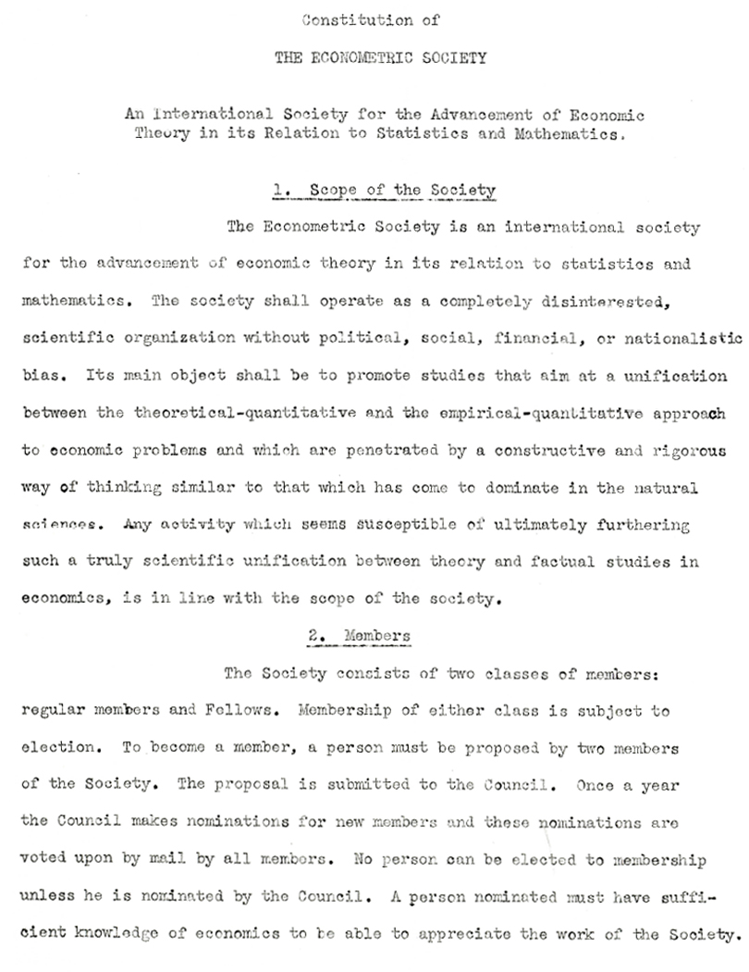
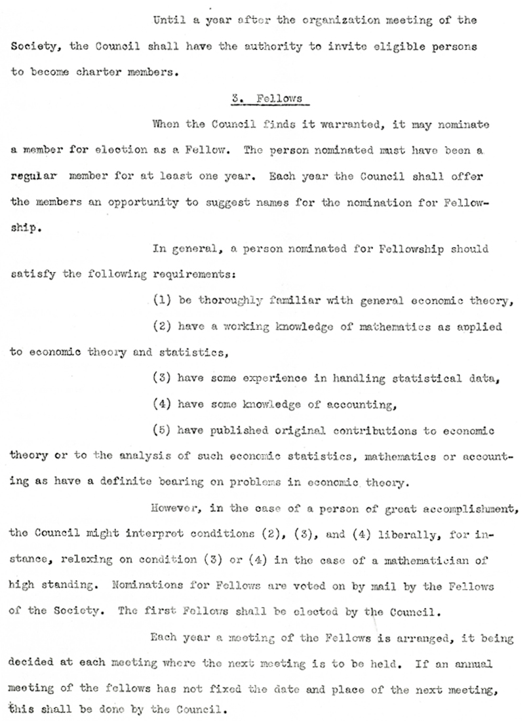

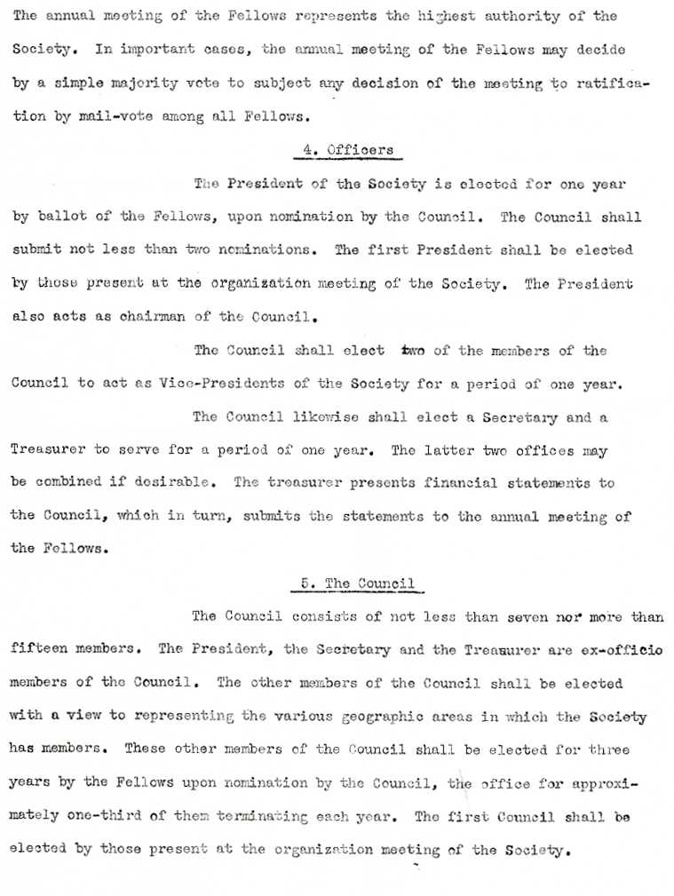

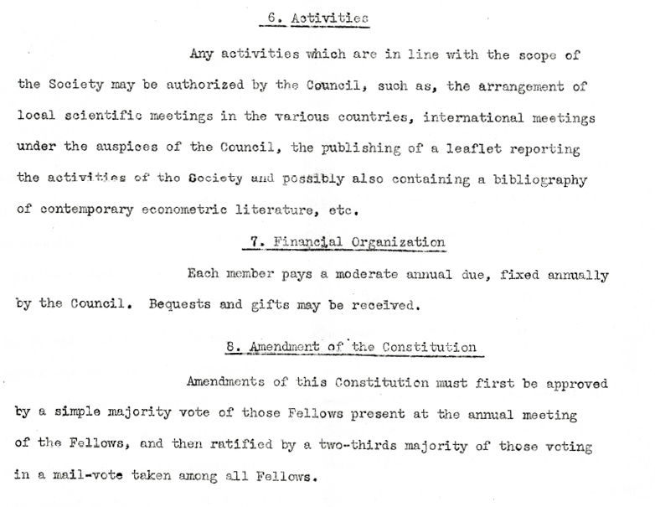

∗ Department of Economics and Frisch Centre, University of Oslo, Norway: olav.bjerkholt@econ.uio.no. Both documents have been retrieved from the Ragnar Frisch papers at the National Library of Norway.

