**Online Appendix**

**Appendix A: U.S. Results**

For the U.S. case, respondents were asked how American they felt when they thought of particular symbols. Using factor analysis, we find that they load onto three “frame clusters,” which we label “culture” (traditional frames), “experiences” (value frames), and “sports” (sports frames). Figure 1 shows the results for the entire US sample, and we see that the “culture” symbols made the respondents feel American at .59, “experiences” at .54, and “sports” at .50. These placements indicate that the respondents are differently understanding these symbols in terms of their Americanness, although the substantive effects are not overly large. The next steps will investigate whether these averages obscure variation by race-ethnicity, ideology, religion, and partisanship.

Figure 1:

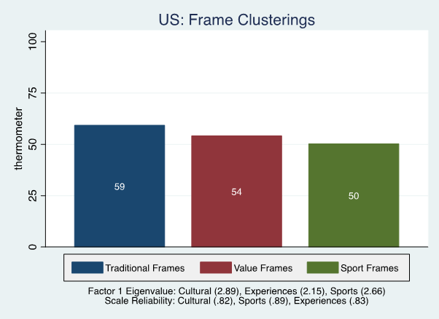

Figure 2 shows the thermometers for the individual “cultural” frames, first in the aggregate and then divided by race-ethnicity, ideology, and religiosity. In the “aggregate” graph (upper left), we see greater warmth toward some symbols – notably American history (.71) and the armed forces (.67) – than toward others – particularly cowboys (.49) and pickup trucks (.49). The American countryside is approximately in-between these two groupings (.62). As we will see, these general patterns repeat themselves among all the specific subgroups examined.

Figure 2:



The upper right figure shows that whites respond more warmly to all these images than do non-whites. Substantively, the differences range from a low of five points (pickup trucks) to a high of fifteen (American history). In a similar way, conservatives and the religious are more positive about these frames than are non-conservatives and the non-religious, although the religious differences are substantively smaller (and in one case, pick-up trucks, the thermometers are approximately the same).

Figure 3 shows how Republicans, Democrats, and Independents view the frames. Republicans report the strongest evaluations of these traditional symbols of everyday American nationhood, while Democrats report the weakest and Independents are in the middle. The greatest difference is for pickup trucks and cowboys, for which Republican warmth is about twenty percentage points higher than for Democrats. We also see a 14 to 16 point difference for history, the countryside, and the armed forces, with Republicans feeling more American about these symbols. Independents cleave closer to Democrats, and in one case (American history,) report the lowest evaluations.

Figure 3:

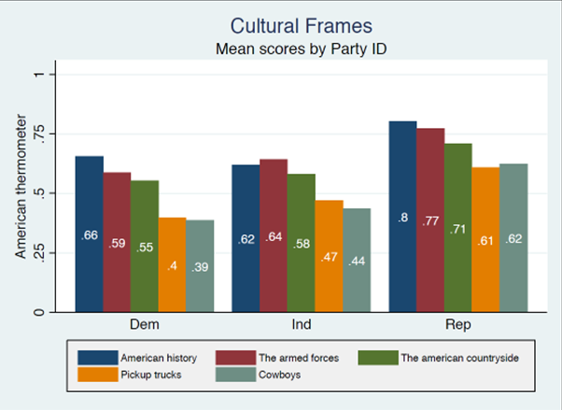

Figure 4 presents the thermometers for the “experiences” frames, showing variation in support for national parks, diversity, immigrants, and alternative neighbourhoods.

Figure 4:



In the upper right corner, we see that national parks are the most highly rated, with diversity just under .60 and immigrants and alternative neighborhoods below .50. When we examine these evaluations by subgroup, we see fewer differences than we did with the cultural frames. While whites appear to highly rate national parks, we see few other substantial differences by race-ethnicity or by religion. By contrast, non-conservatives are about ten points more likely than are conservatives to feel American when thinking about diversity, immigrants, and alternative neighborhoods.

Looking more closely at partisan attachment to these value symbols in Figure 5, we find Republicans are more enthusiastic about national parks, while Democrats feel more American than do Republicans when thinking about diversity, immigrants, and alternative neighbourhoods. This shows that it is not simply the case that Republicans are more nationalistic. In fact, with the right set of symbols, Democrats can be made to feel more strongly attached to the nation than Republicans. This time, Independents more closely resemble Republicans than Democrats.

Figure 5:

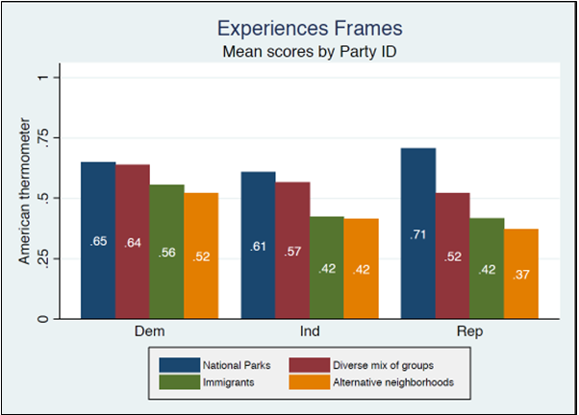

In Figure 6, we examine sports frames, as sports and athletes are widely popular (much more so than are politics and politicians) and can play important roles in politics but are not often studied by political scientists. We find that baseball and football are the most likely to make the respondents feel American (.61 and .59, respectively), while basketball is over ten points behind (.49) and hockey is at the bottom (.39). The latter might not be surprising, as it is the national game of another country (Canada) and its perception as part of America is undoubtedly higher in northern areas where teams and leagues are longer established.

Whites give football a thirteen point higher rating than do non-whites, but the other sports show relatively few differences by race-ethnicity. Hockey makes few whites or minorities feel American, while basketball is about at the middle for both groups. Baseball makes both groups feel American at rates of .58 and .59.

For ideology, we see no double-digit differences in how a particular sport makes the respondents feel American. This is also true for the religion measure, although the religious consistently give slightly higher ratings to all sports.

Figure 6:



In Figure 7, the largest partisan difference is for football. Republicans rate this sport at .72 in contrast to .56 for Democrats and .52 for Independents. Baseball generates relatively high levels of American feelings among all respondents. Basketball is at the middle point while hockey has bipartisan (but likely regionally skewed) low ratings. We might conclude that while some claim baseball lost its status as America’s Pastime due to the rise of football viewership and revenue, “the old ball game” is a political unifier and not a divider.

Figure 7:

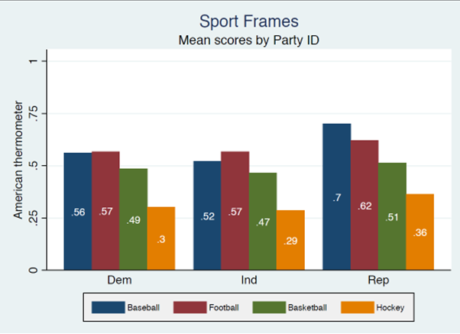

When examining the three aggregate frame clusters by partisanship in Figure 8, we find the largest differences involve the culture-traditional items, with Republicans the most enthusiastic. Democrats, by contrast, identify their Americanism more with the experiences-values items. Republicans are also more attached to team sports as representative of nationhood.

Figure 8:

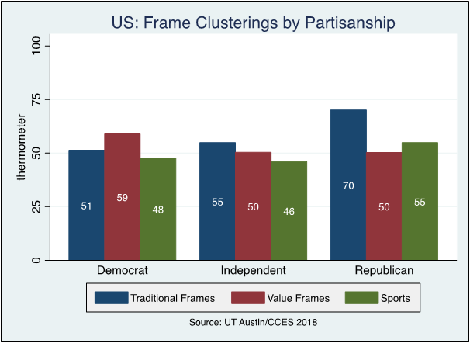

Examining these meta-symbolic categories in Figure 9, we find few ethnic differences for values and sports, but considerably more support for traditional symbols of nationhood among whites as compared to non-whites.

Figure 9:

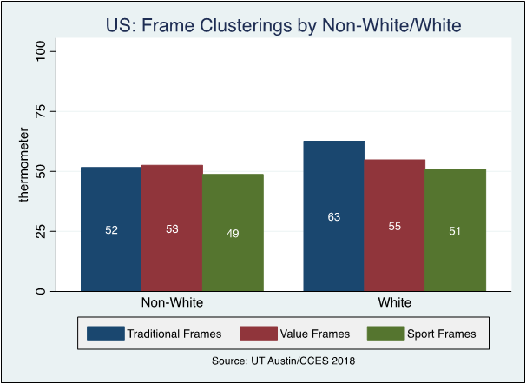

**Appendix B: U.S. Models**

**A. Clusters**

Table 1 contains the OLS regression results for models of the three frame clusters. Figure 10 graphically represents the findings: Republicans and whites are more attached to the cultural, traditional symbols of nationhood – such as history and the countryside – than are Democrats and respondents from other races and ethnicities. A gender dimension also emerges, with women less likely to see such cultural symbols, as well as team sports, as symbols of their sense of nationhood. The religious are more likely to report that team sports make them feel more American. For the experiences cluster, the conservative variable is statistically significant and directionally negatively while the political attention variable is significant and positive.

Figure 10:



**B. Voting and Opinion**

Figure 11 illustrates the regression results from the Trump vote and border wall support models, although some of the statistically significant results are substantively small and therefore not easily visible.

When controlling for ethnicity, ideology, and partisanship, the content of one’s “personal nationalism” (Cohen 1996) predicts a Trump vote in terms of the experiences-values frames but not the other two. The culture-traditional and experiences-values frames are associated with support for a US-Mexico border wall, however.

Figure 11:



Figures 12 and 13 show more clearly the association between the symbolic content of nationhood and Trump voting and support for Trump’s wall. In Figure 12, respondents who feel most American when they see the “cultural-traditional” frames have a nearly .6 chance of supporting the wall compared to around .25 for those whose Americanism is least bound up with these symbols. For the “experiences-values” frames (such as diversity and alternative neighbourhoods), the results are nearly reversed, with those who strongly identify their Americanism with these symbols least likely to favour building a wall. Note that these results hold with partisanship, ideology, and other variables held at their means.

Figure 12:

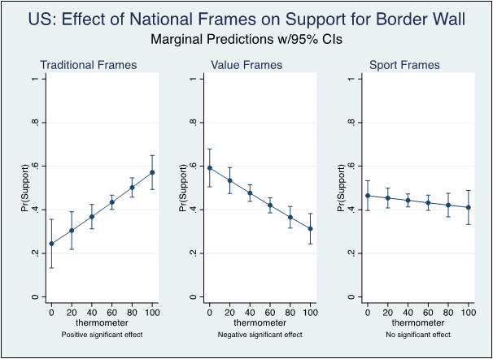

In Figure 13, we see that one set of symbols is statistically significant: “experiences-values” frames. Symbols like diversity and alternative neighbourhoods are negatively associated with voting for Trump; those at the lower end of the scale have close to a .6 chance of voting for Trump, while those at the highest end have just over a .4 chance.

Figure 13:

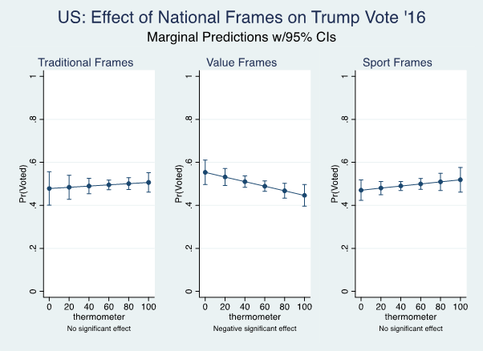

Lastly, the following three graphs show the marginal effects for particular clusters that differ by groups (Whites/non-Whites, Conservatives/non-Conservatives, and Religious/non-Religious). These represent the substantive effects of the statistically significant interaction terms in the regression models. They indicate that the frames matter particularly for race-ethnicity and ideology in terms of support for Trump and the border wall.

Figure 14:

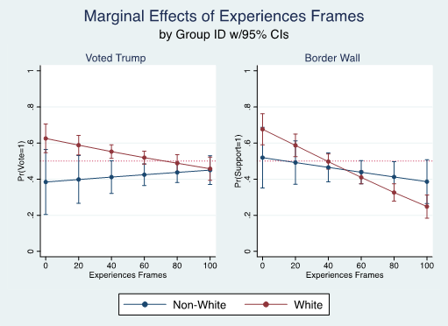

Figure 15:

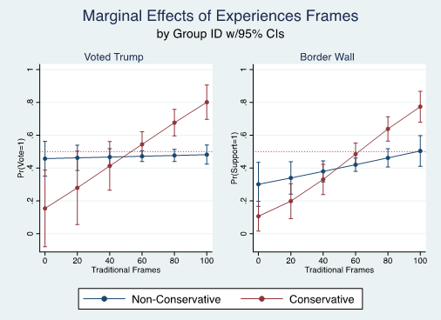

Figure 16:

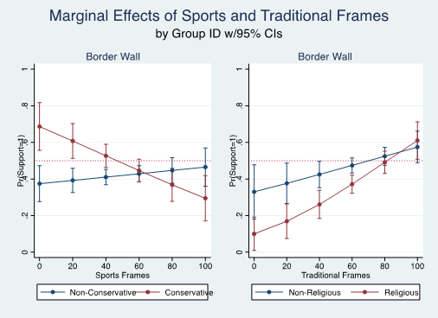

Table 1: Predictors of US Frame Clusters, Linear Regression Estimates

|  |  |  |  |
| --- | --- | --- | --- |
|  | Culture | Experiences | Sports |
| Age | .03 (.08) | -.04 (.08) | -.05 (.09) |
| Education | -1.28 (1.35) | .36 (1.30) | -1.57 (1.40) |
| Income | .51 (.42) | .59 (.40) | .73 (.43) |
| Female | -6.02* (2.58) | -2.42 (2.68) | -8.06** (2.84) |
| Political Attention | 2.10 (1.45) | 3.65* (1.55) | .83 (1.66) |
| White | 7.31* (3.48) | .98 (3.65) | .47 (3.71) |
| Conservative | -.66 (3.61) | -7.97* (3.59) | -5.78 (3.80) |
| Republican | 12.53*** (3.35) | -5.13 (3.68) | 6.08 (3.99) |
| Religious | 2.73 (2.79) | 2.76 (2.94) | 7.33* (2.97) |
| Constant | 42.40*** (5.70) | 44.16*** (6.57) | 47.80*** (6.35) |
| R-Squared | .11 | .05 | .05 |
| F-Statistic | 9.19*** | 3.66*** | 3.41*** |
| Observations | 882 | 884 | 878 |

OLS coefficients; robust standard errors in parentheses

Source: 2018 CCES UT-Austin Module

* *p* < .05, ** *p* < .01, *** *p* < .001

Table 2: Predictors of UK Frame Clusters, Linear Regression Estimates

|  |  |  |  |
| --- | --- | --- | --- |
|  | Values | Traditional | Expressive |
| Age | .04*** (.01) | .06*** (.01) | .01 (.01) |
| Education | -.05*** (.01) | -.03*** (.01) | -.10*** (.01) |
| Income | .00 (.00) | -.00 (.00) | -.01*** (.00) |
| Female | -.00 (.01) | .02* (.01) | .02 (.01) |
| Political Attention | .01*** (.00) | .02*** (.00) | -.01*** (.00) |
| Conservative | .18*** (.01) | .12*** (.01) | .16*** (.01) |
| White | .11*** (.02) | .12*** (.02) | .04* (.02) |
| Religious | .08*** (.01) | .22*** (.01) | .11*** (.01) |
| Constant | 2.65*** (.03) | 2.24*** (.03) | 1.92*** (.03) |
| R-Squared | .06 | .10 | .09 |
| F-Statistic | 94.12*** | 165.55*** | 141.84*** |
| Observations | 11792 | 11902 | 11778 |

OLS coefficients; standard errors in parentheses.

Source: YouGov/BBC, March 2018.

* p < .05, ** p < .01, *** p < .001

**Appendix C: Race and Ethnicity in the US**

The following figures show additional detail by race and ethnicity, as we disaggregate non-White into White, Black, Latino, and Other. Figure A indicates that Whites give the highest rating to these “cultural-traditional” symbols, followed by Latinos, Others, and Blacks.

Figure 17:

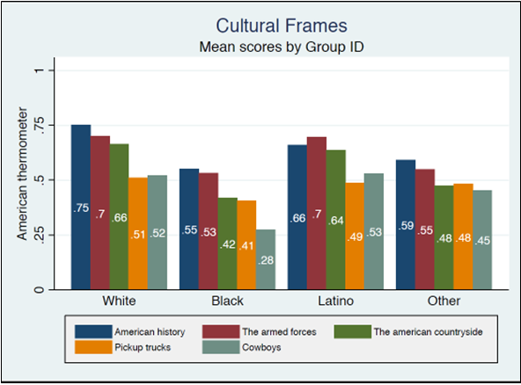

In Figure 18, we see the racial-ethnic group differences for the “experiences-values” symbols. National parks again emerge as distinctive, but the other symbols are not interpreted very differently.

Figure 18:

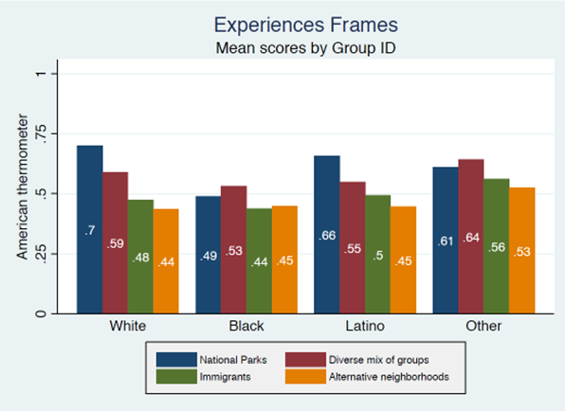

For sports frames (Figure 10), we see some group differences in perceived Americanness. Whites rate baseball as making them feel most American, whereas all other groups rate football the highest. One hypothesis for these results is that Whites may be responding to the traditional claim that baseball is America’s national pastime, while other group ratings reflect the contemporary reality of audiences, ratings, and profitability. No group is particular likely to see hockey as American, while Latinos and Others are the most likely to see basketball in these terms.

Figure 19:

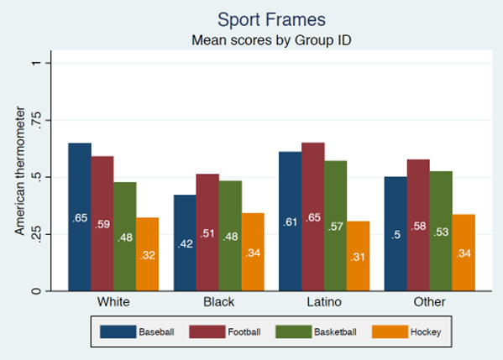

**Appendix D: US Regression Models**

Predictors of US Frame Clusters, Linear Regression Estimates

|  |  |  |  |  |  |  |  |  |  |
| --- | --- | --- | --- | --- | --- | --- | --- | --- | --- |
|  | Standard | | Race  Interactions | | Ideology Interactions | | Religiosity Interactions | | |
|  | Trump Vote | Wall | Trump Vote | Wall | Trump Vote | Wall | Trump Vote | Wall | |
| Traditional | .02  (.01) | .03*** (.01) | .02  (.02) | .02  (.02) | .00  (.01) | .02+ (.01) | .02  (.01) | .02*  (.01) | |
| Experiences | -.02*  (.01) | -.03*** (.01) | .01  (.02) | -.01 (.01) | -.02* (.01) | -.03*** (.01) | -.02* (.01) | -.03***  (.01) | |
| Sports | .00  (.01) | -.00 (.01) | .00  (.02) | -.01 (.01) | .01  (.01) | .01  (.01) | -.01  (.01) | .00  (.01) | |
| Age | .00  (.02) | .04*** (.01) | .00  (.01) | .04*** (.01) | .00  (.01) | .04*** (.01) | -.00  (.01) | .04***  (.01) | |
| Education | -.48*  (.19) | -.14 (.16) | -.44* (.18) | -.14 (.16) | -.41* (.19) | -.09 (.17) | -.55** (.20) | -.12  (.16) | |
| Income | .12  (.09) | .03  (.05) | .13  (.08) | .03  (.05) | .12  (.08) | .02  (.05) | .13  (.08) | .03  (.05) | |
| Female | -.89+  (.47) | -.72** (.27) | -.73 (.47) | -.69* (.28) | -.97* (.45) | -.74** (.27) | -1.01* (.43) | -.74**  (.27) | |
| Political Attention | -.35  (.36) | -.07 (.17) | -.35 (.35) | -.06 (.16) | -.42 (.35) | -.11 (.17) | -.27 (.35) | -.07  (.17) | |
| Conservative | 1.32*  (.63) | .40  (.31) | 1.46** (.51) | .38  (.31) | -.92 (1.48) | -.58 (.61) | 1.25* (.57) | .38  (.32) | |
| Party ID | 1.19*** (.14) | .71*** (.08) | 1.26*** (.16) | .71*** (.08) | 1.27*** (.16) | .72*** (.08) | 1.21*** (.13) | .72***  (.08) | |
| Religious | .91+  (.51) | .85** (.28) | .84+ (.48) | .85** (.28) | 1.00+ (.52) | .90** (.28) | 2.76 (1.70) | 1.06  (.72) | |
| White | 1.51**  (.56) | -.12 (.34) | 4.16+ (2.30) | .11  (.68) | 1.55** (.55) | -.08 (.35) | 1.50** (.55) | -.14  (.35) | |
| White # Traditional |  |  | -.01 (.03) | .01  (.02) |  |  |  |  | |
| White # Experiences |  |  | -.04+ (.02) | -.03* (.01) |  |  |  |  | |
| White # Sports |  |  | .00  (.02) | .01  (.02) |  |  |  |  | |
| Conservative # Traditional |  |  |  |  | .08* (.03) | .05* (.02) |  |  | |
| Conservative # Experiences |  |  |  |  | -.03 (.03) | .01 (.01) |  |  | |
| Conservative # Sports |  |  |  |  | -.03 (.02) | -.05** (.02) |  |  | |
| Religious # Traditional |  |  |  |  |  |  | -.00 (.02) | -.03+  (.02) | |
| Religious # Experiences |  |  |  |  |  |  | -.01 (.02) | .01  (.01) | |
| Religious # Sports |  |  |  |  |  |  | -.02 (.02) | .02  (.01) | |
| Constant | -5.06** (1.64) | -4.88*** (.68) | -7.43* (2.73) | -5.13*** (.84) | -4.76** (1.32) | -4.53*** (.68) | -6.27** (2.17) | -5.07***  (.82) | |
| F-Statistic | 14.75*** | 14.51*** | 10.61*** | 12.08*** | 11.31*** | 12.14*** | 12.18*** | 11.71*** |
| Observations | 603 | 838 | 603 | 838 | 603 | 838 | 603 | 838 |

Standard errors in parentheses.

Source: 2008 CCES UT-Austin Module.

+ *p* < .10, * *p* < .05, ** *p* < .01, *** *p* < .001

**Appendix E: English Regression Models**

Predictors of UK Frame Clusters, Linear Regression Estimates

|  |  |  |  |  |  |  |  |  |
| --- | --- | --- | --- | --- | --- | --- | --- | --- |
|  | Standard | | Race Interactions | | Ideology Interactions | | Religiosity Interactions | |
|  | Conser-vative Vote | Brexit | Conser-vative Vote | Brexit | Conser-vative Vote | Brexit | Conser-vative Vote | Brexit |
| Value | .27*** (.06) | .27*** (.05) | .18 (.21) | .20 (.16) | .22*** (.06) | .20*** (.06) | .23** (.08) | .22** (.07) |
| Traditional | .16** (.05) | .10* (.05) | .09 (.19) | .29+ (.15) | .13* (.06) | .11* (.05) | .19* (.08) | .11+ (.07) |
| Expressive | .24*** (.07) | .50*** (.06) | .21 (.24) | .28 (.19) | .34*** (.07) | .63*** (.07) | .46*** (.09) | .69*** (.08) |
| Age | .55*** (.03) | .28*** (.03) | .55*** (.03) | .28*** (.03) | .55*** (.03) | .28*** (.03) | .55*** (.03) | .28*** (.03) |
| Education | -.45*** (.03) | -.59*** (.03) | -.45*** (.03) | -.59*** (.03) | -.45*** (.03) | -.59*** (.03) | -.45*** (.03) | -.59*** (.03) |
| Income | .04*** (.01) | -.07*** (.01) | .04*** (.01) | -.07*** (.01) | .04*** (.01) | -.07*** (.01) | .04*** (.01) | -.07*** (.01) |
| Female | -.09+ (.05) | -.17*** (.04) | -.09+ (.05) | -.17*** (.04) | -.09+ (.05) | -.17*** (.04) | -.09+ (.05) | -.17*** (.04) |
| Political Attention | -.15*** (.01) | -.11*** (.01) | -.15*** (.01) | -.11*** (.01) | -.14*** (.01) | -.11*** (.01) | -.15*** (.01) | -.11*** (.01) |
| Conservative | 2.88*** (.06) | 1.19*** (.05) | 2.88*** (.06) | 1.19*** (.05) | 3.23*** (.44) | 1.91*** (.35) | 2.89*** (.06) | 1.19*** (.05) |
| White | .78*** (.10) | .31*** (.08) | .24 (.59) | .05 (.46) | .79*** (.10) | .32*** (.08) | .78*** (.10) | .30*** (.08) |
| Religious | .41*** (.05) | .18*** (.04) | .41*** (.05) | .18*** (.04) | .41*** (.05) | .18*** (.04) | 1.47*** (.33) | .94**  (.29) |
| White # Value |  |  | .09 (.22) | .08 (.17) |  |  |  |  |
| White # Traditional |  |  | .08 (.20) | -.21 (.16) |  |  |  |  |
| White # Expressive |  |  | .03 (.25) | .23 (.20) |  |  |  |  |
| Conservative # Value |  |  |  |  | .23 (.15) | .26* (.12) |  |  |
| Conservative # Traditional |  |  |  |  | .17 (.14) | -.04 (.11) |  |  |
| Conservative # Expressive |  |  |  |  | -.60*** (.17) | -.55*** (.13) |  |  |
| Religious # Value |  |  |  |  |  |  | .07 (.11) | .10 (.10) |
| Religious # Traditional |  |  |  |  |  |  | -.07 (.11) | -.02 (.09) |
| Religious # Expressive |  |  |  |  |  |  | -.43*** (.13) | -.39***  (.11) |
| Constant | -3.18*** (.24) | -1.05*** (.20) | -2.68*** (.58) | -.82+ (.45) | -3.27*** (.25) | -1.25*** (.21) | -3.76*** (.30) | -1.43*** (.25) |
| Pseudo R-Square | .31 | .17 | .31 | .17 | .31 | .17 | .31 | .17 |
| Chi-Square | 4945.28*** | 2891.12*** | 4946.20*** | 2984.27*** | 4957.67*** | 2909.41*** | 4960.99*** | 2904.74*** |
| Observations | 11759 | 12183 | 11759 | 12183 | 11759 | 12183 | 11759 | 12183 |

Standard errors in parentheses.

Source: YouGov/BBC, March 2018.

+ *p* < .10, * *p* < .05, ** *p* < .01, *** *p* < .00