**Appendix A: Description of the *Soldiers of the Second World War* Dataset**

Our database would not be possible without the efforts of the Department of Defense, the Census, and the National Archives; the work of researchers at those organizations provide us with an opportunity to explore this unique and necessary question with an extraordinary amount of detail.

As mentioned in the main document, the data comes from information that was taken from individuals at their first point of contact with the military at their place of induction. Representatives for the military, in turn, took a raft of biographical information on the individuals being induced. This included information on the person’s place of birth, place of residence, height, weight, race, ethnicity, parents’ place of origin, occupation, and marital status. All of this information was entered onto punch cards that were meant to be used and analyzed on early computers.

There are a number of concerns that we took into account when using these valuable data; they can help answer important questions regarding American political life. The process by which conscription data were digitized and made publicly available took place in a three-stage process. Handwritten service-member records were put on punch cards so that the information could be read by primitive computers. Decades later, the punch cards were digitized and all the information put into a numerical format. Third, these digital forms were uploaded to the internet in ASCII format, for public use, in 2003. For a more detailed explanation of this process, please see the “Reference Copy of Technical Documentation for Accessioned Electronic Records” from the National Archives and Records Administration. In this document the National Archives detail the entire process in great detail and highlight a number of difficulties that arose during the digitization process. For example, significant corruption of a number of files occurred, including individuals being identified with names such as “ZZZZ” or individuals whose values for weight and height are unrealistic. Ultimately, a vast majority of the records are accurate. Additionally, the errors do not appear to be systematic and we feel confident in assuming that they occur as if random. After cleaning the database of soldiers’ personal information, we merged these data in with census data and electoral data, relying on ICPSR datasets 02896 and 08611, respectively. We cleaned these datasets to provide the information we needed for constructing our covariates as explained in the manuscript. All datasets were merged using ICPSR and FIPS codes.

Our final database consists of 18,528 observations and 89 variables. Below, we discuss the use of these databases to construct our primary dependent and independent variables, and briefly detail the control covariates we selected and why. The full dataset can be found here: <https://dataverse.harvard.edu/dataset.xhtml?persistentId=doi:10.7910/DVN/UQ8HND>.

The following screenshot shows a sample of rows from the raw dataset; as is obvious in the “YearBirth” variable, many pieces of data are incomplete. Without the full four-digit year of birth, it is unclear whether an individual was legitimately born in 1899 or if “99” is an unknown year of birth. State and county codes are unique to this dataset and are not ICPSR or FIPS codes, requiring us to manually re-code all of them. Other variables, such as weight and height, are often impossible; some individuals report heights and weights highly improbable for human beings, in either inches or centimeters, and pounds or kilograms. Substantial cleaning of the data involves a significant amount of dropping data of use. For this paper, we would have wanted to use the variable “Marital Status” (not visible in this sample), but there is simply too much missing and unreliable data in that variable.

We assume that errors in the variables we ultimately use are as-if-random. These errors have likely emerged as a result of the three data-transfer processes throughout the life of the dataset. We are also unable to find older versions of the dataset with fewer errors as they are not publicly available.

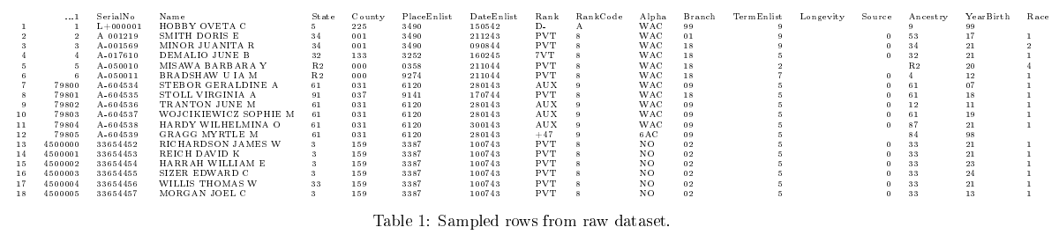​​**Table A1. Sample Rows from Raw Dataset**

**Table A2. Enlistment by Type and Year, U.S. Army, 1939-1945**

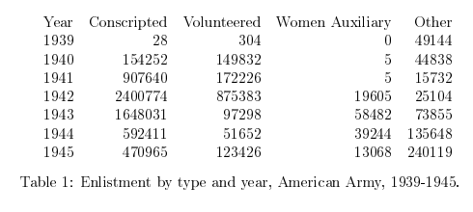

**Appendix B: Female Volunteers**

The following table reports our summary statistics, showing the sample sizes and moments of the distribution for each of our predictor and outcome variables.

**Table B1. Summary Statistics**

|  |  |  |  |  |  |
| --- | --- | --- | --- | --- | --- |
|  | N | Mean | Std. Dev. | Min. | Max. |
| Manufacturing Wages/Population | 18,696 | 30.726 | 42.9834 | 0.1473 | 346.1388 |
| Retail Wages/Population | 24,704 | 0.0178 | 0.0135 | 0 | 0.1358 |
| Wholesale Wage/Population | 23,144 | 0.0057 | 0.0091 | 0 | 0.2501 |
| Service Sector Wages/Population | 24,648 | 0.0026 | 0.0034 | 0 | 0.0804 |
| Prop. Unemployed | 24,632 | 0.0365 | 0.0167 | 0 | 0.1317 |
| Prop. Female College Graduate | 24,704 | 0.0077 | 0.0045 | 0.0009 | 0.0395 |
| Total Population/1000 1940 | 24,704 | 42392.23 | 143590.4 | 0.0004 | 4063342 |
| Prop. Urban Population 1940 | 24,704 | 0.2320 | 0.2538 | 285 | 1 |
| Prop Democratic Presidential 1940 | 24,704 | 67.9996 | 88.2283 | 0 | 99.9 |
| Prop. Democratic Congress 1940 | 22,864 | 61.0307 | 26.8243 | 8.3 | 100 |
| Racial Dissimilarity | 19,975 | 0.5226 | 0.30854 | 0 | 0.9947 |
| Racial Isolation | 19,975 | 0.1084 | 0.1411 | 0 | 1 |
| Prop White Females 21+ | 24,704 | 0.4293 | 0.0863 | 0.0693 | 0.5233 |
| Prop. White males 21+ | 24,704 | 0.4560 | 0.0959 | 0.0750 | 0.6773 |
| Prop Black Females 21+ | 24,704 | 0.0283 | 0.0462 | 0 | 0.2402 |
| Prop. Black Males 21+ | 24,704 | 0.0282 | 0.4623 | 0 | 0.2841 |

The following table contains the list of all covariates from the several coefficient plots in the manuscript. Many coefficients appear small given the large variance in the variables, but our coefficient plots and substantive statistics in the manuscript demonstrate their true magnitude.

**Table B2. Coefficients for Female Volunteerism**

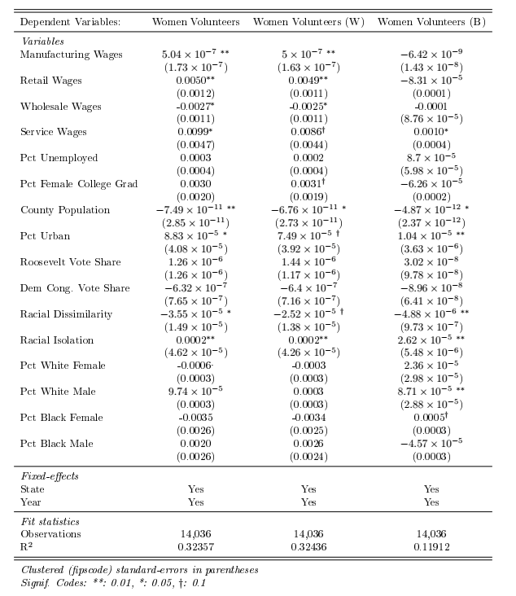

The following table shows our results if we systematically eliminate our hypothesized effects one at a time from the model. Overwhelmingly, our results are robust to these alternate specifications. Only a few effects change. First, our coefficient for female college graduates becomes statistically significant at the 0.05 level when we remove racial dissimilarity and racial isolation. When we remove all our economic variables, racial isolation is no longer statistically significant at the 0.05 level. Racial dissimilarity remains statistically significant.

**Table B2. Coefficients for Female Volunteerism, Without IVs**

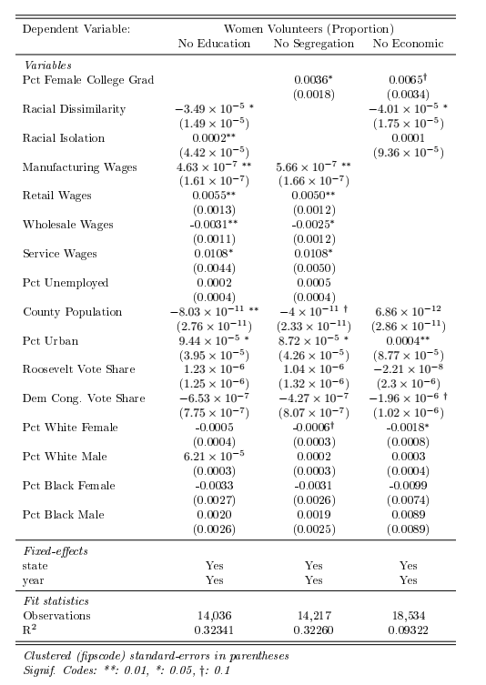

**Appendix C: Male Volunteers**

The manuscript focuses on female volunteers for two reasons. First, female volunteers did not face the prospect of enlistment through conscription, while male volunteers did. This creates a perverse incentive – exploited by male military-age Americans until 1943 when the U.S. Army severely restricted volunteering – to volunteer rather than face conscription. Volunteers had more flexibility in their assignment, and could use that flexibility to avoid or delay being placed in combat units. Second, several of our covariates of interest, including college graduation, were structurally different for men and women in the 1940s due to relatively strict gender roles compared to today. Therefore, direct comparison of these two groups in a standard regression format would have given unwieldy estimates.Instead, we reproduce our manuscript analyses on the sample of 1.7 million male volunteers in the Army during the war.

First, we show male volunteers in 1943:

**Figure C1. Standardized Rate of Male Volunteers by County, 1943**

Note: Darker gray indicates lower volunteerism, while lighter grey indicates higher volunteerism.

Second, we show the correlation matrix of all variables for men volunteers:

**Figure C2. Correlation Matrix**

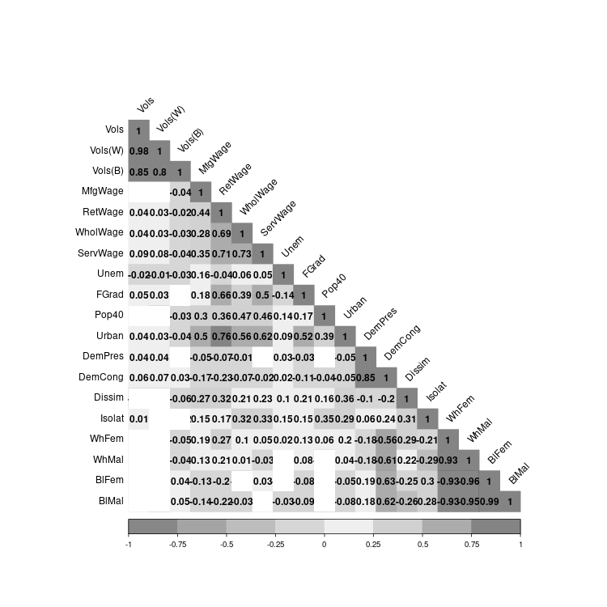

Third, we report volunteer rates for men by race and year:

**Figure C3. Male Volunteers, 1941-1945**

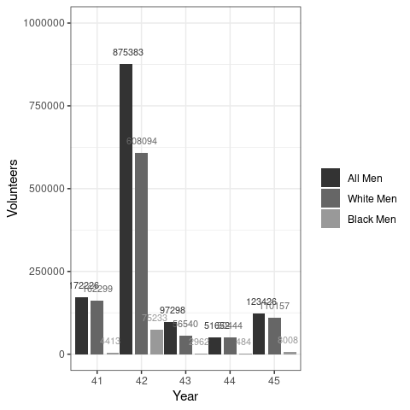

Finally, we show a coefficient plot of our estimates for all covariates:

**Figure C4. Influences on Male Volunteerism**

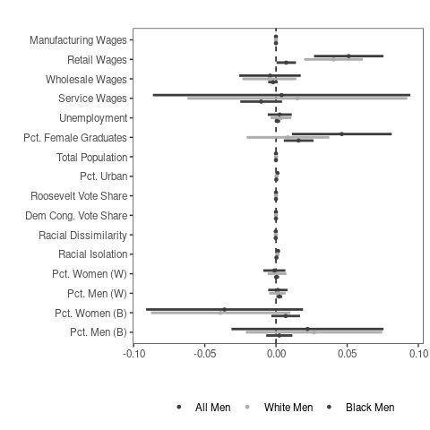

Notably, we find several differences between male and female volunteers. First, we find a statistically-significant and positive relationship between Roosevelt vote share and male volunteerism, although the substantive effects are quite small. Second, we only find a positive association between retail wages and volunteerism among men, while wholesale and service wages in particular report small effects. Interestingly, the effect of increasing female college graduation rates on male volunteerism is positive and statistically significant for all and black male volunteers, but not for white volunteers. For more insight on the male volunteers, there is a forthcoming paper using the data for male volunteers at *Political Research Quarterly,* which can be found here:

<https://journals.sagepub.com/doi/10.1177/10659129221119753?fbclid=IwAR0PxkoQ-HrpVK3LypS6-icxsZJzaPhr0OcmeA8DToywRIXgQd9QoE-yjbQ>.

**Appendix D: Alternate DV: Inverse Hyperbolic Sine**

Concerns that our outcome and predictor variables violate the assumption of nonlinearity in the parameters are understood. To alleviate these concerns, we transformed most of our predictors and outcomes (save the two vote share and two racial variables, which do not need transformation) using the inverse hyperbolic sine transformation. We then re-estimated coefficients from those models, and report those coefficients in the table below.

**Table D1. Coefficients for Female Volunteerism**

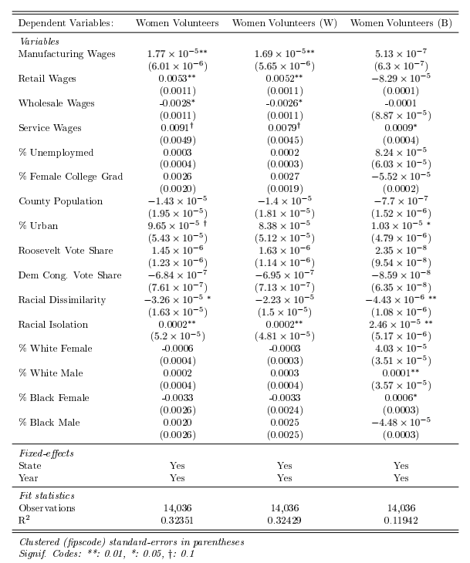

While some coefficient magnitudes change, and some coefficients are marginally significant (0.10 level instead of 0.05), the effects are broadly similar and we again find strong support for most of our hypotheses. The one major change is the percentage of female college graduates, with coefficients in the expected direction for all and white women models, but we fail to reject the null hypothesis.