Research Note: Negative Sentiment and Congressional Cue-taking on Social Media

Supplementary Materials

1 Plots of Facebook Posts Over Time

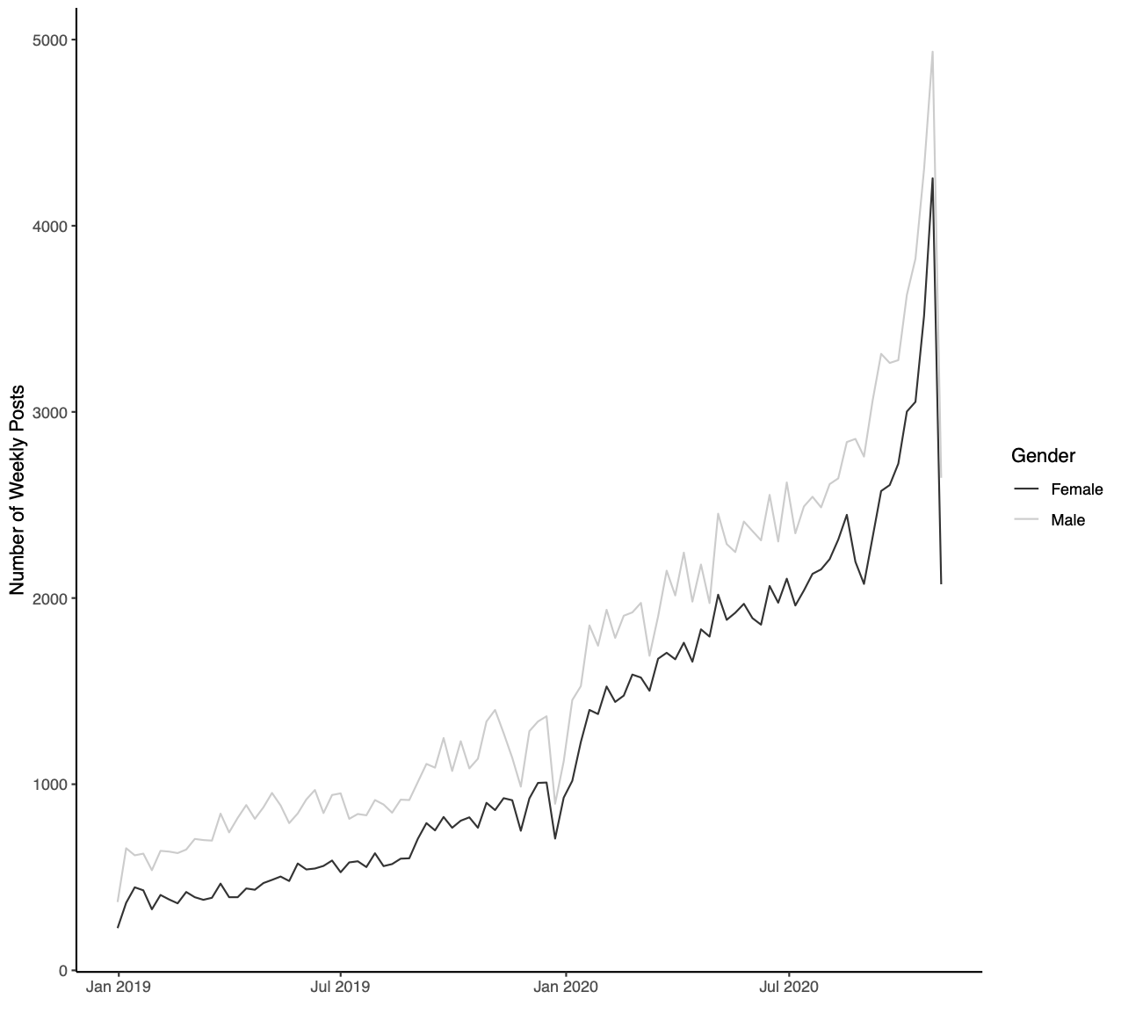
Figure A1. Plot of weekly Facebook posts over time by candidate gender.

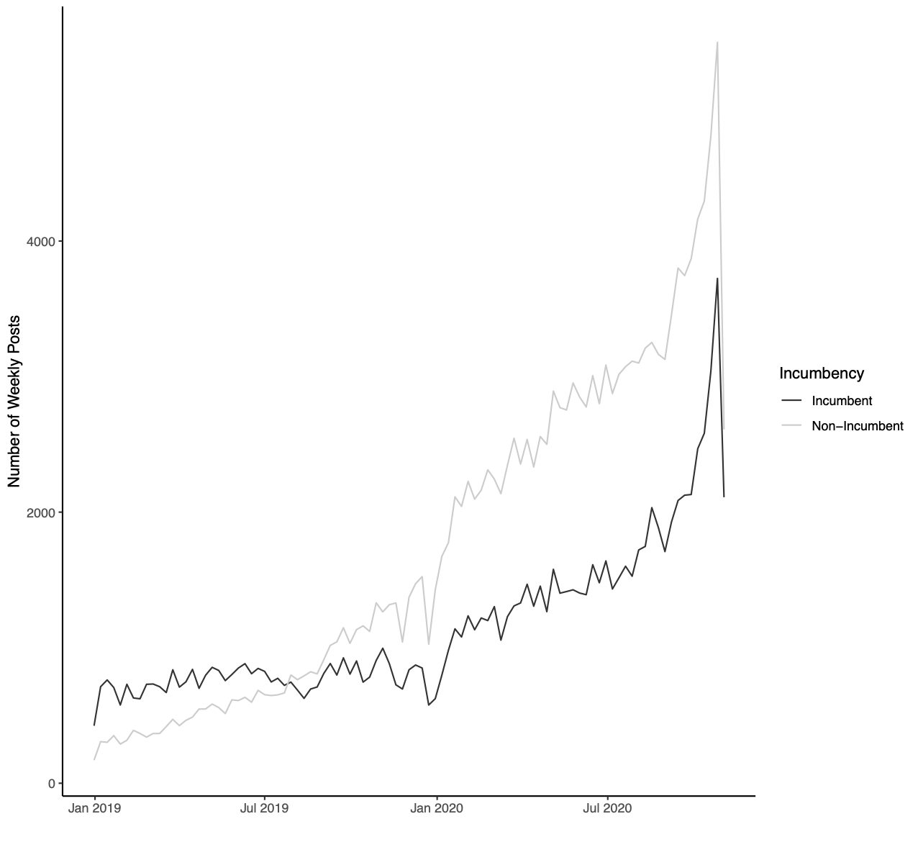
Figure A2. Plot of weekly Facebook posts over time by whether a candidate was an incumbent or a non-incumbent.

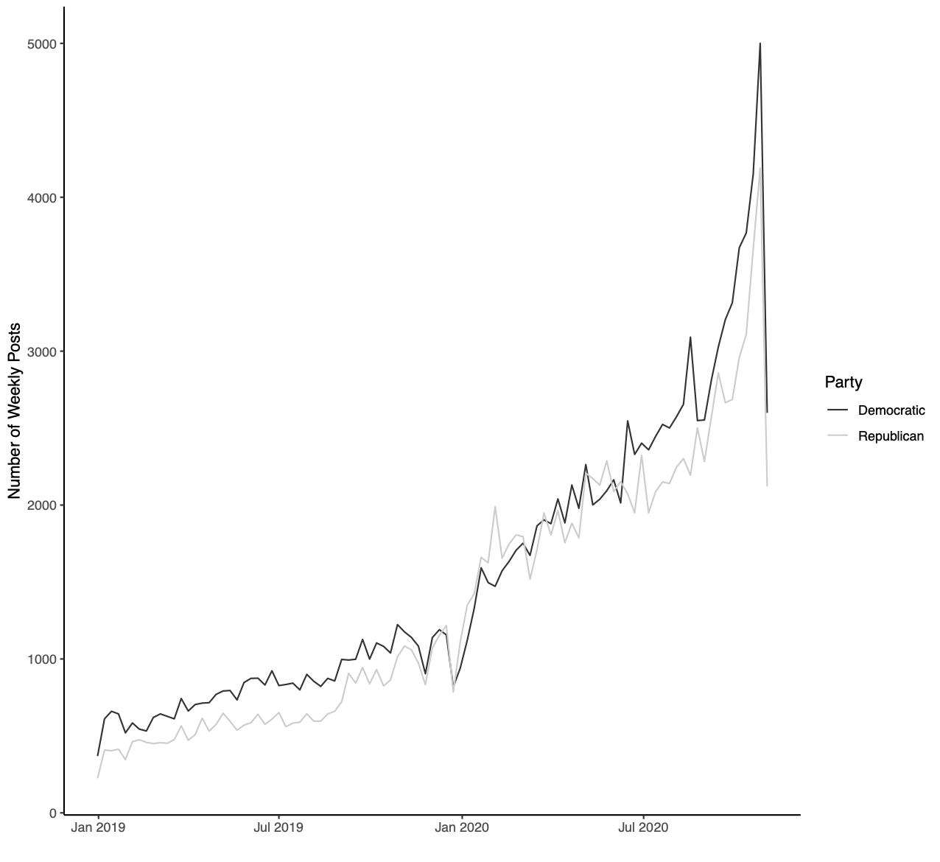
Figure A3. Plot of weekly Facebook posts over time by candidate political party.

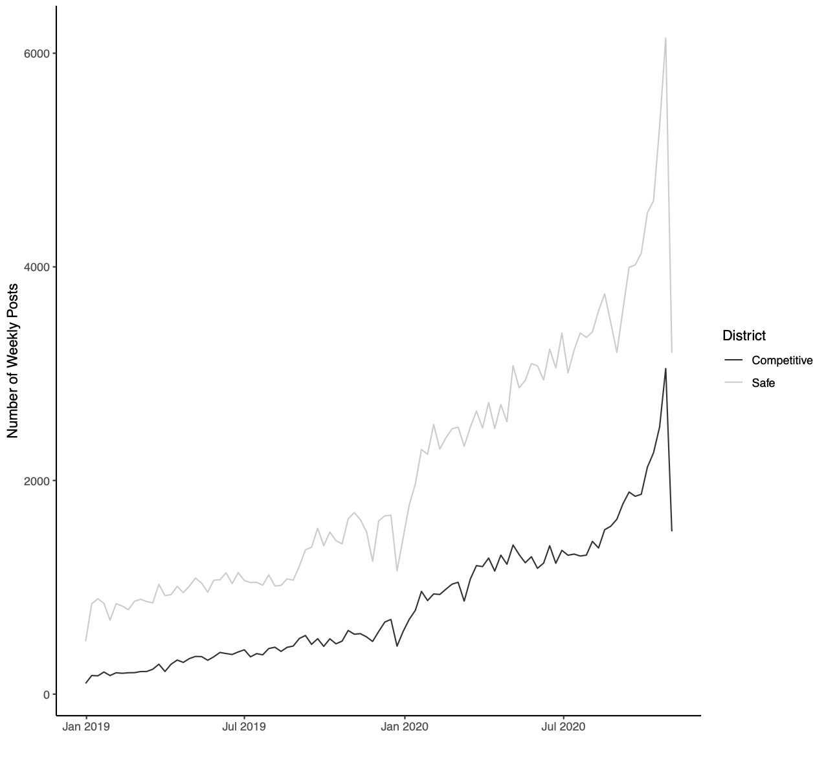
Figure A4. Plot of weekly Facebook posts over time by whether a candidate’s district was safe or competitive in 2020.

2 Additional Regression Analyses

Table A1. OLS regressions of proportion of average negative words per post on candidates' logged average post likes, comments, shares, sad reactions, and angry reactions on Facebook (by candidate-week)
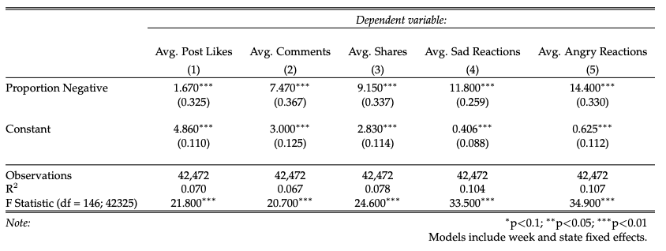

Table A2. OLS regressions of proportion of average negative words per post on candidates' logged average post likes, comments, shares, sad, and angry reactions received (by candidate), with controls.
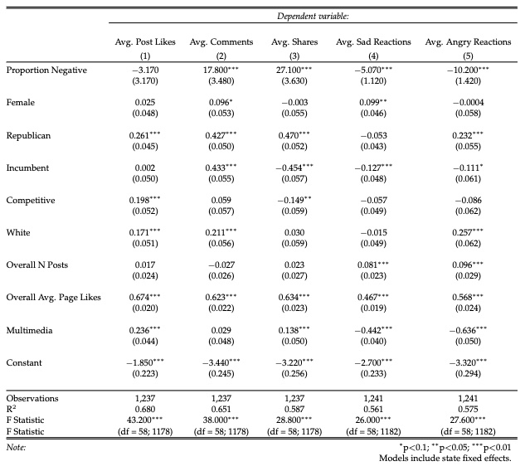

Table A3. OLS regressions of proportion of average positive words per post on candidates' logged average post likes, comments, shares, sad, and angry reactions received (by candidate), with controls.
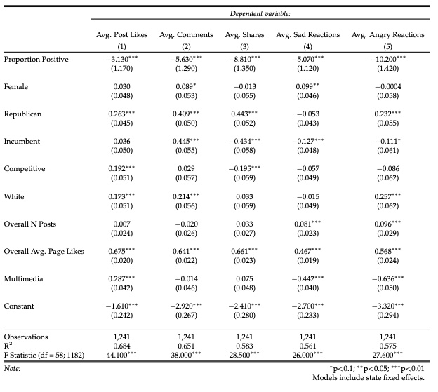

Table A4. OLS regressions of proportion of average negative words per post on candidates' logged average proportion of average sad and anger reactions, respectively, out of all interactions received (by candidate-post type- week), with and without controls.
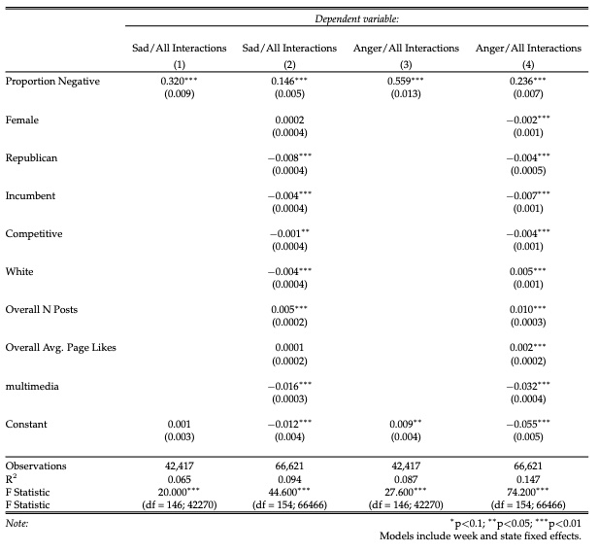

Table A5. OLS regressions of proportion of average positive words per post on candidates' logged average post likes, comments, shares, sad reactions, and angry reactions on Facebook (by candidate-post type-week).

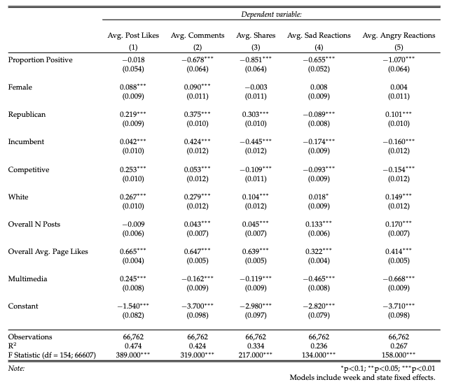

Table A6. OLS regressions of proportion of average negative words per post on candidates' logged average proportion of average love, care, wow, and haha reactions, respectively, (by candidate-week) with controls.

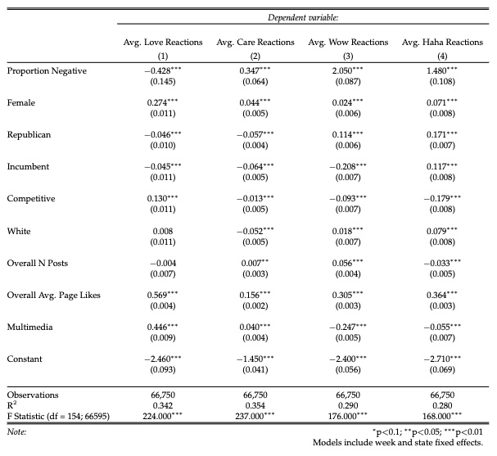

Table A7. OLS regressions of proportion of average positive words per post on candidates' logged average proportion of average love, care, wow, and haha reactions, respectively, (by candidate-week) with controls.
