Online Appendix
Religious Freedom Backlash: Evidence from Public Opinion Experiments about Free Expression

Data

The data is available to view and download at the Knight Foundation’s Website. The survey instrument received pre-approval from the Institutional Review Board at [redacted]. The research plan and hypotheses were pre-registered with OSF [ID number redacted].

Treatments

- Egalitarian - Equality Frame Secular

Foundation Director Addresses Policy Makers

WASHINGTON (AP) – In the keynote address given last Wednesday, Robert Protman, director of the Future of Hope Foundation, gave his vision of what America should be. In his speech, Mr. Protman emphasized the need for the nation to reclaim equality. Below is an excerpt from his speech.

We are intelligent people who fail or succeed based on our commitment to work, and the willingness of the government to ensure equality. We must work for each other and expect the government to provide equal protection. Our ability to achieve greatness is in our adherence to equal opportunity, not ignoring disparities. As a Founding Father stated, ‘Defend the cause of the weak and fatherless; maintain the rights of the poor and oppressed.’ We should heed these words, because they set forth a framework for how this nation and its citizens should behave.

- Religious Nationalism Frame

Foundation Director Addresses Policy Makers

WASHINGTON (AP) – In the keynote address given last Wednesday, Robert Protman, director of the Future of Hope Foundation, gave his vision of what America should be. In his speech, Mr. Protman emphasized the need for the nation to reclaim its religious heritage.
Below is an excerpt from his speech.

We are intelligent people who fail or succeed based on the government’s willingness to secure and preserve our religious history. We must never move away from the religion of our forefathers. Our ability to achieve greatness is in our adherence to their religious lessons, not ignoring them. As a Founding Father stated, ‘Defend our city upon a hill and let is divine light shine upon its people and the world, so that they may see our divine calling.’ We should heed these words, because they set forth a framework for how this nation and its citizens should behave.

- Social Dominance Frame

Foundation Director Addresses Policy Makers

WASHINGTON (AP) – In the keynote address given last Wednesday, Robert Protman, director of the Future of Hope Foundation, gave his vision of what America should be. In his speech, Mr. Protman emphasized the need for the nation to accept that social inequality is natural. Below is an excerpt from his speech.

We are intelligent people who fail or succeed based on willingness to accept that for society to function, some groups belong at the top and others belong at the bottom. Our futile efforts at equality have severely harmed national progress. Our ability to achieve greatness is by uplifting exceptional people, not ignoring them. As a Founding Father stated, ‘It is through acknowledging and uplifting the superior that will allow our nation to compete with others.’ We should heed these words, because they set forth a framework for how this nation and its citizens should behave.

Randomization of Treatments

Table A1 – ANOVA Tests for Randomization of Treatments
 | F | p
Age | .54 | .65
Gender | .73 | .53
Race | 1.40 | .24
Education | .27 | .85
Party-ID | .08 | .97
White Protestant | 1.03 | .38
Non-Religious | 1.12 | .34
Source: 2021 Knight Foundation Survey.

Variable Coding

DVs: Three Religious Freedom Dimensions

All response options range from Strongly Agree (0) to Strongly Disagree (5), and were coded so that support for religious freedom is higher.

- General
  - Religious expression is a fundamental right.
  - Religious expression is used to harm others (reverse coded).
  - Religious expression is threatened in the U.S.
- Majority
  - Business owners who provide wedding-related services should be allowed to refuse services to same-sex couples if same-sex marriage violates their religious beliefs.
  - Governments should be allowed to restrict religious gatherings to protect public health (reverse coded).
- Minority
  - Muslims should be free to build a mosque in your community.
  - Your community should be allowed to develop property, even if the land is considered sacred by some Native Americans (reverse coded).

IVs: Interaction Variables

- Party Identification
  - Democrat (0), Independent (1), Republican (2), Something Else (drop)

- Religious Affiliation
  - White Protestant
    - Evangelical or Protestant Christian AND white
  - Black Protestant
    - Evangelical or Protestant Christian AND black
  - Catholic
    - Catholic
  - Non-Religious
    - No Religion
  - Other Religion
    - Jehovah’s Witness, Mormon, Jewish, Islam/Muslim, Greek or Russian Orthodox, Hindu, Buddhist, Unitarian (Universalist), Other Christian Religion, Other Non-Christian Religion

Tables for Figures

Table A2 – OLS Regression Estimates of Results for Figure 1

 | General Religious  Freedom |  | Majority Religious  Freedom |  | Minority Religious  Freedom
 | B | p | B | p | B | p
Intercept | .63 | .00 | .56 | .00 | .66 | .00
Equality | -.015 | .23 | -.03 | .15 | .02 | .22
Christian Nationalism | -.017 | .20 | -.02 | .24 | .02 | .09
Social Dominance | -.013 | .34 | .01 | .65 | .01 | .59
 | N=2319, R² = 0.001 |  | N=2337, R² = 0.003 |  | N=2335, R² = 0.002
Model Statistics
Source: 2021 Knight Foundation Survey.

Table A3 – OLS Regression Estimates of Results for Figure 2

 | General Religious  Freedom |  | Majority Religious  Freedom |  | Minority Religious  Freedom
 | B | p | B | p | B | p
Intercept | .66 | .00 | .59 | .00 | .68 | .00
Equality | -.03 | .13 | -.09 | .01 | .02 | .45
Christian Nationalism | -.03 | .20 | -.03 | .32 | .001 | .98
Social Dominance | -.05 | .08 | -.0001. | 1.00 | -.02 | .47
Independent | -.09 | .00 | -.20 | .00 | .05 | .04
Republican | .06 | .02 | .11 | .001 | -.08 | .001
Independent * Equality | .01 | .84 | .07 | .10 | -.01 | .76
Independent * Christian Nationalism | .02 | .47 | .04 | .31 | -.01 | .74
Independent * Social Dominance | .02 | .48 | .03 | .51 | .04 | .22
Republican * Equality | .02 | .59 | .11 | .01 | -.02 | .63
Republican * Christian Nationalism | .02 | .48 | .06 | .18 | .05 | .19
Republican * Social Dominance | .06 | .09 | .02 | .62 | .03 | .48
 | N=2085, R² = 0.11 |  | N=2099, R² = 0.24 |  | N=2099, R² = 0.07
Model Statistics
Source: 2021 Knight Foundation Survey.

Table A4 – OLS Regression Estimates of Results for Figure 3

 | General Religious  Freedom |  | Majority Religious  Freedom |  | Minority Religious  Freedom
 | B | p | B | p | B | p
Intercept | .71 | .00 | .67 | .00 | .62 | .00
Equality | -.02 | .42 | -.03 | .49 | .05 | .10
Christian Nationalism | -.04 | .18 | -.02 | .63 | .04 | .16
Social Dominance | -.01 | .84 | .01 | .76 | .04 | .20
Black Protestant | -.04 | .23 | -.12 | .01 | .05 | .11
Catholic | -.08 | .003 | -.14 | .00 | .004 | .90
Non-Religious | -.17 | .00 | -.22 | .00 | .11 | .00
Religious Other | -.09 | .001 | -.16 | .001 | .07 | .07
Black Protestant * Equality | -.06 | .20 | -.05 | .39 | -.07 | .16
Black Protestant * Christian Nationalism | -.04 | .33 | .02 | .75 | -.12 | .02
Black Protestant * Social Dominance | -.03 | .48 | .09 | .15 | -.07 | .14
Catholic * Equality | .02 | .51 | .02 | .73 | -.01 | .83
Catholic * Christian Nationalism | .03 | .38 | -.01 | .85 | .01 | .80
Catholic * Social Dominance | .01 | .86 | -.01 | .79 | -.01 | .72
Non-Religious * Equality | .01 | .84 | -.02 | .71 | -.04 | .27
Non-Religious * Christian Nationalism | .02 | .64 | -.01 | .82 | -.04 | .29
Non-Religious * Social Dominance | -.04 | .32 | -.03 | .50 | -.05 | .20
Religious Other * Equality | .01 | .84 | .03 | .71 | -.09 | .07
Religious Other * Christian Nationalism | .03 | .48 | .01 | .89 | -.04 | .45
Religious Other * Social Dominance | -.04 | .46 | -.03 | .68 | -.09 | .16
 | N=2027, R² = 0.13 |  | N=2041, R² = 0.12 |  | N=2040, R² = 0.04
Model Statistics
Source: 2021 Knight Foundation Survey.

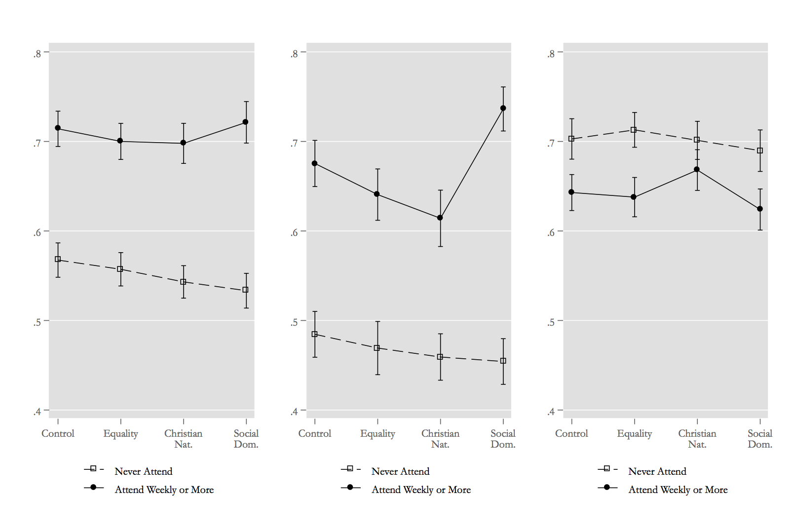
Figure A1. Effect of Treatments by High and Low Religious Attendance on Support for Three Types of Religious Freedom. Comparing two confidence intervals produces a 90% test.

