Appendix B: Factorial Design

Treatment:  Randomized photo and name | Poster Gender (F / M)
Poster Race  (White / Black) | White, woman  (n = 500) | White, man  (n = 500)
 | Black, woman  (n = 500) | Black, man  (n = 500)
Control | Generic image / name  (n = 500)

Total N = 2,500

Appendix C: Descriptive Statistics

 | N | Mean | SD | Min | Median | Max | Range
Age | 1,932 | 47.59 | 19.248 | 18 | 49.5 | 94 | 76
Income | 1,932 | 4.78 | 1.732 | 1 | 5.0 | 7 | 6
Educ. | 1,932 | 3.20 | 1.088 | 1 | 3.0 | 5 | 4
Race | 1,932 | 1.88 | 0.899 | 1 | 2.0 | 3 | 2
PID | 1,932 | 2.10 | 0.771 | 1 | 2.0 | 3 | 2
Female | 1,932 | 0.53 | 0.499 | 0 | 1.0 | 1 | 1

Appendix D: Logistic Regression Models for H1

Note for all models: Reference category for Q treatment is CONTROL; Reference category for race is WHITE, NON-HISPANIC; Reference category for Party ID is REPUBLICAN; All dependent variable variables are coded 1 if the post was flagged.

Logistic Regression Post 1
 | Dependent variable:
 | Post Reported
Q1conditionBlack male | 0.206
 | (0.145)
Q1conditionBlack female | -0.105
 | (0.147)
Q1conditionWhite male | 0.020
 | (0.142)
Q1conditionWhite female | 0.060
 | (0.143)
Age | 0.007***
 | (0.002)
Female | 0.071
 | (0.092)
Income | 0.035
 | (0.030)
Education | 0.008
 | (0.046)
Race - Black | 0.037
 | (0.138)
Race - Other | 0.134
 | (0.104)
Democrat | 0.498***
 | (0.127)
Independent / Other | 0.081
 | (0.124)
Constant | -1.342***
 | (0.249)
Observations | 2,081
Log Likelihood | -1,369.399
Akaike Inf. Crit. | 2,764.798
Note: | *p<0.1; **p<0.05; ***p<0.01

Logistic Regression Post 2
 | Dependent variable:
 | Post Reported
Q2conditionBlack male | 0.240
 | (0.158)
Q2conditionBlack female | 0.078
 | (0.162)
Q2conditionWhite male | 0.147
 | (0.160)
Q2conditionWhite female | 0.008
 | (0.160)
Age | 0.005*
 | (0.003)
Female | 0.032
 | (0.103)
Income | -0.044
 | (0.033)
Education | 0.005
 | (0.052)
Race - Black | 0.028
 | (0.147)
Race - Other | 0.076
 | (0.117)
Democrat | 1.108***
 | (0.148)
Independent / Other | 0.288*
 | (0.151)
Constant | -1.733***
 | (0.280)
Observations | 2,046
Log Likelihood | -1,157.990
Akaike Inf. Crit. | 2,341.981
Note: | *p<0.1; **p<0.05; ***p<0.01

Logistic Regression Post 3
 | Dependent variable:
 | Post Reported
Q3conditionBlack male | 0.101
 | (0.142)
Q3conditionBlack female | -0.023
 | (0.141)
Q3conditionWhite male | 0.219
 | (0.140)
Q3conditionWhite female | -0.016
 | (0.141)
Age | 0.013***
 | (0.002)
Female | 0.325***
 | (0.091)
Income | -0.036
 | (0.029)
Education | -0.043
 | (0.046)
Race - Black | 0.004
 | (0.137)
Race - Other | -0.058
 | (0.103)
Democrat | 0.259**
 | (0.125)
Independent / Other | 0.042
 | (0.121)
Constant | -0.713***
 | (0.245)
Observations | 2,051
Log Likelihood | -1,388.292
Akaike Inf. Crit. | 2,802.584
Note: | *p<0.1; **p<0.05; ***p<0.01

Logistic Regression Post 4
 | Dependent variable:
 | Post Reported
Q4conditionBlack male | -0.189
 | (0.146)
Q4conditionBlack female | -0.181
 | (0.144)
Q4conditionWhite male | -0.076
 | (0.144)
Q4conditionWhite female | -0.187
 | (0.145)
Age | 0.001
 | (0.002)
Female | 0.292***
 | (0.093)
Income | -0.041
 | (0.030)
Education | 0.065
 | (0.047)
Race - Black | 0.111
 | (0.138)
Race - Other | -0.080
 | (0.106)
Democrat | 0.832***
 | (0.129)
Independent / Other | 0.266**
 | (0.126)
Constant | -0.790***
 | (0.251)
Observations | 2,024
Log Likelihood | -1,337.661
Akaike Inf. Crit. | 2,701.322
Note: | *p<0.1; **p<0.05; ***p<0.01

Online Appendix E: Effect of Treatment Condition and Partisanship on Reporting

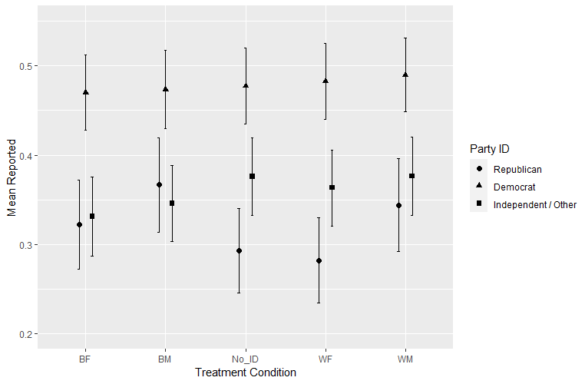

Online Appendix F: Logistic regressions predicting effect of treatment race / gender X participant race / gender

Reporting Post as Violating Terms of Agreement
 | (1)  Treatment x Race | (2)  Treatment x Gender
Treatment
Black | 1.04
 | (0.09)
Female |  | 0.87
 |  | (0.09)
Female | 1.28** | 1.24*
 | (0.11) | (0.12)
Race
White | . | .
Black | 1.14 | 1.09
 | (0.18) | (0.16)
Other | 1.07 | 1.01
 | (0.14) | (0.13)
Treatment Black ^{x}  Black | 0.89  (0.18)
Treatment Black ^{x}  Other | 0.86  (0.14)
Treatment Female ^{x}  Female |  | 1.08  (0.13)
Age | 1.01*** | 1.01***
 | (0.00) | (0.00)
Income | 0.98 | 0.98
 | (0.04) | (0.04)
Education | 1.01 | 1.01
 | (0.06) | (0.06)
Party
Republican | . | .
Democrat | 2.32*** | 2.34***
 | (0.15) | (0.15)
Independent / Other | 1.23 | 1.23
 | (0.15) | (0.13)
Intercept | 0.22  (0.28) | 0.23  (0.28)
N | 8,202 | 8,202
Coefficients are odds ratios (exponentiated) with standard errors in parentheses. Data are stacked on post / question and analyzed using a fixed effects model to allow for analysis of treatment condition across posts.
*p < .10, **p < .05, ***p < .01

