Assessing Racial/Ethnic and Gender Gaps in Political Science PhD Students’ Methodological Self-efficacy

Supplementary Materials

Amy Erica Smith Iowa State University

Shauna Gillooly American Council of Learned Societies

Heidi Hardt

University of California, Irvine

1. Online Survey

Recruitment. The survey was fielded between December 13 and December 16, 2019. Participants were recruited from the top 50 PhD programs in the United States, according to the 2019 US World News Report list. The latter is widely accepted as an authority on academic program rankings. We developed our list of student subjects to recruit via publicly-available departmental websites, as well as via emails to administrative support staff. In total, we emailed invitations to approximately 2,000 students and these invitations offered a $15 gift certificate for survey completion. Given budget limitations, we cut off survey administration at 300 students despite additional survey interest. In total, 308 students began the survey, and 297 completed it.

Instrument and Administration. The survey was administered in the online software Qualtrics XM. The primary purpose of the questionnaire was to study how gender and race affected perceptions of diversity in role models, and subsequently general various dimensions of self -efficacy. One key component of the questionnaire involved a survey experiment in which students were asked to read and respond to a randomly assigned syllabus in quantitative and qualitative methods, in which we systematically varied the percentage of readings authored by women. That experiment is analyzed elsewhere.

In addition to standard quantitative response batteries, the survey provided a number of spaces for respondents to write open-ended, textual explanations of their answers. Text and coding of relevant variables is presented below.

Sample Characteristics and Representativeness. Table S1 presents the detailed demographic profile of our sample, as well as comparisons to the broader graduate student population in political science, from the American Political Science Association’s (APSA) 2019 statistics on the demographics of its general members. One should note that APSA’s data varies a bit from our own since many of its members are people who have already completed their PhDs. This difference is primarily notable in age distribution: APSA’s membership demographic skews much older than graduate students. However, our survey is still representative of the larger demographic composition of the field of political science.

1

Table S1. Characteristics of the Sample

 |  | Our Survey | APSA 2019
 | Race/Ethnicity (multiple responses allowed)
 | Black or African American | 3.4% | 4.9%
 | Hispanic, Latino, or Spanish | 10.4% | 5.9%
 | White | 73.7% | 75.3%
 | Asian | 15.5% | 9.5%
 | Middle Eastern or North African | 3.0% | 1.7%
 | Other | 4.0% | 2.3%
 | Gender
 | % Female | 45.8% | 37.4%
 | % Male | 50.8% | 62.4%
 | % Non-binary or Other | 1.4% | 0.2%
 | % Gender NA | 2.0% | No data
 | Age
 | 21-25 | 26.6% | 1.6%
 | 26-29 | 40.4% | 5.9%
 | 30-35 | 26.6% | 18.6%
 | 36-45 | 6.4% | 29.9%
 | First in family to graduate from college? | 19.5% | 18%
 | Has a dependent (e.g., elderly family member, child) | 10.1% | No data
 | Has a partner (e.g., married or civil union) | 57.8% | No data

2. Variable Coding

Methodological Orientations. These four items are based on questions reading, “Please rate the following:

- Your interest in quantitative methods

- Your ability in quantitative methods

- Your interest in qualitative methods

- Your ability in qualitative methods
Responses to each were on a scale running from 1 (“very low”) to 5 (“very high”); each item was recoded to run from 0 to 1. (See summary statistics in Table S2.)

Table S2. Summary Statistics for Attitudinal Variables

 |  | Minimum | Maximum | Mean | Standard
 |  |  |  |  | Deviation
 | Quantitative Methods Self-Efficacy | 0 | 1 | 0.61 | 0.24
 | Qualitative Methods Self-Efficacy | 0 | 1 | 0.49 | 0.26
 | General Academic Self-Efficacy | 0 | 1 | 0.71 | 0.17
 | Quantitative Methods Interest | 0 | 1 | 0.69 | 0.31
 | Qualitative Methods Interest | 0 | 1 | 0.59 | 0.28

2

General Academic Self-Efficacy. We measured general academic self-efficacy using an index (alpha =
.83) based on the mean of responses to a battery of eight items. Student were asked to state the extent to which they agreed with the following statements, on a 1-5 scale:
- I fit well in my PhD program.
- I am likely to finish my PhD.
- My research is likely to get published.
- My research is likely to be cited.
- Most of my fellow graduate students (who know me) think I am or will be successful.
- My fellow graduate students support me (non-financially).
- My PhD department supports me (non-financially).
- My advisor supports me (non-financially).
The index is then rescaled to run from 0 to 1. (See summary statistics in Table S2.)

Student Race/Ethnicity. Indicator variables for race and ethnicity are based on a question asking “What race/ethnicity do you identify as? Please check all that apply.” Twenty-four students identified as White plus some other race/ethnicity. For the sake of analysis, we code as “White” only students who checked “White” but no other box; otherwise, we code the student based on their non-White identification.

Distribution is reported in Table S1.

Student Gender. Student gender is based on responses to a question asking, “What gender do you identify as?” In addition to male and female, response options included “gender non-conforming or nonbinary,” “other,” and “prefer not to answer.” Only 3 students identified as non-binary and 1 as “other,” while 5 chose not to answer the gender question. Distribution is reported in Table S1.

Year in Program. This variable is self-reported, and runs from 1 to 8. The mean on the variable is 3.8.

Student Age. This variable is based on a question asking simply “How old are you?,” and is recoded in age brackets. Distribution is reported in Table S1.

First Generation Status. This indicator variable is based on a question asking, “Are you a first-generation college graduate - meaning that you were the first in your family to graduate from college?” Distribution is reported in Table S1.

Dependents. This indicator variable is coded “1” for respondents who replied in the affirmative to a question asking, “Do you have primary care-taking responsibility for a dependent (i.e. elderly family member, child/children)?” Distribution is reported in Table S1.

Partner. This indicator is based on responses to the question, “What is your family status?” The dummy variable is coded “1” for students who chose “Married,” “Civil union,” “Living with a partner,” or “Other stable relationship with a partner.” It is coded “0” for those who chose “Single” or “Divorced.” In addition, we coded it “1” for the two students who chose “Other,” as one wrote in “Engaged,” and another wrote in “Dating.” Distribution is reported in Table S1.

Note that Dependents and Partner are interacted in much of the analysis.

Program Rank. PhD program rank is based on US News and World Reports rankings from 2019. The original variable runs from 1 to 51; we recode the variable to run from 0 to 1 to aid in interpretation of results alongside the other independent variables. Note that higher values of the variable correspond to what are typically called “lower,” or less prestigious, rankings.

3

3. Additional Analyses

A. Distribution of Quantitative Efficacy by Race

Figure S1 displays the distribution of quantitative self-efficacy by race and ethnicity. The figure indicates that the distribution is substantially more left-skewed among MENA and Black/African American students than among other groups. It is notable that the modal response among Asian and White students is 0.75, while the modal response among Latinos/as and Blacks is 0.5, and the modal response among MENA students is 0. At the same time, the distribution among Latinos/as is substantially to the right of that among Black students, as illustrated that there are no Latino/a students in the bottom bin, and no Black students in the top bin.
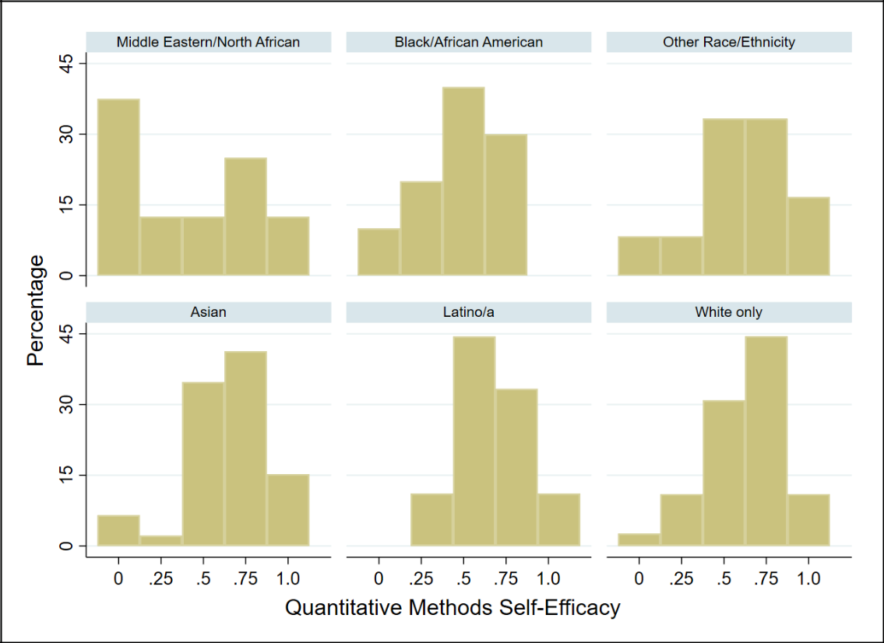

Figure S1. Distribution of Quantitative Self-Efficacy, by Race/Ethnicity B. Intersectional Analysis of Quantitative Efficacy

In Figure S2 and Table S3, we examine whether racial gaps in quantitative efficacy hold for both women and men. Breaking the analysis out, we find larger gaps among women, and none among women. As a result, the gender gap varies by race/ethnicity.

4

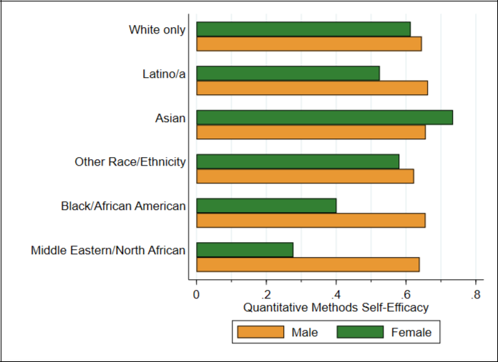

Figure S2. Mean Quantitative Self-Efficacy, by Race/Ethnicity and Gender

Table S3. Race*Gender Analysis of Quantitative Self-Efficacy (Hierarchical Models)

 | Coefficient | Standard Error
Middle Eastern/North African | -0.01 | 0.13
Black/African American | 0.01 | 0.13
Other Race | -0.02 | 0.11
Asian | 0.01 | 0.05
Latino | 0.02 | 0.06
Female | -0.03 | 0.03
Female * MENA | -0.33* | 0.17
Female * Black | -0.22 | 0.16
Female * Other Race | -0.01 | 0.14
Female * Asian | 0.11 | 0.08
Female * Latina | -0.11 | 0.10
Constant | 0.65 | 0.03
Number of Observations | 285
R-squared (within) | 0.11
R-squared (overall) | 0.08

Notes: Dependent variable is scaled to run 0 to 1. The baseline categories are male and white. Nonbinary/other gender students are excluded in this interactive analysis. Symbols indicate * p < .10; ** p < .05; *** p < .01.

5

C. Multivariate Hierarchical Models

Table S4 presents hierarchical logistical regression models, corresponding to the results presented in Figure 1 in the main text. The coefficients of MENA and Black/African American identification are nearly identical to those from bivariate analysis, while other racial/ethnic identification variables do not reach standard levels of statistical significance. Coefficients for gender shrink and become statistically significant. In addition, self-assessed quantitative ability is correlated at standard levels of statistical significance with program rank, but not with gender, year in program, age, first generation status, or having dependents.

Table S4. Determinants of Quantitative Self-Efficacy (Hierarchical Models)

 |  | (1)
 | Coefficient | Standard
 |  | Error
Middle Eastern/North African | -0.22*** | 0.08
Black/African American | -0.18** | 0.08
Other Race | -0.04 | 0.07
Asian | 0.03 | 0.04
Latino/a | -0.02 | 0.05
Female | -0.04 | 0.03
Other/Nonbinary Gender | -0.13 | 0.14
Year in Program | 0.01 | 0.01
Age 26-29 | 0.05 | 0.04
Age 30-35 | 0.01 | 0.05
Age 36-45 | -0.04 | 0.08
First Generation Student | 0.03 | 0.04
Has Dependents | -0.12 | 0.24
Has Partner | -0.02 | 0.03
Has Dependents X Has Partner | 0.14 | 0.24
Rank of PhD Program (0-1 scale) | -0.17*** | 0.05
Constant | 0.67 | 0.05
Number of Observations | 285
R-squared (within) | 0.08
R-squared (overall) | 0.12

Notes: Dependent variable is scaled to run 0 to 1. The baseline categories are male, white, and aged 21-25. Symbols indicate * p < .10; ** p < .05; *** p <

.01.

D. Analysis Controlling for Methodological Orientations

Figure S3 presents racial gaps in interest in quantitative methods; it shows that MENA students report substantially lower interest, at .40, versus between .69 and .72 for Black, Asian, Latino/a, and White students.

6

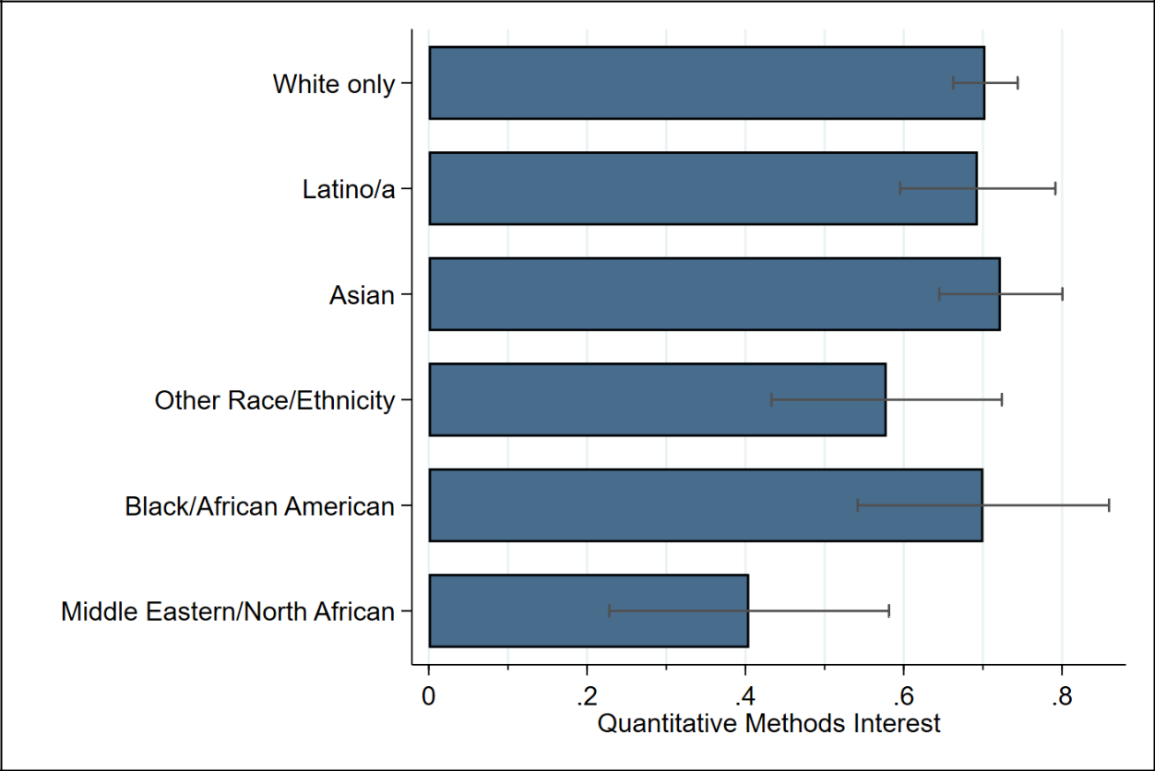

Figure S3. Conditional Means of Quantitative Interest, by Race/Ethnicity Note: 90% confidence intervals shown.

Table S5 analyzes racial/ethnic gaps in quantitative efficacy, controlling for interest in quantitative methods, as well as interest and efficacy with respect to qualitative methods (see Section 3D below for further discussion of qualitative methods orientations). In this analysis, the gap between white and MENA students drops by two-thirds, but the gap between Black and white students is unchanged. Only Black/African American identification and program rank remain sizeable and statistically significant determinants of quantitative self-efficacy, and it is noteworthy that the racial gap is larger than the predicted gap between the highest and lowest ranked PhD program in the sample.

Table S5. Determinants of Quantitative Self-Efficacy, Controlling for Other Methodological Orientations (Hierarchical Models)

 | Coefficient | Standard Error
Quantitative Methods Interest | 0.50*** | 0.04
Qualitative Methods Self-Efficacy | 0.14** | 0.06
Qualitative Methods Interest | -0.14*** | 0.05
Middle Eastern/North African | -0.05 | 0.07
Black/African American | -0.17*** | 0.06
Other Race | 0.06 | 0.06
Asian | 0.02 | 0.03
Latino/a | -0.01 | 0.04

7

 | Coefficient | Standard Error
Female | -0.01 | 0.02
Other/Nonbinary Gender | 0.04 | 0.11
Year in Program | 0.01 | 0.01
Age 26-29 | 0.02 | 0.03
Age 30-35 | -0.02 | 0.04
Age 36-45 | -0.02 | 0.06
First Generation Student | 0.00 | 0.03
Has Dependents | 0.11 | 0.19
Has Partner | 0.01 | 0.02
Has Dependents X Has Partner | -0.12 | 0.19
Rank of PhD Program (0-1 scale) | -0.11*** | 0.04
Constant | 0.30 | 0.06
Number of Observations | 285
R-squared (within) | 0.45
R-squared (overall) | 0.49

Notes: Dependent variable is scaled to run 0 to 1. The baseline categories are male, white, and aged 21-25. Symbols indicate * p < .10; ** p < .05;

  - p < .01.

E. Analysis of Qualitative Efficacy and Interest

We replicate all of the analysis for quantitative methods to study qualitative orientations. Figure S4 presents levels of self-efficacy and interest in qualitative methods, by race/ethnicity. We find no statistically significant gaps in either dependent variable by race.

8

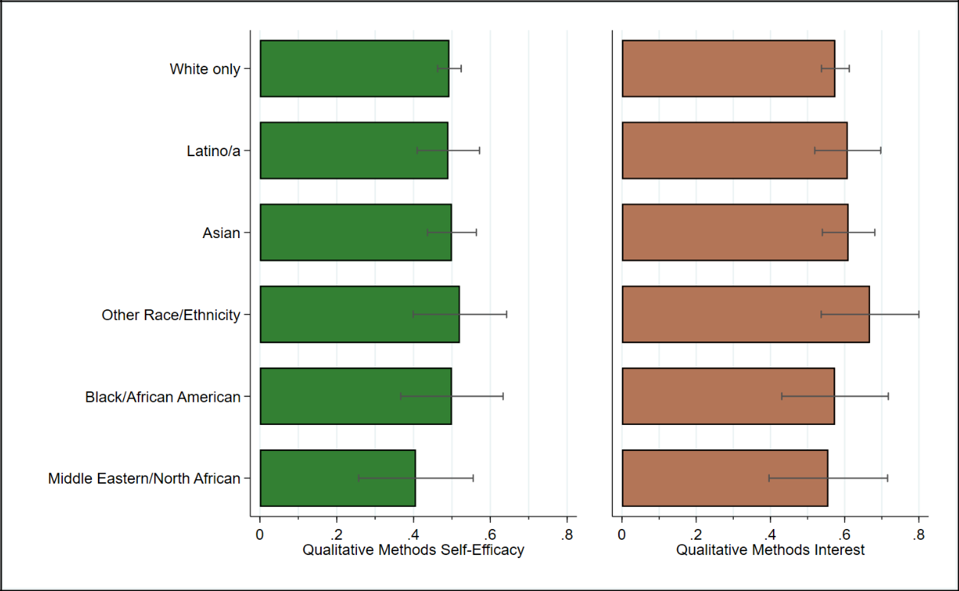

Figure S4. Conditional Means of Qualitative Methods Orientations, by Race/Ethnicity Note: 90% confidence intervals shown.

Table S6 presents equivalent results to Tables S4 and S5 for qualitative self-efficacy. In the first model, we find that self-assessed qualitative ability is positively correlated at standard levels of statistical significance with being female and older in age, and negatively so with MENA identification, year in program, and with having dependents (particularly so for single parents). However, qualitative self-efficacy is not significantly associated with PhD program rank. In the second model, we find that year in program, age, and having dependents remain statistically significantly associated with qualitative self-efficacy, even controlling for interest in qualitative methods. The coefficient for MENA identification again becomes insignificant at standard levels.

Table S6. Determinants of Qualitative Self-Efficacy (Hierarchical Models)

 | (1) |  |  | (2)
 |  | Standard |  | Standard
 | Coefficient | Error | Coefficient | Error
Qualitative Methods Interest |  |  | 0.53*** | 0.04
Middle Eastern/North African | -0.15* | 0.09 | -0.12 | 0.07
Black/African American | -0.01 | 0.08 | 0.00 | 0.07
Other Race | 0.02 | 0.08 | -0.04 | 0.06
Asian | -0.03 | 0.04 | -0.04 | 0.04
Latino/a | -0.03 | 0.05 | -0.03 | 0.04
Female | 0.10*** | 0.03 | 0.04 | 0.02

9

 | (1) |  |  | (2)
 |  | Standard |  | Standard
 | Coefficient | Error | Coefficient | Error
Other/Nonbinary Gender | 0.18 | 0.14 | 0.10 | 0.12
Year in Program | -0.03*** | 0.01 | -0.02* | 0.01
Age 26-29 | 0.00 | 0.04 | 0.00 | 0.03
Age 30-35 | 0.19*** | 0.05 | 0.11*** | 0.04
Age 36-45 | 0.29*** | 0.08 | 0.19*** | 0.06
First Generation Student | 0.03 | 0.04 | 0.01 | 0.03
Has Dependents | -0.72*** | 0.25 | -0.88*** | 0.21
Has Partner | -0.01 | 0.03 | -0.04 | 0.03
Has Dependents X Has Partner | 0.58** | 0.25 | 0.78*** | 0.21
Rank of PhD Program (0-1 scale) | -0.03 | 0.05 | 0.00 | 0.04
Constant | 0.53*** | 0.05 | 0.23*** | 0.05
Number of Observations | 285 |  | 285
R-squared (within) | 0.13 |  | 0.40
R-squared (overall) | 0.15 |  | 0.44

Notes: Dependent variable is scaled to run 0 to 1. The baseline categories are male, white, and aged 21-25. Symbols indicate * p < .10; ** p < .05; *** p < .01.

10

